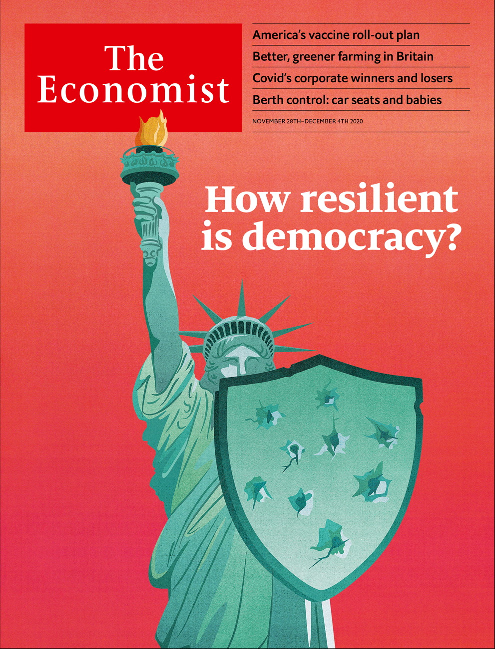

# Table of Contents

The world this week

Politics this week

Business this week

KAL’s cartoon

Leaders

Democracy contains the seeds of its own recovery: The resilience of democracy

Covid-19’s corporate winners and losers: What doesn’t kill you

Ethiopia: Preventing war crimes

Fiscal stimulus: The right kind of discipline

Covid-19 and school exams: Papers, please

Agriculture in Britain: Ploughing its own furrow

Letters

Letters to the editor: On covid testing, Germany, women's suffrage, free speech, rock stars, Singapore, trains, bitcoin

Briefing

Democracy in India: Subcontinental drift

United States

The covid-19 vaccines: Grabbing a cold one

The virus and the heartland: View from the ICU

Team Biden: In transit

The other transition: Miss gender

Obscure laws: Panic attacks

Lexington: The end of the embarrassment

The Americas

Venezuela: They’re going to win, by a lot

Diego Maradona: Divine and damned

Bello: The future of bolsonarismo

Asia

Rule of law in South Korea: Prosecution complex

Sri Lanka’s Tamils: The war within

Crime in Singapore: A city reels

India and Pakistan: Shell game

Banyan: Hurly-barley

China

China studies: Barriers to Sinology

Television entertainment: Loaded questions

Chaguan: Patriotism before profit

Middle East & Africa

American policy in the Middle East: You’re sanctioned!

Israel and Saudi Arabia: The not-so-secret alliance

Uganda’s election: Bullets before the ballot

Nigeria: It’s all in the script

Migration from west Africa: Africa’s do-or-die boat people

Europe

The Sweden Democrats: On their way in

Swedish gang violence: Segregated cities

Sicily and EU cash: No cosying up to Cosa Nostra

France and Germany: War of words

Poland: Disco populism

Charlemagne: Newtonian Europe

Britain

Public spending: A combustible mix

Potholes: Revolutionary roads

Covid-19 vaccines: Emergency exit

Farming after Brexit: Fresh fields and pastures new

Bagehot: Sunak’s secret self

International

Exams and covid-19: Testing, testing

Business

Live events: The roar of the crowd

Publishing: Book-binding

Shopping frenzies: Fade from black

The attention economy: You’ve been botted

Diversity consulting: All inclusive

Bartleby: Winter is coming

Schumpeter: The climate centurion

Finance & economics

Christine Lagarde: Culture shock

Janet Yellen: Something for everyone

Buttonwood: Home-schooled

Stimulus in America: A clash over cash

Personal debt in China: Overdue action

Money transfers: Intrepid banking

Free exchange: An unbalanced debate

Science & technology

The coronavirus pandemic: Another covid-19 vaccine joins the party

Sterilising medical instruments: Sunlight is the best disinfectant

Palaeontology: Nursery days

Children’s car seats: Berth control

The death of Arecibo: Si monumentum requiris respicite

Books & arts

The underworld of empire: Brothers in arms

Historical fiction: Cops and plotters

Creatures of the deep: Thar she blew

Lives of the composers: Too beautiful

Johnson: Average Joe

Economic & financial indicators

Economic data, markets and commodities

Graphic detail

Covid-19 and lockdowns: Second act

Obituary

Jan Morris: Unaltered states



Friday, November 27, 2020

|  |  |
| --- | --- |
| The world this week | 3 |
| Leaders | 6 |
| Letters | 1 |
| Briefing | 1 |
| United States | 6 |
| The Americas | 3 |
| Asia | 5 |
| China | 3 |
| Middle East & Africa | 5 |
| Europe | 6 |
| Britain | 5 |
| International | 1 |
| Business | 7 |
| Finance & economics | 7 |
| Science & technology | 5 |
| Books & arts | 5 |
| Economic & financial indicators | 1 |
| Graphic detail | 1 |
| Obituary | 1 |

### 加迪迪QQ1562739651问外刊群群号

|  |  |  |
| --- | --- | --- |
|  | Sections | Leaders |

The world this week

Politics this week

.

Business this week

.

KAL’s cartoon

.

|  |  |  |
| --- | --- | --- |
|  | Sections | Leaders |

|  |  |  |  |
| --- | --- | --- | --- |
|  | Articles | Sections | Next |

# Politics this week

Nov 26th 2020 |

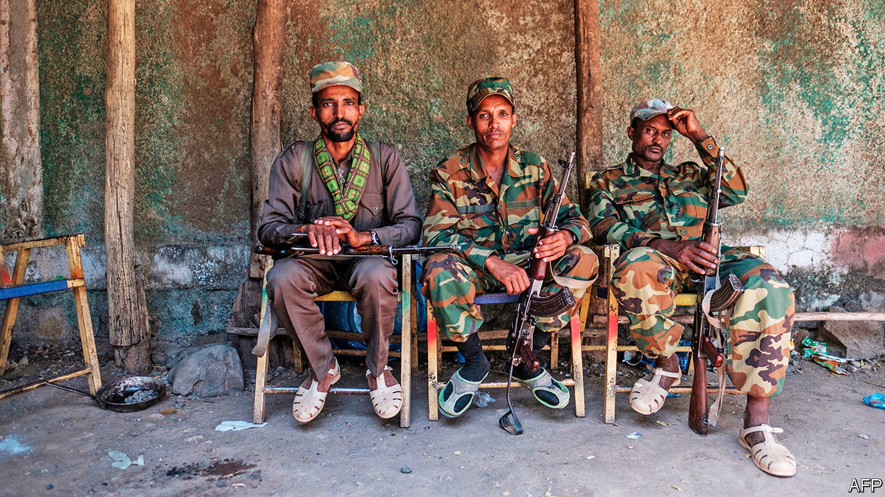

Federal forces in Ethiopia said they had surrounded Mekelle, the capital of the northern region of Tigray, and were about to attack the city to crush a rebellious regional government. They warned civilians to leave or receive “no mercy”. Ethnic clashes are exploding. Non-Tigrayans are being targeted in Tigray—perhaps 600 were massacred in one town. Tigrayans are being singled out elsewhere. Many have been arrested. Tigrayan soldiers in the national army have been disarmed. See [article](https://www.economist.com/node/21795685).

Pre-election violence claimed at least 45 lives in Uganda. Bobi Wine, an opposition candidate, was arrested yet again. His supporters protested. Security forces shot several of them. See [article](https://www.economist.com/node/21795721).

Israel’s prime minister, Binyamin Netanyahu, travelled to Saudi Arabia to meet Muhammad bin Salman, the powerful crown prince. There was no hint that the Saudi regime was about to recognise Israel. Rather, the meeting seemed intended to warn Iran to restrain its nuclear programme or risk a military strike, and to hint to Joe Biden that the two will oppose significant shifts in policy on the Middle East. See [article](https://www.economist.com/node/21795703).

Iran released Kylie Moore-Gilbert, a British-Australian academic detained in 2018 and convicted of espionage in a secret trial. She was reportedly swapped for Iranians arrested abroad. Separately Iran said it will soon execute Ahmadreza Djalali, an Iranian-Swedish doctor, convicted in an unfair trial on charges that were brought after he refused to spy for the government.

Nicolas Sarkozy, president of France from 2007-12, went on trial accused of corruption and influence-peddling. He is charged with having tried to bribe a judge by promising assistance for a promotion in return for information about an investigation into him.

France’s lower house passed a bill that would make it illegal to share images of police for “malicious purposes”. This law, if also passed by the Senate, would make it harder to expose police brutality. Brussels is taking a look.

Donald Trump at last directed federal agencies to co-operate with the transfer of power to Joe Biden. The president’s refusal to do so had hindered the flow of classified information and other material to Mr Biden. Mr Trump also pardoned Michael Flynn, his first national security adviser, who had pleaded guilty to lying to the FBI during the Mueller investigation. Mr Trump is still contesting the election result, without success.

Mr Biden started choosing his team, picking Antony Blinken, who worked in Barack Obama’s administration, as his secretary of state. Avril Haines, another Obama veteran, is to be the director of national intelligence; Jake Sullivan, a former aide to Mr Biden, national security adviser. He also created a new position of special envoy on climate change. The job went to John Kerry, who signed the Paris accord in 2015 as Mr Obama’s secretary of state. In 2019 Mr Kerry started an initiative to hold politicians accountable if they fail to reduce emissions. See [article](https://www.economist.com/node/21795743).

Joshua Wong, a prominent activist in Hong Kong, was remanded in custody after pleading guilty to charges relating to last year’s pro-democracy unrest in the city. Also detained were two leaders of Mr Wong’s now-disbanded political group, Demosisto: Agnes Chow and Ivan Lam. The three are expected to be sentenced next month.

China launched a spacecraft, Chang’e 5, in the first attempt by any country to retrieve rock samples from the Moon in more than 40 years. It is due to return to Earth in December.

Friendly governments and other donors promised to give the Afghan government $12bn over the next four years at a conference in Geneva. That marks a decline from the $15bn pledged four years ago.

Authorities in Singapore charged Jolovan Wham, a civil-rights activist, with disturbing public order for briefly holding up a sign with a smiley face on it. They maintain the act was an illegal protest. See [article](https://www.economist.com/node/21795710).

Police in Thailand summoned 12 of the leaders of ongoing protests around the country in connection with an investigation into lèse-majesté. The protesters have called for reforms to the monarchy.

Thousands of Guatemalans protested against the budget passed by the country’s Congress. Some set fire to Congress itself. They were angry that the budget included extra money for congressmen’s meal allowances but less for the judiciary, malnutrition and health. Congress backed down.

Mexico’s Senate voted for a bill to legalise cannabis for recreational use. It would permit users to have up to 28g of cannabis and allow them to grow up to four plants at home. If the bill passes the lower house of Congress Mexico would become the third country, after Uruguay and Canada, to legalise cannabis fully for recreational use nationwide.

Diego Maradona, one of the best footballers of all time, died, aged 60. Short of stature, a dazzling dribbler and scorer of marvellous goals, Mr Maradona inspired Argentina, his national team, to victory in the World Cup in 1986 (with a bit of help from his miraculous “hand of God”). He also struggled with addictions to cocaine and alcohol. See [article](https://www.economist.com/node/21795732).

## Coronavirus briefs

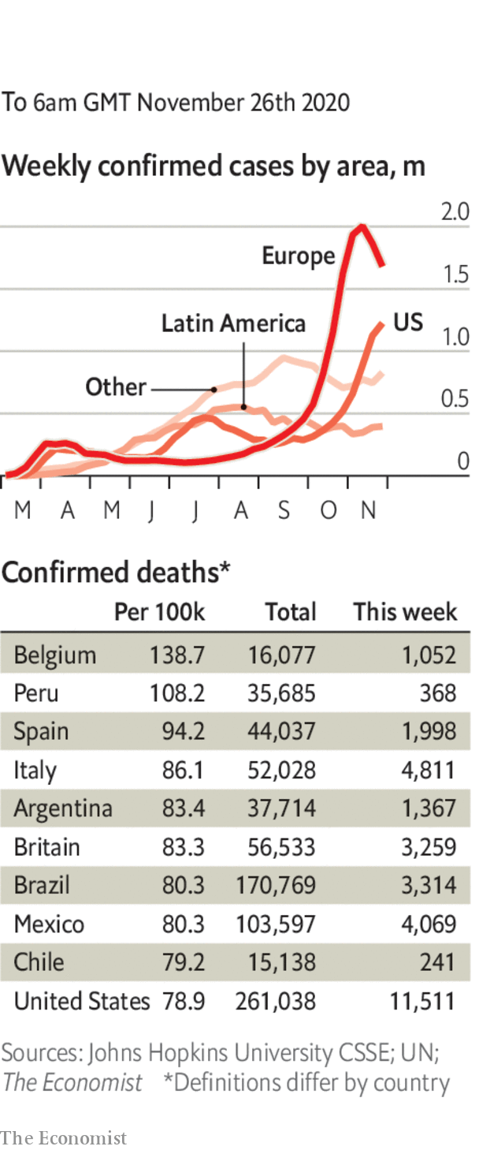

Several Asian countries, including Japan, Malaysia and South Korea, reported an increase in cases. In Japan the government suspended a campaign in some areas to encourage people to travel.

Some European countries outlined plans to ease restrictions over Christmas. In Britain three households will be able to meet up over a five-day period. France will start reopening shops on November 28th and most other restrictions will end on December 15th. Restaurants will remain closed until January 20th, however. Germany went in the other direction and tightened its measures until at least December 20th.

The Australian states of New South Wales and Victoria reopened their border. It was shut in July, and flights between Sydney and Melbourne cancelled, amid a surge of the virus in Victoria. After a rigid lockdown, it has reported no new cases for several weeks.

This article was downloaded by calibre from <https://www.economist.com/the-world-this-week/2020/11/26/politics-this-week>

|  |  |  |  |
| --- | --- | --- | --- |
|  | Articles | Sections | Next |

|  |  |  |  |
| --- | --- | --- | --- |
| Previous | Articles | Sections | Next |

# Business this week

Nov 28th 2020 |

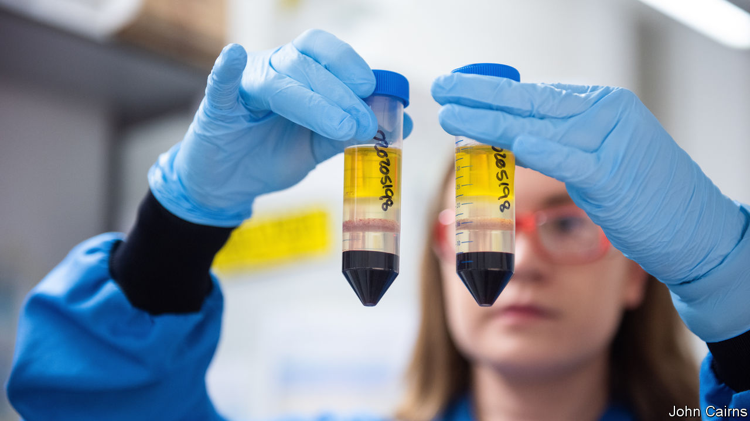

Researchers at AstraZeneca, a drug company, and Oxford University reported that their vaccine for covid-19 is 70% effective on average. In one course of treatment that rises to 90%, close to the efficacy of the other two recent vaccine successes, though questions have been raised about the data behind AstraZeneca’s trial. Its jab is expected to be cheaper and easier to distribute globally. Three billion doses could be ready next year. See [article](https://www.economist.com/node/21795672).

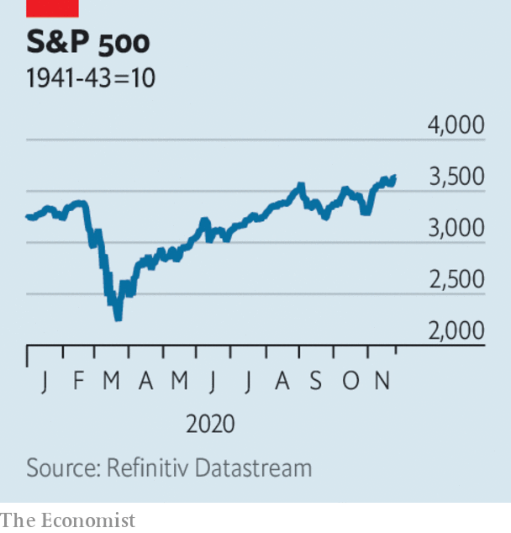

The good news on vaccines is one factor that has pushed stockmarkets into new territory. The Dow Jones Industrial Average passed the 30,000 mark for the first time and is on course for its best monthly gain since 1987. The S&P 500 hit a new record; it is up by more than 10% this month. See [article](https://www.economist.com/node/21795683).

## Mellow Yellen

The growing probability of a smooth transfer of power to Joe Biden also cheered investors. His choice of Janet Yellen as treasury secretary was seen as a safe bet. The former chairwoman of the Federal Reserve should pass her confirmation hearing in the Senate, even if it remains under Republican control. Her first task will be to help craft a new stimulus bill. See [article](https://www.economist.com/node/21795683).

One of the clearest signs yet that businesses are adapting to the new administration came from General Motors. The carmaker is withdrawing its support from the current government’s legal challenge to California’s vehicle-emission standards, the toughest in America. Mr Biden will bring in “ambitious” targets when he takes office, when he will also have a new climate tsar.

Tesla’s share price soared again, following the news that it is to be included in the S&P 500 index from next month, which means tracker funds will be obliged to buy its stock. The electric-car maker’s market capitalisation raced past $500bn this week. That is more than five times the combined value of GM and Ford.

Rishi Sunak, Britain’s chancellor of the exchequer, produced his spending review, which was as grim as expected. Mr Sunak noted that the emergency had “only just begun”, forecasting that borrowing will be £394bn ($530bn) this year, or 19% of GDP, which would be the highest deficit in peacetime. In addition to a public-sector pay freeze he also took a swipe at foreign aid, by abandoning a policy of spending 0.7% of national income on it. See [article](https://www.economist.com/node/21795690).

With the roll-out of vaccines for covid-19 on the horizon, airlines announced a raft of measures that they hope will make flying easier. Qantas became the first big carrier to suggest that it may ask passengers to prove they have had a vaccination before boarding a plane. Five airlines, including United and Lufthansa, said they would offer a “common pass” to travellers who have tested negative. American airports had their busiest weekend since March, handling more than 3m people ahead of Thanksgiving.

The good news about vaccines also spurred a rally in oil markets. Brent crude rose above $48 a barrel, its highest price since early March, before markets went into meltdown over the coronavirus.

Bertelsmann emerged the winner in a bidding war for Simon & Schuster, the publishing arm of ViacomCBS. Bertelsmann, which owns Penguin Random House, is paying $2.2bn for the firm, though getting the deal completed will be a page turner. Regulators will look closely at the rationale for combining the publishers, which would have a third of the American market. See [article](https://www.economist.com/node/21795718).

The drastic slowdown in global human activity because of covid-19 has led to only a “tiny blip” in the concentration of greenhouse gases in the atmosphere, according to the World Meteorological Organisation. Emissions may have been reduced by between 4% and 7.5% for the whole of the year relative to 2019, but CO2 remains in the atmosphere for centuries, so any amount of emissions contributes to a build-up. According to the WMO this year’s “blip” will be no bigger than normal annual fluctuations.

Showing that America is not the only country that has a problem with Chinese tech firms, India’s government banned another 43 apps that it said were “prejudicial” to the country’s “sovereignty and integrity”. Tension along the Himalayan border between China and India has risen since June and Delhi has banned 200 Chinese apps in all, in what it describes as a “digital strike”.

## Move over Hollywood

Netflix announced that it would spend $1bn on expanding its studios in Albuquerque, creating one of the largest film-production sites in North America. Ten new stages, backlots and other facilities will generate 1,000 production jobs and almost 1,500 in construction. It will make films there, as well as the next series of “Stranger Things”. Last year Netflix opened a production hub at Britain’s Shepperton Studios and earlier this year plans were approved to build a studio complex near Ashford in southern England that may house Netflix and Amazon.

This article was downloaded by calibre from <https://www.economist.com/the-world-this-week/2020/11/28/business-this-week>

|  |  |  |  |
| --- | --- | --- | --- |
| Previous | Articles | Sections | Next |

|  |  |  |  |
| --- | --- | --- | --- |
| Previous | Articles | Sections | Next |

# KAL’s cartoon

Nov 28th 2020 |

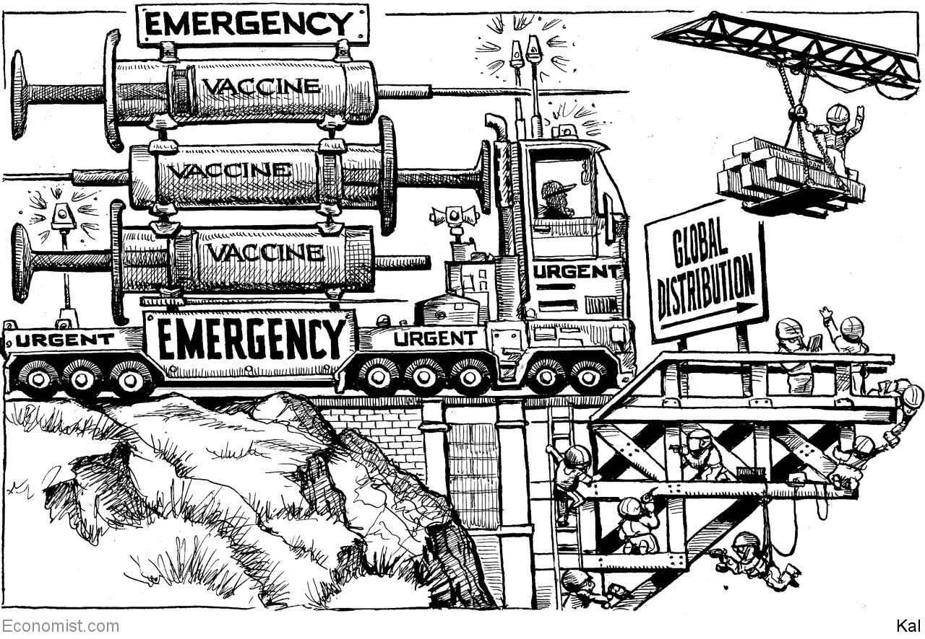

This article was downloaded by calibre from <https://www.economist.com/the-world-this-week/2020/11/28/kals-cartoon>

|  |  |  |  |
| --- | --- | --- | --- |
| Previous | Articles | Sections | Next |

|  |  |  |
| --- | --- | --- |
| The world this week | Sections | Letters |

Leaders

Democracy contains the seeds of its own recovery: The resilience of democracy

.

Covid-19’s corporate winners and losers: What doesn’t kill you

.

Ethiopia: Preventing war crimes

.

Fiscal stimulus: The right kind of discipline

.

Covid-19 and school exams: Papers, please

.

Agriculture in Britain: Ploughing its own furrow

.

|  |  |  |
| --- | --- | --- |
| The world this week | Sections | Letters |

|  |  |  |  |
| --- | --- | --- | --- |
|  | Articles | Sections | Next |

#### The resilience of democracy

# Democracy contains the seeds of its own recovery

A global democratic recession need not go on forever

Nov 26th 2020 |

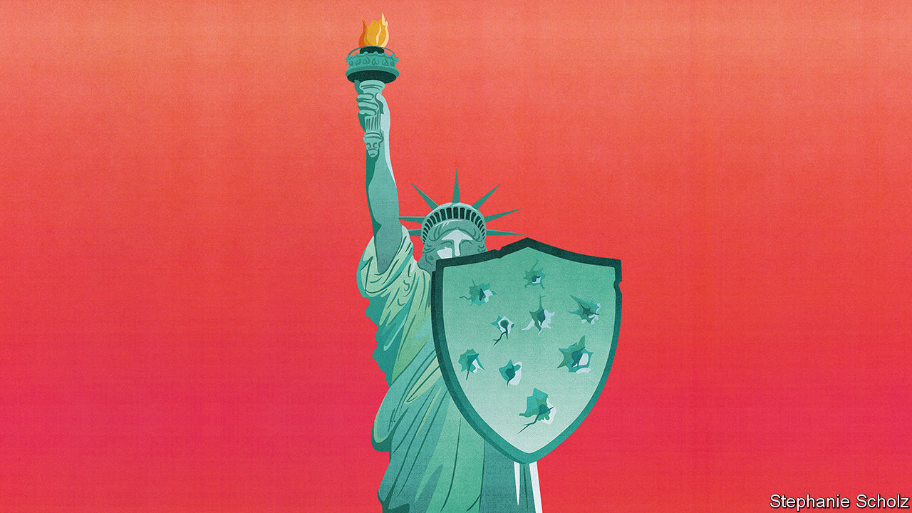

FOR ALL Donald Trump’s efforts to overturn this month’s election, American democracy never looked likely to buckle after polling day. Sure enough, on November 23rd, even as the president once again condemned “the most corrupt election in American history”, he agreed that the federal government should give Joe Biden the resources he needs to prepare for office.

Mr Trump has still done harm, as have the Republican leaders who indulged him (see article). Given that four in every five Republican voters say the vote was “stolen”, trust in the fairness of elections has been shaken and Mr Biden unjustly undermined from the very start. Henceforth in close votes routine jobs like counting and certifying votes will risk being part of the battleground. That is not a threat to the republic’s existence, but it does mark a further partisan deterioration in American democracy.

It is also part of a global democratic recession. The collapse of the Soviet Union led to a flourishing in the number and quality of liberal democracies, but the trend has now gone into reverse. Hungary and Poland are blocking the European Union budget because their governments refuse to bow to the rule of law (see article). Our briefing describes how in the world’s largest democracy the Bharatiya Janata Party (BJP) under Narendra Modi is capturing institutions, including the courts, the police and now, it is feared, the election commission. The Economist Intelligence Unit (EIU), our sister organisation, has been compiling a democracy index since 2006. Last year’s score was the worst ever. Covid-19 has accelerated the decline.

The threat is not from military coups but governments in power. Given time, unscrupulous leaders can hollow out democracy completely. Two decades ago Venezuela held meaningful elections; today it is about to eliminate the last kernel of opposition (see article). But even in countries where such a calamity is unthinkable, the erosion of norms and institutions leads to worse government. To reverse this, you have to understand what has gone wrong.

Whether you support them or not, Mr Trump and his fellow populists came to power as a response to the failings of democratic governments. In rich countries working-class voters came to believe that politicians did not care about them, after their living standards stagnated and they became worried about immigration. In central and eastern Europe governments seeking to join the EU paid more heed to Brussels than their own voters. In developing countries corruption sent the message that the ruling classes were chiefly interested in their own bank accounts.

Enterprising politicians responded to these feelings by elevating identity far above policy so as to show voters that their grievances matter. Such was the upheaval that some old parties were swept away—in France in 2017 they won just a quarter of the vote between them. Poland had thrived under a centrist government, but Law and Justice told voters that their Catholic values were under attack from Brussels. In Brazil Jair Bolsonaro endorsed voters’ contempt for the political class (see article). So relentless is Mr Trump’s focus on the identity of his base that he did not even propose a programme for his second term.

Identity politics, boosted by social media and partisan television and radio, has re-engaged voters. Participation is the only component of the EIU’s democracy index to have improved since 2006. Mr Biden and Mr Trump both won more votes than any presidential candidates in history. But in solving one of democracy’s problems, identity politics has created others.

That is because a politics that reinforces immutable identities leads away from the tolerance and forbearance a democracy needs to solve social conflicts. In arguments about who gets what, people can split the difference and feel content. In arguments about who they are—over religion, race and anti-elitism, say—compromise can seem like betrayal. When ways of life are at stake the other lot are not just mistaken, they are dangerous. Having not mattered enough, elections now matter too much.

In some countries majoritarian leaders have exploited this tribal loyalty to nobble the institutions supposed to check them. In Turkey Recep Tayyip Erdogan governs as if democratic power is absolute and condemns those who block him as enemies of the republic. In Mexico Andrés Manuel López Obrador sidesteps entire branches of government, which have supposedly been captured by the elites, and appeals directly to his supporters in referendums. In India, when the electoral commission pursued BJP candidates less scrupulously than their opponents, one of the three top commissioners objected—only to find his family investigated for tax evasion.

America’s institutions are protected by the professionalism of its judges and officials. Many of them feel bound by standards laid down by those who came before them. When Mr Trump tried to subvert the election, he failed abjectly because countless people did their duty.

As a result, the main harm identity politics does to America comes through animosity and gridlock. Politics is supposed to resolve society’s conflicts, but democracy is generating them instead. Partly because tribes live in different information universes, matters of fact like wearing masks and climate change are transformed into disputes about people’s way of life. The result is that American politics has once again become unresponsive. It fires people up so much that it obstructs the compromises needed for society to move forward.

## Vote for change

Some warn that the discontent this creates will cause democracies to die—an outcome that its foes, championed by Vladimir Putin, have schemed to bring about. And yet, there are plenty of reasons to hope. One of democracy’s strengths is that it promises lots of chances to start again. So long as elections take place, there is always the possibility of kicking the rascals out even in places where governments stack the vote. In the cities of Hungary and Poland voters have begun to reject repression and cronyism. In EU elections last year populists did worse than expected. Perhaps the pendulum has already begun to swing. India is too vast and too diverse for a single party to rule on its own.

Democracy is adaptable, too. In America’s election Republicans picked up Hispanic and black votes; and in Britain last year the governing Conservative Party won Labour seats in the Midlands. That mixing is just what politics in both countries needs, because it encourages parties on the left and right to break out of their tribal redoubts and to tilt the balance of political effort away from identity and back towards outcomes.

Democracy is, for good or ill, also linked to the fortunes of the superpower that is most closely tied to it. America supports democracy partly through example and advocacy. At home Mr Biden will attempt to restore norms such as the independence of the Justice Department. Abroad, he will not indulge autocrats and tyrants as much as Mr Trump has. And America could boost democracy through power politics. If Mr Biden wants to create an alliance to help America keep ahead in the race against China for tech dominance, democracy will help define it.

Above all, democracy is something people strive for. Every weekend Belarusians risk their liberty and their lives by taking to the streets to defy the dictator who refuses them the right to choose who should govern them, just as Hong Kongers, Sudanese and Thais have. It is an inspiration that voters everywhere should carry with them to the ballot box.■

This article was downloaded by calibre from <https://www.economist.com/leaders/2020/11/26/democracy-contains-the-seeds-of-its-own-recovery>

|  |  |  |  |
| --- | --- | --- | --- |
|  | Articles | Sections | Next |

|  |  |  |  |
| --- | --- | --- | --- |
| Previous | Articles | Sections | Next |

#### Winners and losers

# Will big firms benefit from the covid crunch?

It’s complicated, and the implications for competition uncertain

Nov 28th 2020 |

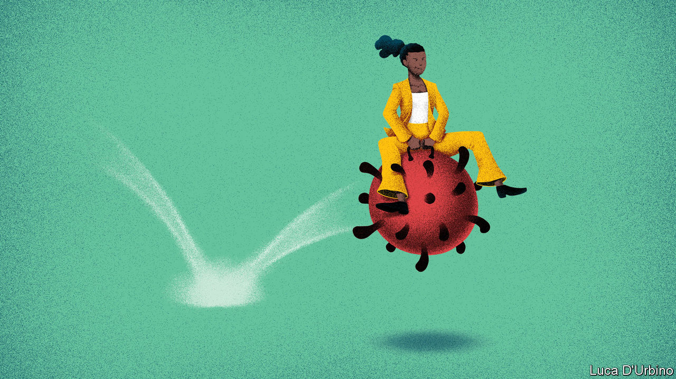

Editor’s note: Some of our covid-19 coverage is free for readers of The Economist Today, our daily [newsletter](https://my.economist.com/user#newsletter). For more stories and our pandemic tracker, see our [hub](https://www.economist.com/news/2020/03/11/the-economists-coverage-of-the-coronavirus)

AS THE PROSPECT of a widely distributed vaccine draws nearer—this week AstraZeneca and Oxford University announced results for their jab (see article)—bosses and investors are turning one eye away from the immediate struggle of coping with the pandemic and looking instead at the longer-term competitive picture. Who has won and who has lost? Like viruses, recessions usually come for the weakest first. Companies with sickly balance-sheets or frail margins quickly succumb. As promising startups become crushed closedowns, it is often the incumbents that have the resources to wait it out.

Yet the covid-19 recession has been sharper than normal, and more complicated. The world economy is expected to shrink by over 4% this year, the deepest downturn since the second world war, and there is still a risk of a double-dip recession (see [article](https://www.economist.com/node/21795692)). Bail-outs, central-bank stimulus and forbearance by banks and landlords have slowed the process of creative destruction and cut the number of defaults. Social distancing is laying waste to some industries while boosting others, as people find new ways to do old things.

As a result the normal pattern in which powerful firms gain more clout is less emphatic than you might expect—so far. Investors are struggling to get to grips with such an unusual outlook. This is partly why, although anticipated, the news on vaccines in the past few weeks has caused gyrations in financial markets as fund managers bet more heavily on firms they feared to touch just a few weeks ago.

What, then, is a good way to assess the winners and losers? In many businesses the incumbents will remain on top, because their entire industry has proved immune to online disruption. In other cases the incumbents will win—but because they have mastered new digital innovations. Finally, in some parts of the economy where technological change seems to have been speeded up, the running is being done by new entrants.

Live music is one industry that the pandemic has completely unplugged (see [article](https://www.economist.com/business/2020/11/22/covid-19-and-the-business-of-crowds)). With concerts and festivals banned, Live Nation, the largest concert organiser, has seen its sales fall by 95% compared with a year ago. Yet with no way to replicate a mosh-pit online, the industry is not being disrupted so much as put in the deep freeze. As Live Nation’s buoyant share price suggests, it can afford to wait until life returns to normal. Many other industries, such as air travel, cannot move online. This year will do grave damage to airlines’ balance-sheets—their total debt has reached half a trillion dollars. (British Airways is literally selling off the family china to shore up its finances: half a dozen first-class teacups can be yours for just over $30.) But those that survive will find the skies less crowded.

Elsewhere there has been more digital disruption—but it is the incumbents that have benefited. Advertising has shifted even further online, where the duopoly of Facebook and Google rules. Likewise, much office-based work has moved to the home, leading to empty office buildings and abandoned photocopiers. The upshot of this disruption is that people are more reliant than ever on big tech firms that provide cloud services. Though the pandemic will cause permanent change to all such industries, the dominant names in each will be familiar.

Yet there is a third group of industries which have been disrupted in ways that threaten the incumbents. Live sport has more or less continued throughout the pandemic, as teams have found ways to test or quarantine players. But the absence of crowds has contributed to a plunge in TV viewership, the financial engine of the sports industry. Instead, people are tuning in more often to highlights clips, betting sites and other interactive ways of enjoying sport on social apps, threatening the cable-TV firms. In catering, a growing appetite for delivery services such as DoorDash, whose revenues this year have more than trebled, points to a future in which eating at home becomes more common. Food retailers and restaurants will have to adapt, or see their profits nibbled away.

And what is the picture for the economy as whole? If you look at America’s stockmarket, the shares of the biggest companies by sales have outperformed this year—but only in 33 out of 59 industries, and by a median margin of just two percentage points. In many areas the battle for supremacy is still raging. Thus, in e-commerce Amazon’s sales have surged but it faces revived competition in the form of Walmart’s online operation and Shopify, a digital upstart. Covid-19 has brought with it economic damage on a vast scale. Yet the rapid changes that have been forced on many industries are leading to innovation that will outlive the pandemic—and in some cases are leaving incumbents less mighty than before. Consumers and trustbusters alike must hope that these newly competitive parts of the economy remain hotly contested long after the pandemic abates.■

This article was downloaded by calibre from <https://www.economist.com/leaders/2020/11/28/will-big-firms-benefit-from-the-covid-crunch>

|  |  |  |  |
| --- | --- | --- | --- |
| Previous | Articles | Sections | Next |

|  |  |  |  |
| --- | --- | --- | --- |
| Previous | Articles | Sections | Next |

#### Things don’t have to fall apart

# The world needs to stop war crimes in Ethiopia

Atrocities are mounting in Tigray. Outsiders should press both parties to talk

Nov 26th 2020 |

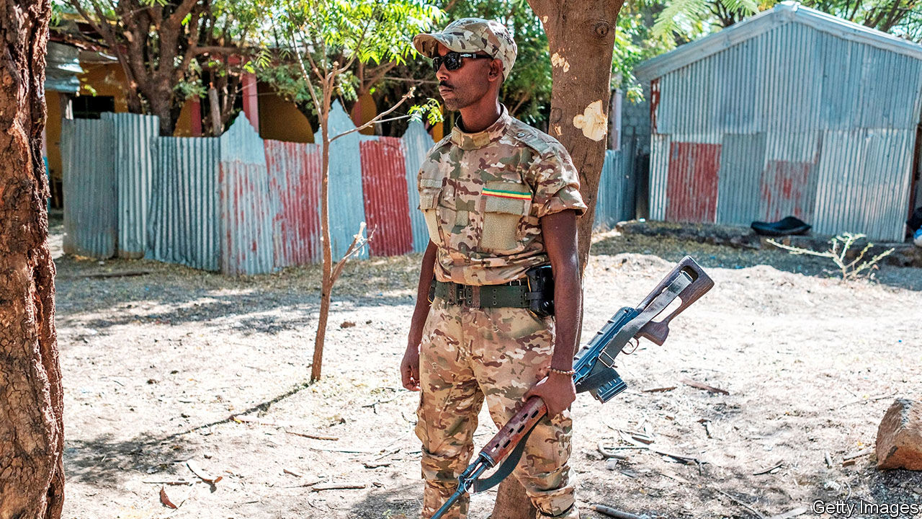

FIRST, THE police and militia shut the roads out of Mai Kadra, a farming town in Ethiopia’s northern province of Tigray. Then they went from door to door, checking ID cards and singling out non-Tigrayans. They destroyed SIM cards to stop people phoning for help. Then, on November 9th, members of a Tigrayan youth group stabbed, hacked, burned and strangled hundreds of Amhara men, according to the Ethiopian Human Rights Commission (EHRC). When federal government troops entered the town the next morning at least 600 people were dead, says the EHRC.

Because of an internet and telephone blackout, as well as restrictions on journalists and NGOs, it is hard to be sure exactly what happened. But there is no doubt that a massacre occurred. Amnesty International has videos of bodies strewn across the town. And it seems likely that it was committed by forces allied to the Tigrayan People’s Liberation Front (TPLF), the ruling party in Tigray. It is also beyond doubt that federal government forces or their allied ethnic militias have also committed atrocities in the same area. Tigrayans who have fled across the border to Sudan tell of attacks on civilians by Amhara militiamen and government soldiers. The government says undercover TPLF agents are sowing disinformation.

Ethiopia’s civil war is less than a month old, but its horrors are multiplying fast. Government forces surround Mekelle, Tigray’s capital. On November 21st Ethiopia’s army warned the city’s 500,000 inhabitants that it would have “no mercy” and that they should “save themselves”. A day later Abiy Ahmed, Ethiopia’s prime minister, gave the TPLF 72 hours to surrender. To treat an entire city and its people as a target would be a war crime. In a country as riven with ethnic tensions as Ethiopia, it could also lead to wider bloodletting. Tigrayan civilians elsewhere are already being singled out. Hundreds have been arrested in the capital, Addis Ababa. Tigrayans in the army have been disarmed or detained. Those in the civil service have been told not to come to work. Tigrayans trying to leave the country are turned back at the airport. “This has the smell of Rwanda,” says a foreign diplomat.

Both sides passed up opportunities to reduce tensions before the first shots were fired by the TPLF on November 4th. Now each appears to think it has the upper hand. Abiy seems to be trying to topple the TPLF before Joe Biden takes charge in America. The TPLF’s leaders, many of whom are graduates of its guerrilla war against a Marxist dictatorship in the 1970s and 1980s, seem to think they can win concessions by fighting from the hills and dragging the war out. Both sides act as if they have more to gain from killing than talking.

Outsiders need to convince them otherwise. First, the UN and African Union (AU) should make it clear that those who commit war crimes will be held accountable. Independent investigators should be allowed in to determine what happened at Mai Kadra. Non-combatants must be spared. Humanitarian corridors should be opened to allow aid to flow.

If Ethiopia commits grave war crimes, the UN and AU should also impose an arms embargo. This would not stop the killing entirely—the region is awash with guns and machetes. But halting the flow of artillery shells and bombs would dampen it and send a clear signal to both parties.

Donors should rethink their support for Ethiopia, which relies on aid. Western powers are hesitating for fear of being accused of neocolonialism. The AU is reluctant to act because of its policy of not interfering in its members’ internal affairs. But if nothing is done, Ethiopia will slide deeper into crisis. It could even break apart, like Yugoslavia in the 1990s. Good neighbours should apply pressure now to prevent such a catastrophe. ■

This article was downloaded by calibre from <https://www.economist.com/leaders/2020/11/26/the-world-needs-to-stop-war-crimes-in-ethiopia>

|  |  |  |  |
| --- | --- | --- | --- |
| Previous | Articles | Sections | Next |

|  |  |  |  |
| --- | --- | --- | --- |
| Previous | Articles | Sections | Next |

#### The right kind of discipline

# Budget deficits should depend on the unemployment rate

Fights about stimulus are breaking out everywhere. Time for rules-based budgeting

Nov 28th 2020 |

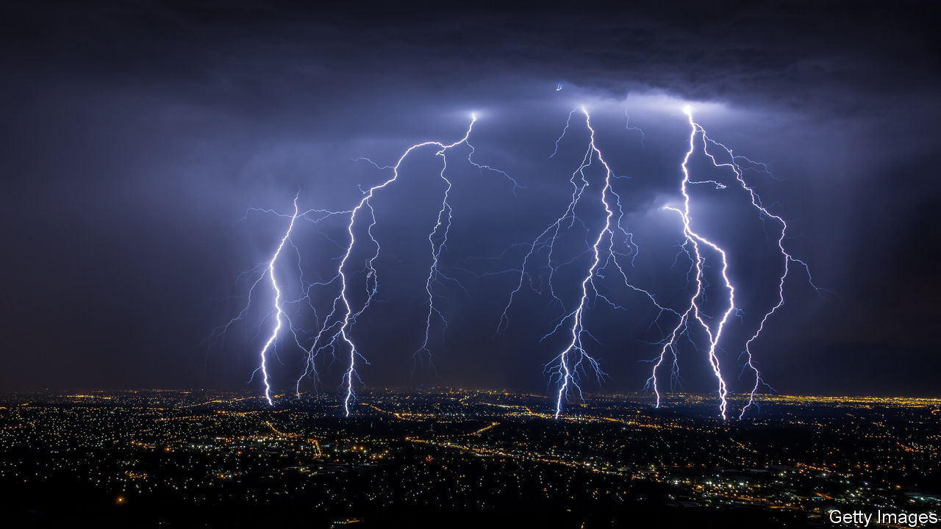

ECONOMIC FORECASTERS could be forgiven for feeling a sense of whiplash. As covid-19 runs rampant in Europe and America the world economy is taking another hit from the pandemic. America’s consumers are gloomy; Europe’s service sector is contracting. At the same time the growing prospect of mass vaccination in 2021 raises the prospect of an imminent recovery. In 2020 economists were too pessimistic about how fast growth would rebound after the first wave of infection, especially in America. A vaccine might allow another snapback in 2021.

A springtime consensus that governments should spend big on rescue packages has given way to bickering and confusion. In America Steve Mnuchin, the treasury secretary, is bringing to an end some of the Federal Reserve’s emergency programmes (see article). Janet Yellen, whom President-elect Joe Biden this week chose to be Mr Mnuchin’s successor, will be greeted by a legal and political storm about the Fed’s lending authority. Congress looks unlikely to agree to renew emergency spending on unemployment insurance and loans before Mr Biden takes office. In Europe Hungary and Poland are holding up the EU’S budget and its €750bn ($900bn) “recovery fund” in a spat over whether the disbursement of cash should be conditional on countries upholding the rule of law. The European Commission has warned several countries about their debts. Britain’s government is trying to reconcile an instinctive suspicion of deficits with a recognition that the economy still needs life support, in part by cutting the foreign-aid budget (see article).

Clear thinking is needed. It should start with the recognition that public debts in rich countries, though soaring, are sustainable because of rock-bottom interest rates. Despite borrowing 19% of its GDP this year, Britain will save about £13bn ($17bn) on debt interest compared with last year. While rates are low, higher debt will not by itself demand belt-tightening after the crisis.

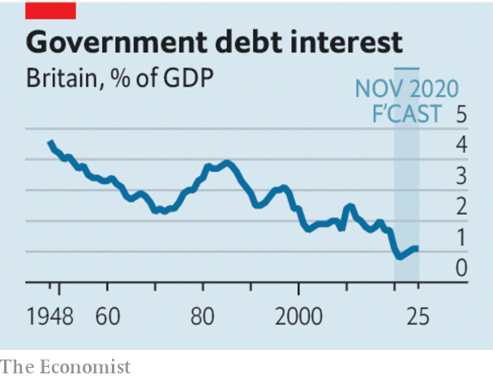

A different problem will arise if the pandemic scars economies, reducing tax revenue and increasing welfare spending for a long time. The result would be a persistent shortfall in the public finances. Yet the extent of the pandemic’s lasting impact is highly uncertain owing to the novel nature of the crisis. The main driver of recent economic fluctuations has been government diktats about whether shops and restaurants can stay open, the impact of which baffles orthodox economic models. America’s unemployment rate undershot the Fed’s summer forecast by more than two percentage points within a matter of months. The scenarios presented by Britain’s official forecasters this week ranged from there being no enduring damage to a long-term hit to GDP of 6% a year.

It is better to wait to see how large a hole the pandemic leaves in budgets than to risk slowing the recovery with premature austerity. Britain has chosen to wait. More countries should follow the example of Australia and pledge not to tighten fiscal policy actively until the economy has crossed a defined threshold—in its case an unemployment rate of 6%. Much as clear “forward guidance” by central banks helps monetary stimulus to work, fiscal rules would help boost confidence in the future.

Sadly, putting in place a new, formal, fiscal framework will be hard in America, with its divided and gridlocked political system. All the same, a pragmatic deal may be possible in the short run—Democrats should accept the smaller stimulus on offer from the Republicans, rather than hold out for the enormous spending they would prefer. With the unemployed burning through their savings and small firms facing a bleak winter, the speed of emergency support matters more than its size.

The consequences of any policy mistakes will be all the greater today because low interest rates mean that central banks cannot easily ride to the rescue. Governments can afford to wait a little longer before tightening the purse-strings. And waiting is the cautious and responsible choice. ■

This article was downloaded by calibre from <https://www.economist.com/leaders/2020/11/28/budget-deficits-should-depend-on-the-unemployment-rate>

|  |  |  |  |
| --- | --- | --- | --- |
| Previous | Articles | Sections | Next |

|  |  |  |  |
| --- | --- | --- | --- |
| Previous | Articles | Sections | Next |

#### Papers, please

# Exams are grim, but most alternatives are worse

Despite covid-19, schoolchildren should still sit exams

Nov 26th 2020 |

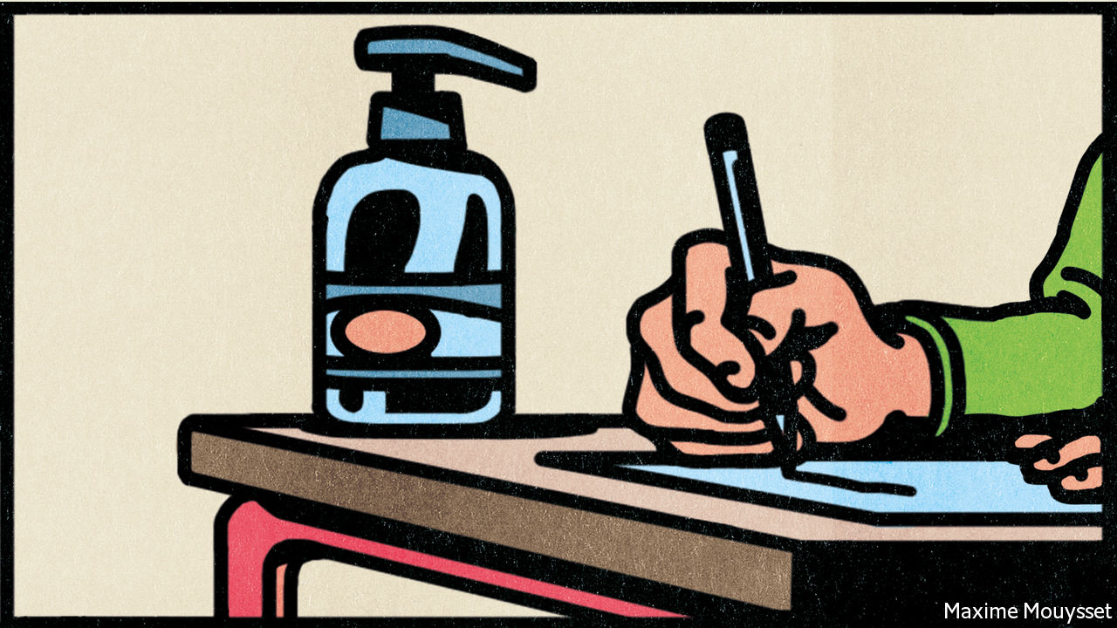

AROUND THE world covid-19 has messed up children’s education. They began to be shut out of classrooms all the way back in February. Even in countries where schools have stayed open, lessons and tests have been disrupted. Some countries pressed ahead with national exams (see article) this year. A few others, including Britain, France and Ireland, cancelled them all. They came up with new ways of awarding grades instead. The fact that big exams have proved so vulnerable to disruption has led to new questions about their usefulness. Are there better ways of measuring what children have learned?

Exams have plenty of problems. They are often unreliable; a study in Israel found that test-takers’ performance can be affected by smog. Many children find them stressful. Plenty of places run them badly. School-leavers in China are often set questions that require them to parrot propaganda. Poorly written test papers in developing countries lead to wild swings in pass rates. Countries, including Algeria and Ethiopia, have resorted to shutting down the internet at exam time to prevent cheating.

Yet most of the world’s best-performing school systems retain some kind of high-stakes tests, and for good reason. Other kinds of assessments are rarely better and many are worse. If teachers are responsible for appraising their pupils’ work, they may reinforce their own biases. Studies have caught them giving lower grades to students from ethnic minorities or those who are fat. Grades in American high schools are inflating fast, in part because pushy middle-class parents insist their little darlings deserve better. A glut of top marks makes it even harder for clever pupils from poor homes to stand out.

Forgoing exams does not always alleviate pupils’ anxiety. Some would rather be tested at the end of their course than have their work constantly assessed. Coursework can waste students’ efforts by encouraging them to tweak a few projects endlessly. That leaves less time for other kinds of learning.

The pandemic should not alter these judgments much. It is true that officials in England, where important exams were cancelled, would have found it easier to calculate which grades to hand out if their system had allowed pupils to acquire some marks in advance of their final tests. But other places managed to plough ahead with exams. Countries as diverse in their success against covid-19 as China, Germany and Spain all held some kind of examination this year, even if they changed the format.

In many countries the prospect—and pressure—of exams probably helped get pupils back into classrooms after initial lockdowns came to an end. Those facing important tests were generally invited back to school first. Their return helped give teachers and parents confidence that other pupils could safely join them. Kenya ended up letting exam-takers return to school in October, even though it had previously announced that it was cancelling all classes until the end of 2020.

Some countries that called off exams this year are still deciding whether and how to hold them in 2021. Many pupils are still making do with remote learning. Wales says it will not hold any of the tests usually sat by 16- and 18-year-olds next year because disparities in the amount of face-to-face teaching pupils are receiving would make formal exams unfair.

Governments may need to tweak next year’s tests, as many did this year. That could mean cutting the amount of material to be tested. Exam boards may also have to boost the grades of pupils who have spent the most time out of the classroom. But the most important exams should go ahead in some form. Many pupils have studied ferociously throughout this difficult year. They should have the chance to earn the grades they deserve. ■

This article was downloaded by calibre from <https://www.economist.com/leaders/2020/11/26/exams-are-grim-but-most-alternatives-are-worse>

|  |  |  |  |
| --- | --- | --- | --- |
| Previous | Articles | Sections | Next |

|  |  |  |  |
| --- | --- | --- | --- |
| Previous | Articles | Sections | Next |

#### Agriculture

# British farming after the common agricultural policy

Outside the EU, Britain can farm greener and better

Nov 28th 2020 |

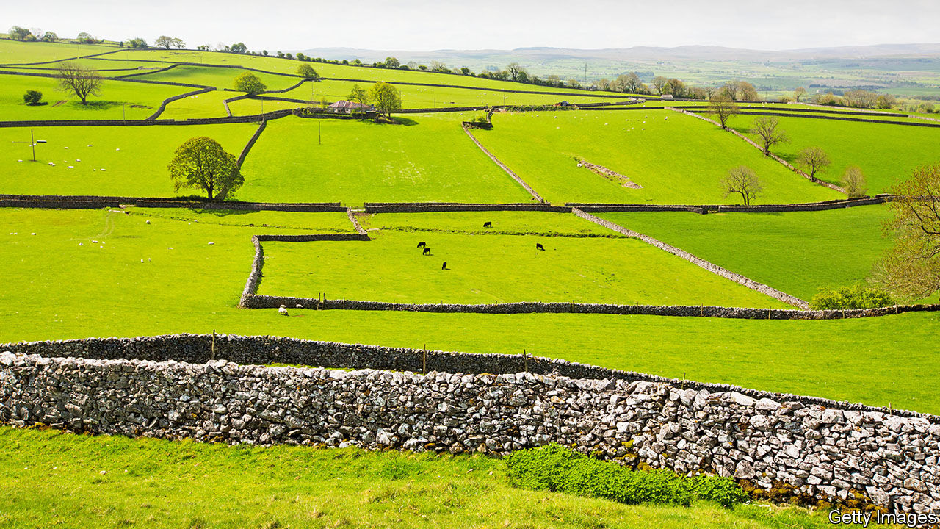

MANY OF THE claims made by Brexiteers have turned out to be rubbish. Contrary to their assurances, Britain will not soon be signing a trade deal with America. The border between Ireland and Northern Ireland, which the Brexiteers said would not be a problem, turns out to be a big one. Britain will probably end up letting French and Spanish trawlers into its waters. But one of the Brexiteers’ boasts is entirely right: Britain really ought to be able to come up with better agricultural policies outside the EU.

It can hardly do worse. The common agricultural policy (CAP), which Britain leaves on January 1st after 47 years, has been a lousy deal for the country. At considerable cost to the taxpayer, it has subsidised intensive farming methods that have denuded the countryside (see [article](https://www.economist.com/node/21795727)), causing more ecological damage than climate change. Since 1970 the population of nesting farmland birds has been cut in half. Tariffs have raised the price of food. Some farmers have benefited from subsidies. But others have not, because the subsidies are capitalised into land values, raising the cost of getting into farming.

Soon after the Brexit vote in 2016, ministers talked bravely about doing away with farming subsidies and paying for public goods. Yet England has moved as slowly as a ruminating cow. With just five weeks left in the CAP, and some subsidy cuts beginning soon after, it has provided few details about what will replace them. Northern Ireland, Scotland and Wales are even tardier. They will stick with the old subsidy system for the next few years.

For almost half a century Britain has barely had to think about creating policies for 70% of its land area. Now, amid a pandemic and Brexit, it is confronted with fundamental questions. Should the country subsidise farming? How should it help the environment? What should it do about food imports? All these questions are made trickier by the deeply peculiar way in which Britons think about the land.

There are good arguments for abolishing all public support and leaving farming to the market. The original rationale for farm payments—to boost domestic food production—has not made sense for decades. Countries like Britain are secure because they are wealthy and because international supply chains work, not because they grow lots of food. And subsidies are a crutch for indifferent farmers. After New Zealand did away with its subsidies in the 1980s, some farms went bust. Fewer than had been feared, though—and the survivors became technologically sophisticated and export-oriented.

Britain is not quite like New Zealand, for reasons that go to the heart of Britons’ odd relationship with the countryside. In New Zealand, and also in America, people distinguish between farming and nature. Farmland is something that you might travel through in order to get somewhere pretty. Britons expect their agricultural land to be beautiful. Even national parks like Dartmoor and the Lake District are mostly farmed. English nature poetry is stuffed with shepherds, wheatfields and skylarks, John Clare’s “sweet minstrel of the farm and plough”. Rambling along farmland footpaths is important to many Britons, and has been especially so during the pandemic. When other entertainments were cancelled, those who could grabbed their boots and headed for the fields with the dog.

British farmers are expected to produce not only skylarks and hawthorn, but increasingly to help with flood management and soaking up carbon dioxide, too. So it makes sense to pay them something. Today they get £2.5bn ($3.3bn) a year simply for farming, and can apply for another £500m for worthy things like planting hedgerows. One sum is too large, the other too small. If farming subsidies were cut, along with the tax breaks on capital gains, inheritance and fuel (outrageously, farmers pay very little duty on the “red diesel” they use) there would be money to spare.

There is already a system, albeit a stingy, bureaucratic one, for paying farmers to take corners of their land out of production. Leave 16 square metres of a field fallow, so a skylark could nest in it, and you get £9. That is fine, but the taxpayer should also pay for wholesale changes, such as “rewilding” or small fields, which research shows are more biodiverse than large ones. They are also more interesting for walkers, as anyone who has tramped across the breadbasket of eastern England can attest.

Civil servants are now working on a new English schedule of payments for green activities, which are supposed to be introduced in 2024. That is the wrong approach, in a couple of ways. Because different parts of the country would benefit from different things (more hedgerows in East Anglia, better stone walls in the Yorkshire Dales) local authorities, not central government, should set the priorities and distribute some of the money. It would be better still if reverse auctions were used. At the moment, officials must guess the price that will induce enough farmers to plant hedges or set aside land for butterflies. America’s Department of Agriculture asks them to bid, then takes the best offers. That reveals the true cost.

Britain must also deal with the vexed issue of food imports. Farmers’ organisations argue that the country should not import foods that are harder on the environment or on animals than would be allowed under domestic rules. An impressive coalition, ranging from celebrity chefs to shepherds, backs the campaign, which raises the spectres of American chlorine-washed chicken and hormone-treated beef. Most Britons agree.

## The grass below—above the vaulted sky

The government is refusing to be so bound—a deeply unpopular decision that is nonetheless correct. In practice, it will remain tied to EU food standards because of the overriding importance of trade with the bloc. It should not restrict its freedom any more than that. To insist that imports meet domestic standards ignores the fact that other countries have different climates and pests, so need different tools. East African countries have spent the past year fighting locust swarms with some insecticides that are banned in Britain—but then, Britain has no locusts. If Britons care about farming methods in other countries, let them show it by their purchases, as they have shown that they prefer free-range eggs. The government, meanwhile, should start repairing half a century’s-worth of damage to the countryside. ■

This article was downloaded by calibre from <https://www.economist.com/leaders/2020/11/28/british-farming-after-the-common-agricultural-policy>

|  |  |  |  |
| --- | --- | --- | --- |
| Previous | Articles | Sections | Next |

|  |  |  |
| --- | --- | --- |
| Leaders | Sections | Briefing |

Letters

Letters to the editor: On covid testing, Germany, women's suffrage, free speech, rock stars, Singapore, trains, bitcoin

.

|  |  |  |
| --- | --- | --- |
| Leaders | Sections | Briefing |

|  |  |  |  |
| --- | --- | --- | --- |
|  | Articles | Sections | Next |

#### On covid testing, Germany, women's suffrage, free speech, rock stars, Singapore, trains, bitcoin

# Letters to the editor

A selection of correspondence

Nov 28th 2020 |

Letters are welcome via e-mail to letters@economist.com

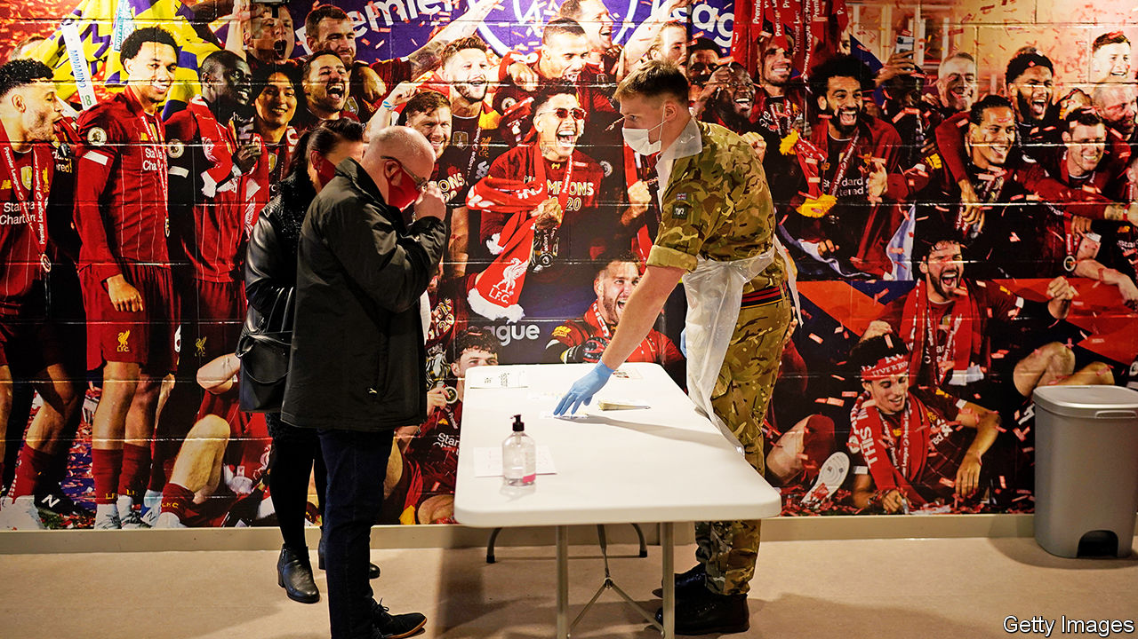

## Work incentives

Although there was a carrot for people who got tested for covid-19 in Slovakia’s mass-testing programme, there was a strong stick, too (“[Scouse lessons](https://www.economist.com/britain/2020/11/21/liverpools-mass-testing-shows-promise-but-must-reach-more-people)”, November 21st). The carrot for those who got tested and proved negative was access to freedoms and exemptions from an otherwise strict curfew. But employees who did not take part in the nationwide test had to self-isolate, in effect, and could not go to work. If they weren’t able to provide any other certificate of a negative test to their employer they had to stay at home and take annual or unpaid leave. However, if they took part and tested positive they could claim sick leave, but still had to self-isolate with their whole household.

This carrot-and-stick approach led to a 95% turnout for the nationwide test, helping Slovakia halve its covid-19 prevalence in just a week.

KRISTINA LONDAKOVA  
London

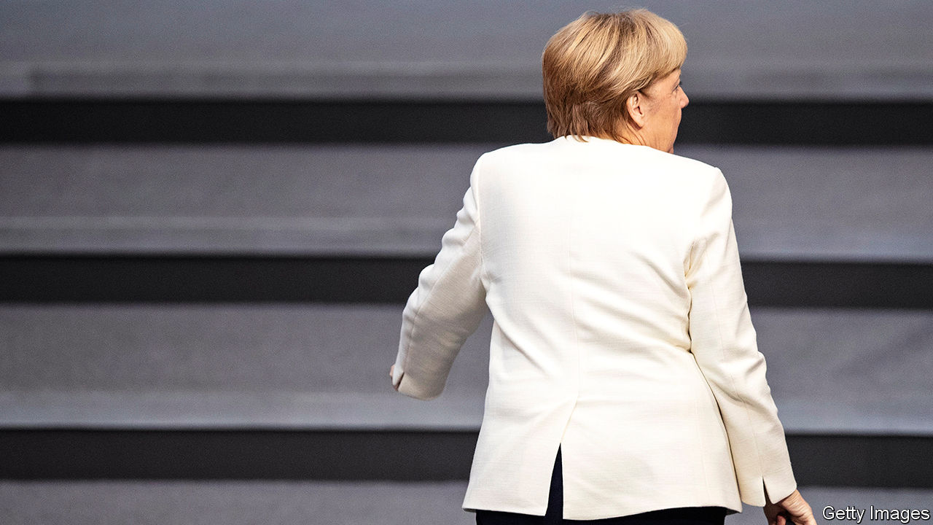

## Veering to the left

I strongly disagree that Germany’s Christian Democratic Union is a “centre-right” party (“[The long farewell](https://www.economist.com/leaders/2020/10/31/germanys-ruling-party-is-making-a-hash-of-choosing-its-next-leader)”, October 31st). This might have been true in the early years of the Merkel era. Nowadays, however, both the CDU and the Christian Social Union in Bavaria have lost any kind of sustainable trait of conservatism.

The euro has been turned into a political football, immigration laws and regulations are a mess, defence, national security and other areas that are of importance to conservatives are in disarray. NATO and the wider European alliance are in bits. Even worse, a radicalised party, which evolved from a liberal-minded down-to-earth opposition to Angela Merkel, has managed to establish itself permanently across the country.

The conservative parties have turned into rather leftish marketing professionals. Their primary goal is to conserve power and to celebrate “ethical” views, instead of bringing the country and Europe forward. Sadly, Richard von Weizsäcker’s assessment of Helmut Kohl’s turn to a self-centred policy focus was made substantial throughout the Merkel years.

It is time for Mrs Merkel to step down now. New and bold leadership is needed to provide answers and solutions to how Germany will earn its living in the near future and how it will play a geostrategic role. A lot is at stake.

JOHANNES WARBECK  
Augsburg, Germany

## Women and the vote

[Banyan](https://www.economist.com/asia/2020/11/05/new-zealand-allows-assisted-dying-among-other-progressive-steps) gave New Zealand the honour of being the “the first place in the world to give women the vote” (November 7th). That was in 1893. In 1869 the American territory of Wyoming gave women the vote, as did the territory of Utah in 1870, if only for a few years.

In what is now Canada some women voted as early as 1793, not because British common law said they could, but because it didn’t say they could not. Canadian legislatures closed that loophole but in 1873 female property owners in British Columbia got the right to vote in municipal elections.

CEC JENNINGSToronto

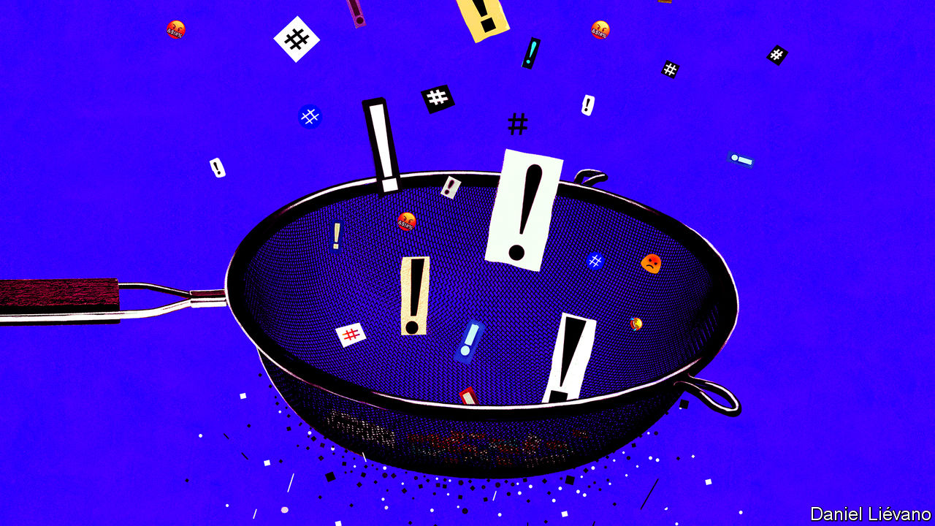

## Talk all you want

Much of the discussion regarding social media and free speech does not distinguish between the freedom of speech and the right to be heard (“[The great clean-up](https://www.economist.com/briefing/2020/10/22/social-medias-struggle-with-self-censorship)”, October 24th). Freedom of speech is protected, but the right to be heard is not. Speakers were never guaranteed a platform for their views until social media came along. Now everyone has a chance to be heard.

But denying access to anti-vaxxers, say, would in no way limit their right to free speech. They would still have all the freedom of speech they enjoyed before Facebook was created. They can talk to their neighbours, write letters, call people on the telephone, publish pamphlets, organise petitions and even start their own social-media platforms.

TREVOR SCHINDELER  
North Bay, Canada

The distinction between free speech and free publication is that I am free to write offensive screeds. I am free to post them off to editors and publishers. They, however, are under no obligation to print my diatribes. Neither is Facebook or Twitter.

ADAM ISLER  
New York

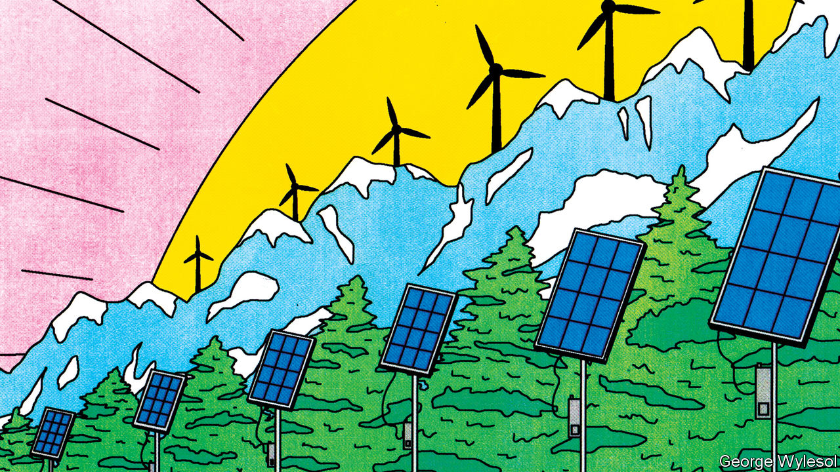

## Handle with care

I was perplexed by your refusal to concede that the Travelling Wilburys featured more than just George Harrison and Bob Dylan (“[Greenbacks for greenery](https://www.economist.com/business/2020/10/29/climate-conscious-venture-capitalists-are-back)”, October 31st). Were Jeff Lynne, Roy Orbison and Tom Petty not even worthy of an “among others” after mentioning a former Beatle and a Nobel laureate?

ANDREW GUSH  
Chicago

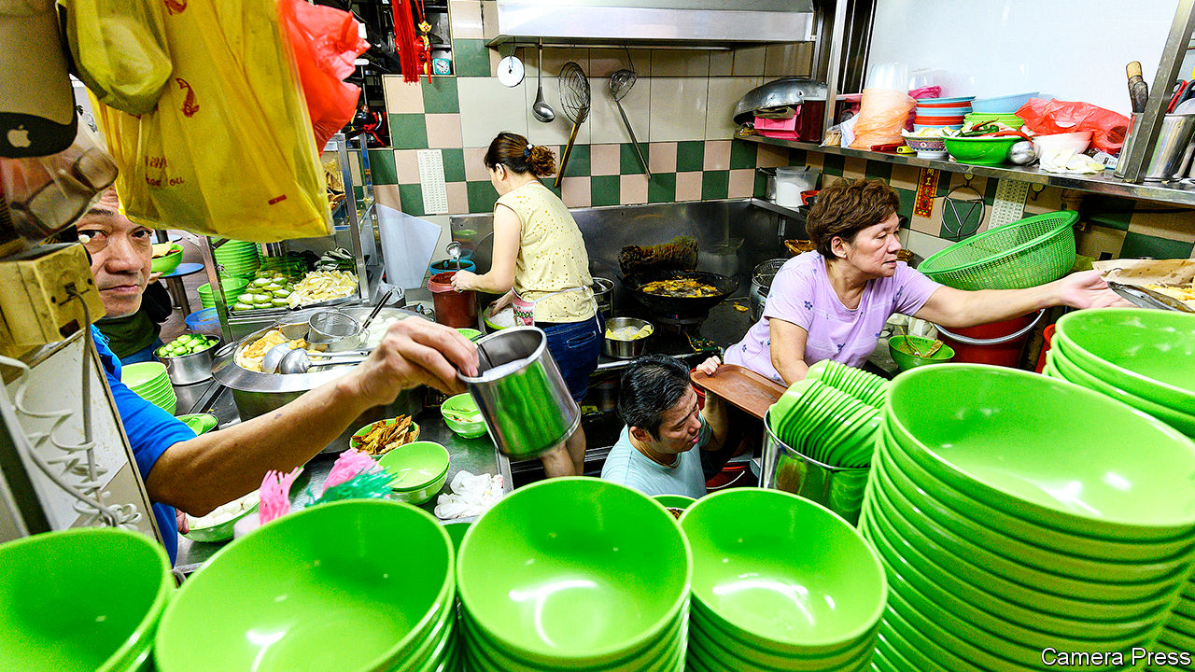

## Singapore’s food hawkers

Food-hawker centres are Singapore’s community dining rooms and offer affordable diverse food (“[Out with the new](https://www.economist.com/asia/2020/10/31/singapores-government-helps-old-food-hawkers-but-not-young-ones)”, October 31st). Indeed, Singaporeans have such passion for the food that we have nominated hawker culture to be included as a UNESCO Intangible Cultural Heritage. UNESCO’s evaluation body has recently recommended the inscription.

Our hawker centres were first built in the 1970s, providing street hawkers with more hygienic settings. We ceased building new centres in 1985 and resumed in 2012. This partly explains the low rents of older-generation hawkers and the high median age of those working in the centres. The government began offering training programmes in 2013 to attract new hawkers to the trade, along with significantly subsidised fees and stall rentals. The operators of new hawker centres also run programmes to support new entrants. The results have been promising.

The median age of new hawkers since 2013 is 46, much lower than the national median. Many young enterprising hawkers have gone beyond selling traditional fare to offer Western and other fusion foods. We expect the median age to decrease further.

These efforts will sustain the trade, and keep Singapore’s hawker culture flourishing for future generations.

T.K. LIM  
High Commissioner of Singapore  
London

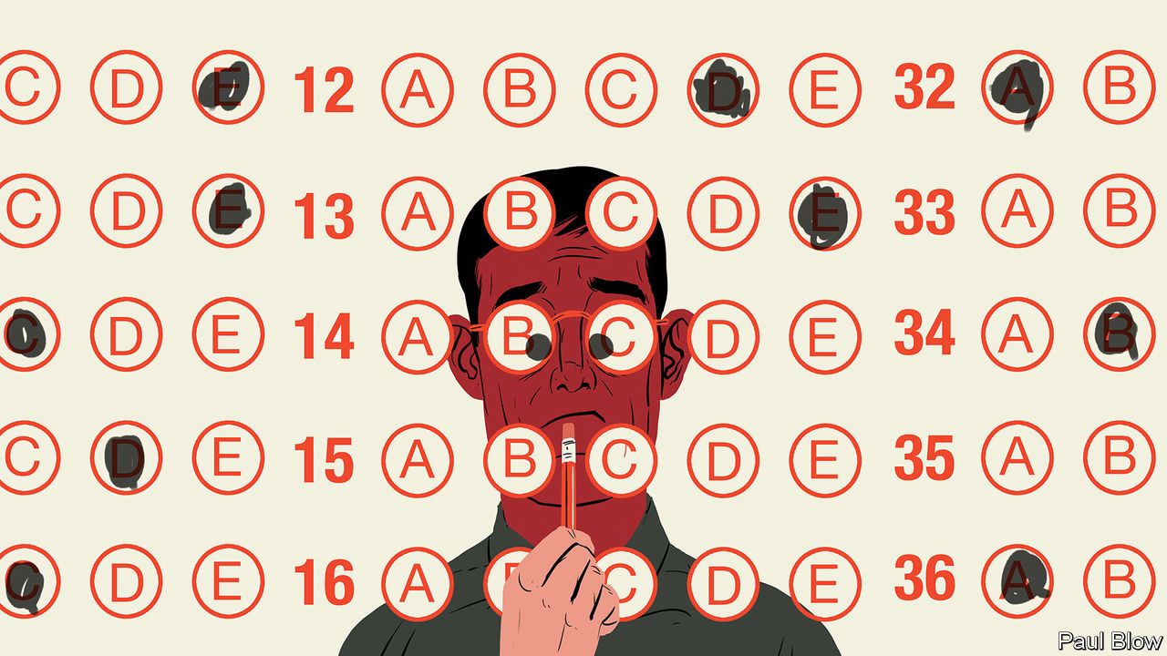

## Train of thought

It came as no surprise to learn in [Bartleby’s](https://www.economist.com/business/2020/11/05/questionable-behaviour) column on psychometric testing that introverts make the best train drivers (November 7th). I drive trains on urban passenger lines and cherish my autonomous mobile “office”, with no one to report to (unless something happens to passengers, the train or track infrastructure). My breaks between journeys are spent reading The Economist, in addition to other literary material carried in a tote bag. The best times to catch up with unread back issues are the unforeseen delays, which can last hours. I’d rather have The Economist keep me company on the train than a fellow human being.

EUGENE ANTHONY  
Perth, Australia



## Bitcoin’s new romantics

At the risk of being as out of place as jeans and a T-shirt at the Blitz club in London on a Tuesday night I feel that Buttonwood left the main question unanswered: did Steve Strange have any bitcoin? (“[Blitz-coin](https://www.economist.com/finance-and-economics/2020/10/29/getting-down-with-the-cool-kids-on-bitcoin)”, October 31st.)

STUART SMITH  
Maastricht, Netherlands

This article was downloaded by calibre from <https://www.economist.com/letters/2020/11/28/letters-to-the-editor>

|  |  |  |  |
| --- | --- | --- | --- |
|  | Articles | Sections | Next |

|  |  |  |
| --- | --- | --- |
| Letters | Sections | United States |

Briefing

Democracy in India: Subcontinental drift

.

|  |  |  |
| --- | --- | --- |
| Letters | Sections | United States |

|  |  |  |  |
| --- | --- | --- | --- |
|  | Articles | Sections | Next |

#### India’s diminishing democracy

# Narendra Modi threatens to turn India into a one-party state

An increasingly dominant prime minister and the ongoing erosion of checks and balances

Nov 28th 2020 | DELHI

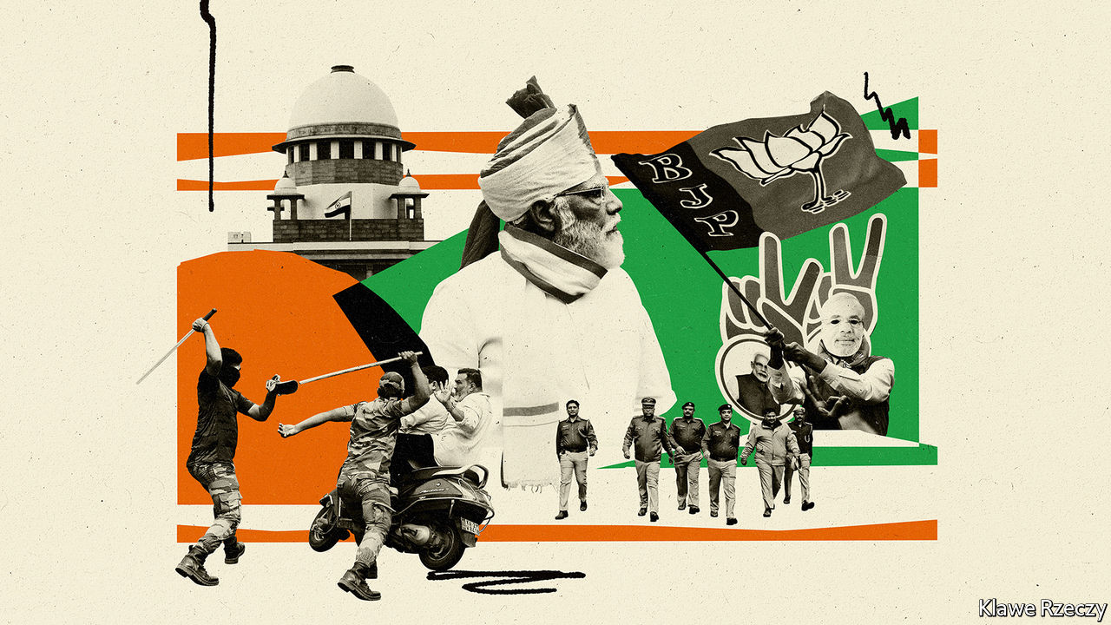

IN EARLY NOVEMBER justices at India’s Supreme Court turned their attention to an urgent plea. Arnab Goswami, a prominent journalist, had been dragged from his home and hurled into jail. Government ministers decried the arrest as an assault on free speech, demanding that Mr Goswami be granted bail. The hearing was brief. “If we as a constitutional court do not lay down law and protect liberty, then who will?” proclaimed one judge. That evening Mr Goswami swept out of Mumbai’s Taloja prison into a rapturous crowd. “This is a victory for the people of India!” he crowed.

But was it? To much of India’s commentariat, Mr Goswami’s case represented not a test of freedom so much as a test of power. On its current trajectory, by all evidence (as the chart on the next page illustrates), the world’s largest democracy is headed to a future that is less, not more free.

Mr Goswami is a controversial figure. He has pioneered a style of attack journalism that makes his nightly television programme look like a show trial from China’s Cultural Revolution. Its victims are often critics of government policy. They are typically reduced to a corner box as Mr Goswami swells into a finger-jabbing prosecutor, denouncing them as “antinational” or, worse, an agent of Pakistan.

What landed Mr Goswami in jail was not something he said, though his tirades against the Mumbai police have indeed enraged the local government, which happens to be opposed to the prime minister, Narendra Modi, and his Bharatiya Janata Party (BJP). The journalist’s alleged crime involved a big unpaid debt to a decorator, who had left a suicide note blaming him, among others, for his fatal distress. “Abetment” to suicide remains an offence in India. The case had been closed in 2019, when the BJP still wielded power in Mumbai, and its reopening smacked of a vendetta.

So the court’s ruling was not surprising. What shocked was the speed of its intervention. Mr Goswami spent just a week in detention, and his case had hardly reached the lowest rung of courts, yet the country’s topmost judges ignored the court’s backlog of some 60,000 cases to schedule a bail hearing within a day of the anchor’s appeal. This is in a country where prisons hold twice as many inmates awaiting trial, some 330,000 people, as they do convicts.

A majority of these “undertrials” come from minority groups and a quarter have spent more than a year behind bars, reckons Leah Verghese, a law researcher. When Mr Modi clamped direct rule on the erstwhile state of Jammu and Kashmir in August last year, thousands of its residents were detained. Out of more than 550 writs of habeas corpus such as Mr Goswami’s that Kashmiris filed, courts have disdained to look at all but a handful.

In the same week that Mr Goswami won his swift reprieve, Father Stan Swamy, an 83-year-old Jesuit priest who has championed rights for tribal peoples and is being held as an alleged Maoist terrorist, made a plea before a lower court. As he suffers from Parkinson’s disease and cannot hold a cup steady, lawyers requested that he be allowed to have a straw in his prison cell. The court postponed the hearing for 20 days.

Even more striking is the courts’ foot-dragging over constitutional questions. In 2017 Mr Modi slipped through parliament a controversial law that created “electoral bonds”, asserting that as a budgetary matter it need not be scrutinised by the upper house, which was not then in BJP control. The Supreme Court still has not examined the constitutionality of this innovation, which allows unlimited, anonymous donations to political parties. Other big questions its judges have yet to take up include the imposition last year of direct rule on Kashmir and some 140 legal petitions against the Citizenship Amendment Act of 2019, which by inserting religion as a criterion for citizenship undermines the secular nature of the Indian state.

## Sleepwalking into authoritarianism?

Slow, uneven and arbitrary justice are not new to India. Yet its courts have often tried to check executive power. It was a judge’s ruling that Indira Gandhi, perhaps India’s most powerful prime minister, had cheated in an election that prompted her in 1975 to plunge India into a 21-month Emergency, during which she threw opponents in jail and ruled by decree. Legal professionals now liken the current moment to that darkest period for Indian democracy. “This government has done so much damage to personal liberty,” says Ajit Prakash Shah, a former high-court judge. “But the courts, especially the Supreme Court, have watched this indiscriminate and violent trampling of dissent like mute spectators.”

It is not only the courts, alas, that seem eager to stay in step with the government. Many cogs in India’s institutional machinery are not merely complacent, but have grown complicit in a project that threatens to turn the country into a one-party state. At least during the Emergency the threat was clear, says Tarunabh Khaitan, vice-dean of law at Oxford University and author of a paper, “Killing a Constitution with a Thousand Cuts”, that details India’s institutional decay. “What we have now is a wolf in sheep’s clothing,” he says. “There is no full-frontal big-ticket attack on democracy, but there are multiple, simultaneous attacks on all fronts…We are sleepwalking into authoritarianism.”

Of the ostensibly independent institutions that are now compliant, India’s police stand out. Despite individually humane and honest officers, the impression Indians hold of the force is that its main purpose is to protect the powerful and persecute the weak. A case in point is the Delhi police’s management of communal riots that racked parts of India’s capital for three days last winter, leaving 53 dead.

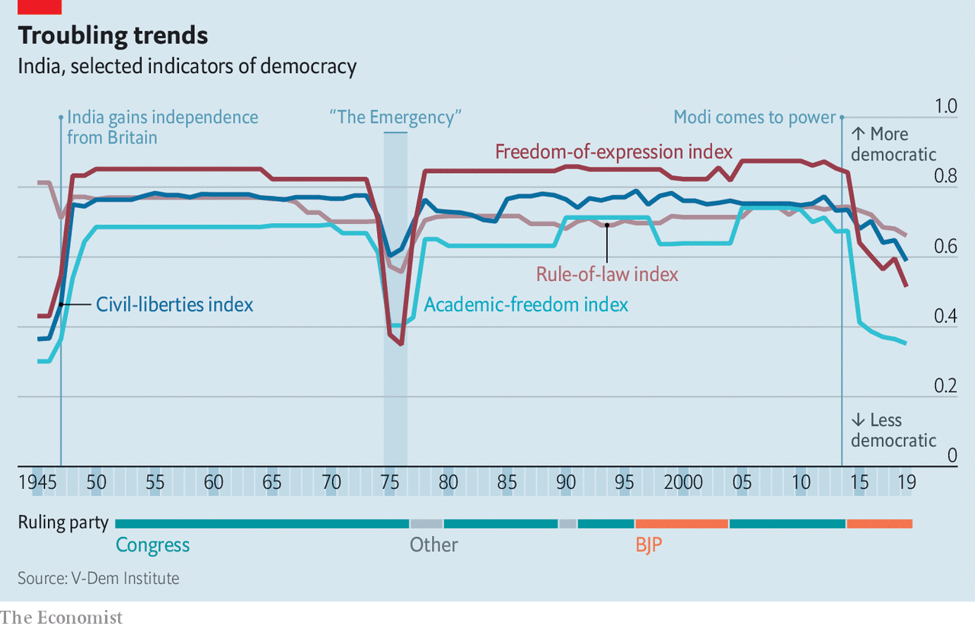

Top officers in the force, which before Mr Modi’s government stopped releasing statistics comprised just 2% Muslims in a city with a 13% Muslim minority, had been filmed standing next to a BJP politician at a rally where he threatened to attack protesters, mostly Muslims, holding a peaceful sit-in against the new citizenship law. During the violence, police were filmed throwing rocks and torturing captured Muslim youths. More than two-thirds of those beaten, shot and hacked to death were Muslim. Yet Delhi’s finest have declined to register complaints against BJP members for incitement. Their investigations have focused on a purported Islamist-Marxist conspiracy to foment unrest in order to embarrass Mr Modi at a time when he was hosting President Donald Trump.

An amendment made last year to the Unlawful Activities Prevention Act (UAPA), a draconian law from 1967 that allows the state to label and then ban groups as terrorist, now empowers the government to designate any individual as a terrorist. The state may hold suspects indefinitely with no right of bail, confiscate their property and implicate any associate as an accessory to terrorism. During India’s harsh lockdown to combat covid-19 last spring, police in Delhi quietly rounded up scores of youths alleged to have been involved in the riots, and charged many under the UAPA.

Having enjoyed a stranglehold on the Lok Sabha, parliament’s lower house, for six years, and more recently acquired control of the upper Rajya Sabha, Mr Modi’s government has passed a slew of other laws not only to expand its powers, but to dilute those of potential challengers. One thorn in its side has been a law from 2005 that upholds citizens’ right to obtain information (RTI) from state officials. Seen as a big advance for transparency in a country where mandarins remained aloof and unchallenged, the law created an independent commission to ensure that requests from the public receive a response. The number of requests runs at over 1m a year.

In 2019 the government amended the RTI law. It reduced the tenure and prestige of the role of the commission’s chief. Small wonder that the commission is rejecting a growing number of information requests from the public, citing “insufficient documentation”, even as the number of pending requests has swollen by 50%. Having frequently neglected to fill empty seats on the 11-person commission, the government in October tapped a journalist whose chief works are two books that glowingly laud the “Modi model” of government.

Such appointments are a prerogative of the executive, one that previous leaders have scarcely been shy of exercising. More unusual under Mr Modi has been his almost axiomatic choice of candidates with Hindu-nationalist credentials, often from his home state of Gujarat, and his insistence on inserting loyalists even into institutions that had been seen as sanctuaries from party politics. Twice Mr Modi has replaced heads of the Reserve Bank of India, the country’s respected central bank, after they expressed less than fulsome praise of his economic policies. As India’s latest comptroller and auditor-general (CAG), Mr Modi reportedly passed over seven senior secretaries from within the organisation and instead parachuted in a retired official from Gujarat. The CAG has a record of honest and incisive reporting, but has raised hackles by exposing government waste.

## Modi operandi

In 2016 Mr Modi similarly ignored institutional precedent in the Indian army, lifting General Bipin Rawat over the heads of two senior officers to appoint him its top commander. Last year, following a change of rules that stretched the retirement age, General Rawat was promoted to chief of staff of India’s combined forces. The army maintains a tradition of keeping a distance from politics that makes it almost unique in its region, but observers have detected a growing tendency for officers to weigh in publicly on civilian matters, and retired soldiers whisper reproach against officers for “cosying up” to politicians.

Mr Modi has made a spectacle of his own commander-in-chief role as no other recent prime minister, and also minted electoral gold from pre-election military operations. Helpfully, India’s soldiers have remained silent at useful moments, too. As independent satellite evidence emerged this summer showing that Chinese forces had occupied strategic posts in territory claimed by India along remote sections of the countries’ border, the army steadfastly refused to comment on Indian government assertions that no land had been lost.

Even the impartiality of the Election Commission of India (ECI), with a sterling seven-decade record of managing the mammoth logistics of Indian votes, has come under scrutiny. During the 2019 general election, which Mr Modi won by a landslide, his opponents sharply protested when the prime minister and other top BJP leaders repeatedly escaped serious censure for issuing what amounted to communal dog whistles, whereas the ECI promptly sanctioned rival candidates for lesser infractions of its strict codes of conduct. One of the body’s three top commissioners did object, but was overruled. His family subsequently found itself being investigated for alleged tax evasion. The official quit the ECI before the end of his term.

Given that India continues to run elections that by most standards are admirably free and fair, it may seem churlish to voice fears for its democracy. After all, even as America’s presidential count was mired in controversy in early November, election officials in Bihar—India’s poorest state, with a population of 125m—managed to count the votes without a hitch in less than a day. Like so many others in recent years, that election was won fair and square by Mr Modi’s team, in Bihar’s case in alliance with a local party.

The BJP’s supporters scoff at the notion that its rise under Mr Modi has entailed any subversion of institutions or dilution of democracy. Such protests are merely sour grapes, insists Raghavan Jagannathan, editor of Swarajya, a right-wing magazine. “Our democracy is flawed, but it is a work in progress, not just about the people who are currently in power.” Modi apologists point to disturbing trends in states that are not ruled by the BJP. Kerala recently introduced a law to punish “offensive” speech by up to three years in prison (but withdrew it after heavy criticism). In Odisha, a family with connections to the BJP that owns a television channel critical of the local ruling party has found itself buried in lawsuits.

Indian politics is a game of hardball. The BJP is the world’s largest political machine, with many multiples the energy, organisational strength and financial backing of its rivals. It has a strong leader in Mr Modi, and a strong narrative, however unpalatable it is to many. This contrasts sharply with the vacillation of Congress, India’s previous dominant party. Led by a fading Gandhi dynasty, it has slowly disintegrated. Ghulam Nabi Azad, one of 23 Congress leaders who recently petitioned Sonia Gandhi, the party president, for sweeping changes, says its leadership has lost connection with people on the ground. Its organisational structure has “collapsed”. Indians who loathe Mr Modi are often just as disparaging of Rahul Gandhi, the party’s mediocre current figurehead.

## Grand designs in Delhi

In the absence of a strong opposition at the centre, the most effective resistance to the BJP’s dominance lies in state capitals, as well in the press and more broadly in civil society. These bastions are all under heavy assault. Mr Modi’s fearsome chief lieutenant, Amit Shah, the home minister, has made no secret of his determination to topple Mamata Banerjee, a staunch and often vitriolic critic who has run the pivotal state of West Bengal since 2011, in state elections next year. Opposition parties holding slim majorities in other big states, including Rajasthan and Maharashtra, are acutely aware of the BJP’s capacity to “persuade” defectors to its side. This recently happened in Madhya Pradesh, where Mr Modi’s party unceremoniously unseated Congress after luring away a chunk of its deputies.

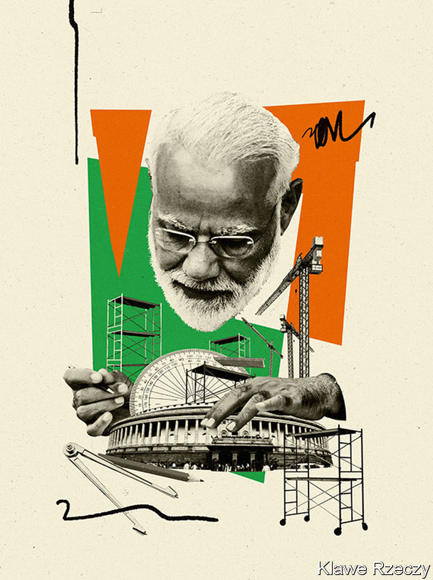

By leaning on the big conglomerates that dominate the mainstream media, by favouring outlets that share its ideology, such as Mr Goswami’s, and by flooding social media with agitprop, the BJP has largely marginalised critical voices in the press. In the past two months, new rules have curtailed the permitted level of foreign investment in online media and placed the entire sector under the authority of the broadcasting ministry. The moves appear to be aimed at getting a grip on one of the main remaining outlets for dissent, say editors at three of India’s increasingly popular news sites. One that specialised in hard-hitting investigative stories, HuffPost India, closed on November 24th.

Compliance regulations regarding foreign donations have already been used to shut down tens of thousands of NGOs. The most recent example is the local chapter of Amnesty International, an advocacy group for human rights. In September the government added onerous filing requirements and rules that forbid larger charities from funding smaller ones.

Mr Khaitan, the Oxford law professor, is not alone in warning that the BJP’s one-sided advantage is subtly changing the nature of India’s game. “We do not have a level playing field any more,” he says. “What we are getting is not quite a one-party state, but certainly a hegemonic state.” The trajectory resembles that in other democracies, such as Hungary, Poland and Turkey, where autocracy is on the rise (see chart).

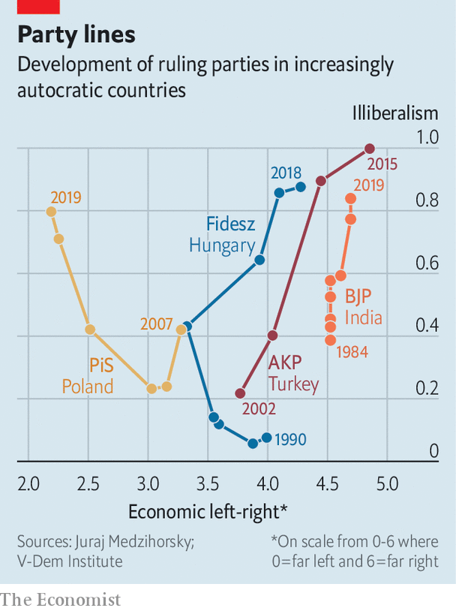

Mr Modi is now taking a keen interest in reshaping Delhi, India’s capital, in more imperial fashion. Following an opaque and hasty process that to no surprise ended with the choice of Mr Modi’s own favourite architect, a fellow Gujarati, as chief designer, the city’s Central Vista, a 3km-long avenue of lawns not unlike the National Mall in Washington, is going under the knife. It will be flanked by ten giant, identical government office buildings. The project foresees the building of a new, expanded parliament, big enough to seat double the 545 MPs that currently sit in the lower house. The old building will become a “Museum of Democracy”. And, naturally, there will be a bigger, fancier residence and office for the prime minister himself.

Another sign of Mr Modi’s direction of travel can be detected in the differing “read-outs” after his congratulatory phone call to President-elect Joe Biden. Among the things that Mr Biden’s team said the two had discussed was a shared commitment to “strengthening democracy, at home and abroad”. In the version from Mr Modi’s office, that bit was left out. ■

This article was downloaded by calibre from <https://www.economist.com/briefing/2020/11/28/narendra-modi-threatens-to-turn-india-into-a-one-party-state>

|  |  |  |  |
| --- | --- | --- | --- |
|  | Articles | Sections | Next |

|  |  |  |
| --- | --- | --- |
| Briefing | Sections | The Americas |

United States

The covid-19 vaccines: Grabbing a cold one

.

The virus and the heartland: View from the ICU

.

Team Biden: In transit

.

The other transition: Miss gender

.

Obscure laws: Panic attacks

.

Lexington: The end of the embarrassment

.

|  |  |  |
| --- | --- | --- |
| Briefing | Sections | The Americas |

|  |  |  |  |
| --- | --- | --- | --- |
|  | Articles | Sections | Next |

#### Grabbing a cold one

# America will be the first country to roll out a covid-19 vaccine

Here is how the federal government and states plan to do it

Nov 28th 2020 |

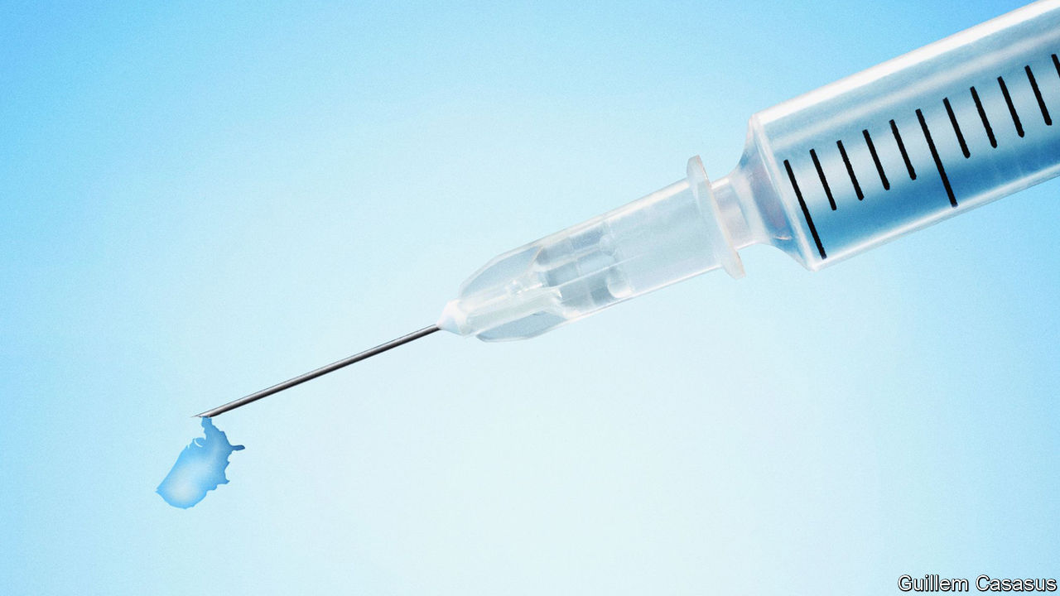

Editor’s note: Some of our covid-19 coverage is free for readers of The Economist Today, our daily [newsletter](https://my.economist.com/user#newsletter). For more stories and our pandemic tracker, see our [hub](https://www.economist.com/news/2020/03/11/the-economists-coverage-of-the-coronavirus)

ASKED WHAT keeps her up at night as Texas prepares for the arrival of the first covid-19 vaccines, Imelda Garcia from the state’s health department singles out two opposite scenarios: either a serious shortage of vaccine, or lots of it sitting around unused because nobody wants to take it. These two worries are on the minds of many other public-health experts as 6.4m doses of vaccine stand ready to be dispatched across America, on a nod by the Food and Drug Administration (FDA), the federal drug regulator.

That nod is expected on December 10th or shortly after, when the FDA will make a decision on the first covid-19 vaccine submitted for approval in America, a jab developed by the drug firms Pfizer and BioNTech. Moderna, the developer of another vaccine, is expected to undergo FDA review on December 17th. Both vaccines are about 95% effective if administered in a two-dose regimen. They are unlikely to stem America’s runaway epidemic until next spring, at best. But America is leading the way on covid-19 vaccination—so lessons from its early experience will be closely watched in Europe and other parts of the world.

Organising America’s supplies of covid-19 vaccines is the task of Operation Warp Speed, a programme set up by the current administration in May. It pre-purchased 100m doses of both Pfizer’s and Moderna’s vaccines this summer, and large quantities have already been made. Each firm expects to have about 20m doses ready to distribute in America by the end of this year. This amount is roughly what would be needed to inoculate all America’s health-care workers, who are a priority group for the first vaccine supplies.

Next will come groups particularly vulnerable to the disease, including essential workers at high risk of infection (such as police officers, teachers and bus drivers), care-home residents, people with high-risk medical conditions and those over 65. The order of priority between these groups, which are suggested by the Centres for Disease Control and Prevention (CDC) and other national health agencies, may vary somewhat from state to state. The current plan is that vaccine supplies, as they become available, will be divvied up among states and six big metropolitan areas proportionately to their population. Each state will decide how to distribute them. At the current pace of vaccine production, widespread vaccination of the elderly is not on the cards until February.

The logistics of vaccinating more than 300m Americans would be daunting with any vaccine. But Pfizer’s will be “extremely challenging”, says Claire Hannan of the Association of Immunisation Managers. “It’s nothing like we’ve seen before,” she says. The vaccine must be stored at -70°C, which is the temperature in ultra-freezers rarely found outside research laboratories and big medical centres. To deal with that, Pfizer will be distributing the vaccine in “thermal shippers”, special containers packed with dry ice designed to hold between about 1,000 and 5,000 doses. (It is now designing a smaller version to make distribution easier.) But the dry ice must be replenished regularly, the container can be opened only twice a day and, once taken out, the vaccine lasts in a regular fridge for only five days. When ready to administer, it must be diluted with saline, which is also not a common step for vaccines.

People handling the Pfizer vaccine will need extensive training, says Ms Hannan. “This isn’t something where you can watch the video and then you are ready to go.” She worries that these new procedures will come at a time when hospitals and their staff are overwhelmed and exhausted by the flood of patients (see [article](https://www.economist.com/node/21795735)). Because of all the intricacies involved, a fair amount of the first supplies of Pfizer’s vaccine may end up being spoilt.

Moderna’s vaccine is more in line with what vaccinators are already used to. It must be stored at -20°C, the temperature of standard pharmacy freezers, keeps in a regular fridge for 30 days, comes in packs of 100 doses and does not need dilution. This vaccine, if approved, would be delivered by McKesson, a medical distributor that already delivers vaccines nationally.

Wherever the vaccines arrive, supplies to do the jabs must turn up at the same time. These will be distributed by McKesson in pre-assembled packs of the syringes, alcohol wipes, gloves and other items needed for each covid-19 jab. Operation Warp Speed has been stockpiling these through the summer—to avoid a repeat of the fiasco with personal protective equipment for health workers in the spring, when state and federal authorities were competing with each other in a mad scramble for scarce global supplies.

At present, states and the Department of Defence, which is leading the logistics of vaccine distribution, are focused on preparing for Pfizer’s vaccine. State authorities have been enrolling vaccination providers, drawing up lists of health workers and others who need to be vaccinated first, and setting up systems to keep track of vaccines. They have just started doing “dry runs”, placing vaccine and syringe orders into the national system and practising what they will be doing with Pfizer’s thermal shippers (which, for now, arrive with empty vials).

The logistics of moving vaccines around will be complicated. The really hard part, though, will probably be convincing people to take them. America’s plan is to make vaccination available free at all the usual places where people get their flu shots, such as pharmacies and doctors’ surgeries. The federal government is setting up a fund to cover providers’ fees for the jab for the uninsured; health plans will cover this fee for their members.

Many immunisation experts worry that this “build it and they will come” approach is naive. At the moment, surveys suggest that anywhere between 20% and 60% of Americans may not accept a covid-19 vaccine. In one survey only a third of nurses said they would voluntarily get vaccinated. Some people are worried that the vaccines may not be safe, suspicious that corners may have been cut in the rush to develop them so quickly. Others have seen various kinds of alarming misinformation. Muddled messages from various political leaders have also done their share of harm.

All vaccinators, therefore, must be well trained to answer people’s questions about the risks and benefits of the vaccine, potential side effects, the longevity of protection and so on. But such training has not yet started, partly because this sort of box-insert information will be published officially as part of FDA’s decision on the vaccine. In some places, such as Washington, DC, health departments have started talking to community leaders to get a sense of the particular concerns of various groups. Media campaigns to encourage people to get vaccinated will be important.

All this will throw up unfamiliar challenges. Unlike many other countries, America has a more “passive” approach to vaccination and is not used to doing big immunisation campaigns, says Tom Kenyon from Project HOPE, a health non-profit, who used to lead the CDC’s global health programme. This works for childhood vaccination. But covid-19 is different. Lots of mini vaccination drives to cover specific groups, such as frontline workers, will be crucial, says Dr Kenyon.

This sort of groundwork, training and campaigning is expensive. The Association of Immunisation Managers estimates that, all told, state and local authorities will need $8.4bn. The CDC has put the total at around $6bn. So far, however, states have received only $200m for vaccination preparation, and a promise of another $140m this year. Approval of a big federal pot of money for this has been caught up in the political wrangling in Washington. The Moderna vaccine, developed with America’s National Institutes of Health, is a triumph of American science. Failing to vaccinate enough people to stop the virus would be a failure of American politics.■

This article was downloaded by calibre from <https://www.economist.com/united-states/2020/11/28/america-will-be-the-first-country-to-roll-out-a-covid-19-vaccine>

|  |  |  |  |
| --- | --- | --- | --- |
|  | Articles | Sections | Next |

|  |  |  |  |
| --- | --- | --- | --- |
| Previous | Articles | Sections | Next |

#### The view from the ICU

# The Midwest is America’s covid-19 hotspot

The disease is killing more than 550 people there every day

Nov 26th 2020 | CHICAGO

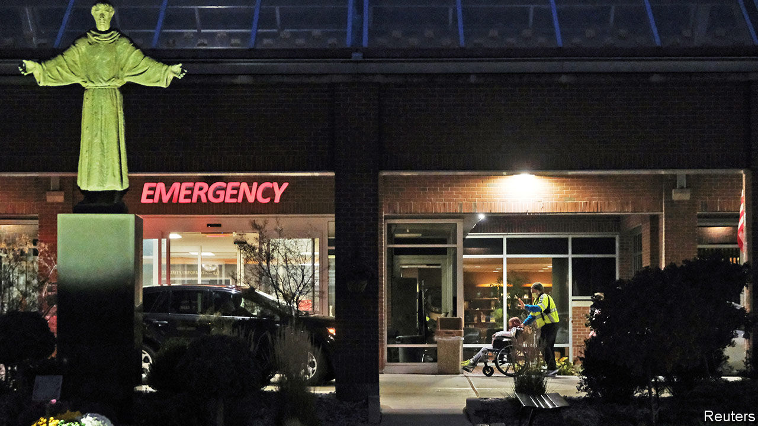

“WE AS PHYSICIANS struggle to conceive of the idea of exponential growth,” says Dan Runde, of the emergency medicine department at University of Iowa Hospitals and Clinics, in Iowa City. “There’s so short a window. You go from barely handling things, to not at all. It’s so fast.” He recalls how Iowa had some 700 patients in hospital infected with covid-19 at the start of November. A few weeks later, he says, that tally had doubled. At times almost every ICU bed is filled.

His hospital, like others, tried preparing for such a surge. In-patients, where possible, were sent home; a dozen new ICU beds were added; some elective surgeries were postponed. Then staff watched in alarm as nearly one in every two covid-19 tests run in Iowa turned out positive, foretelling a surge in hospitalisation—and deaths. His hospital, the state’s best-equipped, takes in patients from far and wide when others can’t cope. That already means an “aggressive triage process”. “We’re already getting to the line to be full. We have to start saying no. If you’re not going to die in the next six to 12 hours, then you have to wait,” he says.

Iowa’s hospital system is not overwhelmed, but it could be soon, just as wards are rapidly filling in Ohio and Pennsylvania. “I’m very concerned, bordering on terrified,” says the doctor. He worries that members of the public, and governing politicians, don’t grasp what happens when hospitals overfill. Not only covid-19 patients suffer; disruptions also threaten care for those afflicted by cancer, heart disease, car accidents and more. Rates of excess, non-virus deaths could surge. Across Iowa, 80% of ICU beds are now occupied. In North Dakota it is over 90%.

Smaller hospitals suffer the greatest strain—not least because 130 rural ones closed across America in the past decade, putting pressure on those that remain. Ben Christians, an emergency-care doctor at one in Sioux Falls, South Dakota, says it has just experienced by far “the worst month” of the entire pandemic, eclipsing the outbreak in the spring. For the past two months “we’ve been functioning at over 100%” of ICU beds, and adding other sorts, he says. Finding enough trained staff is the biggest constraint. He admits patients from 80 sparsely populated but ever more afflicted counties, sometimes over 150 miles away. The smallest rural clinics, with just a handful of beds and a single doctor, are easily overrun.

Across South Dakota, by November 25th, 43% of covid tests were coming back positive—still terribly high, but a slight fall on before. At the main emergency ward, “some days almost every patient is covid-positive”, he says. This is exhausting, because staff are constantly donning and removing cumbersome protective gear. Some fall ill, or endure what is sometimes called “moral injury”. That means trauma, such as when nurses care for otherwise isolated, confused and slowly dying patients. Holding iPads so that relatives can share last words can upset health workers, too.

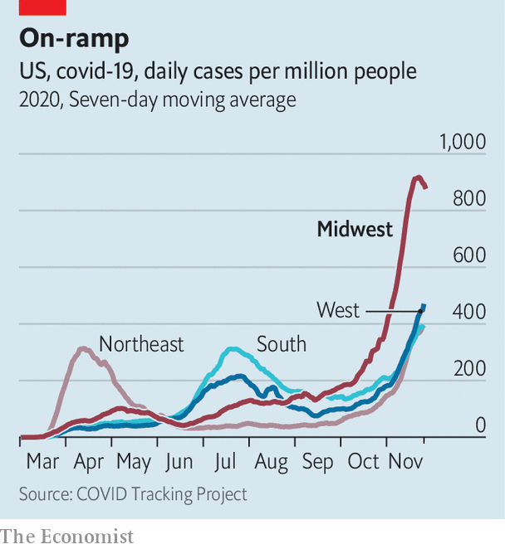

Doctors who need to get deteriorating patients into bigger hospitals have also struggled. Dr Runde helps to run patient transfers in Iowa and says it can take hours of calling hospitals, some in other states, to find a bed. As bigger hospitals in cities fill, less-sick patients are pushed back to smaller rural ones. In Sioux Falls another 1,000 patients, including 100 on supplemental oxygen, are monitored in their homes. Shuttling patients around is not ideal.

Frontline staff have learned better ways to treat patients, so mortality is not soaring along with infections. Kurt Chamberlain, an emergency doctor in eastern Iowa, says his hospital, St Lukes near Cedar Rapids, has 76 patients, far more than before: “We couldn’t have handled that in May.” Everyone knows, for example, that they must avoid putting patients (except the most desperate) on ventilators. Dr Christians estimates that only 5-10% of those who are intubated survive it. Emma Nash, an ICU fellow at a hospital in Omaha, Nebraska, says emergency oxygen is delivered, instead, via a high-powered nasal cannula.

At home, herself shivering from the virus, Dr Nash says hospital resources are spread thin. “The rest of the country should see what’s happening here and realise they’re not out of the woods,” she says. (Infections are surging again in the South, especially.) In mid-November the Midwest accounted for half of all new cases in nursing homes in America. Deaths are also ticking up. On average covid-19 is now killing over 1,550 Americans daily, with the dozen midwestern states accounting for an outsize share of that—560 deaths each day.

In North Dakota nearly one-in-ten people is a confirmed covid case. Why is the region so afflicted? People in northern states are probably meeting indoors, where coronavirus spreads most easily, more than those in warmer spots. Those in rural places, like north Wisconsin, who earlier avoided outbreaks may be shunning protective measures. And policymakers are at fault. Many Republican governors and legislators have long refused to shut bars or restaurants, order statewide mask-wearing or ban mass-gatherings—such as the Sturgis bike rally in South Dakota. All that helped to spread the virus.

Since the election a few, belatedly, have changed their tune. Kim Reynolds, Iowa’s governor, at last issued a statewide mask mandate, after months of scorning the idea. North Dakota’s governor, Doug Burgum, has done the same, also this month. Some cities, such as Sioux Falls and Omaha, do require masks, but in rural areas denial of the virus and rejection of mitigation efforts are both common.

Figures from recent days suggest infections may have fallen off from record highs in some states. But no one is cheering in the emergency wards. Health workers fear that Thanksgiving gatherings will prove to be superspreader moments. Ignoring pleas from public-health officials to stay home, many millions of Americans have flown and driven to family celebrations in the past few days. Meanwhile many college students have just gone home for the year. Dr Runde and the others all say that portends predictably grim results to come. “It is like slow-motion horror. We’re just standing there and being run over.” ■

This article was downloaded by calibre from <https://www.economist.com/united-states/2020/11/26/the-midwest-is-americas-covid-19-hotspot>

|  |  |  |  |
| --- | --- | --- | --- |
| Previous | Articles | Sections | Next |

|  |  |  |  |
| --- | --- | --- | --- |
| Previous | Articles | Sections | Next |

#### In transit

# Joe Biden unveils a reassuringly familiar national-security team

The mixture of brains and experience will delight allies

Nov 28th 2020 | WASHINGTON, DC

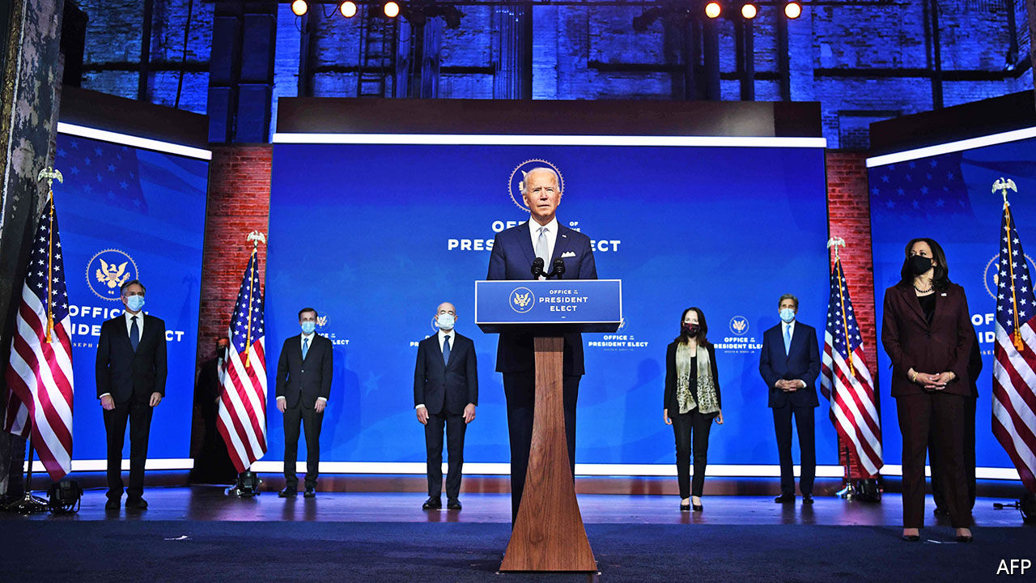

LESS THAN 24 hours after Donald Trump concluded that he could block the transition to Joe Biden’s incoming administration no longer, the Democratic veteran took the stage alongside his chosen national-security team. “America is back, ready to lead the world, not retreat from it,” he said. The happy gurgles of relief this elicited in Washington, DC, London, Tokyo and beyond may be imagined.

Even more than expected, Mr Biden’s choices reflected a stress on unflashy expertise, pragmatism and personal loyalty. His secretary-of-state nominee and national security adviser, respectively Antony Blinken and Jake Sullivan, are well-regarded Obama administration veterans. Mr Blinken, mild-mannered, impeccably coiffured and Francophone, served as the former vice-president’s national security adviser and as a deputy secretary of state. Mr Sullivan, possessed of a first-rate intellect and slightly lesser coiffuring, was another well-liked Biden NSA.

Being friends, they would not be at each other’s throats as Mike Pompeo and John Bolton were. The likely result of their partnership (cue more cooing) would be a return to low-key, competent governing, and a predictable foreign policy that reflects Mr Biden’s long-standing views. Messrs Sullivan and Blinken could be expected to engage with global problems, through alliances where possible, and rebuild the institutions they were charged with. America, suggested Mr Blinken, should have the “humility and confidence” to rely on its allies. By choosing a relatively low-profile secretary, notwithstanding Mr Blinken’s qualities, Mr Biden may additionally be signalling that he intends to do the highest-level diplomacy himself.

It was hard not to hear this as a repudiation of Mr Trump—and harder still when Mr Biden’s chosen Director of National Intelligence (DNI), Avril Haines, promised that, if confirmed by the Senate, she would “continue speaking truth to power”. Another Obama administration veteran, and former deputy chief of the CIA, she would be the first woman DNI. Alejandro Mayorkas would be the first Latino and immigrant to lead the Department of Homeland Security. Mr Biden’s chosen UN ambassador, Linda Thomas-Greenfield was a rare black woman at the heights of American diplomacy, before she was sacked by Mr Trump.

The diversity of Mr Biden’s nominees is also from Mr Obama’s playbook. It is intended in part to mollify the hard-left, whose champions the president-elect has otherwise ignored. His nomination of John Kerry, to be his empowered climate envoy, was another challenge to the left. Mr Kerry is a pillar of the reviled Democratic establishment; yet the left must love his newly-created post. Mr Biden’s nominees have been duly welcomed across the party. By way of dissent, Representative Alexandria Ocasio-Cortez and other lefties have limited themselves to signing a petition against the possible reappointment of Mr Biden’s former chief of staff, Bruce Reed, a relatively obscure figure, on account of his past openness to welfare reform. If that constitutes the serious Democratic infighting that some news reports have described it as, Mr Biden can rest easy.

Stiffer criticism of Mr Biden’s nominees has come from Republican hawks. Senator Marco Rubio characterised them as a bunch of privileged do-gooders who would be “polite & orderly caretakers of America’s decline”. That rather ignored the fact that most of Mr Trump’s team are Ivy Leaguers, who have not restored American hegemony—and that Ms Thomas-Greenfield grew up poor in Louisiana. Yet Mr Rubio’s spiky comments speak to a legitimate question about how Mr Biden’s national security approach will differ from Mr Obama’s.

Mr Sullivan and Mr Blinken have criticised the Obama administration’s areas of diffidence (on Syria and China especially). Mr Biden has additionally underlined that the post-Trump world is different from the one his former boss presided over. On balance, that is probably to his advantage.

Besides lashings of goodwill, his administration will have some useful leverage to work with, in the form of Mr Trump’s sanctions on Iran and tariffs on China. It will have little incentive to dispense with either in a hurry. Even if Iran can be persuaded to comply with the terms of the nuclear containment deal (negotiated by Mr Sullivan) that Mr Trump abrogated, Mr Biden would try to broaden it. And there is no appetite in Washington for giving China something for nothing. Notwithstanding the happy rhetoric, this might augur a foreign policy that is neither a total repudiation of Mr Trump’s nor a re-embrace of Mr Obama’s, but a cross between the two.■

Dig deeper:  
Read the [best of our 2020 campaign coverage](https://www.economist.com/us-election-2020) and explore our [election forecasts](https://projects.economist.com/us-2020-forecast/president), then sign up for Checks and Balance, our [weekly newsletter](https://www.economist.com/checksandbalance/) and [podcast](https://www.economist.com/checks-and-balance-our-weekly-podcast-on-american-politics) on American politics.

This article was downloaded by calibre from <https://www.economist.com/united-states/2020/11/28/joe-biden-unveils-a-reassuringly-familiar-national-security-team>

|  |  |  |  |
| --- | --- | --- | --- |
| Previous | Articles | Sections | Next |

|  |  |  |  |
| --- | --- | --- | --- |
| Previous | Articles | Sections | Next |

#### Miss gender

# A book on transitioning girls is denounced as transphobic

Abigail Shrier has written the first book-length study of a fascinating phenomenon, yet it has been widely ignored

Nov 28th 2020 | WASHINGTON, DC

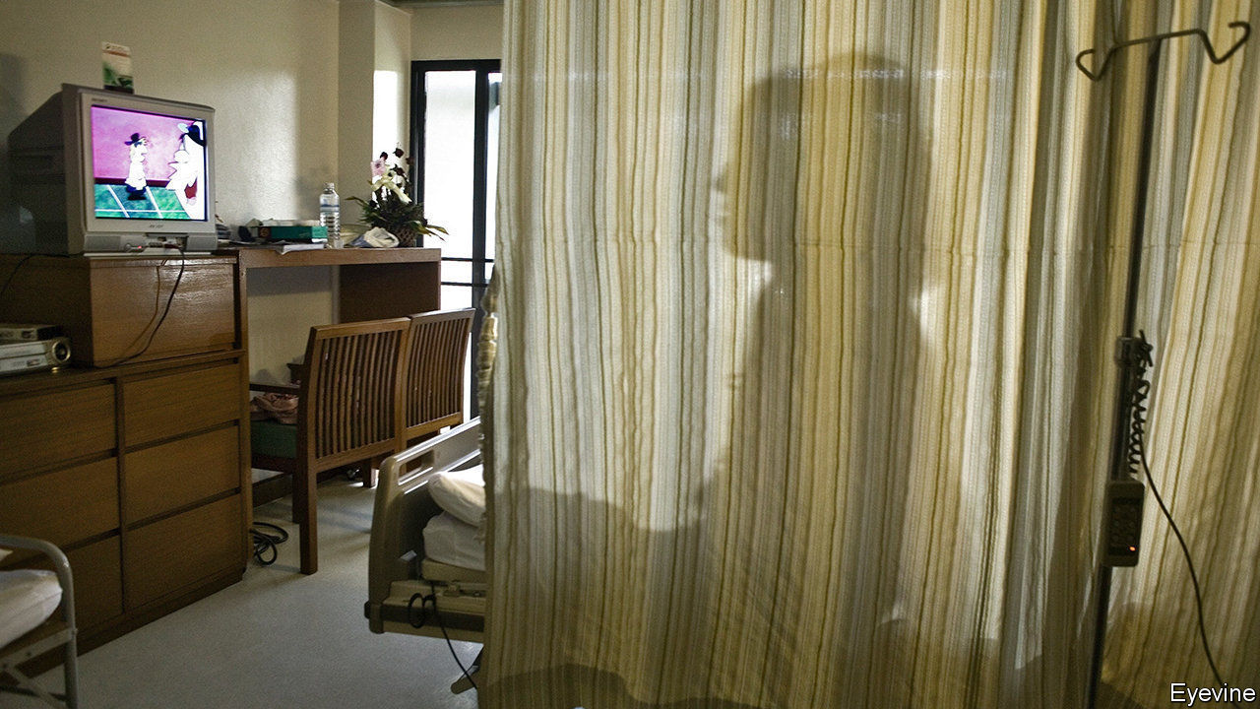

A TEENAGE GIRL who decides to alter her body so that it resembles a boy’s commits herself to a lifetime of medical treatments. “Top surgery”—a double mastectomy—is a major operation. She must take regular, large doses of testosterone. This may increase her chance of developing heart problems. It also causes the uterus to atrophy, often painfully, which may necessitate a hysterectomy.

Some of the changes to her body will be irreversible, and likely to cause distress if she changes her mind. If she has taken puberty-blockers as well as testosterone she may well be infertile. Only a few months of testosterone may have altered her voice and given her a lifelong five o’clock shadow. Fortunately for such girls, “bottom surgery”—a phalloplasty—is so often problematic that few request it.

All this, coupled with the fact that adolescence is confusing at the best of times, might suggest that teenagers should, by and large, be discouraged from embarking on biomedical gender reassignment. That is the argument running through “Irreversible Damage,” a book by Abigail Shrier, a journalist. It is not one that holds much sway in America. As the number of transgender clinics has grown from one in 2007 to at least 50 today, so has the number of young patients in them. Once they were mostly boys; today they are girls. Ms Shrier argues that many are victims of an ideology which holds that the feeling of being in the wrong body must be affirmed at all costs. It has fuelled a craze, she writes, to which teenage girls are particularly susceptible.

“Irreversible Damage” is full of stories from the mostly white, privileged world in which this seems to have flourished. Teenagers, often awkward and anxious, who have lost themselves in an online world that lionises anyone who identifies as trans. YouTubers, who “extol the glories of testosterone as if it were a protein shake” and dismiss parents who are sceptical of trans-identification as “toxic”. Teachers, who do not tell parents that their child is going by a different name at school. The group she reports on in greatest detail is parents. Many of them come across as hapless. Apparently unable to tell their children that feelings of pain and confusion, especially in adolescence, are part of life and usually pass, they instead hope therapists will sort everything out.

Ms Shrier is damning of some of the professionals who have built careers working with trans-identifying children. She points out that this is the only medical field apart from cosmetic surgery in which both diagnosis and treatment are determined by the patient. She describes doctors and therapists (who would ordinarily consider it their job to challenge their patients’ assumptions) bowing to the judgment of vulnerable teenagers. They also, grievously, tell parents who do not accept that their daughters are boys that failing to affirm their identity may heighten the risk of suicide (research does not back this up).

Data on transgender medical interventions are poor—no one knows how many teenagers have transitioned—and one wonders at times if Ms Shrier may have become so steeped in the phenomenon that she exaggerates its reach. But she tells the stories of those she interviews with great care. She writes empathetically about the distress of gender dysphoria, “the relentless chafe of a body that feels all wrong,” and the experience of adults who have transitioned (a group that has long suffered discrimination). She quotes her interviewees at such length that it would be hard to claim she has misrepresented them.

Yet despite this the book has been denounced as transphobic. This month, a prominent lawyer from the American Civil Liberties Union tweeted, from his personal account, that “stopping the circulation of this book and these ideas is 100% a hill I will die on”. A professor of English literature at Berkeley suggested that people should steal the book and burn it. Few mainstream newspapers have reviewed it, though it is one of the first accessible treatments of a subject that has generated much fascinated coverage.

This is a clear illustration of what the book claims: the dominance of an ideology that brooks no dissent or debate. One of the most shocking episodes it describes concerns Lisa Littman, a medical doctor and researcher at Brown University, who noted in a paper in 2018 that most transgender children were teenage girls with no history of gender dysphoria. Many of the teenagers in her study had been exposed to peers who had come out as trans shortly before doing so themselves; a majority had spent more time on the internet. The study sparked a bullying campaign, which prompted Brown to publish an apology, though the paper’s findings never changed. She was fired from another job as a consultant.

In “Irreversible Damage” Ms Shrier describes meeting Dr Littman and wondering out loud about the cultural factors that might be causing so many American girls to want to become boys. She is impressed when Dr Littman refuses “to theorise beyond the limits of her data”. This punctilious respect for the facts had threatened to destroy her career.■

This article was downloaded by calibre from <https://www.economist.com/united-states/2020/11/28/a-book-on-transitioning-girls-is-denounced-as-transphobic>

|  |  |  |  |
| --- | --- | --- | --- |
| Previous | Articles | Sections | Next |

|  |  |  |  |
| --- | --- | --- | --- |
| Previous | Articles | Sections | Next |

#### Panic attacks

# The “gay-panic” defence remains legally admissible in 39 American states

That is 39 too many

Nov 28th 2020 | NEW YORK



DANIEL SPENCER was a quiet, 32-year-old film editor who had recently moved to Austin, Texas from Los Angeles. He was also gay. In 2015 his neighbour, James Miller, stabbed him to death. The case was harrowing. But a legal quirk uncovered during the trial made it even worse. Mr Miller introduced the “gay-panic” defence in court, arguing that at some point on the night of the murder, Mr Spencer had tried to kiss him. The victim’s apparent homosexuality had made Mr Miller fearful for his safety and thus diminished his responsibility. Despite a lack of physical evidence (and the fact that Mr Miller defended himself by stabbing the victim twice in the back), he was sentenced to just six months in jail, with ten years on probation.

The case was no anomaly. The “gay- panic” defence remains legally admissible in 39 states according to the Movement Advancement Project, a think-tank. It normally bolsters either insanity or self-defence claims, and its use goes back decades. The brutal ‘candlestick murder’ of Jack Dobbins in Charleston in 1958 resulted in a full acquittal of the man who confessed to the crime, based on the fact that the victim had allegedly made unwanted advances. Although attitudes to homosexuality have changed since then, the law in some places has not.

The defence is “the problem hiding under the sofa”, says Jason Marsden, executive director of the Matthew Shepard Foundation, which lobbies against hate crimes. It occurs in so few cases, scattered across multiple jurisdictions, that it seldom attracts much attention.

The American legal system is no stranger to bizarre lines of defence. In 2013 Ethan Couch killed four people while drunk-driving in Texas. His lawyers successfully argued that the 16-year-old was suffering from “affluenza”, having grown up sheltered by wealthy parents who had failed to teach him the consequences of his own actions (he initially avoided prison and was instead put on probation for ten years). Lawyers for Colin Ferguson, a Jamaican immigrant who killed six people on a train in New York in 1993, pursued a “black-rage” defence, claiming that a lifetime of racial prejudice had driven Mr Ferguson insane (they were unsuccessful).

But the track record of the “gay-panic” defence makes it particularly egregious. The FBI keeps no data on the sexuality of homicide victims, and state-by-state records on hate crimes are spotty, so numbers can be difficult to pin down. But Carsten Andresen, a criminal-justice professor at St Edward’s University in Austin, Texas, has been busy compiling a database. His research shows that since the 1970s, gay- and trans-panic defences have reduced murder charges to lesser offences in 40% of the roughly 200 cases that he has identified. In just over 5% of cases, the perpetrator was acquitted or the charges dropped.

It took until 2014 for California to introduce the first ban on the defence (the state’s attorney-general at the time, Kamala Harris, led efforts to push the ban through). Since then, ten more states have followed, most recently Colorado in July of this year. Proposed bans are in committee stages in a handful elsewhere, including Texas and Minnesota, but 30 statehouses remain silent on the issue. And the fact that a third of cases since 1970 have occurred in the past ten years suggests that the problem may be worsening, or at least that “every step forward is followed by several steps back”, says Mr Andresen. For now, nearly two-thirds of gay Americans are living in states where their very existence can be claimed to be a reasonable cause for violence against them. Daniel Spencer probably did not know this when he invited his neighbour over for an evening of wine-drinking and guitar-playing.

This article was downloaded by calibre from <https://www.economist.com/united-states/2020/11/28/the-gay-panic-defence-remains-legally-admissible-in-39-american-states>

|  |  |  |  |
| --- | --- | --- | --- |
| Previous | Articles | Sections | Next |

|  |  |  |  |
| --- | --- | --- | --- |
| Previous | Articles | Sections | Next |

#### Lexington

# The end of the embarrassment

The assumption that Republicans will remain in thrall to Donald Trump could be misplaced

Nov 26th 2020 |

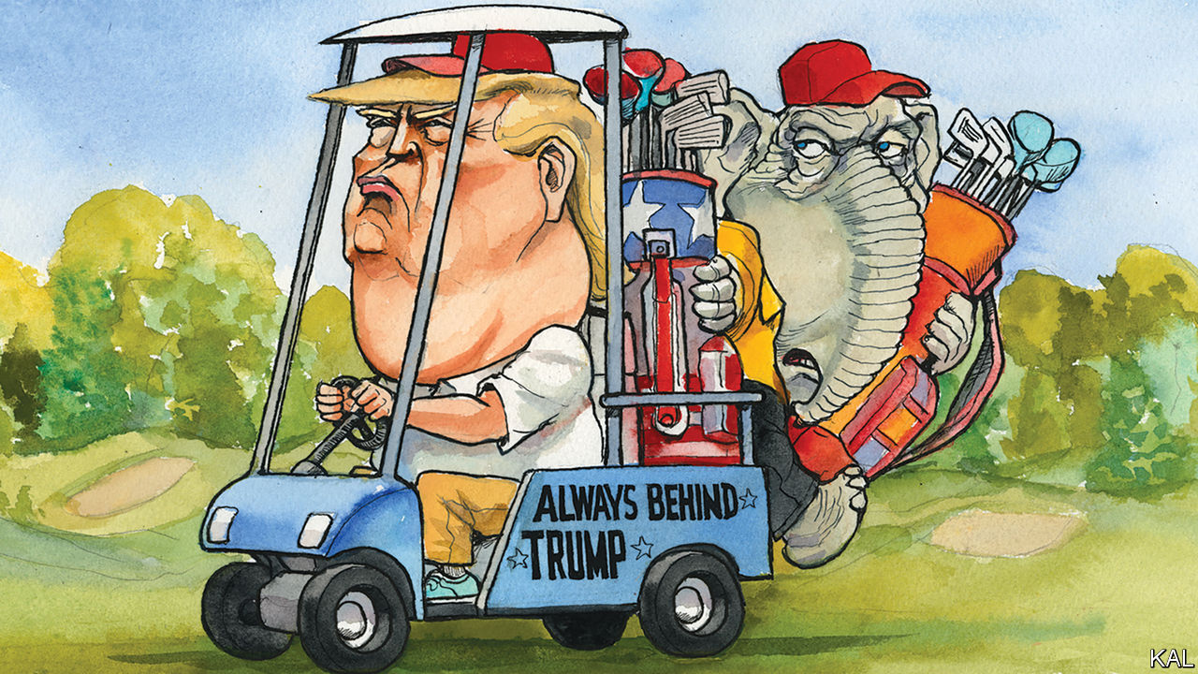

APPALLING AS IT has been to witness an American president try to steal an election, Donald Trump’s efforts have amounted to less than the best-informed prognosticators feared. Back in June a bipartisan group of over 100 political operatives and scholars, gathered by the Election Integrity Project, war-gamed the aftermath of four scenarios: an unclear result, a narrow win for Joe Biden, a clear victory for Mr Trump and the same for Mr Biden. Only in the last simulation was America spared authoritarianism by Mr Trump, a constitutional crisis and street battles.

Mr Biden’s actual winning margin was at the outer edge of a “clear victory”. And the president’s response to it has been even wilder than the war-gamers envisaged. (They did not imagine, in such an event, that he would try to coerce Republican state legislators to overthrow the results.) Yet none of the other features of the Trump coups they envisioned has materialised. Attorney-General Bill Barr has gone to ground. High-powered conservative lawyers have taken a pass on the president’s bogus fraud claims.

Hence the ridiculous Rudy Giuliani, dripping sweat and hair dye and ranting about George Soros and Hugo Chávez, has been the spear-point of Mr Trump’s attempted heist. It has been laughable, a shambles. It has also illustrated—yet again—Mr Trump’s iron grip on his party, to the extent that most commentators seem to think the Republican nomination for the 2024 election is already his for the taking. They could be right. But Lexington is sceptical.

That is not to deny the president’s success in fast-tracking the myth of his stolen re-election to the pantheon of right-wing grievances. The same livid Trump superfans who have been rallying all year against mask-wearing and the scourge of devil-worshipping Democratic paedophiles have gathered, outside state legislatures from Arizona to Pennsylvania, to demand that state lawmakers “stop the steal”. Right-wing conspiracy theorists have been spitting out explanations—involving shadowy Biden-Harris vans crammed with ballots in Nevada, vanishing sharpie signatures in Arizona and so forth—for how the steal took place. A large majority of Republican voters say Mr Biden’s victory was illegitimate.

A bigger majority of Republican politicians are afraid to disabuse them. Three weeks after Mr Biden’s victory, only a few Republican senators had dared acknowledge it. The damage this has done to their party, and American democracy, could be profound. The next Republican loser to cry fraud will be preaching to the converted. Still, the assumption that Mr Trump will continue to preside over the mess he has made of the right is premature.

There is a reason why Grover Cleveland, in 1892, is the only one-term president to have been given another crack of the whip by his party. Voters want winners. And it is not obvious why Mr Trump—a politician whose pitch is based on his claimed inability to lose—should be a second exception to that rule. Once the smoke of the 2020 battle has cleared, many of his supporters may see him as he is: a loser whose deranged loss-denialism encapsulates why he ran behind down-ballot Republicans all across the country. There are even signs that one or two of his cheerleaders are already chewing on that pill. “You announce massive bombshells, then you better have some bombshells…,” said Rush Limbaugh, puzzling over Mr Giuliani’s performance.

The argument for Mr Trump bucking history rests on an assumption that he will shift his bully-pulpit to the disaggregated conservative media. With Twitter growing less tolerant of his disinformation, his offspring and supporters are migrating to Parler, which takes a laxer view of it. By becoming a staple on the ultra-Trumpist OAN or Newsmax channels—which Mr Trump recommended his followers switch to after Fox News called the election for Mr Biden—he could access 50m conservative homes. That would constitute a powerful foghorn. But Mr Trump’s ability to dictate terms to the Republican Party does not rest on his ability to entertain its voters. It relates to his power to terrorise Republican lawmakers with a possible primary challenge. And it is not clear that, once out of day-to-day politics, he will be able to do that.

OAN viewers are divorced from reality in more ways than one. Where Fox’s heavyweight newsgathering and polling operations help it to influence the political debate, the hard-right channels are comparatively irrelevant. Almost no one watches Newsmax on Capitol Hill. It is notable that the Tea Party movement, a Trump progenitor, was inspired by an anti-government rant on CNBC. For all his millions of listeners, Mr Limbaugh could not have had the same mobilising effect; such rants are expected of him.

It is not hard to imagine Mr Trump, without the ballast of his office, drifting into a state of lucrative but ever-more irrelevant bloviation. He might not have to resort to singing “Baby Got Back” in a bear costume to get an audience, as Sarah Palin recently did on Fox. But his wilderness years could resemble those of John McCain’s embarrassing running-mate more than most commentators imagine. “There is only so long you can live outside the maelstrom of the American news cycle and maintain relevance,” notes Jerry Taylor, founder of the Niskanen Centre and an astute observer of the right. Mr Trump’s campaign against the Murdoch channel is probably raising his chances of learning that lesson by the day. It has all the makings of a showdown between machine-tooled corporate competence and his own raging ineptitude.

## Dances with bears

It is possible to imagine other scenarios. If the Trump clan captures the Republican National Committee (a prize Donald Trump junior is eyeing), Mr Trump would have a more than adequate platform. Yet take this as a caution. The Trump-bruised commentariat is exaggerating his prospects. When a poll this week suggested 53% of Republicans want him to be their nominee in 2024, it was reported as a testament to his strength. An alternative reading is that almost half of Republicans already want to see the back of him.■

This article was downloaded by calibre from <https://www.economist.com/united-states/2020/11/26/the-end-of-the-embarrassment>

|  |  |  |  |
| --- | --- | --- | --- |
| Previous | Articles | Sections | Next |

|  |  |  |
| --- | --- | --- |
| United States | Sections | Asia |

The Americas

Venezuela: They’re going to win, by a lot

.

Diego Maradona: Divine and damned

.

Bello: The future of bolsonarismo

.

|  |  |  |
| --- | --- | --- |
| United States | Sections | Asia |

|  |  |  |  |
| --- | --- | --- | --- |
|  | Articles | Sections | Next |

#### Consolidating dictatorship

# Venezuela’s regime will win December’s legislative election, by a lot

A rigged vote will end the opposition’s control of the last democratically elected institution

Nov 26th 2020 | CARACAS

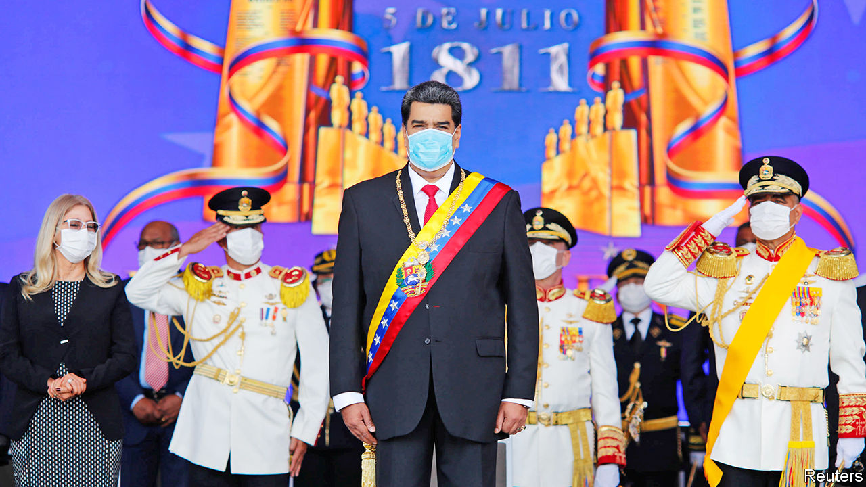

“WE ARE going to rescue the National Assembly,” sing Chucho y Omar Acedo, a pop duo hired by the Venezuelan regime to drum up enthusiasm for the forthcoming parliamentary election. Their catchy ode to the government, broadcast repeatedly on state media, makes it seem simple. “A future with greatness is arriving ...Happiness and hope are returning,” the band chants, to a Latin beat.

The first claim is probably correct. The National Assembly is the one branch of government still controlled by the opposition to the authoritarian regime of Nicolás Maduro. In an election due to be held on December 6th the socialist ruling party, the PSUV, will dislodge it. The regime has taken steps to ensure that it cannot lose. It has cemented its control over the National Electoral Council (CNE).

Pop musicians are not the only means of ensuring that turnout will be high and pro-regime. “I don’t want to vote but I have to because of my work,” says an employee of the tourism ministry. She intends to cast her ballot for the PSUV because she assumes it is not secret and fears losing her job if she shows disloyalty. Most of the opposition is boycotting the election, on the grounds that it will be fixed. A last-ditch attempt by the European Union to delay it by six months to create conditions for a fair election (like having a trustworthy CNE) came to nothing.

Although the result is preordained, the vote will matter. The regime’s takeover of the National Assembly will be a big step in its march towards full dictatorship. It will strip Juan Guaidó of his job as the legislature’s president. As the holder of that office he claims to be Venezuela’s rightful president, on the grounds that Mr Maduro won re-election fraudulently in 2018. That claim is recognised by more than 50 countries, including the United States, several large Latin American democracies and nearly all EU members.

Mr Guaidó will lose the speakership just before Joe Biden assumes the presidency of the United States, on January 20th. The new American administration and its partners will have to reconsider their approach to restoring democracy to Venezuela.

The opposition’s current hold on the legislature came about by accident. In 2015 Venezuela’s “Bolivarian” regime, in power for 16 years, was so convinced that it would win the election held that year it did not cheat enough to secure victory. It lost in a landslide, especially in the poor barrios that were once its stronghold. Venezuelans rightly blamed Mr Maduro for a severe recession (which was about to get much worse), high inflation (soon to become hyperinflation) and shortages of basic goods.

The coalition of opposition parties that won control of the legislature should have been able to check the regime. But Mr Maduro, while recognising its victory, ignored its consequences. The puppet supreme court vetoed all the laws passed by the legislature. Eventually, he replaced it with a rubber-stamp Constituent Assembly.

Parliament remained a threat to the regime, especially after Mr Maduro began a second six-year term in 2019. His rigged re-election gave Mr Guaidó constitutional grounds to assume the interim presidency in January of that year. The administration of Donald Trump tightened sanctions, seeking to deny Venezuela income from oil, its main export. The hope was that angry Venezuelans, joined by the armed forces, would switch their loyalties to Mr Guaidó within weeks. Fair national elections would soon follow.

Twenty-one months later the opposition is discredited and divided. The armed forces have not defected. The regime looks entrenched. Some components of the opposition will participate in the legislative election, thinking it is better to have a toehold on power than no purchase at all. Mr Guaidó’s allies plan a referendum opposing the vote, to be held mostly online.

Venezuelans are more miserable than ever. American sanctions come on top of years of economic mismanagement by the Bolivarian regime. Since 2017 they have cost the Venezuelan state $17bn-31bn in revenue, estimates the Washington Office on Latin America (WOLA), a think-tank. That is between a third and a half of this year’s shrunken GDP. This year alone the government has had to slash its imports by half, worsening the misery.

The effects are felt by people like Alicia Hernández, a former lawyer from Ciudad Bolívar in southern Venezuela, who walks up to 20km (12 miles) a day to find fuel and food for her children. In the once opulent oil city of Maracaibo on the northern coast residents make home-brew petrol from stolen crude. The exodus of Venezuelans since Mr Maduro became president in 2013 has reached 5m people, a sixth of the population, the largest such movement ever in South America.

Now, despite his catastrophic record in office, he looks forward to untrammelled power. Once the PSUV wins the assembly election it will choose one of its own to preside. Mr Guaidó will lose his title on January 5th, when the term of the current legislature ends. His allies deny this. The forthcoming vote “is not an election”, declares Leopoldo López, Mr Guaidó’s mentor, who is in exile in Spain. “The National Assembly is not being replaced. There will just be a continuation of what is already in place constitutionally.”

In fact, Venezuela’s constitution does not spell out what should happen if a legislature’s term ends without a duly elected successor. “There’s far from a consensus on this issue among constitutional scholars in Venezuela,” says Geoff Ramsey of WOLA.

The main risk for Mr Guaidó is that doubt over his claim to the interim presidency will erode his international backing. Mr Ramsey expects “a sort of slow walk away” from support. European “backsliders” are looking for a way to distance themselves from Mr Guaidó, grumble diplomats who represent more hawkish governments in Caracas. Among them are Spain and Portugal, which are uneasy about continuing to recognise an interim president who has no power nor much prospect of winning it.

Mr Trump, who will still be in office on January 5th, is unlikely to waver. His backing of Mr Guaidó helped him win Florida in the United States’ presidential election. Mr Biden, who won that election, will adjust American policy. He has called Mr Maduro “a dictator, plain and simple” and expressed support for Mr Guaidó. But the president-elect has also rejected the idea of engineering regime change.

The Biden presidency is expected to focus its diplomacy on countries such as Turkey and China that continue to do business with Mr Maduro’s regime, thereby propping it up. They would seek ways to alleviate the humanitarian crisis while pushing Mr Maduro to negotiate seriously with the opposition on restoring democracy. Mr Biden is thought to favour modifying sanctions to lessen the pain felt by ordinary Venezuelans.

But democracy would mean the demise of the regime, which is not in its plans. It is “incapable of negotiating”, fumed a European diplomat in Caracas after the abortive effort to delay the legislative election. Changing Mr Maduro’s mind will require pressure from his friends. For now, he is bent on “rescuing” the National Assembly. Bringing “happiness and hope” to Venezuelans is another matter.■

This article was downloaded by calibre from <https://www.economist.com/the-americas/2020/11/26/venezuelas-regime-will-win-decembers-legislative-election-by-a-lot>

|  |  |  |  |
| --- | --- | --- | --- |
|  | Articles | Sections | Next |

|  |  |  |  |
| --- | --- | --- | --- |
| Previous | Articles | Sections | Next |

#### Divine and damned

# The blessed and cursed life of Diego Maradona

One of Argentina’s, and the world’s, greatest footballers dies

Nov 28th 2020 |

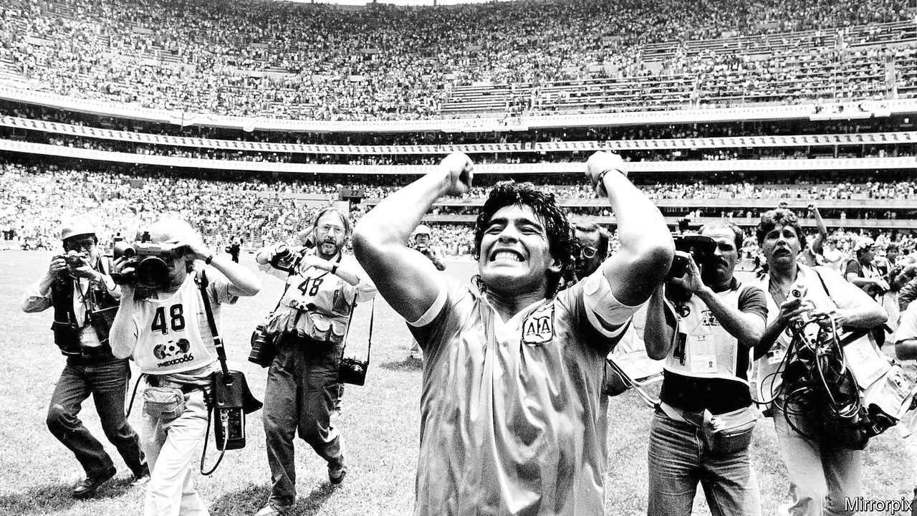

HE WILL LIVE forever on that sunny June afternoon in 1986 in the Aztec stadium in Mexico City. It was the quarter-final of the World Cup between Argentina and England. In the 55th minute Diego Armando Maradona collected the ball in the Argentine half and carved his way through the England defence as if it wasn’t there before striking a low hard shot. It was one of the greatest goals of all time. It came just four minutes after Maradona, with the match scoreless, had risen to meet a miscued clearance in the England penalty area and punched the ball into the net. He had scored, he said later, “a bit with the head and a bit with the hand of God”. With no video refereeing back then, the goal stood. It was, he said, a kind of revenge for Argentina’s defeat at English hands in the Falklands (Malvinas) war four years earlier.

Between them, those goals summed up Mr Maradona, who died of a heart attack aged 60 on November 25th. Blessed with divine talent, he had little respect for the rules in a life that offered riches but which was always a struggle. He embodied the idiosyncrasy of his country, as Clarín, an Argentine newspaper, noted: “Maradona is the two mirrors, that in which it’s a pleasure to regard ourselves and that which shames us.”

The son of a maid and a factory worker, he grew up in a tin-and-cardboard shack in Villa Fiorito, in the rustbelt suburbs of Buenos Aires. As an adult he stood five feet, five inches, but his stocky body and muscular legs gave him explosive power. His trademarks would be surging runs, the ball glued to his feet, and instinctive vision.

His professional career began when he was 15 at Argentinos Juniors, a historic but modest club. Success there took him to Boca Juniors and then to Barcelona and Napoli. But he found fame and fortune hard to handle. He craved affection. Nightclubbing in the company of freeloaders and gangsters led to cocaine addiction. There were many women, some of whom he beat, and enough children to form a football team.

The second half of Mr Maradona’s life was tragically grotesque. Obese and often in pain (referees were less protective in his day), he made pathetic attempts at comebacks. He failed as a manager, notably of Argentina’s national team. Made rich by capitalism, he saw no contradiction in friendships with anti-capitalists Fidel Castro and Hugo Chávez.

Whether Mr Maradona was the greatest-ever player, ahead of his compatriot, Leo Messi, or Brazil’s Pelé, is a debate there is no need to resolve. With his humble origins, Guaraní blood and mop of dark curls, for Argentines he was ever the pibe de oro, the golden boy. “You made us immensely happy,” said Alberto Fernández, Argentina’s president, as he declared three days of national mourning. ■

This article was downloaded by calibre from <https://www.economist.com/the-americas/2020/11/28/the-blessed-and-cursed-life-of-diego-maradona>

|  |  |  |  |
| --- | --- | --- | --- |
| Previous | Articles | Sections | Next |

|  |  |  |  |
| --- | --- | --- | --- |
| Previous | Articles | Sections | Next |

#### Bello

# The future of bolsonarismo

Brazil’s weak economy could deny President Jair Bolsonaro a second term

Nov 26th 2020 |

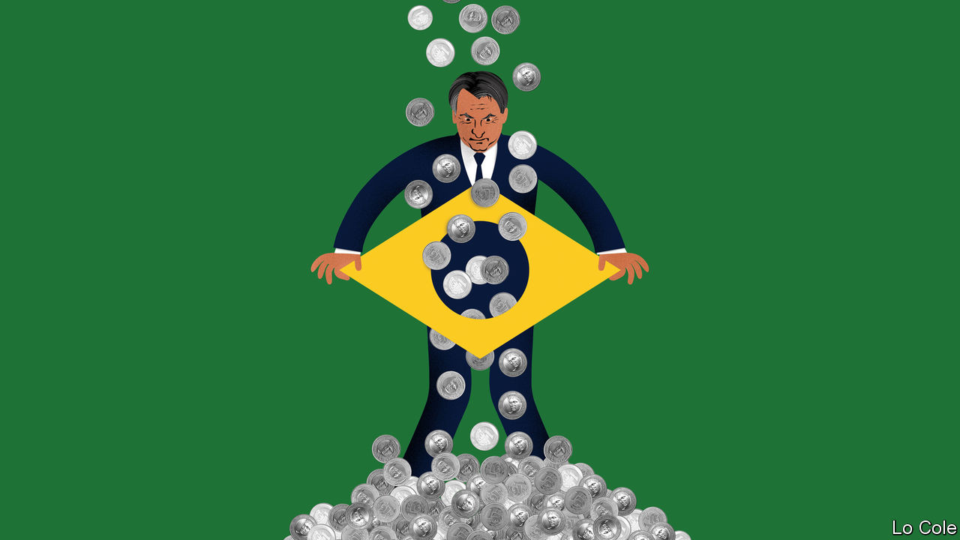

THIS HAS been a bad month for Brazil’s populist president, Jair Bolsonaro. First, Donald Trump, whose victory in 2016 served as a template for his own and with whom he aligned his government, lost his bid for a second term. And then the candidates Mr Bolsonaro backed in municipal elections on November 15th nearly all fared poorly, while the big winners were mainstream parties. Some pundits are rushing to write his political obituary. “The elections of 2018 were a hiatus and those of 2020 have put things back in their right place,” wrote Eliane Cantanhêde, the political columnist of O Estado de S. Paulo, a newspaper.

Brazilian liberals hope she is right, and that Mr Trump’s defeat will be an augury of Mr Bolsonaro’s fate at the next election in 2022. A former army captain, Mr Bolsonaro is scornful of democracy and its checks and balances, has stuffed his government with military men, says offensive things about gay, feminist and black Brazilians, favours gun ownership and underplays both covid-19 and climate change. His election broke the mould of Brazilian politics and was in some ways an aberration. Even so, it would be a mistake to write off his chances of a second term.

In 2018 Mr Bolsonaro was the beneficiary of an unusual moment in which the country’s political class was widely seen to have failed. His chief opponent, Luiz Inácio Lula da Silva, a once idolised former president, was in jail, barred from running by a conviction for bribe-taking in the so-called Lava Jato (Car Wash) scandal. Lula’s left-wing Workers’ Party was seen by many not just as corrupt and self-serving but incompetent, having driven the economy into what was then its deepest recession in a century. But the opprobrium extended to centrist politicians, many of whom were caught up in Lava Jato.

Mr Bolsonaro, who posed as an anti-political outsider, tapped into conservative currents in Brazilian society, some long present, some newer. He attracted disproportionate support from men and evangelical Protestants. But what tipped the election to him was the popularity of his talk about family values and law and order in the poor peripheries of Brazil’s big cities, the Workers’ Party’s former base, argues a recent book by Jairo Nicolau, a political scientist. His victory owed much to the skilful use of social media in a way that was novel in a Brazilian election.

As president, Mr Bolsonaro empowered hard-right ideologues, pursued polarisation and all but self-destructed. Six months ago, amid rising tension caused by the pandemic, corruption allegations against one of his sons and threats of impeachment, he came close to ordering the armed forces to shut down the Supreme Court. Some of his military advisers talked him out of that. Mr Bolsonaro saved his presidency by edging away from anti-politics and towards conservative politics as usual, allying with the centrão (big centre), a clutch of conservative parties of professional politicians who hold 221 of the 513 seats in Congress. An emergency stipend paid to 66m people has blunted criticism of his mishandling of the pandemic. Brazil has had more than 6m confirmed cases and 170,000 deaths. Mr Bolsonaro’s approval rating has risen from 30% to 40%.

His most likely path to a second term involves cementing his alliance with the centrão, which did well in the municipal elections. His attempts to set up his own political party, announced a year ago, have yet to bear fruit. An alliance with the centrão would make him a much less credible campaigner against corruption and the political class. But it would offer the kind of political machine that historically helped to win Brazilian elections—useful since social media alone are unlikely to give him such a competitive edge twice. If the opposition remains divided both between left and centre and within those camps, that would help him, too.

The big problem for Mr Bolsonaro is the economy. The emergency stipend has helped the country avoid a deeper recession. But how long can the government sustain it? Public debt is heading for 100% of GDP. Even with interest rates low, that is a big number for a country with a history of default and inflation. Economic recovery may be slow and austerity looks unavoidable next year. Income per person has already fallen below its level of 2010. Many Brazilians are suffering. Nationalist sound and fury will not pay the bills. Mr Bolsonaro remains today a competitive candidate. But by 2022 Brazilians may be less receptive to him than they were in 2018.

This article was downloaded by calibre from <https://www.economist.com/the-americas/2020/11/26/the-future-of-bolsonarismo>

|  |  |  |  |
| --- | --- | --- | --- |
| Previous | Articles | Sections | Next |

|  |  |  |
| --- | --- | --- |
| The Americas | Sections | China |

Asia

Rule of law in South Korea: Prosecution complex

.

Sri Lanka’s Tamils: The war within

.

Crime in Singapore: A city reels

.

India and Pakistan: Shell game

.

Banyan: Hurly-barley

.

|  |  |  |
| --- | --- | --- |
| The Americas | Sections | China |

|  |  |  |  |
| --- | --- | --- | --- |
|  | Articles | Sections | Next |

#### Prosecution complex

# South Korea’s president wants to take politics out of prosecutions

But his reforms seem to be having the opposite effect

Nov 28th 2020 | GWACHEON

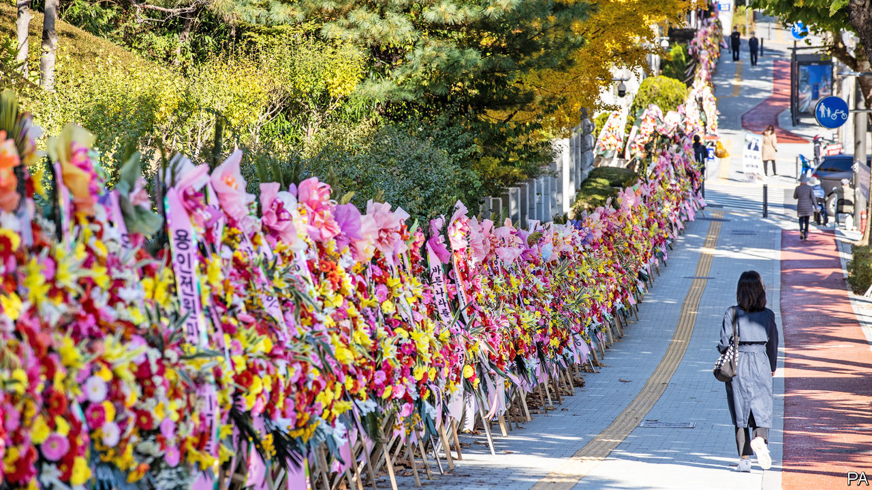

THE IMAGERY is funereal. The slogans attached to the sides of the vans outside the Ministry of Justice are framed in black, like pictures of someone recently deceased. They read, “Democracy is dead” and “The Ministry of Justice is dead.” The dozens of funeral wreaths made of white and yellow plastic flowers that have been laid against the building’s fence also carry messages. One addresses the president: “Moon Jae-in, you’re going to die.” The majority express wrath for the justice minister: “Choo Mi-ae, you bitch.” Funeral music wails from speakers mounted on the vans.

The protest, organised by a right-wing group which insists that the wreaths’ message is strictly metaphorical, and an earlier phalanx of flowers left at the prosecution service (pictured above) are rather extreme expressions of support for Yoon Seok-youl, the chief prosecutor, whom Ms Choo suspended on November 24th—the first time a justice minister has taken such a step. Among other things, she accuses Mr Yoon of spying on judges hearing cases against her predecessor and of lacking political impartiality. Mr Yoon denies wrongdoing and says he will challenge the “unjust” demotion in court. He says the prosecution service is being unfairly targeted by the justice minister. That implies criticism of Mr Moon, who has made reforming it one of his political priorities.

The life-and-death rhetoric employed by both sides may be overblown, but Mr Moon is locked in a ferocious dispute with prosecutors. He says he wants to stop both the frequent manipulation of prosecutions by the executive and the pursuit of vendettas against government officials by the prosecutors. But rather than ending the tug-of-war, Mr Moon’s approach risks intensifying it, with potentially grave consequences for him and his government.

South Korea’s prosecutors have the power not just to indict suspects but also to launch investigations, a task more commonly performed by the police in other countries. Under the administrations of Lee Myung-bak and Park Geun-hye, Mr Moon’s predecessors, they were accused of using their authority to increase their own standing as well as to align themselves with the political aims of the government when it suited them. They were seen as too soft on powerful politicians and businesspeople, and too hard on those whom they or the president of the day regarded as pesky opponents. Both Mr Lee and Ms Park are now serving long prison sentences for corruption which critics say prosecutors did not scrutinise sufficiently during their time in office.

A central aim of Mr Moon’s reform of the prosecution service, parts of which passed the National Assembly earlier this year, was to put an end to such abuses by limiting prosecutors’ investigative powers. Under the new laws, which took effect in the summer, they are supposed to yield some authority to the police and some to a new agency to investigate government officials and business bigwigs.

Some see an element of hypocrisy in this. Early in his term Mr Moon was focused on breaking the power of big business and remedying the corrupt habits of his predecessor, and made it clear that prosecutors had his support in using their sweeping powers in this effort. “That has made it harder to implement prosecution reform, which involves taking away some of these powers,” says Park Myung-lim of Yonsei University.

Mr Moon appointed Mr Yoon to his post because of his reputation as a hard-nosed, independent prosecutor who did not shy away from cases that the government would rather leave untouched: for instance, investigating the national intelligence service while Ms Park was still in office. Mr Yoon says that the president encouraged him to apply the same scrutiny to Mr Moon’s own associates. He has done so with gusto, particularly when it comes to the officials working to curb the power of his own agency. Cho Kuk, Ms Choo’s predecessor as minister of justice, was forced to resign last year after prosecutors began investigating his family for nepotism and alleged financial irregularities. Ms Choo herself has come under scrutiny for allegedly seeking favourable treatment for her son during his military service.

None of these investigations has resulted in any convictions, prompting accusations from Mr Moon’s supporters that, rather than being scrupulously independent, Mr Yoon is using his powers to undermine the president’s reforms, perhaps to further his political career or to deflect scrutiny from his own associates. (Mr Yoon’s mother-in-law was indicted on charges of fraud on November 24th, following an investigation from which he had to recuse himself.) The government’s critics, however, point to Ms Choo’s repeated interventions in investigations that could become awkward for the government. They charge that the government is reverting to the tactics of its predecessors, using prosecution reform as a pretext to protect the president’s allies. The reform has become “a shield to cover up whatever misdemeanours Moon’s colleagues commit”, asserts Jun Sung-in of Hongik University.

Despite such claims, most South Koreans seem to support the reforms. But the power struggle between Mr Yoon and Ms Choo has done little to turn the prosecution service into a duller, more workaday agency. Mr Park of Yonsei University thinks that Mr Yoon’s suspension may convince the entire prosecution service to take their boss’s side, which would not only defeat the intention of the reforms, but also potentially paralyse Mr Moon’s administration through endless prosecutions. If Ms Choo manages to assert herself, in contrast, the service may revert to doing the government’s bidding, says Park Kyung-sin of Korea University Law School.

For Mr Moon himself, the most important question may be whether the situation increases the danger that he will share the fate of his jailed predecessors. So far, not even his fiercest critics have accused the president of crimes that could match theirs. As his term draws to a close, he may nevertheless find himself under growing scrutiny by prosecutors who are miffed at his efforts to curb their power, yet retain enough of it to cause him misery. ■

This article was downloaded by calibre from <https://www.economist.com/asia/2020/11/28/south-koreas-president-wants-to-take-politics-out-of-prosecutions>

|  |  |  |  |
| --- | --- | --- | --- |
|  | Articles | Sections | Next |

|  |  |  |  |
| --- | --- | --- | --- |
| Previous | Articles | Sections | Next |

#### The war within

# Sri Lanka’s Tamil minority has become more politically fractured

But the island’s new nationalist government may change that

Nov 28th 2020 | JAFFNA

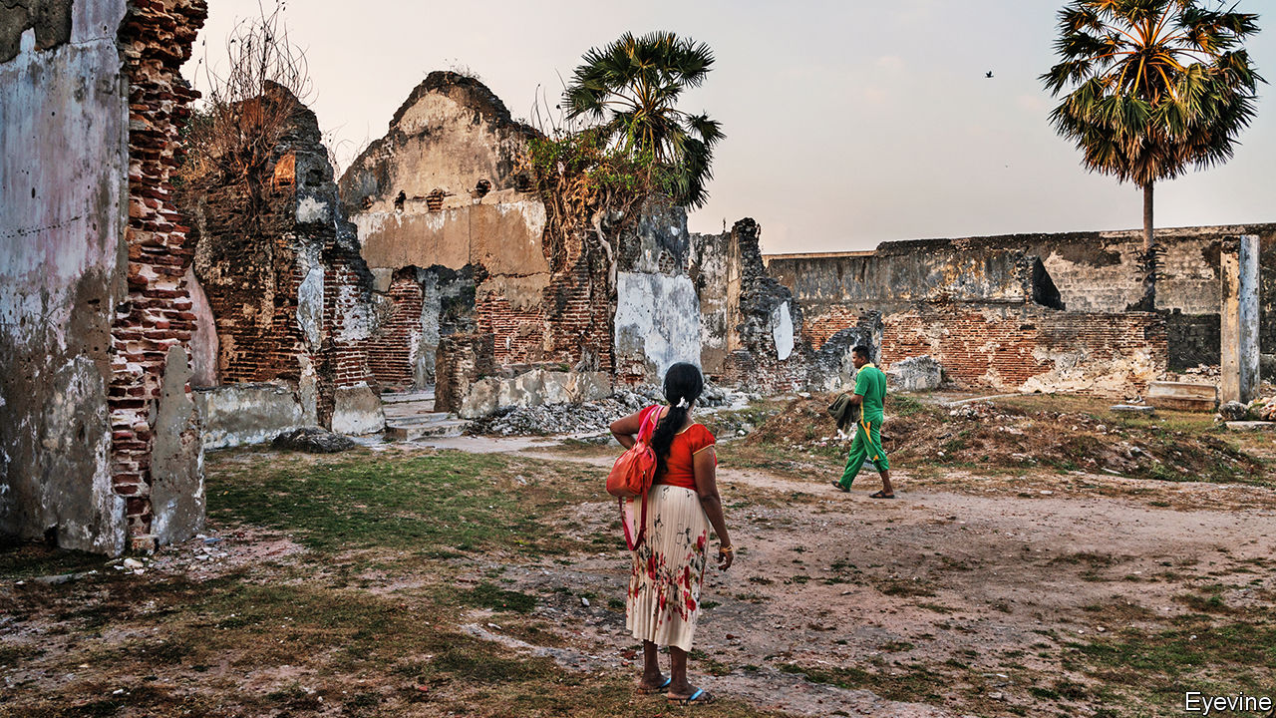

HANGING ABOVE the desk of Emmanuel Arnold, the mayor of Jaffna, are images of three Hindu deities, as well as the Buddha, Jesus and the Mosque of the Prophet in Medina. He has to respect all the religions of his city, he explains. Most Sinhalese, the country’s biggest ethnic group, are Buddhist; Tamils, who predominate in the north, including Jaffna, tend to be Hindu, and there are also small Christian and Muslim minorities. (Mr Arnold himself is Christian.) The ecumenical display, however, prompted griping from his staff: there is little sense of unity in Jaffna these days, even among the Tamil majority, let alone between religions and ethnicities.

Tamil hopes for an independent homeland were dashed in 2009, when the government defeated the Tamil Tigers, a ruthless separatist insurgency. But many in the north still hanker for autonomy, as promised by amendments to the constitution adopted in 1987 but never fully implemented. Anxieties about majority rule have swelled since the election last year as president of Gotabaya Rajapaksa, who as number two in the Ministry of Defence presided over the defeat of the Tigers in a campaign in which many Tamil civilians also died.

For almost 20 years the main standard-bearer for Tamils in Sri Lankan politics has been the Tamil National Alliance (TNA), a multi-party union led by Mr Arnold’s Illankai Tamil Arasu Kachchi (ITAK). But in elections in August, it slumped from 16 seats in the 225-seat parliament to ten. (Mr Arnold was one of its losing candidates.)

Mathiaparanan Sumanthiran, the TNA’s spokesman and an MP, blames this “very serious setback” on popular disillusionment after the TNA failed to strike a deal on autonomy with the previous president, Maithripala Sirisena. The alliance had been instrumental in Mr Sirisena’s surprise victory over Mahinda Rajapaksa, the brother of Gotabaya, in presidential elections in 2015. Yet reconstruction and development of the north after the long civil war was neglected under Mr Sirisena. Equally gallingly, an assembly to draft a new constitution came and went without making a specific proposal. Mr Sirisena began feuding with his prime minister, and most reforms went out of the window. “We put all our eggs in one basket,” laments Mr Sumanthiran.

The result has been a fracturing of Tamil politics. Canagasabapathy Wigneswaran, a retired Supreme Court judge who had served as the chief minister of Northern Province, of which Jaffna is the capital, left the TNA to form his own party. He won a seat in parliament in August, as did Gajendrakumar Ponnamabalam, another Tamil nationalist who split from ITAK. Others threw their lot in with the Rajapaksa brothers’ party, the Sri Lanka People’s Front (SLPF), on the basis that it could at least provide funds for development. One of them, Angajan Ramanathan, also won a seat. Velupillai Sivagnam, a provincial councillor with ITAK who is in his 70s, cannot remember a time when there were so many different Tamil parties.

In his maiden speech in parliament, Mr Wigneswaran demanded self-determination for Tamils, who he insisted were “the first indigenous inhabitants of this country”, reigniting a long-running and futile argument over whether Sinhalese or Tamils could claim dibs on the island. But that, says Singaravelu Kumaravel, a Tamil activist, is what many Tamils want: representatives who will rail on their behalf.

Many younger Tamils, however, are not interested in the separatist cause. They have no memory of the 26 years of civil war, says Sivasubramaniam Raguram of Jaffna University. They simply hope for better jobs, which draws them to the SLPF. Without more energised youngsters, however, the future of the “liberation struggle” looks grim, Mr Raguram worries.

Mr Sumanthiran, however, is more optimistic. He suspects that Mr Rajapaksa’s government will embrace Sinhalese chauvinism so openly, and pursue such discriminatory policies towards Tamils, that it will inadvertently spur Tamil unity. The new parliament has already adopted several constitutional amendments, and Mr Rajapaksa wants a whole new constitution—but the topic of Tamil autonomy has barely come up. Despite their wildly divergent politics, all 13 Tamil MPs signed a letter earlier this month to the president and another of his brothers, Chamal, who is minister for irrigation. It complained about “colonisation” in the form of government efforts to promote Sinhalese migration to Tamil areas. It will not be their last complaint. ■

This article was downloaded by calibre from <https://www.economist.com/asia/2020/11/28/sri-lankas-tamil-minority-has-become-more-politically-fractured>

|  |  |  |  |
| --- | --- | --- | --- |
| Previous | Articles | Sections | Next |

|  |  |  |  |
| --- | --- | --- | --- |
| Previous | Articles | Sections | Next |

#### A city reels

# Public order in Singapore has been shaken by a hand-drawn smiley face

An activist who stood in a public place with the offending image has been charged with illegal assembly

Nov 28th 2020 |



IN MARCH AN activist named Jolovan Wham stood outside a police station, held up a piece of cardboard with a smiley face drawn on it and got somebody to take a picture. Passers-by, if they noticed at all, might have wondered what he was doing. None reported Mr Wham and his badly drawn emoji to the police—although in retrospect they should have. Indeed, the police themselves remained in the station, apparently oblivious to the dangerous events unfolding outside. But this week the authorities corrected their oversight, charging Mr Wham with holding an illegal public protest.

In Singapore, smiley faces are not as innocent as they seem—at least not in the hands of a hardened criminal like Mr Wham, who has frequently violated the city-state’s laws. Take freedom of assembly. Would-be protesters, even if they number no more than one, must first secure permission from the police. Mr Wham did not. (The one spot where it is possible to gather without approval from the authorities, Speakers’ Corner, has been closed since March, when many public places were shuttered owing to covid-19.)

Mr Wham says the smiley-face stunt was in support of two young activists who were questioned by police in March for posting online a picture even more subversive than Mr Wham’s. They were depicted holding placards which urged the city-state to do more to combat climate change. Mr Wham stands accused of breaching the Public Order Act for the smiley-face incident and another in 2018 in which he held up a sheet of paper calling for defamation charges to be dropped against two journalists who accused government officials of corruption. Mr Wham says he will not plead guilty. If convicted, he may be fined up to S$5,000 ($3,725) for each offence.

Mr Wham has frequently fallen foul of Singapore’s laws in his effort to highlight how “ridiculous and overbearing” they are, as he told the New York Times. He has spent two short stints in jail this year, for “scandalising” the judiciary by alleging that Malaysia’s courts are more independent than Singapore’s, and for hosting an online event which the authorities deemed a public assembly. The webinar featured Joshua Wong, a democracy activist who is in legal trouble in Hong Kong.

Last year police in Kazakhstan arrested a protester for the equally alarming act of holding up a blank piece of paper. But the Kazakh authorities do not have the backbone of their Singaporean counterparts: they soon released the man in question without charge. Eugene Tan, a law professor at Singapore Management University, thinks local prosecutors will have an easy time of it. Mr Wham’s photos were shot in public places and were intended “to draw attention to a particular cause”, he notes. “Those actions get caught under the public-order law.” Alas, the authorities are clearly not cracking down hard enough. Hundreds of Mr Wham’s supporters have posted selfies with smiley faces on social media. Call it a crime wave. ■

This article was downloaded by calibre from <https://www.economist.com/asia/2020/11/28/public-order-in-singapore-has-been-shaken-by-a-hand-drawn-smiley-face>

|  |  |  |  |
| --- | --- | --- | --- |
| Previous | Articles | Sections | Next |

|  |  |  |  |
| --- | --- | --- | --- |
| Previous | Articles | Sections | Next |

#### Shell game

# Flare-ups between India and Pakistan in Kashmir are getting fiercer

Artillery is often thundering along the “line of control”

Nov 24th 2020 |

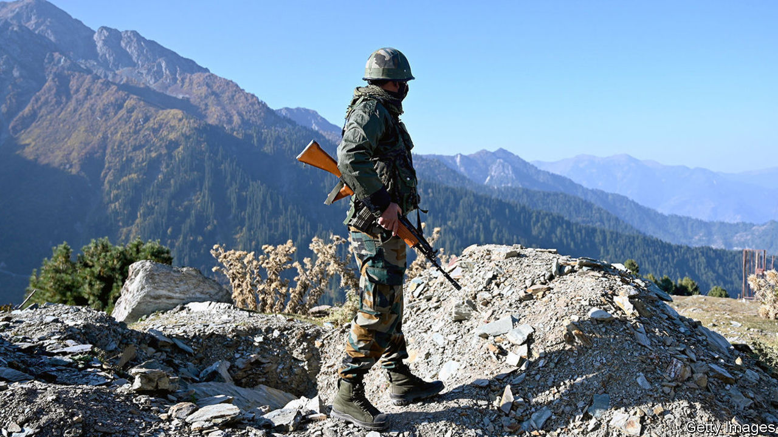

THE “LINE OF CONTROL” (LoC) that wends across the rugged valleys of the former princely state of Jammu & Kashmir is something of a bellwether. It marks the spot Indian and Pakistani forces had reached when they agreed on a ceasefire in their war over Kashmir in 1948. If the two countries are getting on relatively well, the mountains are quiet. Soldiers have even been known to meet on the line to exchange sweets and pleasantries on holidays such as Diwali or Eid. When the two countries met on the cricket field, Ajai Shukla, a retired Indian colonel, reminisced in 2013, “each wicket taken or boundary hit would see intense celebratory gunfire—directed at a nearby, or especially vulnerable, enemy post”. But these days the sweets have gone and the shells are flying in anger.

On November 13th India said that four civilians and five members of the security forces had been killed, and 19 injured, in “unprovoked” Pakistani firing across several parts of the LoC. Pakistan in turn said that five of its civilians and one soldier were killed in an “unprovoked and indiscriminate” Indian attack. Both sides said they had given the other a “befitting reply”. It followed an earlier flare-up in April, when drone footage released by India’s army showed alleged Pakistani ammunition dumps and artillery positions erupting like volcanoes, throwing flaming debris into the cool Himalayan sky.

Though India and Pakistan agreed on an informal ceasefire in 2003, it fell apart a decade later. Since 2018 the number of ceasefire violations recorded by the Indian Army has almost doubled, while Pakistan has documented a 10% jump (the figures differ because violations are defined loosely, including everything from a stray bullet to an artillery barrage). Things have been getting steadily worse: in 2019 the Indian army recorded 3,479 violations; the figure for this year so far is over 3,800.

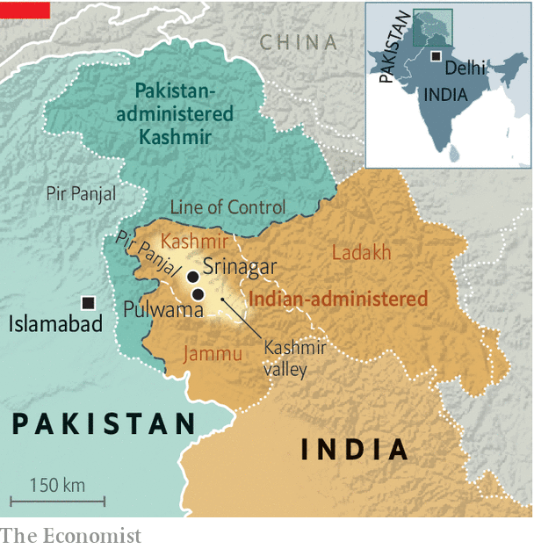

In many respects, the shelling follows a familiar pattern. Former Indian and Pakistani officials acknowledge privately that both sides deliberately target not only army posts, but also villages. That grim contest puts Pakistan at a disadvantage: it has more villages and farmland close to the LoC, and its soldiers are averse to pummelling their co-religionists in the Kashmir valley (they have less compunction about Hindu areas to the south). Pakistan says that 170 civilians have been “martyred” and 918 injured since 2017. But the ritual of strike and counterstrike is also evolving. Last year India began pounding targets north of the Pir Panjal mountain range, where villages are closer together and denser, for the first time in years. It also deployed guided missiles, which can destroy bunkers.

“There is no trigger here,” says Moeed Yusuf, an adviser to Imran Khan, Pakistan’s prime minister. “I can’t see any other reason for this but what is happening internally within India.” Last year India revoked Kashmir’s special status, detained local leaders and restricted phone and internet access. Panchayat (village council) elections are planned on November 28th, with tight limits on campaigning.

But General H.S. Panag, who led India’s Northern Command in 2006-08, says that artillery flurries—“Diwali fireworks”, as he calls them—break out for a jumble of reasons. Indian officials often accuse Pakistan of trying to distract Indian soldiers and thus enable militants to infiltrate. Several alleged infiltrators have been killed in gunfights this month, and on November 23rd India said it had discovered a freshly-dug 150-metre underground tunnel. But Happymon Jacob, author of “Line on Fire”, a book on the LoC, points out that the statistical relationship between infiltration and skirmishing is weak. Shells are as likely to alert troops as distract them, after all.

Another explanation is that cross-border fire is a form of punishment. General D.S. Hooda, another former head of Northern Command, says that the LoC deteriorated in 2013 after Indian troops faced a wave of improvised bombs, sniper attacks and even beheadings. “This led to an immediate spike in cross-border firing,” he says. After a big terrorist attack at Pulwama in the Indian part of Kashmir in 2019, for which a group based in Pakistan claimed responsibility, India grew bolder. “After Pulwama, the general policy was to pound them everywhere,” says General Panag. ■

This article was downloaded by calibre from <https://www.economist.com/asia/2020/11/24/flare-ups-between-india-and-pakistan-in-kashmir-are-getting-fiercer>

|  |  |  |  |
| --- | --- | --- | --- |
| Previous | Articles | Sections | Next |

|  |  |  |  |
| --- | --- | --- | --- |
| Previous | Articles | Sections | Next |

#### Banyan

# Could Australia’s government have handled China better?

The Lucky Country is the object of an unusual amount of bile

Nov 26th 2020 |



IT IS THE oldest move in the Communist Party’s playbook: to lock a country in the doghouse when it has offended the cosmic order. Yet even by China’s standards, the 14 grievances presented to the government of Australia this month are striking in scope and animosity.

The charges include speaking out against Chinese activities in the South China Sea, Xinjiang and Hong Kong; excluding Huawei from 5G telecoms networks; calling for an independent inquiry into the origins of covid-19; passing a law against foreign interference in politics; pressing the state of Victoria to end its involvement in President Xi Jinping’s flagship infrastructure initiative; blaming cyber-attacks on China; and accusing Chinese journalists of being state agents. China also griped about Australia’s hostile media and think-tanks. Make China the enemy, a Chinese official told an Australian broadcaster, and “China will be the enemy”.

The hypocrisy is breathtaking. China severely limits foreign investment, expels foreign journalists, takes innocent people hostage as a diplomatic weapon and routinely interferes in other countries’ politics. As Richard McGregor of the Lowy Institute in Sydney puts it, any provincial boss in China who tried to run a freelance foreign policy in the manner of the Victorian government would never be heard of again.

Meanwhile, China has all but shed any legal pretence for blocking Australian imports. Yet complaining gets Australia nowhere. Coal-carriers are anchored off the Chinese coast, unable to land their cargoes. Australian wine sits stranded on the quay in Hong Kong. For decades Chinese demand has stoked Australian prosperity. In just weeks China has raised obstacles to 13 products which generate over a third of Australia’s total exports to China. Barley, sugar, timber, lobsters and copper ore have all been banned. Wheat is next. Two biggies, iron ore and LNG, have been spared, but presumably only because it is hard to find alternatives quickly.

Could Australia have avoided the doghouse? From cyber-attacks to influencing elections, China poses a threat, and the prime minister, Scott Morrison, insists Australia’s sovereignty is non-negotiable. Yet members of his own Liberal Party as well as the opposition Labor Party think the government’s handling of China has, in the words of Allan Behm of the Australia Institute, been “cack-handed and lacking nuance”. Why, in August, block the Chinese purchase of (Japanese-owned) Lion, a big dairy and drinks company, when the foreign-investment board had already given the nod? And calling alone for a covid-19 inquiry instead of with other countries was inviting Chinese spleen.

Hawkish dynamics within his party are one reason why Mr Morrison has, as Hugh White of the Australian National University puts it, “gone out of his way to poke China in the eye”. One group of MPs, sporting claw-mark stickers on their office windows, calls itself the Wolverines, in homage to trigger-happy American teenagers resisting a Soviet invasion in a cult 1980s film. A member, Senator Eric Abetz, says its anti-China stand is about calling out barbarism: “That’s the Australian ethic—we call a spade a spade.” Yet the antics of members (who include Labor MPs) are “immature, juvenile and destructive”, a foreign-policy expert, Allan Gyngell, recently warned. At one parliamentary hearing Mr Abetz called on Chinese-Australians to denounce the Communist Party.

Still, wariness of China is no longer a fringe activity. In two years the number of Australians who trust China to “act responsibly in the world” has plunged from 52% to 23%, according to the Lowy Institute. In this context, Mr Morrison’s talk of sovereignty, Mr White argues, has a primal appeal: plucky Oz standing up to a bully. But as American power ebbs and Chinese power is in flood, Australians, Mr White contends, “have no conception of how to make [their] way”.

The lack of plan, says John Hewson, a former Liberal leader, is all too evident in the government’s handling of China. The prime minister needs to get out of the fix without appearing to back down. The small businesses suffering from China’s boycott are his party’s natural constituency. The departure of President Donald Trump may help: Mr Morrison got special bile from China for hewing close to him. But the gap he needs to close is wide. Six years ago Mr Xi addressed Parliament in Canberra. Today the Australian government cannot even get a phone call answered. Welcome, China seems to be saying, to the new order.

This article was downloaded by calibre from <https://www.economist.com/asia/2020/11/26/could-australias-government-have-handled-china-better>

|  |  |  |  |
| --- | --- | --- | --- |
| Previous | Articles | Sections | Next |

|  |  |  |
| --- | --- | --- |
| Asia | Sections | Middle East & Africa |

China

China studies: Barriers to Sinology

.

Television entertainment: Loaded questions

.

Chaguan: Patriotism before profit

.

|  |  |  |
| --- | --- | --- |
| Asia | Sections | Middle East & Africa |

|  |  |  |  |
| --- | --- | --- | --- |
|  | Articles | Sections | Next |

#### Barriers to Sinology

# As China’s power waxes, the West’s study of it is waning

Can democracies compete with China without understanding it?

Nov 28th 2020 | HONG KONG

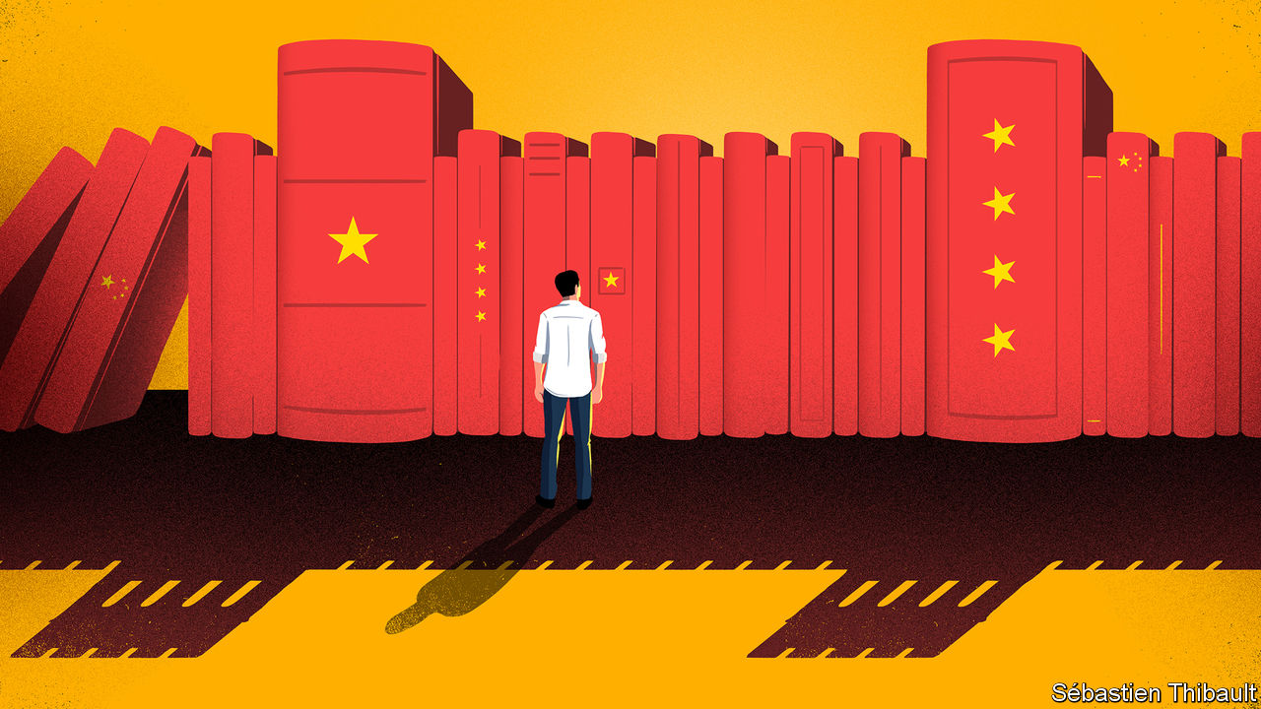

AMERICA’S PRESIDENT-ELECT, Joe Biden, says China is his country’s “biggest competitor”. Yet China’s centrality in the calculations of foreign-policy experts in Washington and throughout the West is hardly matched by the interest shown in academia. Despite China’s efforts to promote interest in the language—and a surge of attention to it in Western schools a few years ago—enthusiasm for China studies at university level remains lacklustre. Fear of China, and restrictions imposed by it, are in part to blame.

In Britain the number of people studying China at university has dipped each year since 2017. Last year it fell by 90 to 1,434, according to the Universities’ China Committee in London, which promotes China studies in Britain. In Australia a survey last year of 16 academics involved in China studies suggested a similar trend. One of the scholars said the number of Australians studying Chinese or China-related topics at university had “obviously decreased” in the past five years. Another lamented a “gradual hollowing out” of China expertise in Australia.

At American universities enrolments in Chinese-language programmes reached 60,000 in 2013. Three years later a follow-up survey found they had fallen by more than 8,000. Students with a serious academic interest in China usually spend time on a campus there. In 2011-12 almost 15,000 Americans did so. By 2018-19 the total number of Americans studying abroad had risen by 20%. But in China their ranks had shrunk by the same proportion, despite an effort by Barack Obama, when he was president, to encourage more American students to go there. This does not bode well for building expertise in a country that is so important to American interests.

There are several reasons why students in the West are lukewarm about focusing attention on China. The first is one that has always plagued this academic field—a high barrier to entry in the form of a language so different from Western tongues, requiring the memorisation of hundreds of characters in order to acquire basic literacy. Those who study Chinese at school often learn only enough to discover just how challenging mastery of the language is.

A related problem is that many native speakers of Mandarin graduate from universities in China and the West with a fluent command of English. In Western businesses, opportunities for work requiring a command of Mandarin may have grown in recent years, but so too has competition for such jobs. People who have grown up in China often have an advantage, not only with language but also in their ability to open doors in China for their employers.

More recently, China’s increasingly repressive political climate has become a powerful deterrent to those mulling the subject. Last year King’s College London tried to set up an undergraduate degree in Chinese language, but abandoned the plan. The faculty found that demand for an existing degree in Japanese was far higher. “People are more attracted to Japan culturally—they like the manga, anime and online games,” says Kerry Brown, the college’s professor of China studies. China’s soft power is weaker. Its censorship of the internet and other media and the polluted air of its cities put students off, academics say.

After Phil Entwistle, a British former academic, finished his PhD in 2015, he was hired by an Irish university to teach a course on relations between China and Europe. He found that many colleagues with non-China specialisms were horrified by his interest in the place. “They asked, ‘Why do you want to study this really awful regime? We don’t want anything to do with China—look at what’s going on there.’” Having lost hope, for the time being, of pursuing any rewarding work on China “given everything that is going on”, Mr Entwistle now works as a headhunter.

For those who stick at it, studying China is getting ever tougher. Minxin Pei of Claremont McKenna College in California calls it “the hardest it has been since the end of the Maoist era”. Gone are the relatively open days of the late 1990s and 2000s. After Xi Jinping took over as China’s leader in 2012, the country began tightening restrictions on work there by Western academics. Archives and databases in China became harder to access; visas and interviews more difficult to arrange.

In 2018 a survey of China-studies scholars in several Western countries as well as Hong Kong found that, in the previous decade, one-third of them had been denied either entry to China or permission to use its archives. Nearly one-tenth said they had been “taken to tea”—a common euphemism for being summoned for a warning by Chinese officials. Many academics tell their PhD students that they may be better off moving to another field because of the risks or the difficulty of doing research in China, says Jean-Pierre Cabestan of Hong Kong Baptist University.

Some scholars now stay away from China because of the risk of being detained there. Their fears have been heightened by the arrests in 2018 of two Canadians—Michael Kovrig, a political analyst, and Michael Spavor, a businessman. The two men’s continuing detention has been interpreted by many Western observers as a sign of growing willingness by China to use flimsy national-security charges against foreigners from countries with which it has quarrels. Academics specialising in sensitive areas such as politics are particularly wary. Iwatani Nobu, a historian of modern China at Hokkaido University, was held for over two months last year on suspicion of spying. According to Japanese media he was accused of buying books in China relating to historical events before the Communist takeover in 1949.

The risks are even greater for China-born academics, who make up a growing share of staff in China-studies departments in the West. Chinese police often treat émigrés as Chinese citizens, regardless of any foreign citizenship they may have acquired. That can mean even harsher treatment should they be arrested. Even in the safety of their campuses abroad, they often keep quiet about topics deemed sensitive by China for fear that Chinese officials will harass their relatives in China or ban them from travelling there.

For Western governments and firms, coping with China is an ever more pressing concern. To respond wisely, they need to understand what makes China tick. If there are not enough Sinologists to guide them, they will surely make mistakes. ■

This article was downloaded by calibre from <https://www.economist.com/china/2020/11/28/as-chinas-power-waxes-the-wests-study-of-it-is-waning>

|  |  |  |  |
| --- | --- | --- | --- |
|  | Articles | Sections | Next |

|  |  |  |  |
| --- | --- | --- | --- |
| Previous | Articles | Sections | Next |

#### Loaded questions

# Officials in China abhor money-worship. A dating show glorifies it

Censors frown on “If You Are The One”, but the programme is wildly popular

Nov 28th 2020 | BEIJING



FEW CHINESE television programmes command as loyal a fan base as “If You Are The One”, a matchmaking show now in its tenth year. In its early days, some 50m viewers tuned in to each episode—an audience second only to the evening news bulletin produced by the state broadcaster. Today “If You Are The One” is the sixth-most-watched show in China. But this modest dip in its domestic ranking has been offset by gains overseas. Broadcasters in Australia and Malaysia have picked it up. Episodes on YouTube attract millions of views around the world.

Each instalment features a male contestant and 24 prospective female dates. The charismatic moderator, Meng Fei, a former news anchor, invites the bachelorettes to grill the bachelor on any topic they like. The main draw of the show lies in their questions, which often focus on the man’s financial standing. In one of the show’s first episodes, a female participant famously quipped that she would rather “cry in a BMW” than smile on the back of her boyfriend’s bicycle. In another one a woman refused to shake a contestant’s hand because he made less than 200,000 yuan ($30,400) a month.

Such unabashed hankering after wealth on a programme watched by legions of young Chinese made the Communist Party feel uneasy. Media regulators promptly ordered the show to stop “showcasing and hyping up money-worship” on pain of cancellation. The ostensible reason was that glorifying gold-diggers contravened the party’s socialist values. Officials, however, may have been concerned about another danger. Chinese men outnumber women, thanks to sex-selective abortion, so many poor males are doomed to remain single. Reminding them that rich blokes have far more romantic options might make them envious—and angry.

These days, female candidates on the programme are no longer allowed to ask male contestants how much they earn or which car they drive. Hobbies from rugby to rap have become the go-to topics of conversation. Yet “wealth fetishism” remains an undercurrent, notes Siyu Chen, a Chinese scholar. The questions are just phrased more diplomatically. Bachelors are probed about their jobs rather than their salaries.

Tactfulness is not always observed. In a recent episode one bachelorette asked whether the man was willing to subsidise her monthly rent of 6,800 yuan. Incidents like this often prompt angry (male) viewers to dig up and publish private information about the “female offender” on Baidu Tieba, a social-media forum which hosts a fan page for the show containing 16m user-generated posts. Many female commentators ridicule these “insecure” men.

Censors reckon the show could try harder to tone down the money motive. Last year the government published an “Outline for the Moral Construction of Citizens in the New Era”. It identifies “money worship” as a cause of “moral failure”. In February regulators hinted that dating shows were not helping. But “If You Are The One” keeps going. Perhaps officials deem that Mr Meng, the host, has done just enough to restrain his contestants’ impulses. Or perhaps the party reckons that crushing the life out of such a popular show could infuriate people. Enraged citizens may be a more unsettling prospect than people lusting for wealth. ■

This article was downloaded by calibre from <https://www.economist.com/china/2020/11/28/officials-in-china-abhor-money-worship-a-dating-show-glorifies-it>

|  |  |  |  |
| --- | --- | --- | --- |
| Previous | Articles | Sections | Next |

|  |  |  |  |
| --- | --- | --- | --- |
| Previous | Articles | Sections | Next |

#### Chaguan

# The first lesson of doing business in China: the state comes first

Chinese entrepreneurs may draw their own conclusions from the tale of Zhang Jian

Nov 28th 2020 |

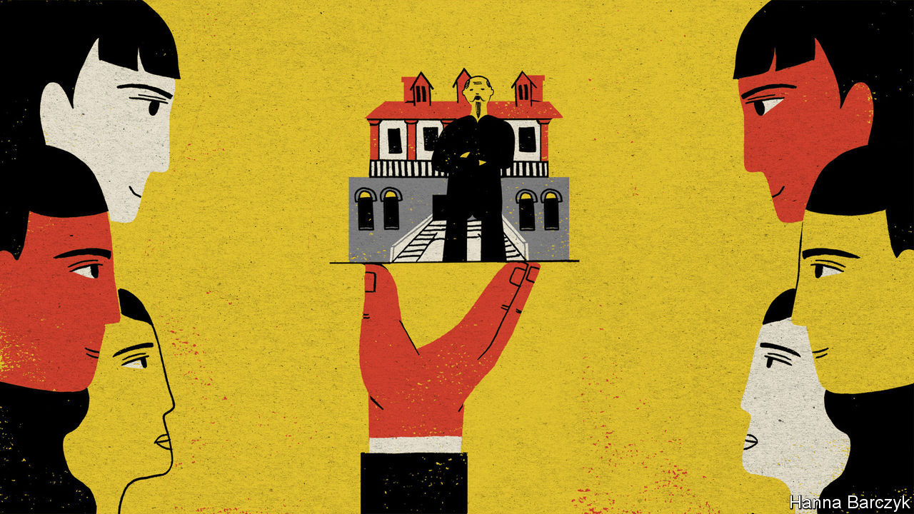

FOUR DECADES after China emerged from Maoist isolation, mystery surrounds some big questions about its rulers’ views of the world. Start with a topical one: what are the true feelings of China’s leader, President Xi Jinping, towards Western-style shareholder capitalism, with its emphasis on free competition, transparency, separation between ownership and management, and oversight by impartial regulators and courts?

Listen to speeches aimed at foreign audiences, and China is an example to the capitalist world. It is presented as a champion of openness and fair play, defending free trade against populist nationalists who have fantasies of turning back the forces of globalisation. Yet at home Mr Xi spends as much time stressing national self-reliance, urging Chinese firms, officials and scientists to end their country’s dependence on foreign technologies.

Fresh confusion was caused when the government abruptly suspended what was expected to be the largest stockmarket flotation in history, early in November. That IPO by Ant, a financial-technology giant, collapsed after its founder, Jack Ma, publicly grumbled about cautious regulators and small-minded banks. In China, many sensed a warning from the government that even billionaires must defer to the party. On November 12th Mr Xi sent another message. He visited the eastern city of Nantong to hail a local industrialist, Zhang Jian, as a patriotic entrepreneur whose life story, from 1853-1926, should be studied by business bosses. Touring the mansion that Zhang called home, Mr Xi praised the scholar-turned-businessman for building a manufacturing empire, as well as founding schools and China’s first museum. When private entrepreneurs get rich they should become wise and socially responsible, Mr Xi said. He instructed that the site become a base for patriotic education.

It is worth listening whenever a secretive regime reveals what it values. On a damp, grey morning this week that hunch took Chaguan to Zhang’s gloomy, allegedly “British-style” mansion in Nantong, to retrace Mr Xi’s steps. Downstairs, he found a delegation of Communist Party members from the Nantong city government. They were filming their own visit for later study. In an antique-filled room upstairs, a local man, Zhang Yuanxin, did not hesitate when asked what lesson he took away from Mr Xi’s praise for patriotic entrepreneurs. A lot of business types think only about money, he explained. Now it is time for them to give back to society.

A retired engineer from a state-owned oil company, Wang Yongjian, gazed at a bronze bust of the mansion’s owner. He noted that Zhang had passed imperial examinations with such distinction that, in another age, he could have served alongside an emperor. But instead, watching China’s agonies in the late 19th century, the scholar-official plunged into business. Mr Wang compared Zhang to British inventors of the first steam engines and to Henry Ford, a pioneering American carmaker.

In reality, Zhang created little that was really new. Instead he imported and copied British looms, Dutch irrigation systems and Japanese salt-making techniques, in a bid to fight off foreign competitors. Revealingly, the exhibition in Nantong does not conceal any of this. Displays trace the entrepreneur’s journey from scholar-official, serene in mandarin’s robes, to indignant nationalist. A diary entry records Zhang’s anger at a treaty, imposed on China after its defeat in the first Sino-Japanese war, which allowed foreign firms to open manufacturing plants in the country. Zhang vows to go into industry himself to save China. Another display shows the steamships that he bought to end the shameful domination of Chinese inland waterways by foreign shipping companies. The dizzying list of businesses founded by Zhang includes cotton mills, steel mills, a bakery, a distillery and a bus company. Institutions he founded include libraries, orphanages, a boy’s school (motto: “Honesty, Loyalty, Independence, Hard Work”) and a school for girls (motto: “Domesticity, Obedience, Thrift, Gentleness”). The exhibition is strikingly incurious about the funding for this empire, beyond faded photographs of supportive officials and images of share certificates. Luckily, Zhang’s conglomerate has been thoroughly studied by historians, among them William Goetzmann and Elisabeth Köll. Their paper in 2005 for the National Bureau of Economic Research, “The History of Corporate Ownership in China: State Patronage, Company Legislation, and the Issue of Control”, describes a cautionary tale.

## Serve the state, and the state will keep competition at bay

Government officials asked Zhang to launch his business in 1895 as a guandu shangban, or government-supervised, merchant-managed enterprise. These firms were modelled on Qing dynasty arrangements by which merchants were granted monopolies, for example in salt-trading, in exchange for collecting taxes and making donations to the emperor to pay for military expeditions or disaster relief. Even after China passed a company law in 1904 and Zhang’s conglomerate became a stockholding firm, he ran it as a paternalist autocrat. His first company meeting, in 1907, saw minority shareholders protest that donations to build schools should come from his own funds, not the firm’s profits. Think of your consciences, Zhang loftily retorted, ignoring them.

Neither fully capitalist nor state-owned, Zhang’s business empire was financed by equity capital but existed to serve the country. That gives Zhang enduring appeal for China’s leaders. Long before Mr Xi praised him, Mao Zedong called him one of four Chinese industrialists who should never be forgotten. Objectively, Zhang was not such a successful capitalist. Having narrowly avoided bankruptcy in 1922, he was removed two years later as the company’s head by a consortium of banks. His first external audit had revealed an opaque mess of transfers and loans to ailing subsidiaries. Today, he is a model patriot. Modern Chinese entrepreneurs may draw their own conclusions. ■

This article was downloaded by calibre from <https://www.economist.com/china/2020/11/28/the-first-lesson-of-doing-business-in-china-the-state-comes-first>

|  |  |  |  |
| --- | --- | --- | --- |
| Previous | Articles | Sections | Next |

|  |  |  |
| --- | --- | --- |
| China | Sections | Europe |

Middle East & Africa

American policy in the Middle East: You’re sanctioned!

.

Israel and Saudi Arabia: The not-so-secret alliance

.

Uganda’s election: Bullets before the ballot

.

Nigeria: It’s all in the script

.

Migration from west Africa: Africa’s do-or-die boat people

.

|  |  |  |
| --- | --- | --- |
| China | Sections | Europe |

|  |  |  |  |
| --- | --- | --- | --- |
|  | Articles | Sections | Next |

#### You’re sanctioned!

# Donald Trump’s sanctions in the Middle East have had little effect

Four years of economic warfare against Iran and its allies have barely changed their behaviour

Nov 28th 2020 | BEIRUT

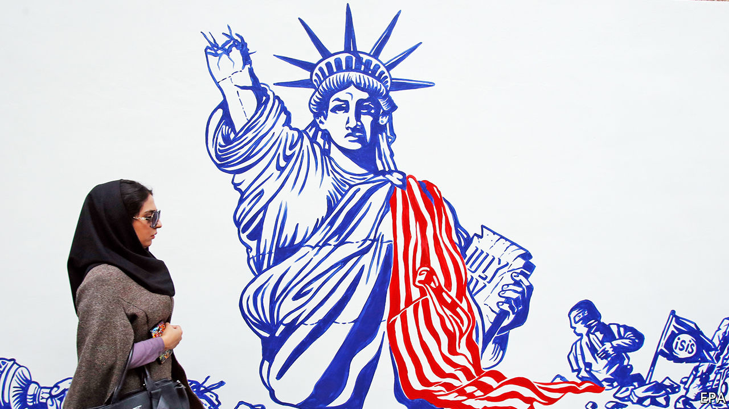

PERHAPS HE SHOULD have done a bit more shopping on his last trip to New York. Last autumn Gebran Bassil, the head of a Christian party in Lebanon, was his country’s foreign minister and aspired to be its next president. On a trip to America in September he visited West Point, a military college, where he decried the corruption that has bankrupted Lebanon. Mr Bassil may be unable to return—because America has blacklisted him for his own alleged corruption.

The sanctions announced on November 6th against Mr Bassil were Donald Trump’s highest-profile move against a Lebanese politician. Yet it is not clear what his administration hoped it would achieve, beyond complicating efforts to form a new Lebanese government in the aftermath of the huge explosion at Beirut’s port in August. Officials have offered contradictory rationales for the move, which illustrates the incoherence in America’s sanctions-heavy foreign policy.

In Mr Trump’s first three years the Treasury Department added an average of 1,070 names a year to its main sanctions list (see chart), compared with 533 under Barack Obama and 435 under George Bush. More than 20% of the 8,600 entries on the list are linked to Iran and the four Arab countries where it wields the most influence: Iraq, Lebanon, Syria and Yemen.

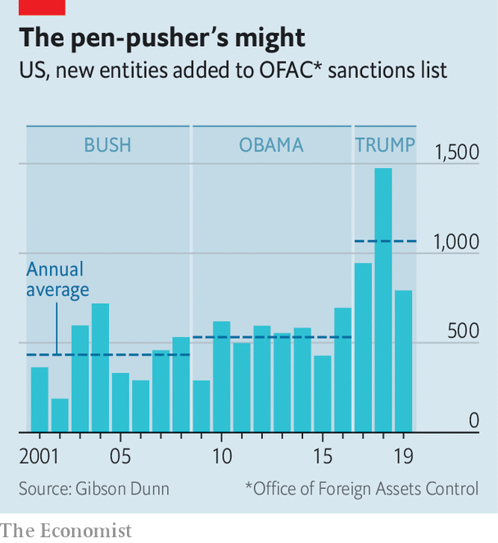

“Maximum pressure”, as Mr Trump calls it, has been a tactical success. In April Iran’s oil exports dipped as low as 70,000 barrels per day, compared with 2.5m two years before. (Exact numbers are elusive because much of Iran’s oil trade is now done in secret.) The rial, Iran’s currency, has lost 85% of its value. Yet economic pain has not brought political change. Sanctions have not compelled Iran to halt its support for militias nor convinced Bashar al-Assad, the Syrian dictator, to stop bombing his people. Sanctions may be an alluring tool for presidents. They are inexpensive, bloodless and largely up to executive discretion. But they often do not work.

Sanctions can be effective when they have broad international support, achievable demands and are targeted at firms and people that need to trade and travel. A multilateral embargo on Iran led to the deal in 2015 that restricted its nuclear programme. Sanctions on Rusal, a Russian aluminium giant, forced a Kremlin-backed oligarch to surrender control of the firm.

Mr Trump’s maximum-pressure campaign, however, fulfils none of these criteria. For a start, many of his sanctions are unilateral, and some have begun to fray. Iran’s oil exports have climbed from their nadir in April, perhaps to as high as 1m barrels a day this autumn, as some countries (particularly China) have defied American threats and snapped up discounted crude.

In its final weeks the administration is debating whether to label the Houthis, an Iranian-backed Shia militia in Yemen, as a terrorist organisation. Such designations are meant to cut off funding. But the Houthis have few legitimate sources of revenue to block, since most of their cash comes from smuggling and extortion in Yemen. Their leaders tend not to buy condos in Miami or invest in Wall Street.

If they would be no more than symbolic for the Houthis, sanctions could have consequences for other Yemenis. Some 80% of the country’s 30m people rely on aid. Since the Houthis control a large swathe of Yemen, aid agencies must deal with them to distribute food and health care. Sanctions would make this harder.

Mr Assad blames sanctions for the lack of progress in rebuilding his shattered country. It is a risible complaint: the main obstacle to foreign investment in Syria is a regime that bombs hospitals and gasses civilians. Still, sanctions undeniably have an effect. To escape the vice, Mr Assad must end attacks on civilians, release prisoners, and hold officials accountable for war crimes. Having won a battlefield victory against rebel groups, though, he is unlikely to agree—particularly to the last demand, which would require him to put members of his own regime in the dock.

Some diplomats argue that this is fine. “You break it, you buy it,” says one, insisting that the West should not help rebuild a country Mr Assad chose to destroy. But this means sanctions are strictly punitive: that economic pain is an end rather than a means. And Mr Trump has been selective about whom he chooses to punish. He refuses to impose legally mandated sanctions on Turkey, for example, because of its purchase of Russian missiles. Nor has he penalised allies with ghastly human-rights records, such as Egypt, which this month detained three prominent activists.

The sanctions on Mr Bassil are instructive. Few Lebanese were upset about the decision. Seen as haughty and entitled—his father-in-law is the president—Mr Bassil was a butt of popular anger during mass protests last year. The American charge sheet against him cites allegations of corruption from his time as energy minister. (He denies them.)

Yet he is hardly the only Lebanese politician accused of graft; looting the state is a policy on which the leaders of most of Lebanon’s factions agree. To date America has gone only after officials linked to Hizbullah, the Shia militia-cum-political party. A top official dismisses talk of imposing sanctions on “our guys”. Dorothy Shea, America’s ambassador to Lebanon, says Mr Bassil offered to “break with Hizbullah, on certain conditions”. The subtext seemed to be that corrupt politicians are only problematic if they pick the wrong partners.

Defenders of Mr Trump’s policy insist that it simply needs more time to work, an argument that is impossible to disprove. Mr Trump leaves office with Iran’s influence undiminished and its nuclear programme accelerated. Sanctions can be a useful foreign-policy tool. But they cannot be the only one. ■

This article was downloaded by calibre from <https://www.economist.com/middle-east-and-africa/2020/11/28/donald-trumps-sanctions-in-the-middle-east-have-had-little-effect>

|  |  |  |  |
| --- | --- | --- | --- |
|  | Articles | Sections | Next |

|  |  |  |  |
| --- | --- | --- | --- |
| Previous | Articles | Sections | Next |

#### A meeting that never took place

# Israel and Saudi Arabia send a clear signal to Iran—and Joe Biden

The meaning of a surprising rendezvous

Nov 23rd 2020 | JERUSALEM

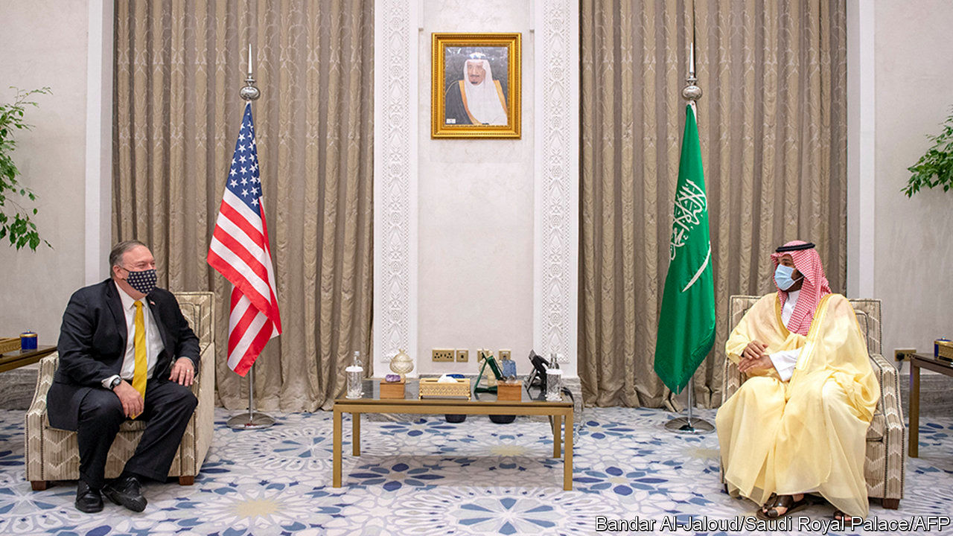

ISRAELI MINISTERS were told at the last moment that a cabinet meeting scheduled for November 22nd had been postponed. Not said was that the prime minister, Binyamin Netanyahu, was making his way to the airport where he was met by the chief of the Mossad spy agency, Yossi Cohen, who also functions as his plenipotentiary to countries with which Israel does not have official relations. As night fell they flew due south, over the Red Sea, to Saudi Arabia.

Sharp-eyed journalists noticed the unusual flight on an online flight-tracking website and quickly put two and two together: Mike Pompeo, America’s secretary of state, was also in the kingdom, meeting Muhammad bin Salman, the powerful crown prince, in Neom, a new high-tech city that the prince is building. Unusually, calls to Mr Netanyahu’s office to confirm reports that all three men had met were not rebuffed with denials. Equally surprising was the lack of action by Israel’s military censors, who in the past had quashed reports of Israeli-Saudi co-operation. One of Mr Netanyahu’s aides snidely tweeted that unlike his defence minister and rival, Benny Gantz, “who is making politics”, Mr Netanyahu “is making peace”. Saudi officials have also confirmed the meeting between Mr Netanyahu and Prince Muhammad, reports the Wall Street Journal.

The two reportedly talked about Iran as well as about establishing diplomatic ties. Yet unlike the United Arab Emirates and Bahrain, which recently “normalised” relations with Israel, Saudi Arabia is not ready to open an embassy in the Jewish state. King Salman bin Abdulaziz has long supported Palestinian demands for an independent state in territories captured by Israel in 1967 and the principles of the Arab Peace Initiative of 2002. This policy, which exhorts members of the Arab League not to establish normal relations with Israel until it withdraws from all occupied territories, is unlikely to change while King Salman is alive. As a sign of the tension within the Saudi royal family over relations with Israel, the Saudi foreign minister belatedly denied that any such meeting had occurred.

And although neither side has offered official confirmation, both seem happy enough that the news has leaked out because of two key messages it sends. The first is a warning to Iran: as it steps up its nuclear activities, the regional alliance against it is becoming bolder. In mid-November the International Atomic Energy Agency said that Iran’s stockpile of low-enriched uranium was 12 times bigger than the limit set by a nuclear accord it agreed to in 2015 (and from which America withdrew in 2018). Israel has in the past threatened to bomb Iran’s nuclear sites if it comes close to building a nuclear weapon.

The second message the meeting sends is to America and the incoming administration of Joe Biden. When Donald Trump took over the presidency, much of his policy in the Middle East seemed focused on unwinding the legacy of his predecessor, Barack Obama, whose administration had struck the nuclear accord with Iran and several other powers. Mr Trump tore up the deal and reimposed economic sanctions that had been lifted under it. His administration has also abandoned a long-standing American policy of acting as an impartial peacemaker between Israel and the Palestinians, saying it would recognise Israel’s annexation of conquered territories. The Trump administration has also delighted Saudi Arabia with its tough stance on Iran and its indulgence of Saudi human-rights abuses, including the murder of Jamal Khashoggi, an exiled journalist.

This may be about to change under Mr Biden, who has called the Saudi regime a “pariah” and threatened to halt arms sales. He has also promised to restart diplomacy with Iran and renegotiate the nuclear deal.

Israel and the Saudis seem to have put the president-elect on notice that they intend to pool their considerable diplomatic and political capital in Washington to oppose major changes in America’s Middle East policy. That is something of an achievement for a meeting that, officially at least, never took place.■

This article was downloaded by calibre from <https://www.economist.com/middle-east-and-africa/2020/11/23/israel-and-saudi-arabia-send-a-clear-signal-to-iran-and-joe-biden>

|  |  |  |  |
| --- | --- | --- | --- |
| Previous | Articles | Sections | Next |

|  |  |  |  |
| --- | --- | --- | --- |
| Previous | Articles | Sections | Next |

#### Bullets before the ballot

# The Ugandan state shoots scores of citizens dead

Unrest erupted after the arrest of Bobi Wine, the leading opposition candidate for president

Nov 28th 2020 | KAMPALA

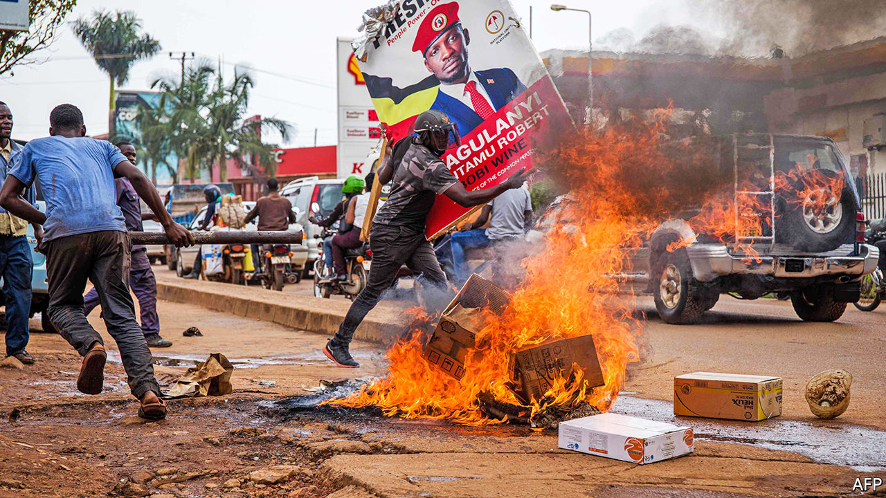

AMOS SSEGAWA was a 15-year-old schoolboy walking past a shop with his mother. John Kittobe was a retired accountant on a trip downtown. Sophie Kusasira was selling food in a market. All were shot dead by Ugandan security forces on November 18th and 19th, along with scores of others, in the worst violence seen in Kampala, the country’s capital, for a decade.

Unrest broke out after the arrest of Bobi Wine, a popstar-turned-politician who is the opposition’s most popular candidate in presidential elections scheduled for January. He draws crowds far larger than the 200-person limit set to contain covid-19. The singer was in Luuka district on November 18th when police bundled him into a van. He was not seen again until a court released him on bail two days later, after he had been charged with “doing an act likely to spread infection of disease”.

In the meantime young men in Kampala and other cities blocked roads with rocks and burning tyres. Police, soldiers and plain-clothes gunmen swarmed onto the streets, firing tear-gas and bullets. The police say that 45 people died in two days of violence, but the number is probably higher. By comparison, the country has registered 191 covid-19 deaths in eight months.

## Firing blind

Supporters of Yoweri Museveni, the president since 1986, were quick to condemn the “hooliganism” of protesters, some of whom smashed car windows, threatened passers-by and attacked police officers. Elly Tumwine, the security minister, declared that “police have a right to shoot you and kill you if you reach a certain level of violence.” But multiple accounts tell of reckless state force. Eyewitnesses say that Mwanje Sudi, a mechanic, was shot dead while sheltering in a yard; a bullet hole can be seen in the gate where he was hiding. Christine Zzawedde, a 58-year-old grandmother, was standing in her back garden when an errant bullet hit her out of the blue. “She was a very humble person, very loving, very accommodating,” says her daughter, in tears.

Ugandans have witnessed such episodes before. In 2009 security forces killed at least 40 people in riots sparked by a dispute over the traditional Buganda kingdom. In 2011 at least nine bystanders were shot dead during protests against inflation and bad governance. Even so, the scale of this month’s protests took the state by surprise. Mr Wine inherits a long tradition of discontent, yet he differs from other leaders: the young people in Kampala’s “ghettos” see him as one of their own.

The battle for the streets matters. Many in the opposition deem it their best hope of gaining power. The protesters have shown they can paralyse the capital for a day or two, but their strategy ultimately relies on the police and army deciding not to shoot.

For the moment, the security agencies are loyal to the president. Their chiefs are too busy bickering with each other to turn on him. The middle classes have not taken to the streets, as they did in Sudan against President Omar al-Bashir. “An officer would rather maim some errant wananchi (ordinary people) and get a slap on the wrist than refuse an order from above,” says Su Muhereza, a political analyst.

The watchful president has concentrated power among those closest to him. His brother, Salim Saleh, a general, acts as an all-purpose fixer. His wife, Janet Museveni, the education minister, has influential networks of her own. His son, Muhoozi Kainerugaba, led an elite army unit until 2017, when he was appointed a presidential adviser; many think he is being groomed for the top job.

Mr Museveni will almost certainly win the election, despite the bloodshed—or perhaps because of it. Maria, a chicken-seller in Kampala, worries that Mr Wine’s supporters are “bringing problems” with “their chaos”: her own cousin is in a cell after being caught with a tyre and a box of matches. Many others fear that Mr Museveni will only leave office violently, so will vote for him in order to have a quiet life. The old soldier promises order, as long as he is in charge. It is the logic of a protection racket. And one day it will break. ■

This article was downloaded by calibre from <https://www.economist.com/middle-east-and-africa/2020/11/28/the-ugandan-state-shoots-scores-of-citizens-dead>

|  |  |  |  |
| --- | --- | --- | --- |
| Previous | Articles | Sections | Next |

|  |  |  |  |
| --- | --- | --- | --- |
| Previous | Articles | Sections | Next |

#### It’s all in the script

# Nigeria argues over the writing on its banknotes

Some say Arabic script smacks unconstitutionally of Islam. Others shrug

Nov 28th 2020 |

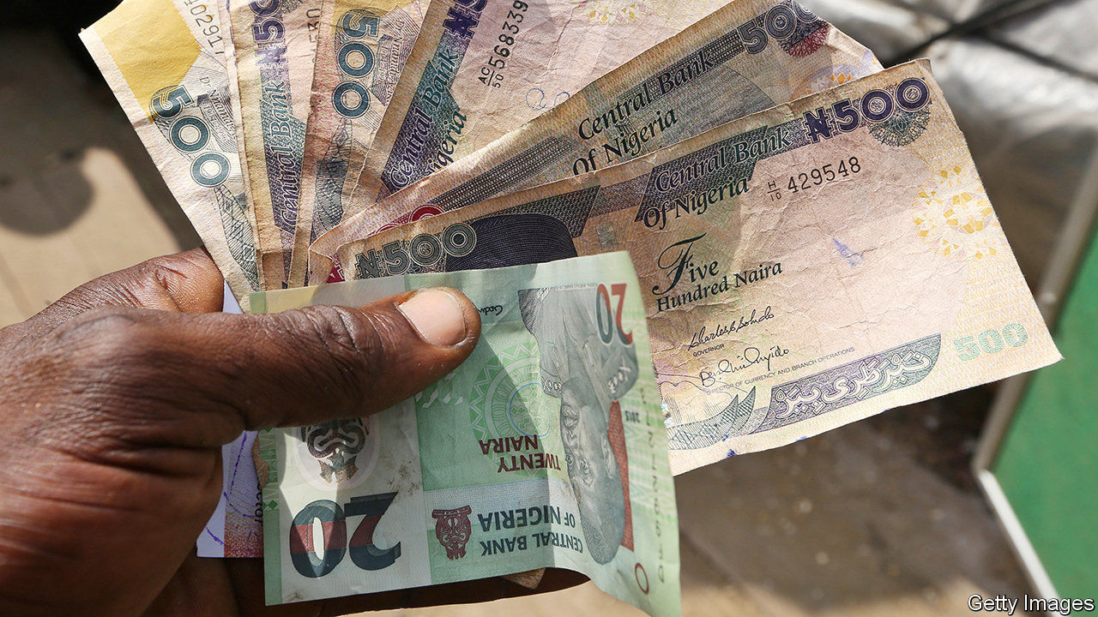

MALCOLM OMIRHOBO is no stranger to the Federal High Court in Lagos, Nigeria’s commercial capital. A human-rights lawyer, he is well-known for filing suits against the government, including one for not releasing his ten-year-old son’s exam results. His latest case has created an especially loud buzz. He is arguing that Arabic script (known as Ajami when used to write non-Arabic languages) on certain Nigerian banknotes violates the country’s secular constitution. He wants it removed. He may also petition the army to delete an invocation in Arabic on its flag.

With perhaps 200m people and 350-plus languages and ethnic groups, Nigeria is a mosaic of cultures. A century ago the British amalgamated the three biggest groups under one administration—Hausa-Fulani in the mainly Muslim north, Yoruba and Igbo in the mainly Christian south—despite each having its own traditions and history. Ethnicity and religion have often clashed, especially in Nigeria’s central area, known as the Middle Belt.

Ajami and other Arab influences have long stirred up arguments over Nigeria’s identity. In the early 2000s a dozen northern states imposed sharia (Islamic law). In 2007 the central bank replaced Ajami with Roman letters on lower-denomination notes of the naira, Nigeria’s currency. It said it was trying to foster national unity by upholding the spirit of the constitution of 1999, which bans the establishment of a state religion and the use of any language in parliament except English, Hausa, Igbo or Yoruba. In 2014 Nigeria’s then president, Goodluck Jonathan, a southerner, did the same with a new 100-naira banknote.

Many northerners were cross. Ajami is a modified Arabic script used for writing Hausa, just as the Roman alphabet is used for English, explains Mustapha Kurfi, an Ajami scholar. For centuries it has been used across Africa for writing Swahili in the east, Mandinka in the west and Yoruba in what is now Nigeria. In northern Nigeria it is used in everyday life. On naira notes it is understood by “the old woman in my village” who cannot read English, explains Aliyu Ibrahim Gebi, a former lawmaker from Bauchi state, in the north-east.

Many Christians, by contrast, fear what they deem to be “Islamisation”. They mutter that President Muhammadu Buhari, a northern Muslim, previously endorsed sharia. Many Christians complain that key cabinet posts are filled by northerners: all 36 states are equally represented in cabinet, but not all posts have equal clout.

Equally, many northerners see southerners as “educated but ignorant”, says a Nigerian-born academic. On both sides, conspiracy theories are rife. Even educated people often believe that Boko Haram, the jihadist group that has ravaged the north-east, has been bankrolled by shadowy elites—northern or southern.

Bad governance makes matters worse. Divisions widen when leadership is weak, says Jacob Olupona, a Nigerian professor at Harvard. “Buhari is not able to manage Nigeria justly,” he says. “This is why things are getting out of hand.” Mistrust of government turns many Nigerians to religious fundamentalism. The rising popularity of Pentecostal churches and of mosques that preach extreme versions of Islam deepens mutual suspicion.

Most Nigerians agree that their country is better together, though many Igbos, whose bid for secession led to a catastrophic war in the late 1960s, may hanker after greater autonomy. “I think the ties that bind us are very strong,” says Ebenezer Obadare of the University of Kansas, the author of “Pentecostal Republic”. Gimba Kakanda, who has also written about ethnicity and religion, argues that national ties still need strengthening: “We need to understand one another, to know each other.” Mr Omirhobo’s case is probably going nowhere. But the argument behind it is far from over. ■

This article was downloaded by calibre from <https://www.economist.com/middle-east-and-africa/2020/11/28/nigeria-argues-over-the-writing-on-its-banknotes>

|  |  |  |  |
| --- | --- | --- | --- |
| Previous | Articles | Sections | Next |

|  |  |  |  |
| --- | --- | --- | --- |
| Previous | Articles | Sections | Next |

#### Africa’s do-or-die boat people

# West Africans are dying trying to reach the Canary Islands

Some mistakenly believe that deaths from covid-19 have created job openings in Europe

Nov 28th 2020 | MBOUR

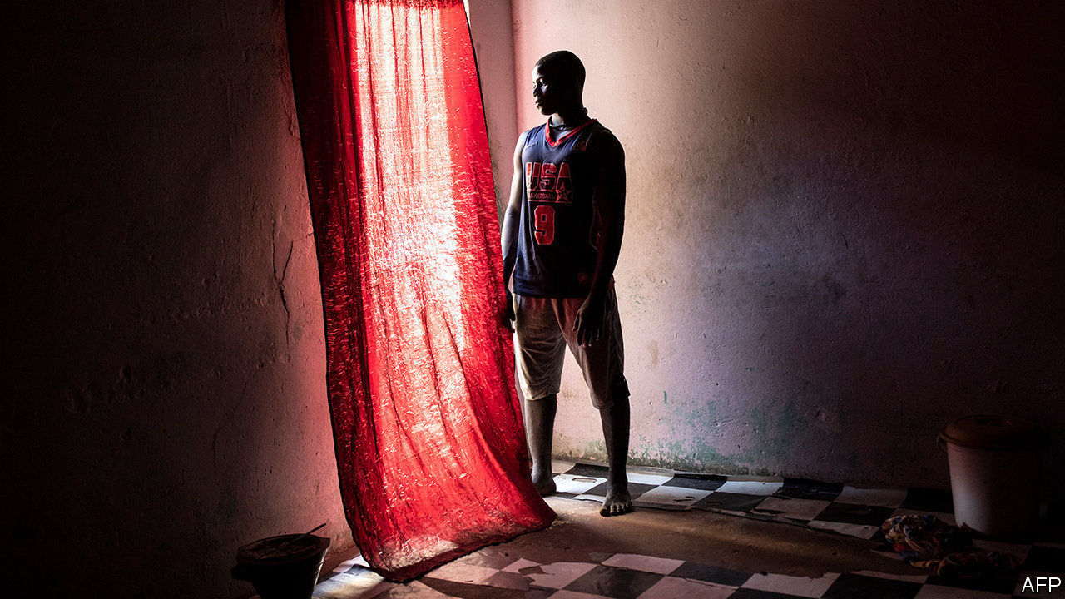

IN THE DEAD of night Abdou Aziz Thiaw and Malick Niang, two brothers, recently squeezed into a battered wooden boat in Mbour, a fishing town in Senegal. Along with some 50 others they hoped to evade police patrol boats and survive the voyage of 1,500km to the Spanish Canary Islands—and, once there, to go on to Europe. Weeks later their mother, Amimarr, got a call. Abdou Aziz had made it. But—her voice falters—Malick died at sea. “No mother in the world wants to see her sons go through that ordeal,” she whispers. “But we must not stop them. There is no alternative.”

This year at least 529 migrants are known to have died trying to reach the Canary Islands from Africa. Almost 400 more, in nine missing boats, are presumed dead. The true total is probably higher still. Migrants are casting off in boats along the whole coast, from Morocco to Guinea (see map). The risk of dying on the Canarian route may be six times higher than making the shorter trip to Europe across the Mediterranean. Despite such danger, more than 18,000 migrants have arrived in the Canary Islands this year, ten times more than in the comparable period last year. About 9,000 have arrived in the past 30 days.

Some are fleeing terror. The United Nations High Commissioner for Refugees (UNHCR) reckons that up to mid-October almost 30% of those crossing were from Mali, a country beset by jihadist violence. In the comparable period last year Malians were only a tenth of the total. People from Guinea and Ivory Coast, both hit recently by election-related violence, account for another 14% of arrivals, says the UNHCR. But since mid-October arrivals from Senegal and Morocco have shot up, too.

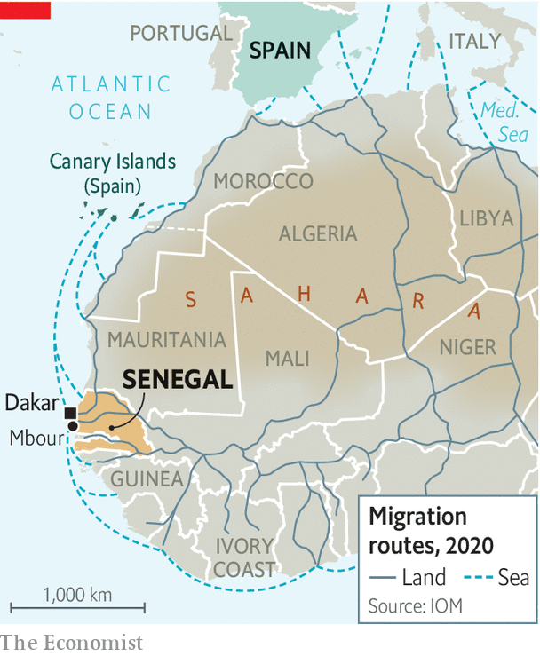

Most Senegalese migrants leave in the hope of finding a job and sending money back home. “Barça ou barzakh,” they tell each other: “Barcelona or death.” Many are fishermen, like Amimarr’s boys. Moussa Sall, a fisherman in Mbour, says that five years ago he could fill two big boxes with the fish he caught in a day. “Today it’s not even certain I will get half a box,” he says.

At least half of west Africa’s main fisheries are overexploited and illegal fishing is widespread. Yet Senegal’s government has renewed a fishing agreement with the EU, which lets 45 powerful European vessels fish for tuna and hake in Senegalese waters. The EU wants Senegal’s fish but not its migrants, says Greenpeace, an environmental NGO.

Covid-19, too, has made things worse for fishermen, many of whom were restricted to working only three days a week. The virus has generally clobbered west African economies, so other jobs are scarcer, too. And some migrants erroneously think that deaths from covid-19 in Europe will have opened new employment opportunities there. Border closures in north Africa and tougher European anti-migration measures along the coast have made the Mediterranean route harder.

In the Canary Islands thousands of migrants have been sleeping on the wharf in the town of Arguineguín. The authorities have put more than 5,000 migrants into hotels and is building a tent city for 6,450 people. The Spanish government has largely refused to have them transferred to the mainland for processing. Some Canarians fear that their islands may be turned into an open-air prison.

To stop the influx, the Spanish government says it is planning to more than double the number of boats and aircraft patrolling the west African coast—and to bump up the rate of repatriation flights, which were halted because of the virus. This month one once again left the Canary Islands for Mauritania. In recent years almost all such flights from the islands were to the country, even though few of the migrants were from it. This is because Spain has an agreement that allows it to send to Mauritania nationals of any country if they are “presumed”—a flexible term—to have passed through it.

## On a road to nowhere

Most of the migrants flown to Mauritania are then promptly bused to the border of Senegal or Mali and dumped there. This may break international law. The UNHCR has urged countries not to send refugees from many parts of Mali back because it is unsafe. In some cases, says Laura Lungarotti of the International Organisation for Migration, migrants who wanted to request asylum in Spain have been deported without being given a chance to do so.

Senegal, by contrast, has received no repatriation flights from the Canaries since 2018, according to Frontex, the EU’s border agency. The migration issue is politically sensitive. The government in Dakar, Senegal’s capital, is nervous about the prospect of boat people being forcibly returned. Protests are mounting in Senegal against the government’s perceived silence about the hundreds who have drowned. Yet European governments are frustrated because only 8% of Senegalese migrants who have been ordered to leave Europe have actually been returned to Senegal. Spanish ministers have recently visited Senegal and Morocco to persuade the governments of those countries to let repatriation flights resume—and to try harder to stop the migrants from setting off in the first place.

That will be hard. Many migrants are still prepared to risk death for a better life in Europe. “I want to leave to earn a living to look after my mama—to show her the love I have for her,” says Beytir, a 31-year-old fisherman in Mbour who has tried the journey twice—and is thinking of trying again. ■

This article was downloaded by calibre from <https://www.economist.com/middle-east-and-africa/2020/11/28/west-africans-are-dying-trying-to-reach-the-canary-islands>

|  |  |  |  |
| --- | --- | --- | --- |
| Previous | Articles | Sections | Next |

|  |  |  |
| --- | --- | --- |
| Middle East & Africa | Sections | Britain |

Europe

The Sweden Democrats: On their way in

.

Swedish gang violence: Segregated cities

.

Sicily and EU cash: No cosying up to Cosa Nostra

.

France and Germany: War of words

.

Poland: Disco populism

.

Charlemagne: Newtonian Europe

.

|  |  |  |
| --- | --- | --- |
| Middle East & Africa | Sections | Britain |

|  |  |  |  |
| --- | --- | --- | --- |
|  | Articles | Sections | Next |

#### On their way in

# How long will Sweden’s nationalists be excluded from power?

The Sweden Democrats’ long-term strategy looks as if it could work

Nov 28th 2020 | STOCKHOLM

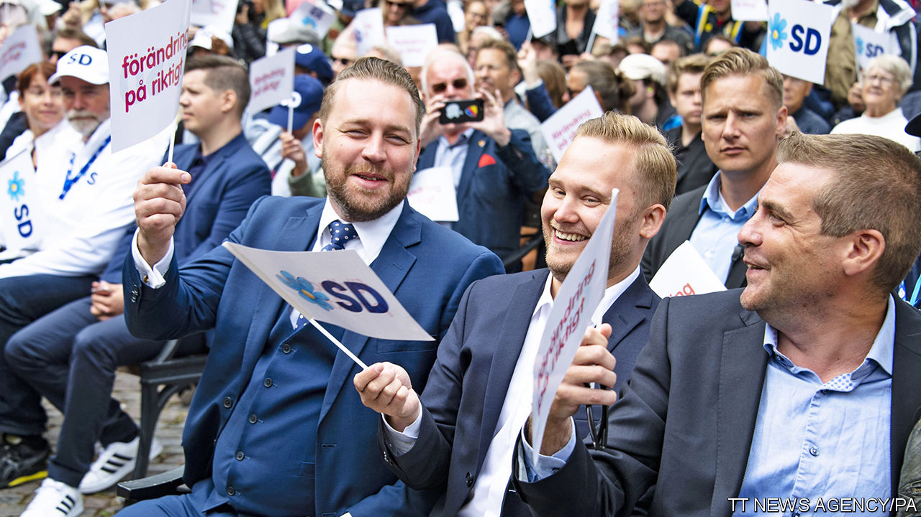

TWO YOUNG men, Andreas Palmlov and Julian Kroon, sit in a bar swapping anecdotes about their native Sweden. The welfare system is so lax that an immigrant drew benefits while serving as the defence minister of Iraq. A lecturer was suspended because students complained that a lesson about fatherhood was heteronormative. And 1m kroner ($116,000) of taxpayers’ cash was lavished on art intended not for human eyes but those of birds and beetles.

Some of the details are disputed. The Iraqi politician, Najah al-Shammari, a Swedish citizen, denies committing benefit fraud. But stories like these help explain why Mr Palmlov and Mr Kroon are members of the Sweden Democrats, a nationalist party. They believe that Sweden is under threat: from immigrants who drain the welfare state, from radicals who undermine traditional values and from an establishment that stigmatises voices of common sense like their own.

Storytelling matters in politics. Voters remember a good yarn more easily than any statistic. And the Sweden Democrats tell a simple, emotive one: that non-European immigrants are ruining Sweden, and a left-wing government is letting them.

In 1988, when it was founded, the party was dismissed as a rabble of neo-Nazis. But since the 1990s it has purged overt racists and cleaned up its image. It gained momentum in 2015 when Sweden opened its doors to refugees, letting in over 160,000 (1.6% of the population), mostly from culturally distant places such as Syria and Afghanistan. The government mishandled the influx, showering the newcomers with handouts but making it hard for them to work. (For example, the de facto minimum wage in shops, hotels and restaurants is nearly 90% of the average wage in those industries, pricing newcomers who are still learning Swedish out of entry-level jobs.) The open-door policy was quickly reversed. But the sight of so many jobless Muslims lent credibility to the Sweden Democrats’ message. At an election in 2018, the party won 17.5% of the vote. To keep it out of power, mainstream parties have had to form unstable coalitions.

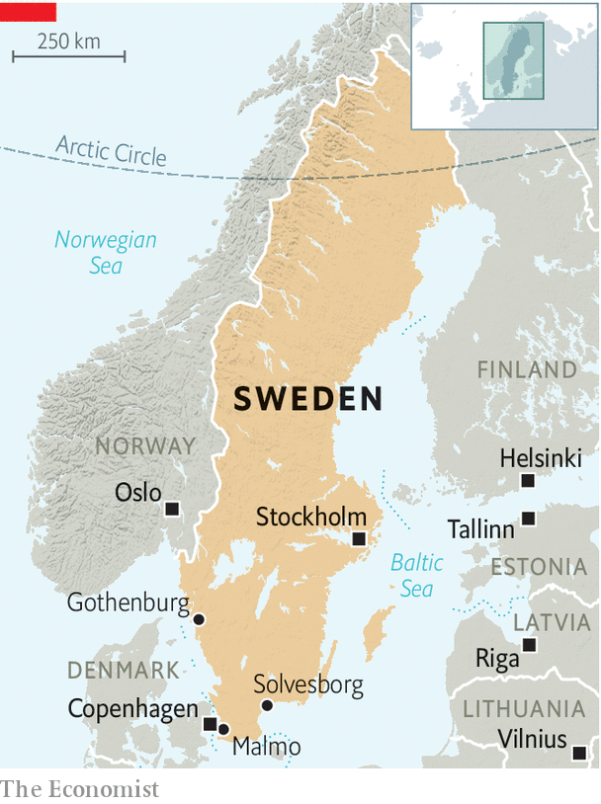

An upsurge in violence between ethnic gangs (see [article](https://www.economist.com/node/21795736)) has given the Sweden Democrats another boost. “The majority society is losing control over areas of Sweden,” says Mattias Karlsson (pictured, with waistcoat), an MP and the party’s unofficial chief ideologue. He wants to hire more police, pay them better and swiftly deport foreign criminals. When an Afghan commits a crime in Sweden, he says, “human-rights people say we can’t guarantee his safety in Afghanistan, so they let him out on the streets again.”

An increase in recorded sex crimes “is to a large extent cultural”, says Mr Karlsson, noting that Sweden took in many refugees from sexist countries. Reality is more complicated. Sweden expanded its definition of rape in 2013, and counts it differently from other countries. If a woman says her boyfriend assaulted her daily for a year, Sweden records 365 offences; other countries might record only one. So the claim, common on alt-right websites, that immigration has made Sweden the “rape capital of the world”, is nonsense.

Still, crime rates among refugees really are higher than among native-born Swedes, partly because so many are jobless. Other parties approach the topic gingerly, for fear of sounding racist. The Sweden Democrats have no such hang-ups. “We say what you think,” is their slogan.

The party is planning for the long term. Its leaders swap notes with American Republicans. Mr Karlsson has set up a think-tank. Mr Kroon runs a fast-growing federation for students. Many are “tired of political correctness”, he says, and need “a new home” outside the “opinion corridor” of socially acceptable (ie, left-liberal) views.

At the national level, centre-right parties have resisted the temptation to cut a deal with the Sweden Democrats, though it would give them a swift path to power. But the taboo is fading. Local politicians have already taken the plunge. The Sweden Democrats enjoy power or a share of it in several towns, especially in the conservative south. Some of their local leaders are risibly incompetent. But others are eager to show that they are not scary and can handle the humdrum tasks of government.

The party’s showcase is Solvesborg, a town of 17,000. The mayor, Louise Erixon, is the ex-partner of the party’s national leader, Jimmie Akesson. She is popular, pro-business and unashamedly populist. She boasts of hiring more security guards, banning begging and barring visits to nursing homes to protect the elderly from covid-19. She favours drug tests in schools, and repatriation for immigrants “who refuse to be a part of [Swedish] society”. She accuses the mainstream parties of weakening “good old Swedish togetherness”. She is thought to have national ambitions.

Ms Erixon came to power thanks to a deal with the centre-right Moderate party, whose national leaders opposed it. But a local one, Emilie Pilthammar, went ahead, for bread-and-butter reasons. Ms Pilthammar says she wanted to bring down a cronyist left-wing administration, boost local business and provide more choice in child care. However she later fell out with Ms Erixon, who she says would give councillors only a few minutes to read key documents before making a decision on them—something she says was bad for democracy. (Ms Erixon denies this.)

Mr Karlsson is “very optimistic” that the Sweden Democrats will gain a share of national power, perhaps after an election in 2022. Nils Karlson (no relation) of Ratio, a research institute, predicts that the centre-right will not join a formal coalition with them but might form a looser arrangement, whereby the Sweden Democrats “consent” to a centre-right government in exchange for policy concessions. “That scares me a lot,” he adds.

Meanwhile, the mainstream parties have all but adopted the Sweden Democrats’ policies on shutting out new refugees. Mattias Karlsson’s suggestion that Sweden does not send Afghans back to Afghanistan would come as news to Jacob (not his real name), who was deported last year. His claim to asylum appeared watertight: he arrived in Sweden as a 14-year-old orphan and a member of a persecuted minority. He had fled Afghanistan after his father disappeared (and was probably murdered by the Taliban). He has studied hard, learned Swedish and stayed out of trouble. He is now back in Kabul taking maths classes. “Yesterday when I was in school, a rocket exploded outside. And again today. It’s hard,” he says. The Swedish family who took him in while he was in Sweden, the Winbergs, have found him a permanent job at a trendy vegetarian restaurant in Stockholm. In theory, he should get a work visa and be allowed to return. But Hans Winberg, an academic, frets that the government is doing everything it can to keep refugees out. “The climate has changed,” he says. “This is painful to me as a Swede.” But many Swedes welcome it. ■

This article was downloaded by calibre from <https://www.economist.com/europe/2020/11/28/how-long-will-swedens-nationalists-be-excluded-from-power>

|  |  |  |  |
| --- | --- | --- | --- |
|  | Articles | Sections | Next |

|  |  |  |  |
| --- | --- | --- | --- |
| Previous | Articles | Sections | Next |

#### Segregated cities

# Why Sweden struggles to curb gang violence

Police are trying to learn from countries with more experience of gang-busting

Nov 28th 2020 | STOCKHOLM

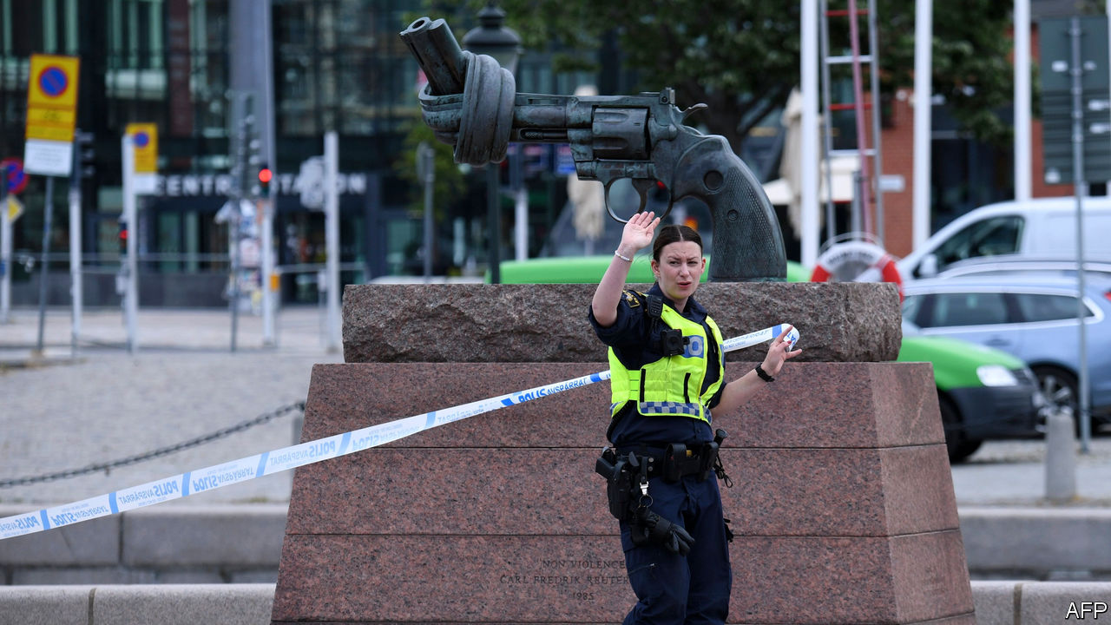

IN AUGUST A criminal clan set up roadblocks in Gothenburg to catch members of a rival gang. The police intervened and made several arrests, but failed to charge anyone. The gang war in Gothenburg eventually ended not because the cops stopped it, but because the gangsters negotiated a truce. Swedes are shocked to see such instances of the forces of law and order losing control of the country’s streets.

Sweden remains exceptionally safe—its murder rate is only a fifth of America’s. But a surge of spectacular gang crimes has captured public attention. This summer two Swedish teenagers were tortured and raped in a cemetery in a so-called humiliation crime. In the first half of this year 20 people, mostly young men, were killed in 163 shootings. A study in 2018 found that a man aged 15 to 29 in Sweden is ten times more likely to get shot than in Germany.

The problem is concentrated in highly segregated immigrant neighbourhoods. In Husby, a suburb of Stockholm, more than 80% of the population are migrants or the children of migrants, most of them from Iraq, Somalia, Syria and Turkey. The scene of ugly riots seven years ago, Husby is officially classified as one of 22 “extremely vulnerable areas” prone to crime and violence. Unemployment in such neighbourhoods is high. Thanks to restrictive labour rules, it is hard for unskilled newcomers to find jobs. Many teenage boys skip school; gangs offer a sense of purpose and belonging.



Around half the street-gang members are foreign-born; 85% have an immigrant background. The gangs are loosely organised, without a strict hierarchy. Their frequent use of extreme violence is a sign of immaturity, says Amir Rostami of Stockholm University. More mature gangs in Germany are less violent, he explains, because it is “bad for business”.

Many native Swedes are calling for tougher policing. So are many immigrants, who suffer most from crime. Sweden has only two cops per 1,000 inhabitants, compared with three in Germany. The government recently decided to hire 6,000 more police and 4,000 in supporting jobs by 2024. Erik Nord, chief of the Gothenburg police, wants 10,000 more officers (and the 4,000 support staff), and more camera surveillance too. The police were only recently allowed to tap criminals’ phones.

Operation Hoarfrost, launched after the fatal shooting of a 15-year-old in November last year, brought in police from across Sweden to crack down on crime in Malmo, a southern city. In recent years the culprit has been arrested in only 20% of gangland murders. The city hopes that more officers and better policing methods will improve this dismal record.

Sweden is also trying to learn from nearby Denmark and Germany. “We want to follow the Danish model,” says Johan Forssell, an MP for the centre-right Moderate party, pointing out that gang members from Stockholm who committed a murder in Denmark were sentenced to 20 years in prison, whereas in Sweden they would have got four years in a social institution because they were under 18.

Police from Sweden went to Essen and Berlin, German cities with high levels of clan criminality, to study local policing. In particular, the Swedes are considering Germany’s tougher gun laws and its methods for confiscating criminal funds. It will take time to reverse the trend, says Mr Rostami, but Sweden is belatedly confronting it. ■

This article was downloaded by calibre from <https://www.economist.com/europe/2020/11/28/why-sweden-struggles-to-curb-gang-violence>

|  |  |  |  |
| --- | --- | --- | --- |
| Previous | Articles | Sections | Next |

|  |  |  |  |
| --- | --- | --- | --- |
| Previous | Articles | Sections | Next |

#### No cosying up to Cosa Nostra

# Sicily is desperate for the EU’s cash

But it needs to get better at arguing for it—and spending it

Nov 28th 2020 | PALERMO

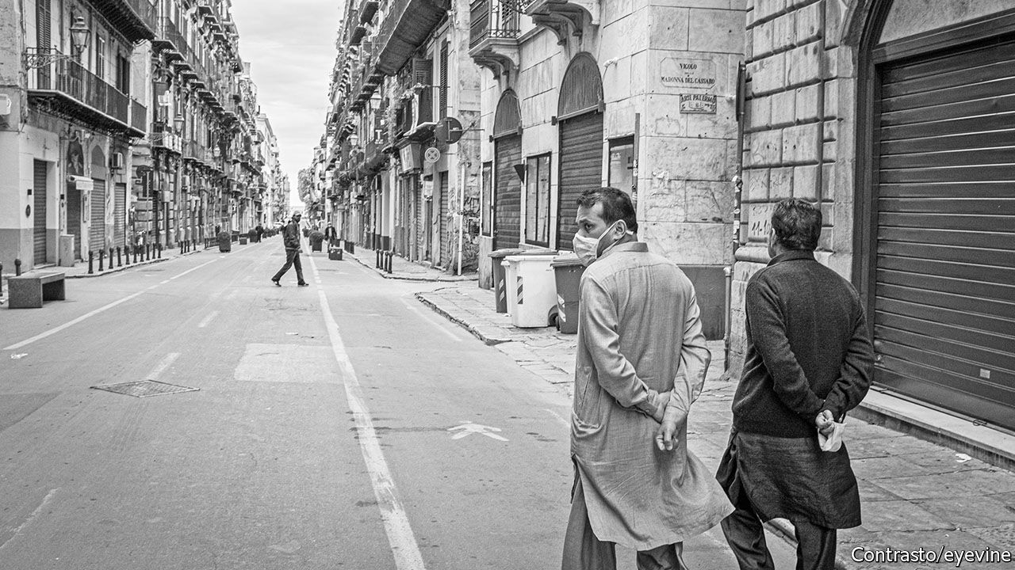

SEBASTIANO (“NELLO”) MUSUMECI, the governor of Sicily, counts off on his fingers some of the many things he says his island lacks: a hub-port to tap into the goods traffic that flows from the Suez Canal into the Mediterranean; an international airport (“Malta, smaller than the smallest Sicilian province, has one,” he notes indignantly); a modern rail system (large stretches of the existing network are either single-track or unelectrified, or both); and a motorway that fully encircles the triangular island (there is a long gap on one side). “Then there is all the social infrastructure we lack,” he goes on. Top of that list is a shortage of nursery schools.

Europe’s efforts to recover from covid-19 focus on poorer regions like Sicily. One of the aims of its €750bn recovery fund, currently blocked by Poland and Hungary (see article) but due to come on stream next year, is to “level up” the EU. The Italian government will soon spell out to the European Commission how it wants to spend its share of the loans and grants on offer—more than a quarter of the total, says the prime minister, Giuseppe Conte. Last month, Sicily’s regional government sent Rome a list of schemes it hopes will qualify for funding. But although the island’s needs are great, the EU scheme may not help to satisfy them.

Most of the projects the regional government wants for the island are large-scale, long-term and designed to fulfil relatively basic requirements. But the conditions attached to the EU’s main recovery fund prioritise schemes that are “smart”, green and can be completed quite fast. Vincenzo Provenzano, who teaches economics at the university of Palermo, worries that the regional government’s aims may be too ambitious and that it ought to focus more on the potential of the EU’s promised Green Deal. “If we want to have immediate effects, we need to work on areas where Sicily has a comparative advantage,” he says. Organic farming, which Sicily has a lot of, is a perfect example.

Other doubts over Sicily’s capacity to benefit from this unique opportunity have a longer history. The island’s bureaucracy is notoriously sluggish. It may struggle to meet the deadlines set for having access to the EU’s funds: 70% of the money has to be committed, with contracts awarded and signed, by the end of 2022, the remaining 30% within the year after. The entire fund has to be spent by the end of 2026. Sicily has in the past found it hard to devise projects suitable for EU funding and then spend the money it has been given.

In any event, a worry persists that EU or state money invested in Sicily will enrich the island’s Mafia, known to affiliates as Cosa Nostra (“Our Thing”). In this respect there are grounds for optimism. Once the beefiest of Italy’s three main organised-crime syndicates, Cosa Nostra has been losing ground since the 1990s to the Camorra, which operates in and around Naples, and to the Calabrian ’Ndrangheta. Since the early 1990s police and prosecutors have relentlessly pursued it. Under Mr Musumeci, a former president of Sicily’s anti-Mafia commission, they have had solid backing from the regional authorities.

One reason Cosa Nostra has retreated from the streets is that it has increasingly concentrated on white-collar crime. As many investigations have shown, it is still able to muscle in on the allocation of contracts and has a special penchant for helping itself to EU financing.

That has prompted the creation of numerous laws and regulations which are intended to thwart the mobsters’ infiltration of the legal economy but which also slow down the approval of public investment projects. Mr Musumeci argues that the precautions have become excessive. He wants the central government to simplify the procedures for being granted the EU’s funds. “We can’t not look to the future,” he says. ■

This article was downloaded by calibre from <https://www.economist.com/europe/2020/11/28/sicily-is-desperate-for-the-eus-cash>

|  |  |  |  |
| --- | --- | --- | --- |
| Previous | Articles | Sections | Next |

|  |  |  |  |
| --- | --- | --- | --- |
| Previous | Articles | Sections | Next |

#### War of words

# The imminent Biden presidency reawakens Europe’s defence debate

And an old row between France and Germany

Nov 28th 2020 | BERLIN AND PARIS

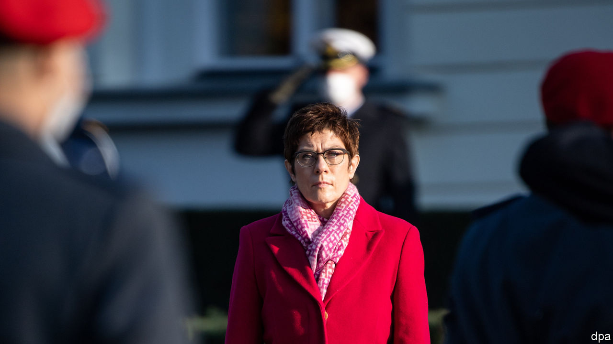

EMMANUEL MACRON does not shy from controversy. But the French president’s recent dig at Annegret Kramp-Karrenbauer, Germany’s defence minister, was sharp. Earlier this month she wrote: “Illusions of European strategic autonomy must come to an end.” Since “strategic autonomy” is a centrepiece of Mr Macron’s European ambitions, he did not hold back. Calling her views a “historical misinterpretation”, he added pointedly: “Fortunately, if I understood things correctly, the chancellor does not share this point of view.”

Franco-German differences are not just normal; they are the basis of the post-war Franco-German link. Usually leaders try to avoid making disagreements personal, and work through them in private. This time, the spat is out in the open. As Europeans prepare for an American presidency under Joe Biden, it has exposed old cracks within the European Union over how far Europe should, or could, do more to defend itself.

Under Donald Trump, Mr Macron edged the European debate in his direction. An American president with undisguised contempt for NATO helped focus European minds, and prompted concerns about the solidity of the American security guarantee. In terms of capacity, European defence does not yet add up to much. An alphabet soup of embryonic security programmes focuses on new co-operation mechanisms, rather than step-changes in Europe’s ability to handle collective defence. Yet France and Germany now agree that Europe must do more. German defence spending, though a smaller share of GDP than in France, has been growing steadily since 2015. A common EU military-strategy document will be concluded under France’s EU presidency in 2022. A new poll finds that 51% of Germans think Europe should grow more independent of America. There is deepening European co-operation in a counter-terrorism operation in the Sahel, albeit with American intelligence backing.

So why do France and Germany appear to be talking past one another? Mr Macron has neither called for America to withdraw from Europe, nor suggested that NATO is “superfluous”, as Ms Kramp-Karrenbauer has hinted. He sees beefing up European defence as a response to a pre-Trump American pivot to Asia, and stresses that it should be “complementary” to NATO. In Germany the deeper divide is not between pro-NATO Atlanticists and pro-Europeans; but between those, like Ms Kramp-Karrenbauer, who encourage difficult domestic conversations about defence spending and military capabilities, and those who would prefer to ignore the subject. If Mr Macron worries that a Biden administration will induce the German establishment back into deep strategic sleep, Ms Kramp-Karrenbauer ought to be among his closest allies in Berlin, not the subject of his barbs.

The difficulty may stem partly from language. Mr Macron uses “European sovereignty” and “strategic autonomy” almost interchangeably, sometimes to cover broader industrial and technological independence. Yet full defence sovereignty means a great deal more than merely Europe’s ability to act autonomously, for example to resolve a limited regional crisis. As Mr Macron pointed out in a speech to the Bundestag in 2018: “In France, ‘sovereignty’ is a common term; in Germany I know it can cause surprise, even fear.” Many Germans also resist Mr Macron’s emphasis on “strategic autonomy”, preferring to talk about the “European pillar of NATO” in order to avoid ambiguity about America’s security role in Europe.

There is also old distrust in Berlin (and elsewhere in the EU) about French intentions. Some officials see in Mr Macron an old-style Gaullist wrapping French interests in a European flag. They suspect him of seeking to undermine NATO and substitute French leadership in Europe for American influence. Others appreciate Mr Macron’s energy but find his unilateralism exhausting—and sometimes counter-productive, as in Libya or the eastern Mediterranean.

Above all, the gulf between the two countries’ defence cultures is just extremely hard to bridge. Defence, says Claudia Major of the German Institute for International and Security Affairs, remains the “problem child”. France has a tradition of military intervention and the use of expeditionary force (and boasts nuclear weapons); Germany’s culture of military restraint is as strong as ever, and politicians struggle to articulate a national strategic interest. Where France instinctively sees threats to Europe’s south, Germans look eastward—and take seriously scepticism towards Mr Macron from eastern Europeans who balk at any hint of weakening transatlantic security ties. The defence minister of Poland has intervened in the spat to say he agrees with the Germans (as has Spain’s prime minister).

If Europeans accept the need to “do more” for their own defence, they have yet to agree on what this means. The idea of partial defence autonomy commands wide and growing support, but not when coupled with the more ambitious and pricey idea of total sovereignty in defence. Instead of a war of words, Europeans must work out what capabilities they need and when, and how to pay for them—no matter who is president in America. ■

This article was downloaded by calibre from <https://www.economist.com/europe/2020/11/28/the-imminent-biden-presidency-reawakens-europes-defence-debate>

|  |  |  |  |
| --- | --- | --- | --- |
| Previous | Articles | Sections | Next |

|  |  |  |  |
| --- | --- | --- | --- |
| Previous | Articles | Sections | Next |

#### Populist Polish pop

# Why Polish politicians fear to sneer at rural music

The ruling party’s supporters adore disco polo

Nov 28th 2020 | WARSAW



“LOVE, LOVE in Zakopane. We’re showering ourselves in champagne. I am the knight, and you, queen of the night.” The balding singer with a stubby moustache and sequined blazer slid across the stage. It was a chilly New Year’s Eve in 2018, but the crowd of 60,000 sang along in the resort town of Zakopane in the foothills of the Tatra mountains. Another 8m Poles watched the public broadcaster’s flagship concert from home, triple the peak viewing figures of its rival television stations.

Disco polo, a musical genre once relegated to country wedding bandstands, has strutted onto the main stage. Created in rural Poland in the late 1980s, it blends folk tunes with drum machines and synthesisers, often with saucy lyrics. “Polka Dot Knickers”, a hit song in 1995, offended many sensibilities. But the genre has bounced back. Almost two-thirds of Poles—and 80% of them in rural areas—say they enjoy it. “Love in Zakopane” has had 226m views on YouTube.

Disco polo bands now perform at venues such as Warsaw’s Palace of Culture and Science and London’s O2 Arena. In September a school in Michalowo, in eastern Poland, launched the country’s first class aimed at making a career in disco polo. This year’s inaugural class of 27 highschoolers is coached in singing and dancing, and learns the technicalities of sound systems. The minister of education at the time commended it: “Maybe it’ll catch on.” The town is building a disco-polo museum.

Polish politicians have long sucked up to disco-polo fans. Back in the presidential campaign of 1995, the two frontrunners were both backed by disco-polo artists. But the patronage afforded to musicians under the ruling Law and Justice party is quite new. Earlier this year TVP, Poland’s public broadcaster, released a hagiography of the disco-polo doyen, Zenek Martyniuk. After singing along at one of his concerts, the station’s boss, a Law and Justice politician, said it was time to end “the hypocrisy and pretence that this is an inferior genre”.

The ruling party has good reason to indulge disco polo’s enthusiasts—they are its core supporters. In last year’s parliamentary elections it got roughly twice the vote-share in rural regions, the heartland of the simple tunes, as it did in big cities. TVP has denounced any politicians or cultural gurus who sneer at disco polo as out of touch with “ordinary” Poles. After its record-breaking viewing figures for the New Year’s Eve concert in 2019 starring Mr Martyniuk, the station ran a gloating segment: “The pseudo-elites are jealous.”

This article was downloaded by calibre from <https://www.economist.com/europe/2020/11/28/why-polish-politicians-fear-to-sneer-at-rural-music>

|  |  |  |  |
| --- | --- | --- | --- |
| Previous | Articles | Sections | Next |

|  |  |  |  |
| --- | --- | --- | --- |
| Previous | Articles | Sections | Next |

#### Charlemagne

# Poland and Hungary enjoy a physics lesson courtesy of the EU

Newton’s laws apply to politics, too

Nov 26th 2020 |

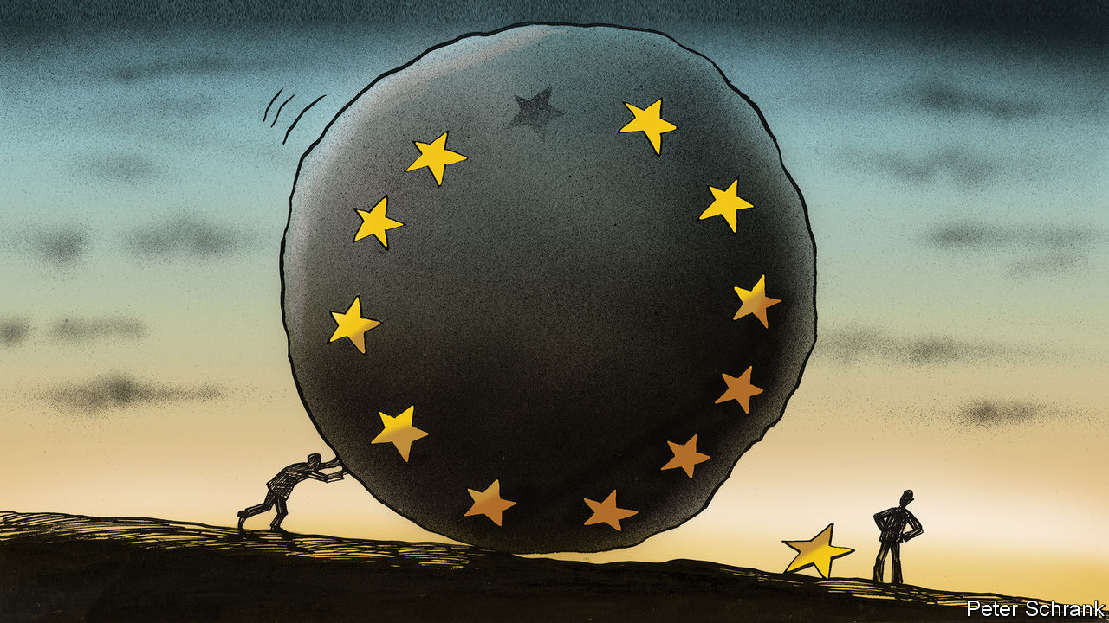

INERTIA IS ISAAC NEWTON’S first law of motion. “Every body perseveres in its state of rest, or of uniform motion in a right line unless it is compelled to change that state by forces impressed thereon,” wrote Newton in 1687. It is the first law of the EU, too: things stay as they are, until a big enough force shoves them to change. The covid-19 pandemic and the ensuing recession gave the bloc an almighty push. Over the summer EU leaders agreed to issue collective debt at scale for the first time, to the tune of €750bn ($890bn). After five days of talks, all 27 heads of government agreed that anyone spending EU money would have to abide by some form of “rule of law” stipulations.

Hungary and Poland are learning the hard way about introductory physics: once things get going, they are hard to stop. The two countries have belatedly teamed up to try and scupper the scheme, arguing that the rule-of-law mechanism goes too far. They have reason to fear a crackdown. Both governments have trampled on democratic norms in recent years, nobbling judges, thwarting journalists and using the state to hobble rivals. There is little Hungary and Poland can do to stop the new rules coming in, since they can be approved by a qualified majority. Instead, they have vetoed other policies. Both have refused to sign off the EU’s budget, which is worth about €1trn of spending over seven years, and withheld permission for the EU to push on with disbursing the €750bn recovery fund, until the rule-of-law scheme is watered down.

Leverage is the stuff of politics as well as physics. At first glance, holding €1.8trn of funding hostage seems a strong lever to pull. Economies in southern Europe are gasping for the cash. But it is a kamikaze attack. EU funds to Hungary and Poland were worth 4.5% and 3% of those countries’ GDP respectively in 2019. It is their own economies they are most in danger of damaging for the sake of a law they cannot stop from being introduced. Some are interpreting the move as a warning shot. If Hungary and Poland are trampled over, a bureaucratic dirty war will commence, with both countries blocking everything they can.

But Newton’s third law also has a role in EU politics: every action has an equal and opposite reaction. Other countries have vetoes over the budget process. Some like the Netherlands, which has a reputation for being a stickler for rules, could block the process if any compromise goes too far. The rule-of-law legislation is narrowly defined. Some countries wanted a far more wide-ranging tool, which would hit governments in their wallets if they trampled on the rights of minorities or gay people.

A nuclear option being discussed in a stage whisper by diplomats (and bellowed by MEPs) would involve other countries simply bypassing the two countries and issuing the debt without them. This would banish Hungary and Poland to an outer circle of the continent. Such strategies have been used before. David Cameron, then the British prime minister, found himself outwitted in 2011 when he refused to sign off on a treaty change without regulatory guarantees for the City of London. His fellow leaders went around him. Mr Cameron’s failure offers a lesson in how not to deal with Brussels, which Warsaw and Budapest would do well to heed if they want to guarantee their place in the bloc. Oddly enough, voters in both countries are strongly Europhile, despite electing governments that enjoy fighting EU institutions.

Once the EU’s rule-of-law tool has come into force, inertia may become the friend of Hungary and Poland, rather than their foe. Any punishment for trampling on the rule of law would have to be approved by a qualified majority of member states. On paper, this improves on the current system. At the moment, a country can be fined and/or stripped of its voting rights for violating the rule of law only if all 26 other governments agree. Since Hungary and Poland have each other’s backs, such a move is impossible. In practice, the new measures may still struggle to be invoked. Hungary and Poland are far from the only countries nervous about EU budget payments being linked to good behaviour. Corruption allegations swirl in Bulgaria. High-profile murders of investigative journalists in Malta and Slovakia have shaken both countries in recent years. Cyprus sells passports. Croatian authorities are accused of beating up refugees at the border. It is not just a case of honour among thieves. EU leaders are reluctant to interfere in the domestic affairs of others for the simple reason that they fear they could be next. In such circumstances, abstention is appealing.

Unlike rules of physics, rules of politics can be bent. The danger is that the new mechanism will become another Stability and Growth Pact, the bloc’s oft-maligned but usually ignored rules on government spending. According to the pact, EU countries are expected to keep their deficits below 3% of GDP in any given year and their debts below 60% of GDP. Even in good times, these targets were missed, but consequences were few. Technically countries could be fined. None ever was. To critics, the rule-of-law mechanism is a very European compromise: strict rules (to placate supporters) which are never enforced (to placate opponents).

## Errors are not in the art but in the artificers

Procedures for reining in misbehaving member states will do little if no one has the guts to use them. Fundamentally, dealing with rogue EU governments is a question of political courage. Big countries, such as Germany, have allowed political alliances to trump principles. Over the past decade, the Hungarian prime minister, Viktor Orban, has reshaped the Hungarian state from within the comfort of the European People’s Party, in which Angela Merkel’s Christian Democrats also sit. Belated action on Poland—a far more important country for the future of Europe—came only after its government had already stacked its constitutional court. The bloc’s failure to act has had consequences. Other countries are sliding in a similar direction and will not stop unless some force impresses thereon. Inertia, after all, is a mighty thing. ■

This article was downloaded by calibre from <https://www.economist.com/europe/2020/11/26/poland-and-hungary-enjoy-a-physics-lesson-courtesy-of-the-eu>

|  |  |  |  |
| --- | --- | --- | --- |
| Previous | Articles | Sections | Next |

|  |  |  |
| --- | --- | --- |
| Europe | Sections | International |

Britain

Public spending: A combustible mix

.

Potholes: Revolutionary roads

.

Covid-19 vaccines: Emergency exit

.

Farming after Brexit: Fresh fields and pastures new

.

Bagehot: Sunak’s secret self

.

|  |  |  |
| --- | --- | --- |
| Europe | Sections | International |

|  |  |  |  |
| --- | --- | --- | --- |
|  | Articles | Sections | Next |

#### Public spending

# The spending review reveals the strains on the Tory party

What covid-19 and Boris Johnson’s promises are doing to the public finances

Nov 28th 2020 |

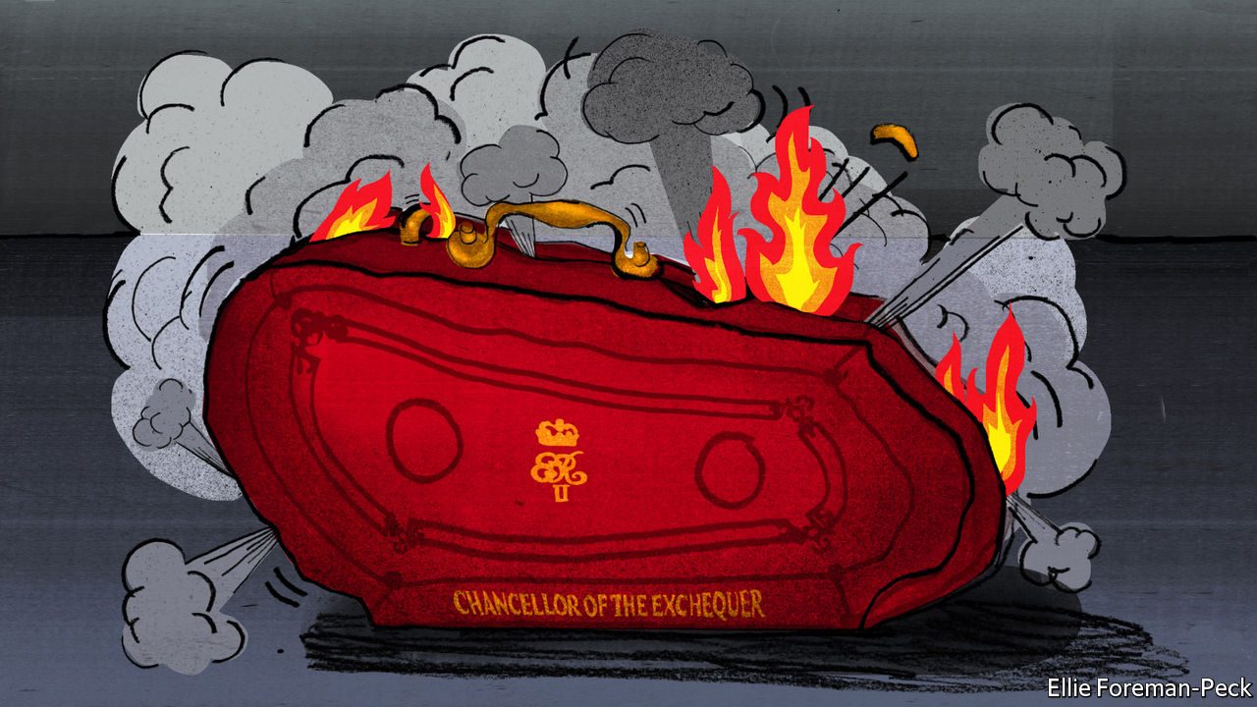

RICHARD HOLDEN is proving expensive. In the election last December, he became the first Conservative to represent the seat of North West Durham, a sprawling constituency of farms and former mining towns, since it was created in 1950. Since then he has been promised a new hospital, and in March won a tax-cut for motorhomes which will benefit the local camper-van factory and cost the exchequer £25m a year over five years. In the spending review on November 25th, the government said it would conduct a study into replacing a railway which was shut in 1963. Mr Holden is also eyeing government funds for a new bus network, some new footpaths and cycle ways, better broadband and a new leisure centre.

Boris Johnson is keen to please Mr Holden, for his seat is one of the so-called “red wall” formerly Labour constituencies in northern England, the Midlands and Wales that flipped blue in the general election. If people there are to stick with the Tories they will need to see their area changing, says Mr Holden. “I want to be able to go to the next election and say we’ve delivered this, we’ve had progress on this, and this is in the pipeline. It’s the fling versus the marriage question—we have to show real commitment to our towns and villages.”

The manifesto on which Mr Johnson won was written in sunnier times. It bound together a wide Conservative coalition with the glue of low borrowing costs and benign economic conditions. It promised to “level up” the gap between southern England and seats such as Mr Holden’s with a flood of spending on roads and railways, hospitals and green energy. Yet this would be done without hiking payroll taxes and VAT—a red line for Mr Johnson’s existing stock of southern Tories—and while cutting the national debt. Britain’s commitment to spend 0.7% of GDP on foreign aid would stay, despite its unpopularity with Tory activists, to keep the party’s dwindling liberal wing happy.

Covid-19 will force Mr Johnson to break some of those promises, and strain his coalition. That became clear in the spending review Rishi Sunak, the chancellor of the exchequer, announced on November 25th. The economy, he said, would shrink by 11.3%—the biggest contraction in 300 years. The spending plans reflect both the demands that the emergency has placed on the public sector (see chart 1) and the government’s political priorities.

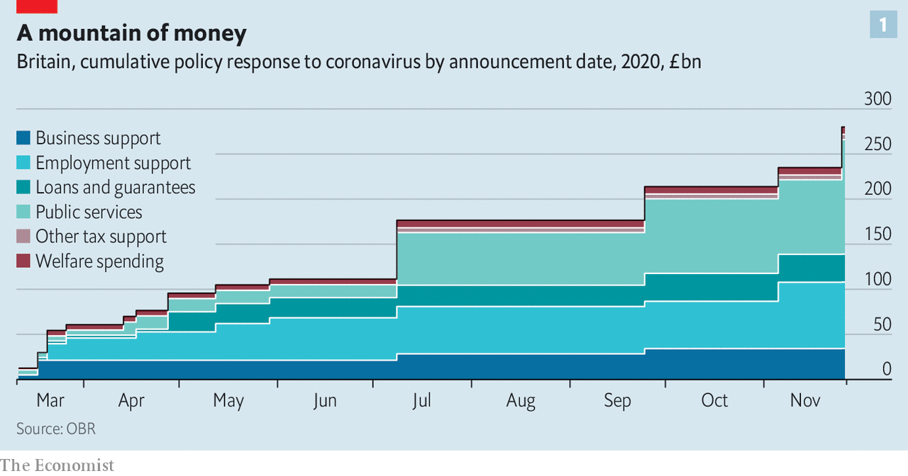

A lot of money is being spent on keeping MPs such as Mr Holden happy. The government knows that the Labour Party cannot return to power without winning back their seats. Those MPs are relentless lobbyists, organised around a caucus known as the Northern Research Group. Partly in order to pay for their shopping lists, public sector net investment will hover just below 3% of GDP in the years after the crisis, higher than in all but two years since the 1970s.

The bit of the coalition that was thrown overboard this week was the shrinking band of liberals. They were outraged when Mr Sunak said he would, after all, abandon Britain’s foreign-aid commitment. David Cameron, the former prime minister who enshrined that commitment in law, had embraced development as part of a “compassionate conservatism” agenda. Liz Sugg, a development minister and former aide to Mr Cameron, quit.

How much further the coalition is strained depends largely on the prospects for recovery. They are highly uncertain. In its forecasts accompanying the review the Office for Budget Responsibility, a fiscal watchdog, set out three scenarios in which the economy regains its pre-pandemic size at the end of 2021, 2022 and 2024 respectively, depending on the path of the virus and the success of the vaccine. So severe and strange has the shock to the economy been that “there is no reasonable basis for forming a view on the likelihood of any particular outcome,” it warned.

The public finances are equally hard to predict, with projected budget deficits in 2025-26 ranging from 1.7% to 6.1% of GDP (see chart 2). And that is without taking into account the possible effect of completing the transition out of the European Union in January. A “no deal” exit would worsen those forecasts. The range of possible paths for the economy next year is simply enormous.

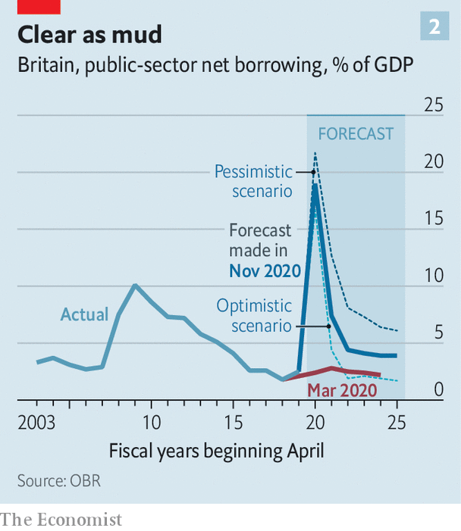

Mr Sunak warned that fiscal consolidation may eventually be necessary. He tightened the spigots only slightly, but those measures hint at rows to come. Public-sector workers, other than those in the National Health Service and the lowest paid, will see their pay frozen for a year—meaning a real-terms cut once inflation is taken into account. Local authorities will get less from the government in grants, making them more reliant on council-tax revenue, which will be toughest for poor areas. That risks leaving Mr Johnson vulnerable to the charge of a return to austerity in his new, working-class seats. A £20-a-week increase in unemployment benefits put in place during the pandemic will be reviewed in the new year.

Beyond that lie harder choices, which will upset other bits of the coalition. Its southern MPs in particular are allergic to tax rises, and are mobilising to warn Mr Sunak against touching taxes on profits, capital gains or pensions. David Davis, a former Brexit secretary, has urged him to fuse the doctrines of Reagan and Roosevelt: steep tax cuts and big spending on infrastructure, funded by cheap borrowing.

The government can take confidence from the fact that, despite massive borrowing, which will reach a peacetime record of 19% of GDP this year, low interest rates mean that the cost of servicing its debt will fall this year. Yet despite the appetite for spending in its new seats, the Conservative Party does not like borrowing. The party’s foot-soldiers view the public purse like a household’s finances, while MPs worry that the public finances are vulnerable if interest rates do rise.

There are sound tactical reasons for taking this view, too. The Tories have kept the Labour Party out of office for a decade by maintaining that only they can control public spending. If voters come to believe that governments can borrow without limits, Mr Sunak warns MPs, there is no reason for them not to vote Labour. Even red-wallers like Mr Holden see the case for prudence. “The worst thing we could possibly do is make irresponsible promises to people, which we can never deliver on,” he says. Uniting a disparate coalition of old and new Tories was possible in good times. After covid-19, a government forced to choose between spending, taxes and debt will find it much harder. ■

This article was downloaded by calibre from <https://www.economist.com/britain/2020/11/28/the-spending-review-reveals-the-strains-on-the-tory-party>

|  |  |  |  |
| --- | --- | --- | --- |
|  | Articles | Sections | Next |

|  |  |  |  |
| --- | --- | --- | --- |
| Previous | Articles | Sections | Next |

#### Potholes

# Britain’s big pothole problem

Politics, the pandemic and innovation may mitigate it

Nov 28th 2020 |

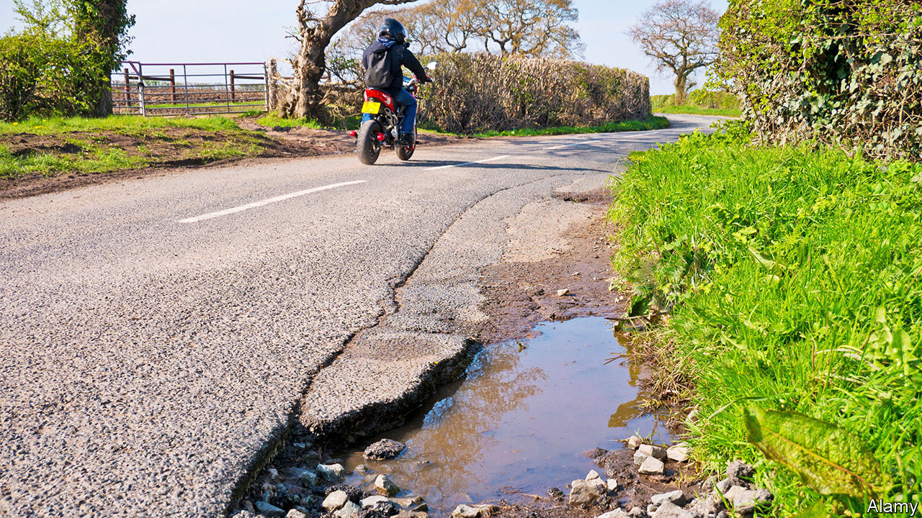

LAST DECEMBER, councillors Bob Smytherman and Martin McCabe threw a birthday party—not for a friend, a relation or a celebrity, but for a pothole. Cars in Worthing, West Sussex, had been bumping over it for a full two years, despite pleas that it be mended. The stunt worked. The following day it was filled in, and a second party—a lavish affair, with cake and candles—marked its demise. But plenty of its fellows survive. Mr Smytherman says the town has so many craters, it’s like “walking on the moon”.

Potholes arouse passions in Britain—not surprisingly, since the country’s road quality ranks 37th in the world, between Slovenia and Lithuania. Councils received 700,000 complaints about potholes last year, says the Federation of Small Businesses. The weather, a topic even more popular among the natives than potholes, is mostly to blame. Potholes form when water seeps under the road surface, breaking the tarmac as it expands and contracts. Budget cuts in the wake of the financial crisis did not help. The Local Government Association (LGA) says road maintenance budgets fell from £1.1bn in 2009 to £701m in 2017—the equivalent of 8m potholes. The Asphalt Industry Alliance claims there is a road-repair backlog of £11bn.

But there may be relief in sight for the suspension of the British motor car. Politics is one reason. Traditional Tories—who love cars, particularly fast ones, and tend to live in the countryside, so rely on roads—are particularly infuriated by them. Northern “red wall” seats that the Tories won from Labour in the last election tend to be rural places where the roads are bumpier and the weather worse. Nottinghamshire, home to several of those contested seats, is Britain’s pothole capital, with 253,920 reported in 2017-19. Hence the promise in the Tory manifesto of the “biggest-ever pothole-filling programme”, and a promise of £2.5bn over five years.

Covid is also fuelling the drive against potholes. Rishi Sunak, the chancellor, needs shovel-ready spending opportunities to justify his claim in the spending review on November 25th that “we’re prioritising jobs”. Potholes are ready and waiting for those shovels—hence his commitment that £1.7bn would be spent this year.

Innovation should help get the job done. Rubberised asphalt is spreading across the nation’s roads. Adding shredded tyres to the bitumen used to make asphalt creates an elasticity that helps it mould into the existing road and stops it breaking down as easily. Tarmac, a materials company, is supplying it to several councils. Sheffield council is trying out a simpler version, designed by another company, Roadmender Asphalt. Cumbria is experimenting with recycled plastic as a bitumen substitute, and in Oxfordshire and Kent “Gipave”, a material made from adding a graphene-based additive to asphalt, is being used to resurface entire roads. It is 15-20% more expensive than asphalt but has twice the lifespan.

Repair design may help, too. Potholes are normally repaired by cutting squares out of the asphalt around them, but corners encourage water ingress, so Roadmole, a small road-repairing firm, produces a remotely controlled machine that cuts circular holes instead. The firm claims that none of the potholes they have fixed in the past eight years has needed to be redone.

In order to innovate, councils need cash. David Renard, the LGA’s transport spokesman, says the government’s bung will help fix the backlog. But the supply of candidates for repair never dries up. Back in Worthing, Mr Smytherman says that his celebrated pothole is beginning to reappear. Another party looms.■

This article was downloaded by calibre from <https://www.economist.com/britain/2020/11/28/britains-big-pothole-problem>

|  |  |  |  |
| --- | --- | --- | --- |
| Previous | Articles | Sections | Next |

|  |  |  |  |
| --- | --- | --- | --- |
| Previous | Articles | Sections | Next |

#### Emergency exit

# Britain’s vaccine roll-out takes shape

There is reason to hope it will go better than the state’s pandemic management

Nov 28th 2020 |

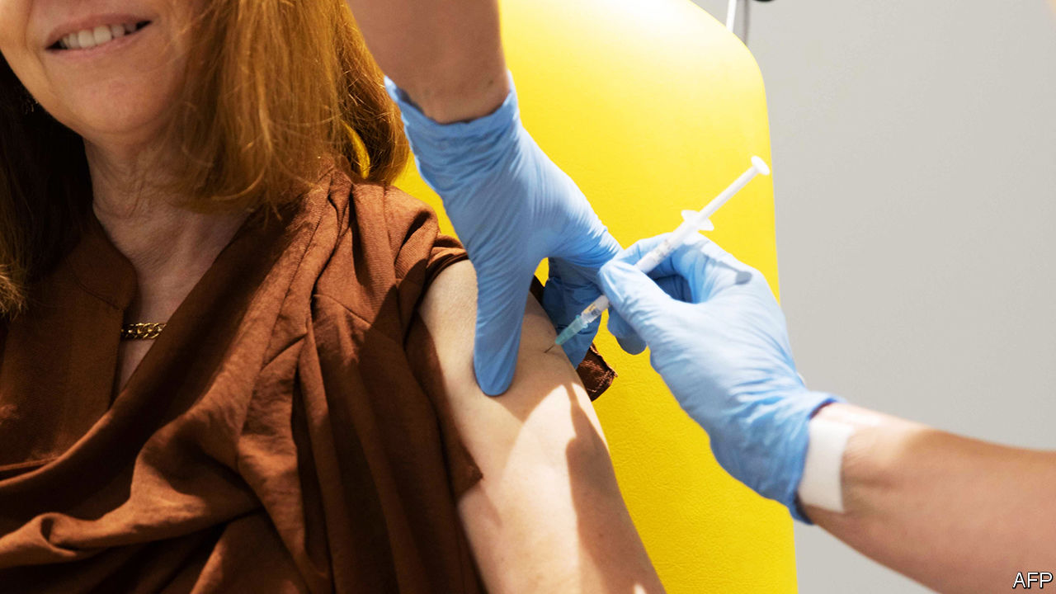

LOTS OF SPACE and vinyl flooring—that is what local directors of public health want. “The last time you went into an NHS appointment...the floor would have been a certain type of splash-proof vinyl in case you bled all over it or threw up,” says one. It is the sort of floor a mass vaccination centre requires.

The search for suitable venues has just become more urgent. On November 23rd the Oxford/AstraZeneca vaccine team announced positive results (though there are some concerns about the data—see article). A cheap, transportable vaccine would be good news for the world. It would also be good news for Britain, and not just because it would be the product of a British university and an Anglo-Swedish firm.

The government has ordered 40m doses of vaccine from Pfizer and 5m from Moderna, the two other firms to have announced phase-three-trial results. Both require two doses per person. It has ordered 100m from AstraZeneca, which may need just one-and-a-half. If all are approved, the AstraZeneca vaccine would thus accelerate the country’s journey to herd immunity.

That approval is in the hands of Britain’s medicines regulator, the MHRA, which is reviewing data from all three firms. AstraZeneca had planned to have 30m doses ready by September; it missed that target, but is expected to have tens of millions ready when approval is granted. One insider says the hope is to deliver 5m jabs a week by mid-January.

The Joint Committee on Vaccination and Immunisation, which advises the government, has drawn up a prioritisation list, with care-home residents and workers at the top, followed by the over-80s and health-care workers. The MHRA will probably at first offer an emergency-use authorisation, which may restrict vaccination to the most at-risk until more evidence is in.

The British state’s lacklustre response to the covid-19 pandemic provides plenty of reason for trepidation about the roll-out. But unlike the testing programme or track-and-trace, the National Health Service will be running things, removing the need to set up a leadership structure and local organisation from scratch.

It is not an entirely new exercise for the health service. Britain dishes out nearly 15m flu jabs a year. The need to store the Pfizer vaccine at -70°C limits the role of general practitioners (GPs) who deliver much of the flu campaign, since few surgeries have sufficiently icy freezers. But the AstraZeneca vaccine can be kept at 8°C.

Around half of the vaccines will be delivered in the community, the other half in mass vaccination centres. They will spring up in places like hospitals, sports halls and universities. Paramedics, physiotherapists and student medics will be called upon to staff them. So, too, may vets, dentists and trained volunteers, for whom the government has tweaked human medicines regulation to allow them to administer jabs.

All of this is a big ask for the NHS at a time of year when it is normally most stretched. This year’s expanded flu vaccine campaign suffered from distribution problems. GPs are in discussions with NHS leadership about what parts of their job can be put on hold to allow them to focus on vaccination. “We would want to protect patient-facing services,” says Steve Mowle of the Royal College of General Practitioners.

Perhaps the biggest challenge will be the IT system. It will need to contact people at the right time for their first and second jabs, and to integrate information with medical records. This is important, says Penny Ward of the Faculty of Pharmaceutical Medicine, a professional body, so that analysts can trawl the records for unidentified side effects. Not all are optimistic. A scientist advising the government says he cannot think of anything since the start of the pandemic “where we relied on digital support and it happened in a timely way”.

In a programme of this scale, things will almost certainly go wrong. But if enough goes right, there is a glittering prize on offer. By spring, vaccination and increased testing “should reduce the need for economic and social restrictions”, in the words of Boris Johnson. “We should be able to render obsolete the very notion of a covid-19 lockdown.” ■

Editor’s note: Some of our covid-19 coverage is free for readers of The Economist Today, our daily [newsletter](https://my.economist.com/user#newsletter). For more stories and our pandemic tracker, see our [hub](https://www.economist.com/news/2020/03/11/the-economists-coverage-of-the-coronavirus)

This article was downloaded by calibre from <https://www.economist.com/britain/2020/11/28/britains-vaccine-roll-out-takes-shape>

|  |  |  |  |
| --- | --- | --- | --- |
| Previous | Articles | Sections | Next |

|  |  |  |  |
| --- | --- | --- | --- |
| Previous | Articles | Sections | Next |

#### Farming after Brexit

# Can farming be greener after the common agricultural policy?

Politics and sheep are getting in the way

Nov 28th 2020 | ST NEOTS



THE FIELD is in Hertfordshire, but it could be almost anywhere in lowland England. It is 600m wide and twice as long. On its northern edge is a frail, gappy hedgerow that would not stop a car, let alone a cow. Wheat and broad beans grew in the loamy soil during the summer, but the field is now almost bare, with scarcely a weed visible. Although you can see for miles, there is little to see—just a few crows and seagulls over a brown desert.

Under the EU’s Common Agricultural Policy (CAP), the farmer of this field is entitled to an annual subsidy of £233 ($311) per hectare. The farm automatically receives as much support as a small sheep farm in an inhospitable hilly region or a beautiful Cotswold farm laced with footpaths. Almost nobody is prepared to argue openly that Britain ought to continue subsidising such environmental degradation. But, with the country due to leave the CAP on January 1st, it still lacks a detailed plan to replace it. And those who support the status quo are finding their voice.

Decades of farm subsidies since the second world war have achieved precisely what their creators wanted: a huge increase in food production. The number of pigs and sheep in Britain more than doubled between 1950 and 2000 (since when they have fallen slightly) as did the land area devoted to wheat. Farmers have become far more productive, thanks to advances in plant and animal breeding and better machines, fertilisers, insecticides and herbicides. Fields have grown, partly because, from the 1950s, farmers were given grants to demolish hedgerows. “Farmers are often blamed. But they do what the government tells them to do,” says Ian Gould of Oakbank, a company that sells seeds and advice.

The CAP has boosted land values, particularly following the switch from production subsidies to per-hectare payments in the early 2000s. According to Savills, an estate agent, the average price of farmland has risen from below £4,500 per hectare to about £16,500 since 2003—a better return than home-owners have seen. Some buyers are enticed by the fact that farms are partly exempt from inheritance tax.

Subsidies also prop up unproductive farms, of which there are many. The average English farm made a profit on its purely agricultural activities of just £6,200 in the 2018-19 fiscal year, before farmers’ unpaid labour was accounted for. Thanks to subsidies, and sidelines such as solar power production and renting buildings, they stagger on anyway. Subsidies “have enabled farmers to stay where they are and not be innovative”, says Helen Radmore, a tenant farmer in Devon. Sales—forced or otherwise—are rare. Last year 47,000 hectares were publicly marketed for sale in Britain, according to Savills. That is just 0.3% of the total agricultural area.

Although the CAP has been good for many farmers, the environment has suffered. Large, unbroken fields are inhospitable to many kinds of wildlife. The zealous eradication of weeds and the move from spring to autumn planting of wheat means little food is available for scavengers in winter. In 2016 a group of researchers from conservation groups estimated that agricultural intensification was the biggest driver of biodiversity loss in Britain since 1970. Urbanisation, invasive species and climate change (to which farming contributes) were all much less harmful.

Every year the Royal Society for the Protection of Birds and the British Trust for Ornithology ask volunteers to count birds. Those binocular-toting folk report that the population of breeding farmland birds—creatures like corn buntings, goldfinches, lapwings, linnets and skylarks—has fallen to 40% of the 1975 level. Farmland birds have disappeared more quickly than woodland or water birds (see chart).

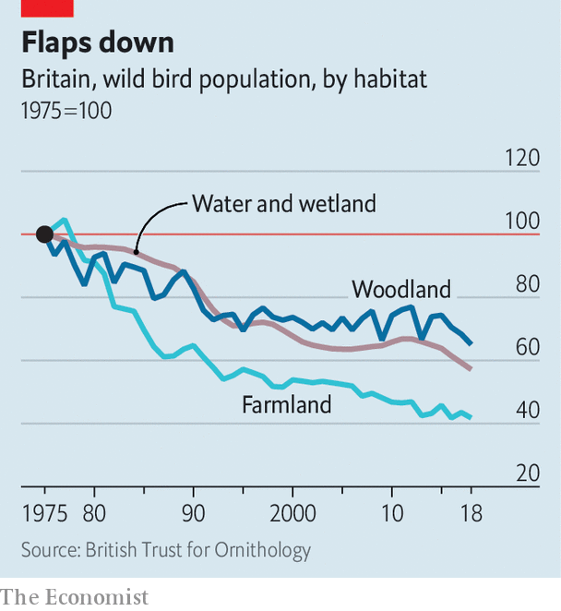

Farms need not be ecological deserts. Consider Samuel Topham’s 1,000-hectare farm in Cambridgeshire, east of St Neots. Like other cereal farmers, he grows crops on huge fields created by his grandfather, a keen remover of hedges. But in the field corners Mr Topham has planted blocks of wild flowers and plants that birds feast on, such as millet. He has set aside plots for lapwings and skylarks to nest, and has restored ponds. Red kites hover over his farm. Pheasants and partridges peck at the ground; they are for shooting.

Mr Topham does this because it pays—just about. Reversing a combine into a tight field corner takes time, increasing the fee that a contractor would charge for harvesting a crop, and compacts the soil. One five-hectare field is not worth ploughing at all; other areas are wet and unproductive. Since the government is prepared to pay him for growing flowers and bird food on those patches, he might as well do it. In all, one-tenth of his farm is dedicated to nature. “I farm the environment,” he says. The idea that farming is simply for producing food he calls “old-fashioned”.

About one-eighth of direct support for farming in Britain, some £450m a year, goes on environmental schemes like these. They are complicated and bureaucratic (asked about them, Mr Topham pulls out a thick binder filled with precise instructions about how he should manage his land) and two-thirds of farmers do not bother. But the government promises a simpler, more generous regime. The Agriculture Act that received royal assent on November 11th will allow the agriculture department to phase out per-hectare payments over the next seven years, and spend more on public goods such as nature. It has pledged to keep the overall level of support constant during this parliament, which will end in 2024.

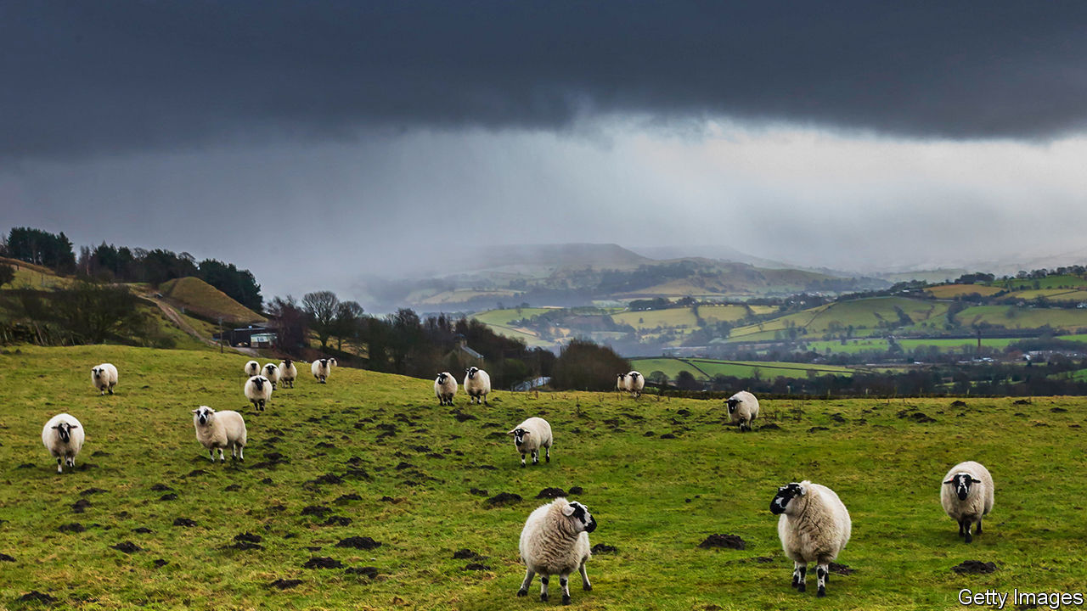

Where sheep may safely overgraze

If the government can pull this off, it will profoundly change farming in England (Northern Ireland, Scotland and Wales, which together have 48% of the United Kingdom’s agricultural land, are moving more slowly in a similar direction). Farmland prices will probably fall, as will rents for tenant farmers, who farm one-third of the land in England. Some who were surviving on subsidies will be driven out of farming—the agriculture bill allows the government to support such people for a few years by means of “de-linked” payments. Biodiversity ought to recover. But two things stand in the way of change: politics and sheep.

Ever since an agriculture bill was published in 2017, farmers’ organisations have protested that the government is emphasising greenery more than growing. They have persuaded some MPs. “Surely the primary public good—the most essential good there is—is food itself,” said Danny Kruger, a Conservative, during a debate earlier this year. The National Farmers Union argues that the coronavirus pandemic shows how important it is for a country to produce its own food. Britain currently grows about two-thirds of what it consumes; that share should not be allowed to fall much further, the NFU says.

Such arguments “are really specious”, says Ian Bateman, a professor of environmental economics at the University of Exeter. Food is a private good, not a public good. Britain’s food security is guaranteed by its wealth and by robust supply chains, which have held up remarkably well during the pandemic. The agriculture bill was nonetheless amended during its passage through Parliament. The government must now “have regard to the need to encourage the production of food by farmers in England” and must report every five years on food security. Both changes seem innocuous. But they could be used as a wedge that will allow farmers to obtain more support for business as usual.

The NFU has also tried to persuade the government to ban imports of food that do not meet British animal-welfare or environmental standards. American chlorine-washed chicken and hormone-treated beef are commonly cited as products that should be excluded on these grounds. But such a ban, if enacted, could be deployed against many other foods. For example, Britain currently imports rapeseed (canola, to Americans) from countries that are allowed to use a group of pesticides known as neonicotinoids, which are banned in the EU, and therefore in Britain.

Amendments to this effect were added by the House of Lords only to be rejected by the Commons. But the campaign is likely to revive as Britain gets into trade negotiations. It is backed by an impressive and diverse line-up, from the Mail on Sunday to television chefs such as Prue Leith and Jamie Oliver to environmental groups like Greenpeace, and is hugely popular. If nothing else, a campaign that focuses on other countries’ dismal environmental standards distracts attention from Britain’s own poor record.

A second problem, which involves upland farms and especially sheep, may prove even harder to solve. In June last year Britain had 33m sheep and lambs, many of them destined to be killed and exported to the EU. In England 30% of them are in hilly regions classed as “disadvantaged”, which include the Lake District, the Peak District, Exmoor and Dartmoor—the country’s most sublime corners. Farms in these areas are often economically marginal even with subsidies. The average income from agricultural activity alone, before subsidies, in severely disadvantaged areas in 2018-19 was minus £22,000.

Whereas almost everyone can agree about how lowland crop farms ought to change—to become like Mr Topham’s, only more so—upland livestock farms divide opinion. Environmentalists such as George Monbiot, a campaigning writer, argue that sheep farming is almost invariably destructive, creating deserts of nibbled grass, and that the land should revert to scrub and trees. Nonsense, retorts James Rebanks, a Lake District shepherd (and a green after his own fashion) in his book “English Pastoral”: “Abandoning farmland isn’t remotely the same thing as restoring a wild ecosystem—plagues of deer replace hordes of sheep and little good is achieved.”

“What people want is countryside easy to walk in and look at, a rough carpet kept free of messy undergrowth,” observed David Lowenthal and Hugh Prince, respectively an American and a British geographer, in 1965. That is probably still true of the English. Although ecologists might not approve, people’s eyes have grown fond of nibbled landscapes. And that is a problem for policymakers.

Jane Bassett farms sheep and cattle on 73 hectares of the Peak District. The small grassy fields on her land are divided by stone walls and scattered with mature trees. She has not applied for any environmental payment schemes, finding them too much hassle—“a lot of bureaucracy for fourteen hundred pounds”. She argues that she is creating environmental goods all the same. People flock to the area to admire and walk in the beautiful landscape and, if she is lucky, stay in her bed-and-breakfast. “That vista”, she says, “is maintained by having farmers in place.”

After many months of work, the Department for Environment, Food and Rural Affairs has provided scant details of the “environmental land management” payment scheme that will be tested next year and fully introduced in 2024. Upland farmers do not believe that the new scheme will provide much money for hard-to-quantify public goods such as landscape. If they are right, the grand plan to replace per-hectare subsidies with green payments could be derailed quickly.

Upland farmers can plead poverty more convincingly than other farmers in England; they may also be able to point to Scottish and Welsh farmers, who will continue receiving automatic subsidies for longer. They are quite likely to enjoy support from English town-dwellers, who associate them with holidays. People care about the environment. But they might turn out to care more about landscape.■

For more coverage of climate change, register for The Climate Issue, our fortnightly [newsletter](https://www.economist.com/theclimateissue/), or visit our [climate-change hub](https://www.economist.com/news/2020/04/24/the-economists-coverage-of-climate-change)

This article was downloaded by calibre from <https://www.economist.com/britain/2020/11/28/can-farming-be-greener-after-the-common-agricultural-policy>

|  |  |  |  |
| --- | --- | --- | --- |
| Previous | Articles | Sections | Next |

|  |  |  |  |
| --- | --- | --- | --- |
| Previous | Articles | Sections | Next |

#### Bagehot

# Rishi Sunak, Thatcherite at heart

The spending review did not reveal the real chancellor

Nov 28th 2020 |

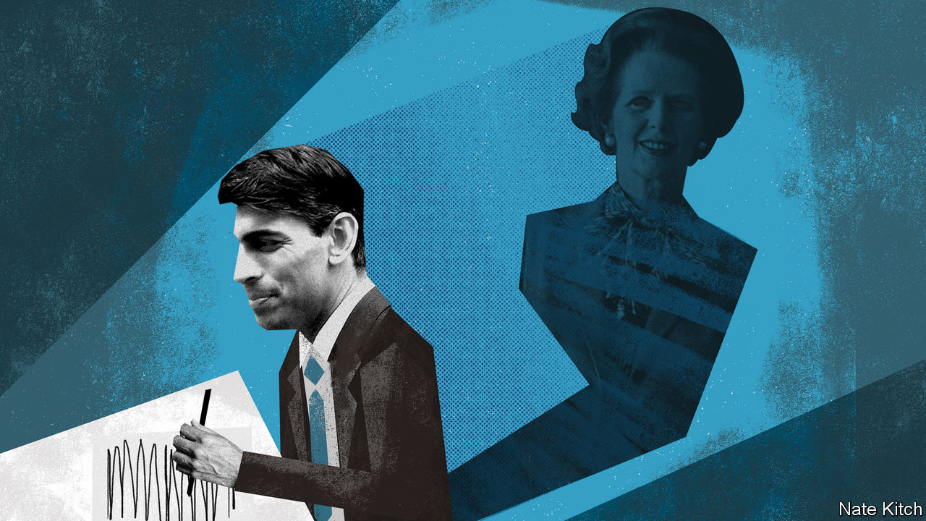

RISHI SUNAK is one of the most familiar figures in British politics. An assiduous public-relations campaign has ensured that the newspapers bulge with profiles of him and his photogenic family. Pundits speculate about how long it will be before he moves into Number 10. Economic policy is now associated with his skinny suits and easy smile in much the same way that it was once associated with Gordon Brown’s crumpled clothes and grumpy scowl.

Yet beyond Mr Sunak’s fabulous wealth and professional competence, not much is known about him. There are several reasons for this opacity. His rise has been so swift that he has left few traces. In early 2015 he was just another bored banker looking for a safe Conservative seat. By early 2019 he was a junior local-government minister dealing with public lavatories. From there he vaulted into Number 11.

The Conservative Party’s various factions project what they want onto the young chancellor: social liberals see him as one of their own because he is from an ethnic minority, while right-wingers welcome him as a fellow-Brexiteer. Mr Sunak’s PR team keeps the screen as blank as possible. Revelations that he likes “Star Wars” and Christmas songs have not been followed by disclosures about his philosophy of life or what makes him tick as a politician. But the deeper reason is that Mr Sunak has two warring identities.

The first identity is that of a pragmatist who tacks to the political winds. He got the job of chancellor when his predecessor, Sajid Javid, fell out with Boris Johnson over plans by the prime minister’s now-departed chief adviser, Dominic Cummings, for Number 10 to seize control of economic policy. As an MP for Richmond, in North Yorkshire, who campaigned energetically across the North of England in the December election, he is an enthusiastic supporter of the prime minister’s agenda of “levelling up” the country and consolidating the party’s recent gains in poorer places far from London. When the covid-19 crisis broke, he announced that “this is not the time for ideology and orthodoxy” and that he was willing to do “whatever it takes” to save the country from disaster. His first budget represented “the largest sustained fiscal boost for 30 years”.

The spending review which he delivered with his usual aplomb on November 25th was designed by Rishi-the-pragmatist, whose Keynesian mantra is “we’re prioritising jobs” and who reeled off a mind-boggling list of spending commitments. It was also a very political budget. Mr Sunak boasted of the “highest sustained level of public investment in more than 40 years”, repeatedly nodded to manifesto commitments to build more hospitals and increase police numbers, and conveniently scattered his largesse around marginal northern constituencies.

But there is another, more ideological Rishi. Mr Sunak may be a social liberal who took his parliamentary oath on a copy of the Bhagavad Gita, but he is also a chip off the old Thatcherite block, even down to the stories about working in the family shop. His parents were immigrants who scrimped to send him to Winchester College, one of the country’s best and most expensive schools. He spent his early career in two of the world’s centres of creative destruction—working for Goldman Sachs in New York and studying business at Stanford University in Silicon Valley. He has the same bullish pride in being British as Margaret Thatcher had. He values the country’s institutions—he describes his time at Winchester (where he was head boy) as “absolutely marvellous”—loves cricket and football, and relishes the rural rituals in his constituency. He came out in favour of leaving the EU in 2015, even though the party establishment was vigorously pro-Remain—a brave position for an ambitious new arrival.

He also has the same ingrained enthusiasm for balancing budgets and limiting expenditure as the grocer’s daughter had. He likes to tell the story of how he learned the rudiments of economics, including the importance of things like National Insurance and VAT rates, by helping his mother do the accounts at her pharmacy when he was still at school. In one of his first speeches in parliament in 2015 he noted that tax receipts had remained at around 36-38% of the economy since 1955 and that this suggested a “natural ceiling to what any government can extract from the pockets of its hard-working taxpayers”. In his speech to this year’s virtual Conservative Party conference he vowed to balance the budget in the medium term and spoke about the “sacred duty” to leave the finances strong.

## Showing steel

Which Rishi Sunak will dominate in the long term? While interest rates remain low, there will be little pressure for him to balance the books. Even so, the chancellor’s Thatcherite instincts are likely to play a growing role in shaping British politics. There were flashes of steel in the spending-review announcement. Mr Sunak not only froze most public-sector wages and reduced foreign aid from 0.7% of GDP to 0.5% (which would have delighted Thatcher). He also reduced planned spending: excluding emergency expenditure on the virus, he cut more than £10bn a year from departmental spending plans next year. As the economy recovers, the Thatcherite Rishi is likely to become more assertive.

Mr Cummings’s attempt to grab power from Number 11 failed, at least in part because the Treasury has performed so much better than other departments have in the course of the pandemic. Mr Sunak’s reputation in his party and the country has continued to rise as Mr Johnson’s has sunk. He has also acquired a cohort of influential supporters among MPs as his star has risen. Strong chancellors have always used their power in the past to shape policy and the economy. Nigel Lawson was a joint architect of Thatcherism, and Gordon Brown ran a rival domestic administration to Tony Blair. Under Mr Sunak, the ghost of Thatcher, handbag and all, will stalk the corridors of power.■

This article was downloaded by calibre from <https://www.economist.com/britain/2020/11/28/rishi-sunak-thatcherite-at-heart>

|  |  |  |  |
| --- | --- | --- | --- |
| Previous | Articles | Sections | Next |

|  |  |  |
| --- | --- | --- |
| Britain | Sections | Business |

International

Exams and covid-19: Testing, testing

.

|  |  |  |
| --- | --- | --- |
| Britain | Sections | Business |

|  |  |  |  |
| --- | --- | --- | --- |
|  | Articles | Sections | Next |

#### Testing, testing

# The pandemic has prompted questions about high-stakes exams

But other ways of assessing students create new problems

Nov 25th 2020 | SÃO PAULO AND SEOUL

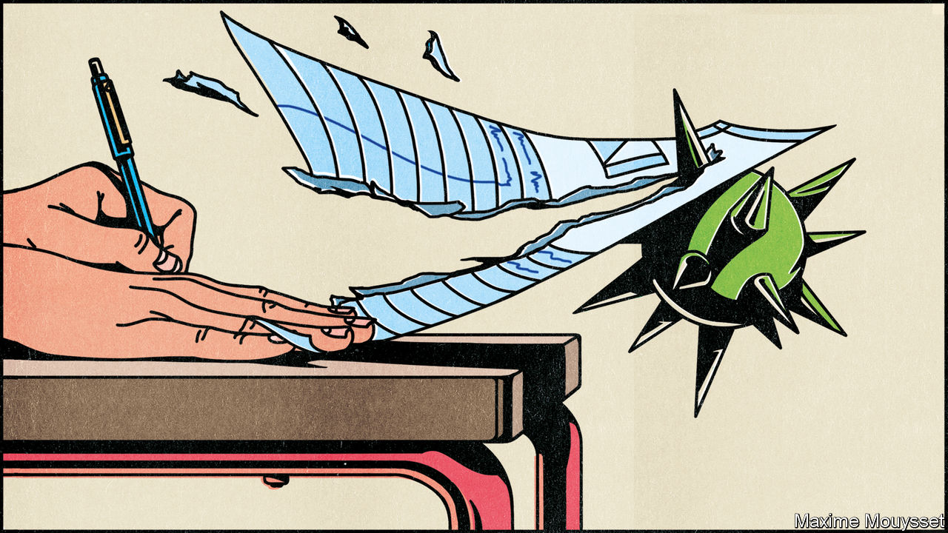

“MY BROTHER THINKS I’m crazy,” says Márcia Ramos, a 53-year-old from Rio de Janeiro. After losing a job in sales a few years ago, Ms Ramos decided to retrain as a lawyer. She and 6m others are now waiting to take the ENEM, an exam that many Brazilian universities use in their admissions process. The test should have taken place in November. Because of covid-19 it has been postponed until January.

The free test-prep class Ms Ramos attends, run by a youth group, has been less effective since it went online. So she is relieved to have more time to cram. The delay to the ENEM has, however, led universities to fill more of their spots for the coming academic year using their own entrance exams. This is bad news for poorer students such as Ms Ramos who have less time and money to study for several tests.

School closures have disrupted the education of close to 1.5bn pupils since the start of the year. Governments have been forced to make difficult decisions about whether and how to conduct important exams. These have revived long-running debates about the fairness of high-stakes tests. That could result in changes that last far beyond the pandemic.

Many countries have ploughed ahead with big exams. On December 3rd half a million youngsters will sit South Korea’s fearsome matriculation exam. Face-masks are mandatory. Papers will be brought to hospitals for any candidate needing treatment for covid-19. Pupils lost at least five weeks of face-to-face learning when the pandemic closed their classrooms; cram schools closed, too. But one 18-year-old from Seoul does not feel hard done by. When classes were forced online pupils “talked less and studied more”, she says.

In July some 10m people sat the gaokao, China’s school-leavers’ exam. The two-day test took place a month late; exam centres set aside quarantine spaces in case candidates developed symptoms while it was happening. Provincial governments in Germany also agreed that their school-leavers’ exams should go ahead, though they account for only a small portion of students’ final grades. Spain suffered one of Europe’s worst outbreaks and imposed one of its strictest lockdowns. Its university-entrance exam still went ahead, though it covered less material than usual.

Some countries allowed exams to go ahead but with alterations. Italy called off written tests for school-leavers, but allowed an oral examination to proceed. Austria and Hungary did the opposite. In America Advanced Placement exams—optional courses that some teenagers take to impress university admissions offices—went online. The papers were shortened to 45 minutes and covered only material candidates were likely to have studied before they were booted out of their classrooms.

Andreas Schleicher, head of education at the OECD, a club of mostly rich countries, thinks more countries could have held exams safely: “You don’t want people to talk; you don’t need them to move around; their desks are quite far apart.” So far it appears that the grades of most pupils who did sit exams this year have been no worse than usual, according to UK NARIC, a British government agency that keeps track of qualifications in other countries. Candidates in Germany performed a little better.

Some countries, including Britain, France and Ireland, cancelled exams. That had least impact in places where pupils rack up marks before any final tests. Other governments asked teachers to help decide students’ grades. These were higher than usual, according to data collected by UK NARIC (see chart). To produce results comparable to the previous year’s, Irish moderators would have had to lower 60% of the grades teachers had suggested for final-year students registered to sit the most difficult papers. They let all but a fifth stand. In France 96% of pupils earned a school-leaver’s certificate, up from 88% in 2019.

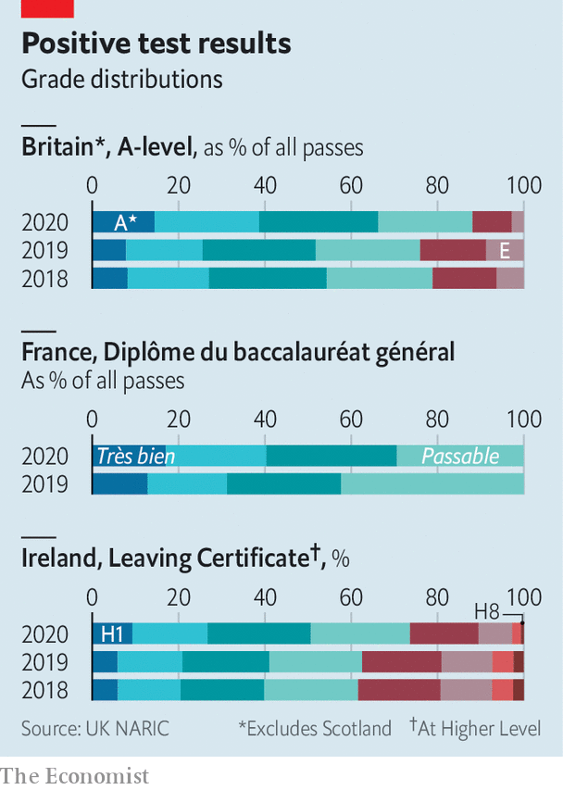

Authorities in England were harsher. They lowered 40% of the grades teachers had proposed for A-levels (exams taken at 18). Outrage ensued. Critics pointed out that the approach moderators had taken risked hurting some children from low-achieving schools. The government eventually agreed that the teacher-suggested grades would stand; as a result the share of entries receiving one of the two highest marks has risen from about one-quarter in 2019 to more than one-third this year. Mary Richardson of University College London says the government was “foolish” to think it could “normalise a completely abnormal situation”. Mr Schleicher from the OECD thinks that by both cancelling exams and abandoning all moderation England ended up with “the worst of all worlds”.

The muddle has revived long-running debates about the value of exams. A few days or hours of testing is a crude way to assess students’ performance in courses that have lasted a year or more. Exams disadvantage clever pupils who deal badly with pressure. Relying on them too much can lead to narrow curricula which include only things that can be tested affordably. Time spent teaching youngsters strategies to maximise their exam scores could otherwise be spent learning more useful stuff.

Some psychologists worry that the pressure of exams is raising the risk that vulnerable youngsters will develop mental-health problems, early signs of which often appear during adolescence and early adulthood. Exams can also label children as failures, when they had no choice but to attend bad schools. And rich parents often pay for tutoring to boost their offspring’s chances.

Yet abandoning exams creates new problems. Continuous assessment means pupils may simply “learn stuff, get a grade and then forget it”, says Dylan William, a British expert in educational assessment. Coursework can encourage students to tinker endlessly with just a few pieces of work. Junking exams only introduces new kinds of stress if the alternative is that all schoolwork counts towards final grades. Without objective assessments, learners from poor homes are more likely to be judged on their backgrounds than on their actual achievements.

Teachers sometimes show bias when marking pupils’ work. A study of 11-year-olds in England compared the grades teachers awarded with scores the same pupils achieved in tests marked blindly. It found that teachers were more likely to give black pupils lower marks than they deserved. According to research published in 2019, some teachers in New York state gave worse marks to essays when they were led to believe the author was fat. Wealthy parents are more likely than poor ones to put pressure on teachers to boost their children’s scores. Worries about corruption help explain why exams remain so crucial to education in China and South Korea.

Teachers in Britain tend to under-predict how well clever pupils from poorer backgrounds will perform in exams. In Wales, where results this year were based on teachers’ predictions, grades rose across the board, but the difference between the number of rich and poor children receiving the highest marks was wider than usual in several subjects, notes Rhian Barrance at the University of Cardiff.

## Revising the system

Some countries had begun making changes before the pandemic hit. Reforms in France mean that from this year school-leavers are supposed to enter their final exams with 40% of their marks already in the bag; previously everything depended on the tests. A few years ago England moved in the opposite direction by abandoning coursework and reprioritising end-of-course exams. In 2019 an admissions scandal forced South Korea’s government to say it would review a programme that seeks to make exam scores less critical to university applications. Chinese officials talk endlessly about shaking up the gaokao, but have only tinkered with it.

The pandemic may amplify calls to get rid of exams that some already thought unnecessary. Universities in America traditionally ask applicants to sit the SAT or ACT, tests which are not required by the public school system. This year many universities waived that requirement after many exam sittings were cancelled. This delighted critics of testing, who say the exams advantage richer applicants who can pay for test-prep. About 70% of American universities offering four-year courses now operate “test-optional” admissions policies, up from around 45% before the pandemic.

In England the pandemic has raised fresh questions about the future of GCSEs, a flurry of exams taken by 16-year-olds. These have become less crucial as a result of reforms that require teenagers to stay in some kind of education or training until they are 18. Developing countries have been gradually junking exams they have traditionally used to decide which children may enter secondary school. This year’s crisis could speed that up.

But the disruptions of 2020 have made clear that exams are useful. Some teachers’ unions in France argue that inflated grades of the sort handed out this summer risk becoming a permanent fixture as a result of the government’s efforts to de-emphasise exams. Teachers in England did not enjoy helping decide who should pass or fail, says Lee Elliot Major, a professor of social mobility at Exeter University. Many will be pleased when external examiners relieve them of that burden.

How exams should proceed next year remains a pressing question. Many countries that closed schools during the early months of the pandemic have managed to keep them open during later lockdowns. But lots of children are still having to return to stints of remote learning when there are suspicions of infections among their peers. In October secondary-school attendance rates ranged from a little over 60% in some areas of England to more than 90% in others. They are lowest in places that already had lots of poor children. In mid-November education authorities in Wales cancelled school-leavers’ exams set for next spring. Politicians said it would be unfair to require youngsters to sit a common exam, given that the pandemic has affected them in different ways.

Sandra Milligan of Melbourne University thinks officials in the Australian state of Victoria have found “the disaster” in England helpful in working out “what not to do” with their own tests. Final exams are going ahead there, even though pupils have endured long lockdowns. Those who score unusually poorly may have their grades raised using a system similar to one that has long benefited candidates who suffer illness or trauma. Ms Milligan would like to see examinations become less central to Victoria’s school system, but opposed those who saw this year’s crisis as an opportunity to rush out changes. Half-cocked school reforms risk hurting those “who can least look after themselves”. ■

This article was downloaded by calibre from <https://www.economist.com/international/2020/11/25/the-pandemic-has-prompted-questions-about-high-stakes-exams>

|  |  |  |  |
| --- | --- | --- | --- |
|  | Articles | Sections | Next |

|  |  |  |
| --- | --- | --- |
| International | Sections | Finance & economics |

Business

Live events: The roar of the crowd

.

Publishing: Book-binding

.

Shopping frenzies: Fade from black

.

The attention economy: You’ve been botted

.

Diversity consulting: All inclusive

.

Bartleby: Winter is coming

.

Schumpeter: The climate centurion

.

|  |  |  |
| --- | --- | --- |
| International | Sections | Finance & economics |

|  |  |  |  |
| --- | --- | --- | --- |
|  | Articles | Sections | Next |

#### Playing on

# Covid-19 and the business of crowds

How sports, music and exhibitions are managing in a time of social distancing

Nov 26th 2020 |

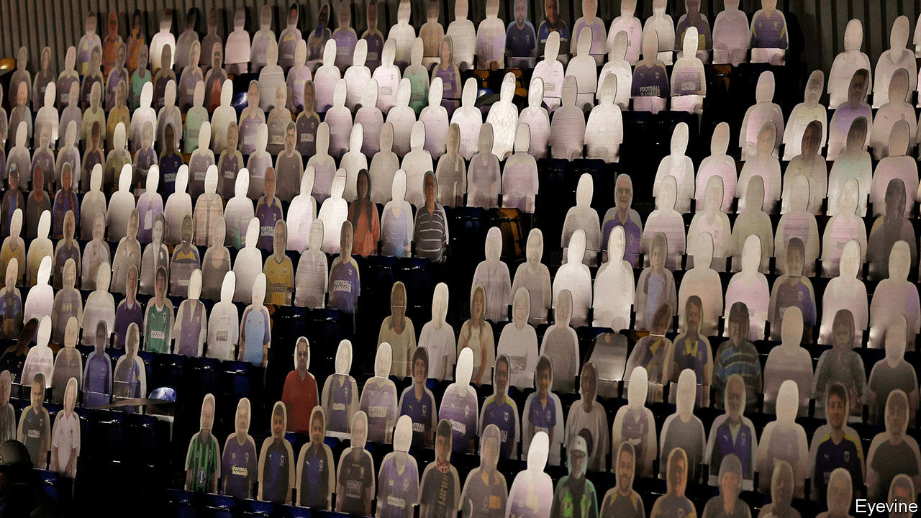

THIS MONTH Britain’s National Exhibition Centre (NEC), the country’s largest events venue, was due to host shows including Motorcycle Live, Simply Christmas and Cake International. Yet instead of being filled with bikes, toys and Sachertorte, the space has been fitted with 380 hospital beds. Covid-19 has wiped out the planned exhibitions, tipped the NEC’s management company into restructuring and caused the government to turn one of its halls into an emergency field hospital.

Social-distancing rules have forced all businesses to think hard about how to keep their customers safely apart. But for events companies the rules pose a particular problem, for these firms’ purpose is to bring people together. Trade shows and conferences lose their value if those attending cannot mingle. Concerts are no fun alone. And the excitement of a goal, slam dunk or home run is not the same without thousands of fans roaring their support. Although stockmarkets have mostly recouped their losses since January, the market capitalisation of listed “crowds businesses” identified by The Economist has sunk from $234bn to $183bn (see chart 1).

Some live-events industries are dealing with the crowds problem more easily than others. But as the pandemic grinds on, it looks as if those that have had the hardest time in 2020 will emerge least scathed when things get back to normal—whereas those that have found ways to adapt may find that the temporary fixes cause long-lasting disruption.

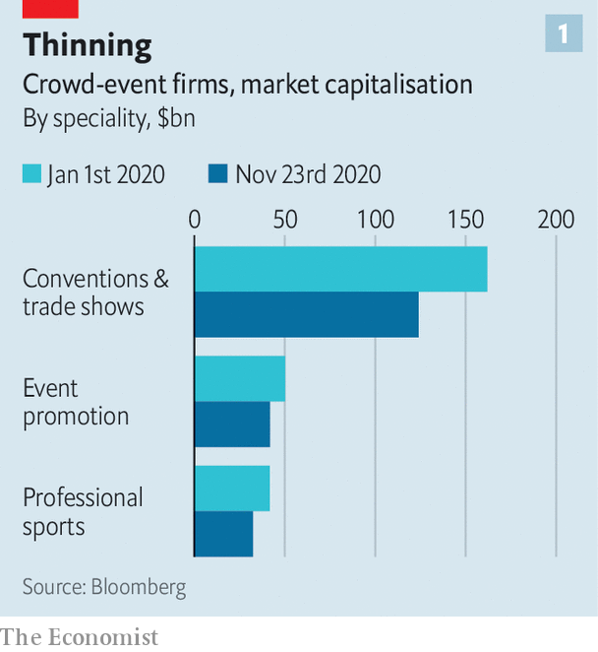

Hardest hit has been the exhibitions industry, which makes up nearly two-thirds of the crowds sector’s market value. According to AMR International, a consultancy, its global revenues will contract by two-thirds this year, to $9bn (see chart 2). The outlook is so uncertain that AMR’s analysts have not hazarded an estimate for next year’s revenues.

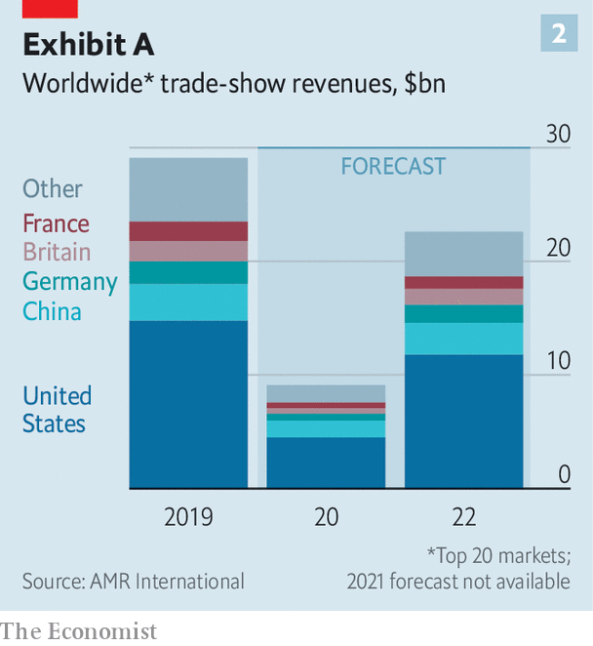

Take the colossal trade-fair centre in Hanover, the size of 60 football pitches. It closed in March and has been empty most of the time since. Deutsche Messe, which runs it, was expecting revenues of €330m ($392m) this year; Andreas Gruchow, a member of its managing board, says that it will end up with about €100m, partly from events it has run in China, which has controlled covid-19 better than America or Europe. A few events have been held in Hanover, following new rules mandating masks, a reduced headcount and so on. But exhibitors “expect the whole world to come to Hanover and visit them at their booth”, observes Mr Gruchow; with international travel on hold, the big fairs are not happening.

Organisers have dabbled online with limited success. Some exhibitions, like Cake International, are best enjoyed in person. Even the liveliest Zoom panels lack the opportunities for networking that justify many conferences’ eye-popping admission price. Exhibitors pay a four- or five-figure fee for a spot in one of Deutsche Messe’s online trade fairs, says Mr Gruchow; for a physical booth at Hanover they would pay up to €300 per square metre, leading to seven-figure bills for the largest participants.

Yet trade fairs’ digital clunkiness will protect the industry from disruption. “You can’t ‘Amazon’ the events business,” points out Marcus Diebel of JPMorgan Chase, a bank. He cites this as a reason for long-term optimism about the industry. RELX, owner of Reed Exhibitions, the world’s second-largest exhibitions company by sales, saw its revenues fall by 70% year on year in the first half of 2020, but its share price is down only 8% since January. That of Informa, the largest, has shot up by a third this month, as successful late-stage trials of covid-19 vaccines have been reported.

Organisers agree that future events will have more digital elements. But a dire couple of years are likely to give way to something much like the old normal. AMR expects revenues to rebound to 78% of last year’s level by 2022.

## Pitch-dark

The opposite is true in sport, another crowd-dependent business. After a pause in the spring, most professional leagues have managed to play on, getting round the lack of spectators in novel ways. FC Seoul populated its stadium with mannequins from a sex-toy supplier (and in the process earned a fine from the South Korean football league for indecency). Others have piped in sound, added cardboard cut-outs or CGI spectators. Some have even live-streamed fans’ faces onto screens in the stands, as in WWE wrestling’s new “ThunderDome” in Florida.

Yet the smooth transition disguises disruption that may last. The cost of forgone ticket revenue has been borne unevenly. In the main American leagues teams keep the income from tickets—and the drinks, hot dogs and so on that go with them—whereas leagues get the proceeds of national broadcasting rights. So teams are on the rack. Major League Baseball, with its long season and relatively modest TV deals, is in bigger trouble than the National Football League, which has fewer games and pricier TV rights. The New York Mets, a struggling baseball team that was sold last month, is expected to lose out on nearly $250m in ticket sales this year.

The pandemic has also accelerated changes in how people watch sports at home. The lack of crowds has contributed to a fall in viewership of full games, as fans switch to highlights and new formats. The National Basketball Association (NBA) highlights show on Snapchat, a social app, has had 37% more viewers this year, even as American television ratings for the NBA finals fell by 49%. People are spending more time on betting sites and forums like Barstool Sports, says Brandon Ross of LightShed Partners, a media-research firm. “There are millennials and Gen Z-ers who would rather just sit and watch the Barstool personalities pontificate...than watch the games themselves,” he says.

The decline in whole-game viewing bodes ill for the big sports broadcasters. ESPN, owned by Disney, announced this month that it was cutting 500 jobs amid “tremendous disruption in how fans consume sports”. Its chairman, Jimmy Pitaro, said the company would now focus on “serving sports fans in a myriad of new ways”; some written and audio content has gone behind its paywall.

Lower whole-game audiences will translate into lower advertising revenues for broadcasters and, ultimately, lower budgets for rights deals, “the overwhelming financial engine for sports”, warns Mr Ross. These trends will persist long after covid-19 is defeated.

If the exhibitions industry looks stable and sport is heading for disruption, live music combines both trends. Coronavirus has pulled the plug on concerts. Live Nation, the world’s biggest live-entertainment company, reported this month that its revenues plummeted by 95% in the third quarter, compared with a year ago. CTS Eventim, a European rival, saw its sales slide by 79% in the first nine months of 2020, year on year.

Rather like the exhibition organisers, however, the big music promoters are protected by investors’ faith that mosh pits and muddy festivals are not easily replicable online. Live Nation’s and CTS’s share prices are down by, respectively, only 10% and 15% since February—not bad for firms that have lost nearly all their revenue.

This suggests that live-music companies can outlive the pandemic. The giants should have no problem. Live Nation has nearly $1bn of cash and the same again in undrawn debt facilities, comfortably enough to see it through to next summer. But many smaller operators will not make it. America’s National Independent Venue Association says that 90% of its 2,900 members expect to close permanently without a bail-out. Live Nation will get a chance to sweep them up, entrenching its dominant position.

That does not mean the live-music industry will escape disruption. Early in the pandemic artists, who these days make more money from touring than recording, performed amateurish streaming concerts from makeshift home studios. Online gigs have since become more professional with the help of companies such as Driift and Dice, which organise elaborate streamed productions.

Tickets are much cheaper than those for in-person gigs—entry to an online show this month by Dua Lipa, a British singer, cost €12.99, about a quarter of the minimum that fans used to have to pay to see her in real life. But there is no limit to capacity. And stars can attract concertgoers in places where they would never tour. BTS, a South Korean boy band, staged an online concert last month which brought in almost 1m viewers from 191 countries.

## A different tune

There are also glimpses of completely new forms of entertainment. In April Travis Scott, an American rapper, appeared in virtual form in Fortnite, an online video game. Some 28m players attended the free concert as avatars. Experiences such as these are not replacements for in-person live music. But they are the makings of a sub-industry that will supplement the incomes of stars with global followings. Covid-19 has dealt live music a severe blow in 2020, but the resulting innovation could help the industry come back stronger—if, perhaps, a bit less crowded. ■

This article was downloaded by calibre from <https://www.economist.com/business/2020/11/26/covid-19-and-the-business-of-crowds>

|  |  |  |  |
| --- | --- | --- | --- |
|  | Articles | Sections | Next |

|  |  |  |  |
| --- | --- | --- | --- |
| Previous | Articles | Sections | Next |

#### Book-binding

# Bertelsmann snaps up Simon & Schuster

The merger will create a new biblio-behemoth

Nov 26th 2020 | BERLIN

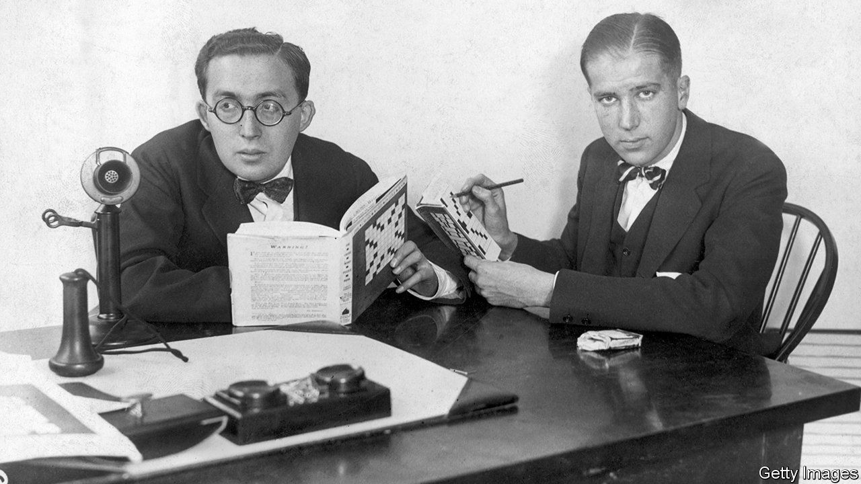

IN THE DAYS before Thanksgiving two top contenders emerged for Simon & Schuster, the fifth-biggest English-language book publisher by revenues, from ViacomCBS, an American media group. On November 25th Bertelsmann gained the upper hand. With an offer of $2.2bn the German parent of Penguin Random House (PRH), the largest publisher by a Tolstoyan margin, outbid News Corp, Rupert Murdoch’s media group, whose catalogue contains HarperCollins, ranked third (see chart).

A merger with Simon & Schuster would give PRH almost one-third of English-language book sales. That is more than double the market share of its closest rival, Hachette Livre, owned by Lagardère, an ailing French conglomerate. (Vivendi, a French group that is Lagardère’s biggest shareholder, also briefly vied for Simon & Schuster.) In America the merged biblio-behemoth would control 70% of the market for literary fiction.

Authors and agents worry that the enlarged PRH may become ever more dominant in distribution—and that market concentration could lead to an excessive focus on bestsellers such Michelle Obama’s memoir of her time as America’s first lady (which was published by a PRH subsidiary) at the expense of niche titles that are no less worthy. Robert Thomson, News Corp’s boss, is certain, for his part, that the Bertelsmann deal will alert trustbusters. Earlier this year America’s Department of Justice thwarted a merger of Cengage and McGraw-Hill, two publishers of educational books. Any delay would be bad news for ViacomCBS, which needs the money badly for investments in video-streaming, where it lags behind rivals such as Netflix, Disney or AT&T, a telecoms giant that owns HBO.

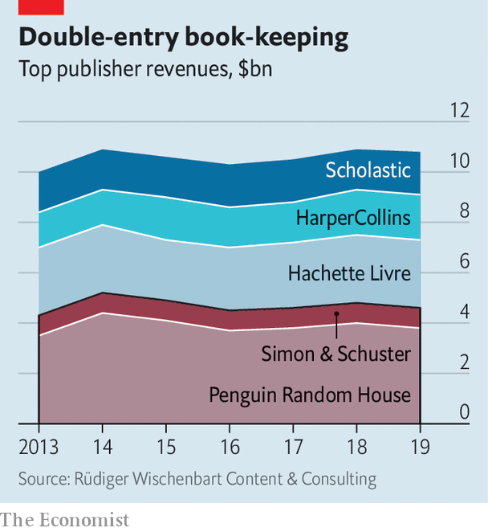

Thomas Rabe, Bertelsmann’s boss, says he is confident that regulators in America and other countries will bless the deal. They rarely block mergers that only reduce the number of big players from five to four. The last big union, Bertelsmann’s takeover in 2013 of Penguin, did not fall foul of antitrust guardians. Moreover, the leading five have lost market share in recent years to smaller rivals, not to mention Amazon, which these days not only sells books (as well as just about everything else) but also publishes them.

That still leaves the question of whether the deal is a good one for Bertelsmann. The price was heftier than even ViacomCBS expected. Covid-19 initially hurt book sales, as it did other discretionary spending. “The first five weeks [of the pandemic] were very tough,” admits Brian Murray, chief executive of HarperCollins.

But with their pantries full, self-isolators turned to fiction for escapism and edification. “People are always predicting the decline of book publishing, but it has actually been very resilient,” says David Steinberger, chief executive of Arcadia Publishing, a publisher of history books.

And Simon & Schuster is a prestigious prize. It was originally set up in 1924 to publish crosswords, but went on to represent Ernest Hemingway, F. Scott Fitzgerald and Tom Wolfe. This year it made waves with the publication of “Rage”, a ferocious account of Donald Trump’s White House by Bob Woodward, a far-famed journalist, as well as a tell-all memoir by the president’s niece, a psychologist.

Nabbing Simon & Schuster is Bertelsmann’s second coup in the space of a week. On November 17th American and Canadian readers set a record for first-day sales, snapping up 890,000 copies of a new memoir by Mrs Obama’s husband, also published by a PRH subsidiary. ■

This article was downloaded by calibre from <https://www.economist.com/business/2020/11/26/bertelsmann-snaps-up-simon-and-schuster>

|  |  |  |  |
| --- | --- | --- | --- |
| Previous | Articles | Sections | Next |

|  |  |  |  |
| --- | --- | --- | --- |
| Previous | Articles | Sections | Next |

#### Holiday shopping

# Black Friday isn’t what it used to be

The fading importance of America’s favourite shopping spree

Nov 28th 2020 | NEW YORK

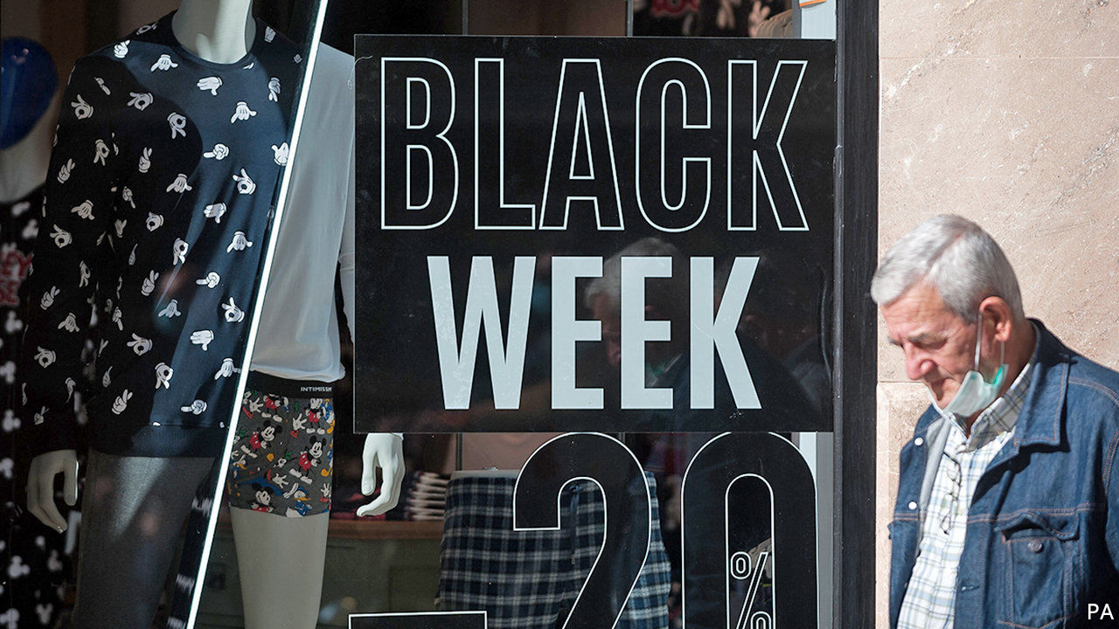

OXFORD-DICTIONARY lexicologists recently declared “blursday” a word of the year. Pandemic-induced date confusion extends beyond self-isolating households. Best Buy, a large American electronics retailer, recently declared that “Black Friday isn’t just one day this year—it’s months long.”

The start of the pre-Christmas shopping season, which this year falls on November 27th, has long been a bonanza for American retailers. The term itself is often credited to Philadelphia’s policemen, who used it to describe the pandemonium caused by suburban shoppers and tourists thronging the city ahead of the annual Army-Navy American-football game on the Saturday after Thanksgiving. By the 1980s shops recognised the branding opportunity—and began marking the occasion with deep discounts and “doorbuster” deals to pull people from their turkey-laden tables to shopping aisles.

These days retailers make one-fifth of their holiday revenue, defined as sales in November and December, in the five days from Thanksgiving to Cyber Monday, invented in 2005 by the National Retail Federation (NRF), a trade group, in recognition of an online sales bump on the first working day after the holiday weekend. Black Friday typically attracts more than twice the foot traffic of other annual shopping sprees in America.

This year, though, covid-19 has made many shoppers reluctant to elbow their way to cut-price wedding gowns or TV sets. So large retailers have, like Best Buy, stretched Black Friday from a frenzied 24 hours to several weeks. Walmart, Target and other big-box retailers announced discounts on holiday items as early as October 11th. In lieu of mall Santas and mistletoe, they offered refurbished online interfaces, generous return policies and expanded options for kerbside pickup. Amid the pandemic-induced collapse of travel and other “experiential” spending, some of the unspent dosh is going on stuff instead, notes Jill Standish of Accenture, a consultancy. NRF expects this year’s holiday retail sales to grow by as much as 5% compared with 2019, as friends and families use gifts to show long-distance appreciation.

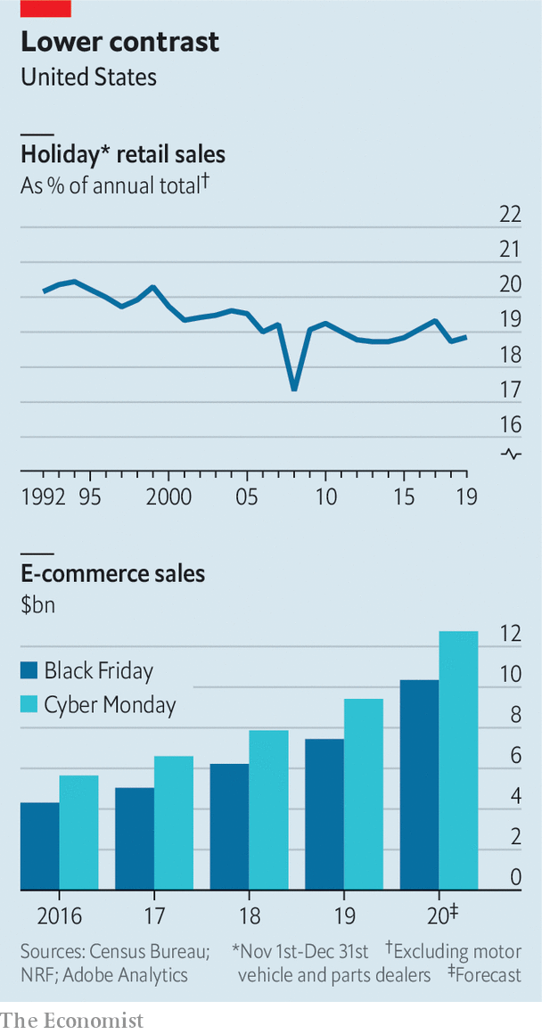

Even if NRF’s forecast proves accurate, however, this year’s haul is unlikely to arrest the stagnation of the holiday shopping season. Its share of annual retail sales faded below 19% throughout most of the past decade, from 20.2% in 1992 (see chart). Online shopping offers perpetually low prices, making one-off discounts somewhat less exciting.

In this light, Black Friday’s in-store stampedes no longer look that appealing. The day’s internet sales have been rising (though Cyber Monday has digitally outshone it since at least 2016). Last year a third of the day’s $23bn trade happened online. Now the share could be closer to a half.

In any case, the idea of squeezing all your bargain-hunting into a day is falling out of fashion. Since 2019 Amazon Prime Day, the e-empire’s signature shopping event, has lasted 48 hours. And this year Singles’ Day, a Chinese extravaganza which normally falls on November 11th, lasted a full 11 days. ■

This article was downloaded by calibre from <https://www.economist.com/business/2020/11/28/black-friday-isnt-what-it-used-to-be>

|  |  |  |  |
| --- | --- | --- | --- |
| Previous | Articles | Sections | Next |

|  |  |  |  |
| --- | --- | --- | --- |
| Previous | Articles | Sections | Next |

#### You’ve been botted

# Is the attention economy being captured by virtual eyeballs?

A short-selling row highlights the dodgy metrics of online commerce

Nov 28th 2020 |



IT WAS A spectacular bit of timing. On November 16th Baidu, a Chinese online-search giant, said it would buy YY Live, a China-focused video-streaming service with 40m monthly users, for $3.6bn. Two days later Muddy Waters, an American short-seller, published a report claiming YY Live was “an ecosystem of mirages” and “almost entirely fake”. The share price of JOYY, YY Live’s parent company, slid by 26%.

Muddy Waters alleges that JOYY’s platforms, including YY Live, are infested with “bots”—computers that log on to “watch” streams, pretending to be human. Many, it says, appear to sit in JOYY’s internal networks. The upshot, it alleges, is that somewhere between 73% and 84% of JOYY’s revenue is suspect.

JOYY responded by saying the report contained “numerous errors, unsubstantiated statements and misleading conclusions and interpretations”. It said it would be open to “cash verification and diligence” conducted by “competent third-party advisers”. (JOYY and Baidu did not respond to requests for comment.)

The allegations are unusual in accusing the platform of creating its own fake users. Technological complexity and minimal human oversight means the “attention economy” is full of virtual eyeballs. But such mischief tends to be the work of outsiders. Last year America’s Federal Trade Commission fined the boss of a firm called Devumi $2.5m for selling fake YouTube views, the first time such a complaint had been brought. Digital advertisers pay to have their ads shown to users. It is an open secret that many end up served to fake viewers, generated by computers infected with malware written for this purpose.

A new report by the University of Baltimore and CHEQ, an anti-fraud firm, estimates that $35bn is lost annually to such scams, from a total market worth $333bn. South-East Asian fraudsters employ humans to scoot between racks of smartphones, tapping ads and installing apps, says Gary Danks of Machine, a firm that offers ad-fraud detection. Those in places with higher labour costs simulate phones on computers.

Companies are fighting back. Last year Uber sued more than 100 ad agencies, accusing them of buying fake views on its behalf. Facebook launched a lawsuit against firms it says create malware that hijacks users phones, forcing them to generate fake ad clicks. Neither suit is likely to stem the fraudsters’ rise.

This article was downloaded by calibre from <https://www.economist.com/business/2020/11/28/is-the-attention-economy-being-captured-by-virtual-eyeballs>

|  |  |  |  |
| --- | --- | --- | --- |
| Previous | Articles | Sections | Next |

|  |  |  |  |
| --- | --- | --- | --- |
| Previous | Articles | Sections | Next |

#### All inclusive

# Social unrest has fuelled a boom for the diversity industry

An army of consultants and recruiters is helping firms become more inclusive

Nov 28th 2020 | BOSTON

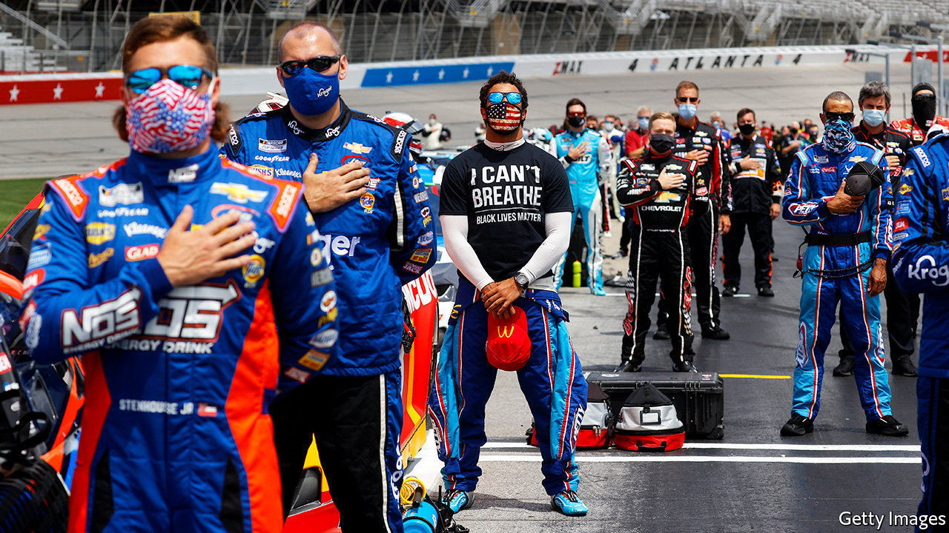

AS PROTESTS AGAINST police violence and racism convulsed America’s streets this summer after the killing by a policeman of George Floyd, a black man, the heat could be felt in the air-conditioned corner offices above. America Inc rushed to announce plans to tackle racial inequality. Walmart said it would set up a $100m initiative to fight racism. Pepsi vowed to double spending with black-owned suppliers. Facebook and Estée Lauder pledged to hire more non-white candidates. JPMorgan Chase promised to extend $30bn in loans over five years to minority households and businesses. Even NASCAR, which runs a motor-racing series for a mostly rural and white fan base, prohibited the display of confederate flags at its events. Diversity, many said, is not just the right thing to do. It is good for business.

For one breed of firms it has been very good indeed. Consultancies and recruiters are enjoying a mini-boom as companies look for advice on how to become more inclusive. The newly created diversity, equity and inclusion (DEI) practice at Bain, a consultancy, now has two dozen staff, and another two dozen want to be part of it at least some of the time, says Julie Coffman, who heads it. She calls diversity “the next digital”. A partner at another consultancy says DEI is the “fastest growing business line we have right now”. Lyndon Taylor, who leads DEI at Heidrick and Struggles, an executive-search firm, discerns a “quantum” jump in demand for such services.

Lots of companies promised to do things during the protests. Now, Mr Taylor says, they must work out what those are and how they are going to do them. The priority is hiring black senior executives or board members. Before 2020 diversity meant women, Latino, Asian and LGBTQ, says Dale Jones, boss of the Diversified Search Group, a 46-year-old recruitment firm originally set up to promote women. Now Mr Jones sees “a hyper focus around black leadership”, with board placements up by half and C-suite recruiting by around a third over the past year.

Julie Hembrock Daum, who recruits board members at Spencer Stuart, another search firm, says she has to temper clients’ expectations about what is possible. She tells them to think long and hard about what qualities they need on their board rather than “a knee-jerk reaction like ‘we need a CEO who is black’”.

Recruiters remind clients that boardrooms and C-suites are not overly blessed with other ethnic minorities, LGBTQ people or women. They also highlight other underrepresented groups, such as veterans, migrants and refugees, the “differently abled” and the all-encompassing “cognitively diverse” (consultant-speak for people who think differently).

The diversity industry has expanded beyond finding new hires. Consultancies’ and recruiters’ services include training staff on bias, advice for diversifying supply chains and coaching senior executives on how to run more inclusive firms. Some offer broad-ranging strategies for organisational and managerial changes. As one recruiter puts it, “hiring can be a quick fix, but you can’t just add a couple of diverse fish. You actually need to change the water in the pond.”

Demand for such services is unlikely to abate any time soon. A survey by Edelman, a public-relations firm, conducted soon after news of Floyd’s death, found that 60% of respondents said a brand’s reaction to the protests “will influence whether I buy or boycott them in the future”. Younger customers and employees are likelier to hold strong views: 53% of those aged 18-34 said they would not work for a firm that failed to speak out during the protests, compared with 42% for all ages.

The change is driven by the drive and passion of younger employees, says Pamela Warren, who in July was appointed co-leader of the DEI council at Egon Zehnder, a big executive-search firm. As more of them enter the workforce, pressure on employers to be more representative of the population will grow—and with it demand for the diversity industry’s services. ■

This article was downloaded by calibre from <https://www.economist.com/business/2020/11/28/social-unrest-has-fuelled-a-boom-for-the-diversity-industry>

|  |  |  |  |
| --- | --- | --- | --- |
| Previous | Articles | Sections | Next |

|  |  |  |  |
| --- | --- | --- | --- |
| Previous | Articles | Sections | Next |

#### Bartleby

# Why office morale will be hard to maintain this year

Covid-19 means fewer seasonal junkets

Nov 28th 2020 |

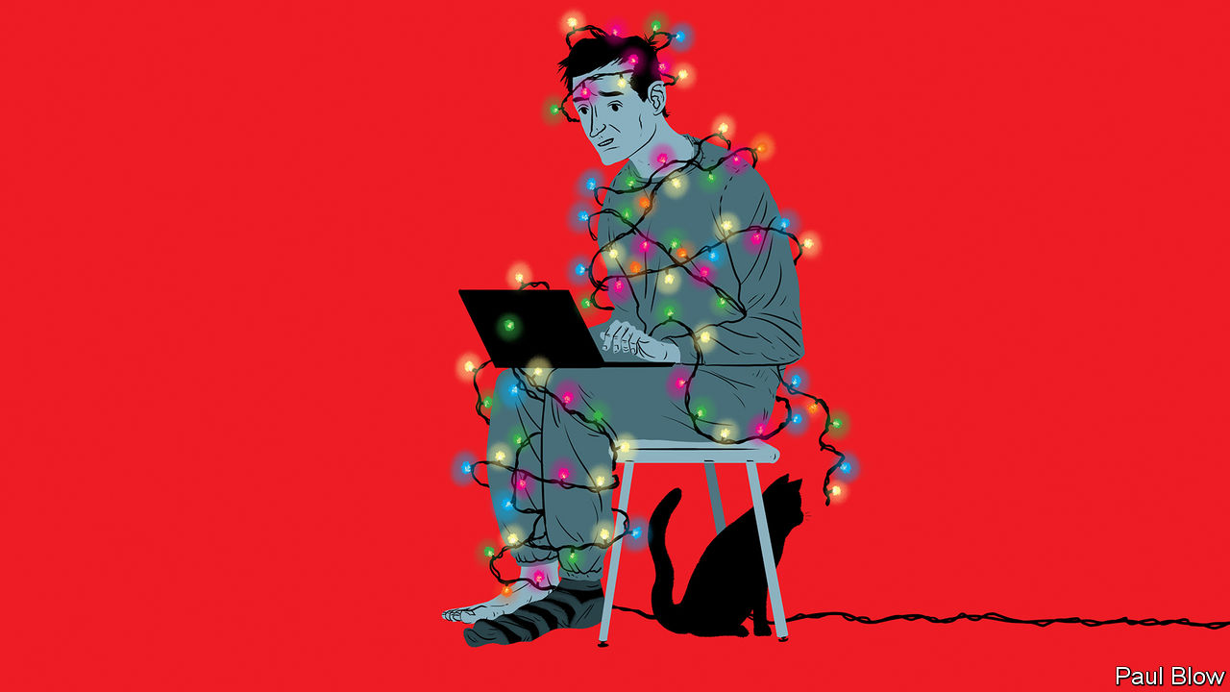

TIME FOR a confession. Normally, Bartleby’s family waits until December before putting up the Christmas decorations. But this weekend, even though it is only November, the festive lights will go up. Furthermore, he has bought some new (especially gaudy) decorative items to brighten up the front of the house.

Your columnist is far from alone. Some celebrities have already decorated their Christmas trees; Joan Collins, an actress, was pictured next to hers on November 10th. The local coffee shop and minimarket had dressed in fir by mid-November. These early seasonal signals have been triggered by the possibility of a long and depressing winter, in which the pandemic will disrupt traditional celebrations and families may be kept apart. There is the prospect of a vaccine but, for most people, not until the spring.

A recent survey found that 68% of Britons said the pandemic had adversely affected their mental health before the nights started drawing in. In the circumstances, many people will be tempted to put up more Christmas lights just to have a cheerful sight.

The approach of winter is a problem for employers and workers alike. When Western economies endured their first covid-19 lockdown, it was the spring. The days were lengthening and people working from home could take a break from their labours and go for a stroll in the local park. Many could take their laptops and work in the garden (if they were lucky enough to have a backyard, and a job that could be done remotely).

But the second wave of the disease has hit as days get both colder and shorter. Workers are stuck inside for most of the day; in many countries, restaurants and bars are shut. The idea of working from home seems less inviting when there is little scope for taking a break.

To counter the seasonal gloom, humans have long celebrated the winter solstice, the moment when the days start getting longer again. This helps explain why even atheists are enthusiastic participants in Christmas festivities.

The fact that the solstice is followed by the start of a new year only adds to the need to mark the event in some way. In Christian countries these celebrations are a part of people’s working lives. At the minimum, this means lights and decorations in the office, or a Christmas tree in reception. Often, it will involve a lunch, after-work drinks or a party for staff, where they can relax and reflect on the year’s efforts. The effect is to bolster team spirit.

Look back to the suggestions made by management consultants about improving winter morale in previous years and it is striking how many of them involve collective activities: ice-skating, fitness classes, potluck lunches and the like. Social distancing now rules out pretty much all these distractions.

Online collective activities are a substitute, but not a great one. When the pandemic is over, few people will want to maintain the tradition of “Zoom drinks”. Quizzes are a potential substitute, although they do not appeal to everyone. Some will be embarrassed if they do not know the state capital of South Carolina or the losing side in the last FIFA World Cup final.

The other way companies can boost morale at the year end is with an annual bonus. But the economic damage caused by the pandemic has crimped many businesses’ ability to offer this perk; they are struggling hard enough just to keep everyone in their jobs.

That leaves another hardy perennial. Around this time chief executives send out a message to all staff in an attempt to rally the troops by recounting the successes of the previous year. These always remind Bartleby of the scene in the BBC sitcom “Are You Being Served?”, when a department store’s elderly owner tells his shop assistants “You’ve all done very well”, before tottering away on the arm of his nurse. It is hard to feel motivated by such bland, indiscriminate praise.

So this year managers need to do a better job. A personal message (or a phone call) to each staff member in their team is a good start. The conversation should contain some praise that is specific to the individual, as well as a check on how the colleagues are feeling at a difficult time. This will be time-consuming—and all the more appreciated for it. The art of management is not merely about hitting a budget.

If this doesn’t happen at your company, never mind. Praise from a boss is priceless. For everything else, there is always a display of luminous reindeer.

This article was downloaded by calibre from <https://www.economist.com/business/2020/11/28/why-office-morale-will-be-hard-to-maintain-this-year>

|  |  |  |  |
| --- | --- | --- | --- |
| Previous | Articles | Sections | Next |

|  |  |  |  |
| --- | --- | --- | --- |
| Previous | Articles | Sections | Next |

#### Schumpeter

# How Enel became Europe’s climate centurion

Who says utilities are cold-hearted and dull?

Nov 28th 2020 |

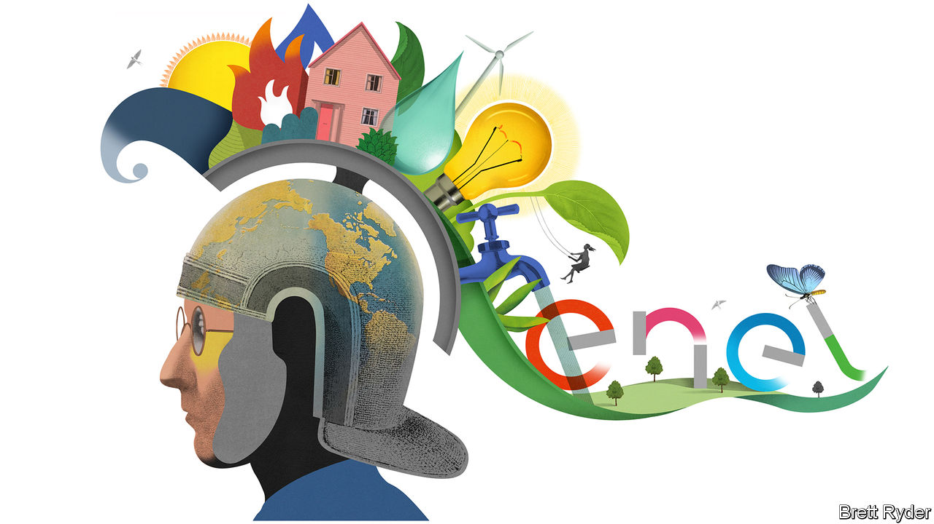

BACK IN THE 1980s a young Francesco Starace was working in the Saudi desert on a wasteful fossil-fuel project. His task was to build an oil-fired power plant. It was highly inefficient. Even though the country sits on a sea of the stuff, the fuel needed to be transported by lorry hundreds of kilometres across the desert from Jeddah. And to begin with there were no customers; its aim was to provide a way to persuade nomadic tribes to settle down in air-conditioned homes. Mr Starace loved the job. Only years later did it strike him how “crazy” it was. He tells the story to illustrate that the significance of sustainability did not dawn on him quickly.

Today the 65-year-old is boss of Rome-based Enel, Europe’s largest utility. Its market value has more than doubled to €85bn ($101bn) since he took over in 2014, making it as big as an oil giant. Concerns about climate change are now all the rage among the world’s business elite. But few companies match Italy’s biggest firm in putting its money where its mouth is. On November 24th Mr Starace unveiled plans to invest €160bn by 2030 to virtually triple its renewable-energy capacity to 120 gigawatts and transform its grids in Europe and Latin America to prepare for an all-electric future. The announcement came weeks after a similarly striking pledge by Iberdrola, Spain’s second-biggest company, to invest €75bn in renewables and grids by 2025. In America NextEra, a pioneering utility which briefly eclipsed ExxonMobil in value of late, has also promised to fork out a fortune on wind and solar.

The triumvirate’s spending plans are still dwarfed by the vast sums oil companies pour into fossil fuels every year. But they make three things clear. First, renewables have moved from niche to the big time. Second, utilities, formerly the dowdiest part of the energy universe, are now where the action is. Third, the oil industry has a lot to learn if it wants to invade their patch.

Sitting in his book-lined study on the eve of the announcement, the bespectacled Mr Starace does not fit with the caricature of a gruff utility boss. He wears a black crew-neck sweater. He reads poetry. He drives a Tesla. When he set about selling off Enel’s legacy coal-fired power stations in 2015 he wanted them turned into museums and art galleries. He talks about energy with a soft-spoken enthusiasm more usually found among tech evangelists. When discussing the money that America, Britain and the European Union are promising to invest in clean energy over the next few years, he purrs: “They finally got it.”

The pandemic, Mr Starace says, has given the world a glimpse of a renewables future. For years it was a matter of hot debate how much intermittent wind and solar power an electricity system could absorb without crashing. Lockdowns, he thinks, have helped settle the argument. They crushed demand, driving out conventional sources of power generation in favour of cheaper renewables, yet systems withstood the shock “beautifully”. Though gas and coal will bounce back, he believes governments will be reassured that renewables do not pose the dangers that their critics claim. Enel is taking advantage of the political tailwinds. By 2023 it plans to invest €16.8bn in onshore wind and solar, promising to raise core earnings, or EBITDA, by 13%. It still operates coal-fired power plants in Italy but vows to close them down by 2027, three years ahead of schedule. In a dig at the oil industry, it has taken to calling itself a “renewable supermajor”.

Renewables catch everyone’s attention. But Enel also proposes big investments in networks and distribution—the pylons that make up a grid, as well as the poles and wires feeding electricity to customers—which it operates in eight countries. To reinforce and digitise them for a future of clean energy, electric vehicles and mass electrification, Enel plans €16.2bn of investments in the next three years. It is also open to making acquisitions. Its total spending will be financed by a slight increase in net debt, green bonds and government clean-energy programmes.

The €20bn in annual EBITDA Enel is likely to generate as a result marks a “mind-blowing” turnaround, says Sam Arie of UBS, a bank. When Mr Starace took over, Enel was debt-ridden and had recently cut the dividend. Yet now it promises a guaranteed payout for the next three years, even as many pandemic-hit companies can scarcely look beyond January. Utility analysts, a nerdy bunch, relish the boldness. “You have made our job a lot more interesting,” one from Goldman Sachs, a bank, told Mr Starace.

Oil companies, which once peered down their noses at utilities, now eye them with envy. They have a lot to learn. For all their efforts to repaint themselves green, their ambitions remain a pale shade of it. Enel’s promised renewables investments in the next three years almost match those of BP, Royal Dutch Shell and Total combined. The oil majors also lack the right skills. Mr Starace says vertically integrated utilities such as Enel are different from most oil companies chiefly because of their relationships both with regulators and customers. “The only thing they have in common with us is the word ‘energy’,” he quips. And, as Meike Becker of Bernstein, a broker, puts it, oil giants tend to lack utilities’ financial discipline. They talk a good game. Utilities, in contrast, like to under-promise and over-deliver.

Dangers lie ahead. Increased competition means Enel is lowering its predicted returns beyond 2023. Its desire to move into India, a minefield of an energy market, may lead it astray. And its zeal to expand could lead to costly bidding wars for networks, such as the one it won in 2018 against Iberdrola in Brazil’s São Paulo state.

## Generation change

Mr Starace, recently given a third term as boss, appears as unflappable as ever. He has strong lieutenants who could take over when he retires. He is a model of southern-European business acumen. And he has a smooth Italian charm. “I’d love him to be the grandfather of my kids,” coos one investment adviser. Not many utility bosses can claim that as an endorsement. ■

For more coverage of climate change, register for The Climate Issue, our fortnightly [newsletter](https://www.economist.com/theclimateissue/), or visit our [climate-change hub](https://www.economist.com/news/2020/04/24/the-economists-coverage-of-climate-change)

This article was downloaded by calibre from <https://www.economist.com/business/2020/11/28/how-enel-became-europes-climate-centurion>

|  |  |  |  |
| --- | --- | --- | --- |
| Previous | Articles | Sections | Next |

|  |  |  |
| --- | --- | --- |
| Business | Sections | Science & ... |

Finance & economics

Christine Lagarde: Culture shock

.

Janet Yellen: Something for everyone

.

Buttonwood: Home-schooled

.

Stimulus in America: A clash over cash

.

Personal debt in China: Overdue action

.

Money transfers: Intrepid banking

.

Free exchange: An unbalanced debate

.

|  |  |  |
| --- | --- | --- |
| Business | Sections | Science & ... |

|  |  |  |  |
| --- | --- | --- | --- |
|  | Articles | Sections | Next |

#### Culture shock

# Christine Lagarde is taking the ECB out of its comfort zone

That is causing some controversy among the experts

Nov 28th 2020 |

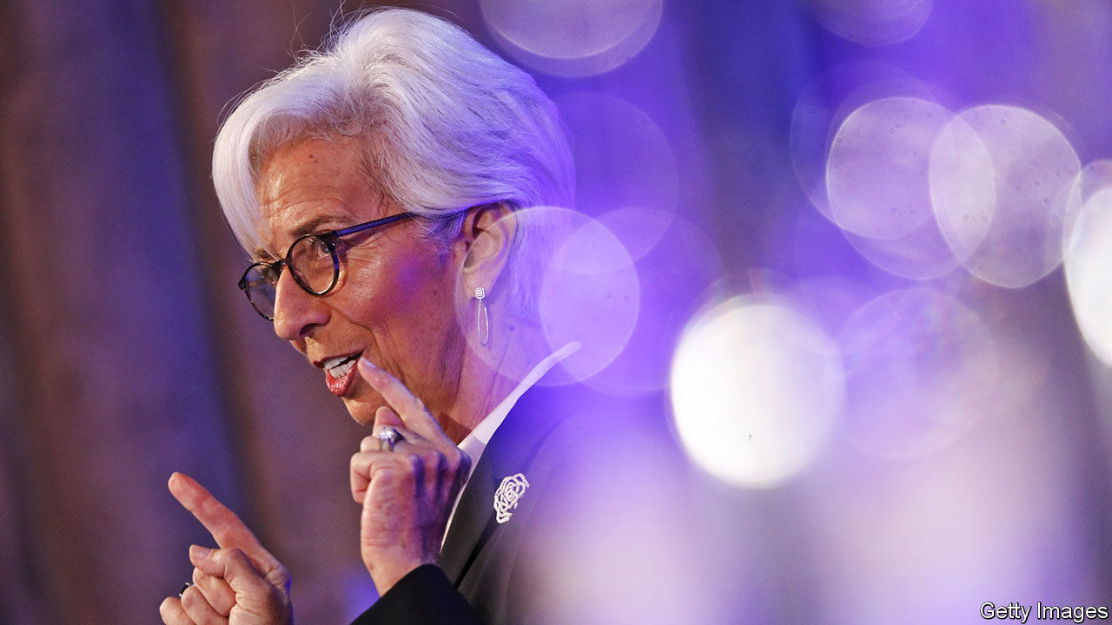

CHRISTINE LAGARDE has been an outsider before. Speaking to The Economist, she relishes the memory of shaking up bureaucrats—“men in grey suits”—when she took over as France’s finance minister in 2007. She even installed a “psychedelic” carpet in her office, to get them to look up from the floor. Now Ms Lagarde, who then went on to run the IMF, is shaking up the idea of what it is to be a top central banker.

The main prerequisite used to be a degree of nerdiness: just think of Janet Yellen, a former chairwoman of the Federal Reserve and Joe Biden’s choice for treasury secretary (see article); Ben Bernanke, her predecessor at the Fed; or Mervyn King, a former governor of the Bank of England. All spent decades in academia. By contrast Ms Lagarde, who has been the head of the European Central Bank (ECB) for just over a year, is not an economist but a lawyer and a former executive and politician. She brings a glittering CV and a high public profile to the job, but is probably more comfortable rubbing shoulders with heads of state than participating in a research seminar.

On the face of it, Ms Lagarde and the ECB have had a decent year. The bank has acted decisively, avoiding the mistakes of the financial crisis of 2007-09 and the sovereign-debt woes of 2010-12. Since the start of the year it has injected stimulus of €2.2trn ($2.6trn) into the economy (see chart 1). In contrast with the austerity of a decade ago, fiscal policy is acting in concert with monetary easing, including at the EU-wide level. The new opportunity to help co-ordinate monetary policy and government spending plays to Ms Lagarde’s strengths. Yet it is precisely her willingness to venture into areas that most central bankers consider political terrain that is causing some controversy among the experts.

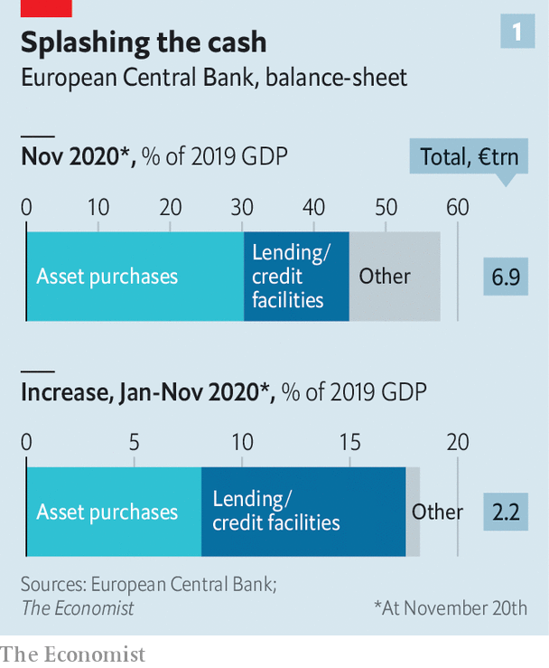

The ECB’s ammunition was sorely depleted even before covid-19 struck. Its benchmark deposit rate was -0.5%, and it had been buying government and corporate bonds through its quantitative-easing (QE) scheme since 2015. But the bank warded off a credit crunch earlier this year by ripping up self-imposed rules. Instead of buying a country’s assets in rough proportion to the size of its GDP, it has bought more of those of Italy and Spain. The ECB has also expanded the generosity of its long-term loans to banks, paying them up to 1% if they continue to lend. That, together with government guarantees, has kept credit from seizing up, even as a second wave of infections and lockdowns make a double-dip recession seem inevitable. An ECB survey published on November 24th found that access to finance was towards the bottom of small firms’ list of anxieties.

All this, however, has done little to revive the outlook for inflation. The bank itself expects annual inflation of only 1.3% by 2022. Market participants are even gloomier (see chart 2). It is becoming harder to believe that the ECB can do much more by itself. The Economist spoke to executives from five of the euro area’s biggest banks. None thought the ECB’s cheap funding alone would stir demand for credit, or encourage banks to lend to risky prospects. Ms Lagarde insists stimulus is “not exclusively a fiscal business”, and that the ECB can still do its bit. But in a speech on November 11th she made a forceful case for further fiscal action.

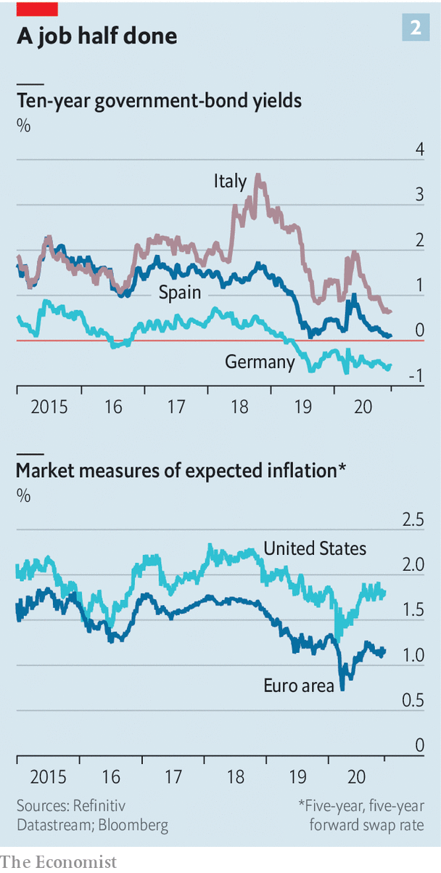

There have been two criticisms levelled at Ms Lagarde. One is that communication slip-ups over the past year show that she has only a weak grasp of the technical detail of monetary policy. That may in part reflect economists’ snootiness. But her missteps did indeed move markets. In March her comment that the ECB “was not here to close spreads” sent Italian government-bond yields soaring. In September her seeming indifference to a strengthening euro and its impact on inflation meant the currency only rose further against the dollar. Both were followed the next day by an explanatory blog post from Philip Lane, the bank’s accomplished chief economist—seeming to correct the president’s words.

Ms Lagarde is only too aware of the fact that markets hang on her every word, and now carefully watches what she says. In order to stress collective decision-making, blog posts by Mr Lane and others on the bank’s executive board will no longer appear immediately after a press conference. Some wonks reckon she has improved markedly on the job. Still, it is hard to imagine her becoming a conviction rate-setter.

Where she does have conviction is on matters such as climate change and gender equality, subjects that she promoted while at the IMF, to which grey-suited monetary policymakers generally give a wide berth—and which are the source of the second concern about her approach to central banking. It is instructive to compare Ms Lagarde’s speeches and interviews over the past year with those of Mario Draghi, her predecessor. Though “inflation” has featured 190 times, she is half as likely to mention it as Mr Draghi did in 2018 and 2019. By contrast, Ms Lagarde has mentioned “climate change” 80 times—compared with just seven across Mr Draghi’s entire eight-year term.

Climate change, according to Ms Lagarde, is an element not just of the ECB’s “secondary” objective—which is to support the EU’s economic policies. More controversially, she sees it as having a bearing on the bank’s primary mandate of price stability. She has said before that the bank will consider the merits of “green” QE, which would tilt bond-buying away from polluters. The idea clashes with the views of many central bankers, including Jens Weidmann, the head of the Bundesbank. At a Bloomberg conference on November 16th, both Ms Yellen and Lord King worried about mission creep at central banks. Few economists think climate change has a big influence on inflation; most would point out that changing polluters’ behaviour is a job for elected officials.

Ms Lagarde intends to win over the rest of the ECB’s 25-strong governing council during the bank’s strategy review, due to conclude in mid-2021. It will cover everything from relatively uncontroversial tweaks to the inflation target to more contested areas, the financial-stability effects of low interest rates and, of course, climate change. She says she hopes to convince her colleagues to “appreciate that they should be not only on the right side of history and face their children and grandchildren with a straight face, but be able to focus on the core mandate of price stability”.

That the euro area has avoided a financial crisis means Ms Lagarde can look back on the past year with some satisfaction. But her term lasts for eight years—far longer than many politicians or executives hang around for. Her push to broaden the ECB’s mission has just begun. And if some countries (eg, Germany) return to economic normality sooner than others (eg, Italy), then the ECB will also face tough choices about when precisely to unwind its emergency measures. The outsider’s next seven years promise to be more controversial than the first one. ■

This article was downloaded by calibre from <https://www.economist.com/finance-and-economics/2020/11/28/christine-lagarde-is-taking-the-ecb-out-of-its-comfort-zone>

|  |  |  |  |
| --- | --- | --- | --- |
|  | Articles | Sections | Next |

|  |  |  |  |
| --- | --- | --- | --- |
| Previous | Articles | Sections | Next |

#### Something for everyone

# Janet Yellen will lead Joe Biden’s Treasury. What does she stand for?

Progressives and conservatives both see something to like in the former Fed chair

Nov 24th 2020 |

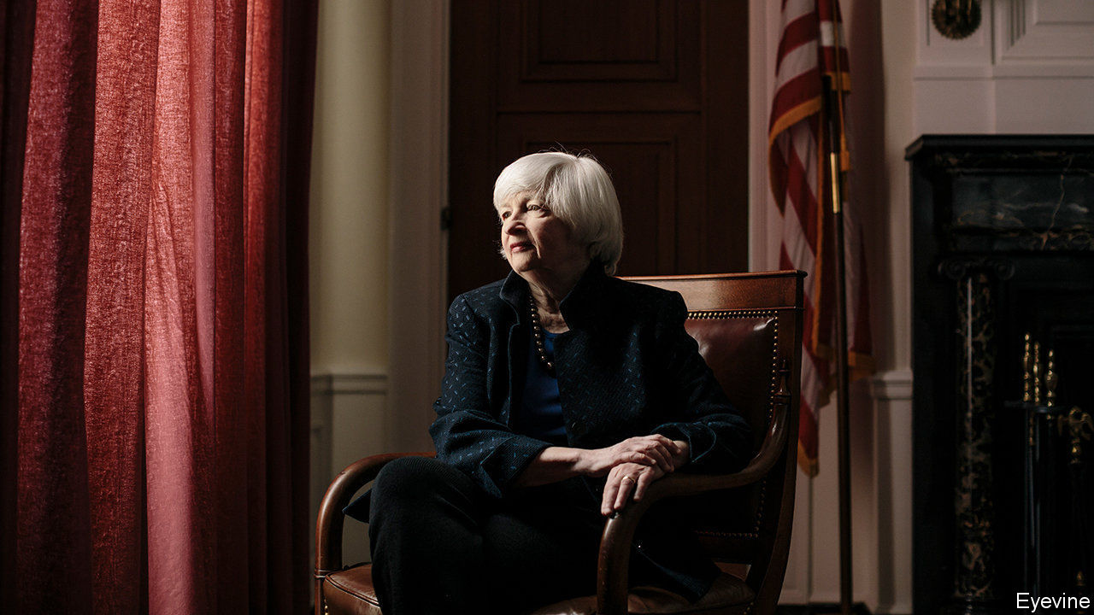

IN THE FIRST instalment of the “Harry Potter” series, the protagonist stumbles across the Mirror of Erised. Anyone who looks into the mirror sees the “deepest, most desperate desire” of their hearts reflected back at them. There is a touch of Erised about President-elect Joe Biden’s decision to nominate Janet Yellen as America’s next treasury secretary, first reported on November 23rd. No economist is more qualified than Ms Yellen, a former head of the Federal Reserve and a respected academic, for the job. Perhaps more important, however, for what is a political role as much as an economic one, people from the progressive left to the conservative right can see something to like in her.

In today’s political configuration, that matters. Mr Biden must tame a split in the Democratic Party between run-of-the-mill centrists and tear-it-down millennial socialists. And before she becomes treasury secretary, Ms Yellen must be confirmed by the Senate, which Republicans currently control. That hurdle ruled out candidates such as Elizabeth Warren, a senator from Massachusetts whom many Republicans would never confirm because she is seen as too hostile to free markets and the financial industry.

In the days before the announcement Washington insiders believed the race was between Ms Yellen and Lael Brainard, a governor of the Fed. Some favoured Ms Brainard on the grounds that she had more expertise in trade economics, others because she is younger than Ms Yellen, and would therefore do a better job of balancing an elderly president. Left-leaning Democrats were particularly taken with Ms Brainard’s monetary doveishness.

Yet Ms Yellen has many advantages of her own. She is an accomplished economist, originally specialising in labour economics, and is the president of the American Economic Association, the field’s pre-eminent learned society. (There are also few better-liked people in the profession; wonks turn up their collars in homage to one of Ms Yellen’s sartorial quirks.) She was a highly competent chairwoman of the Fed between 2014 and 2018, communicating the central bank’s intentions clearly in advance so as not to take investors by surprise. Her experience at the Fed may prove useful given that the central bank and the Treasury must continue to cooperate to help the economic recovery along. Under Ms Yellen there would be little chance of the sort of spat that has developed over the Fed’s lending schemes (see article).

The genius of choosing Ms Yellen lies in the fact that people of all political persuasions can find some reason to cheer her appointment. That means she will almost certainly be confirmed by the Senate. Take monetary policy. Hawks point out that during Ms Yellen’s tenure the Fed raised rates from near zero to 1.25-1.5%. Doves counter that hawks were over-represented on the rate-setting panel at the time, and that Ms Yellen in fact did a good job of keeping them in check.

It is a similar story on fiscal policy. Shortly before Donald Trump became president, Ms Yellen argued that “fiscal policy is not obviously needed to provide stimulus to help us get back to full employment”. She is on the board of the Committee for a Responsible Federal Budget, an organisation that spends a lot of time warning people about the dangers of high public debt. Yet in the pandemic Ms Yellen has urged “extraordinary fiscal support”. In June she co-signed a letter saying “Congress must pass another economic recovery package.”

Passing another stimulus bill may be her first big task. Republicans and Democrats have been unable to agree on a replacement to the bill passed in the spring, with particular disagreement on the size of the eventual package, even as it is now clear that America’s economic recovery is slowing. It is a lot to expect that the sheer force of one person could help break the deadlock, not least because Republicans are likely to retain control of the Senate for a while yet. But if anyone can do it, it may be Ms Yellen. ■

Dig deeper:  
Read our [latest coverage of the presidential transition](https://www.economist.com/us-election-2020), and then sign up for Checks and Balance, our [weekly newsletter](https://www.economist.com/checksandbalance/) and [podcast](https://www.economist.com/checks-and-balance-our-weekly-podcast-on-american-politics) on American politics.

This article was downloaded by calibre from <https://www.economist.com/finance-and-economics/2020/11/24/janet-yellen-will-lead-joe-bidens-treasury-what-does-she-stand-for>

|  |  |  |  |
| --- | --- | --- | --- |
| Previous | Articles | Sections | Next |

|  |  |  |  |
| --- | --- | --- | --- |
| Previous | Articles | Sections | Next |

#### Buttonwood

# Is there an M&A boom coming?

Finance, economics and psychology all come into it

Nov 28th 2020 |

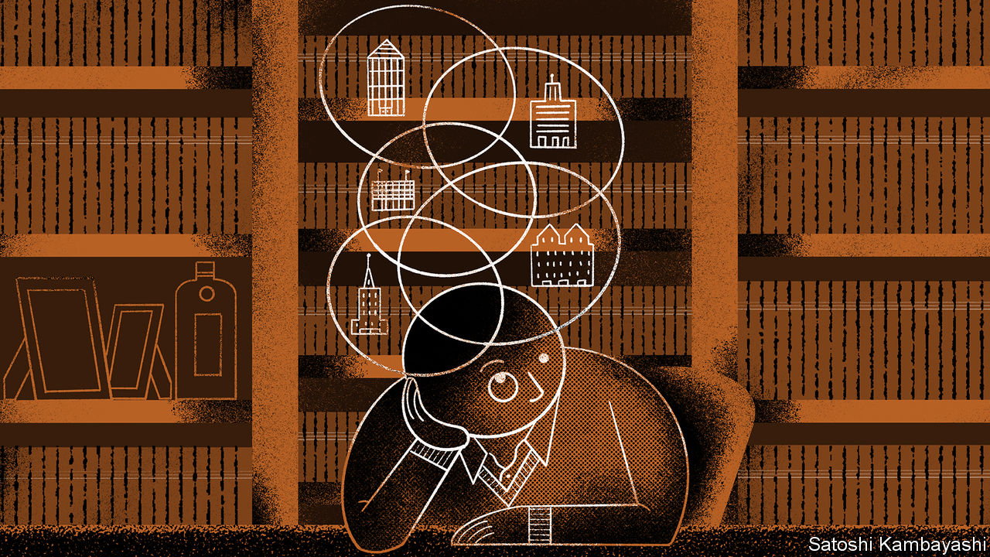

IMAGINE YOU are the boss of a public company. Normally you are busy making decisions, visiting outposts, talking to customers, suppliers and employees. The meetings are endless. You have little time for reflection. Then, suddenly this spring, after a bout of firefighting, the diary is bare. You sit in your study, hiding from the family, and ruminate—about what your firm lacks, about what it has too much of. You call a friendly investment banker and say: “I may need to do a deal soon.”

The results of such stay-at-home strategy sessions are now apparent. The past few weeks have seen a burst of M&A activity. There are merger deals of all kinds, in all parts of the world, across many industries—from tech and health care to banking and publishing. The dealmakers at investment banks are joyful. The last time things were this busy, they say, was in 2007-08.

Shareholders have some call to fear the worst. There is a weighty body of literature, some of it dating from the stockmarket bust of the early 2000s, that says mergers do not create value for the acquiring company. More recent research is more nuanced. Mergers overseen by serial acquirers tend to add to value, it finds. Once M&A gets going, things can quickly get out of hand, of course. But this early in the economic cycle, and in the unusual circumstances, mergers are more likely to have a coherent logic to them.

To understand the burgeoning M&A boom, go back to January and February. Bankers had a full pipeline of deals. Then the pandemic took hold. A dealmaking CEO had to think again. If you had a merger in the works, you pulled it. You couldn’t project numbers with confidence. You didn’t know if you could afford a deal, or finance it. Even then, the calls with bankers never stopped. In place of black-tie events came virtual schmoozing—from one home study to another.

The deal pipeline started to thaw in June or July. Announcements have been coming thick and fast since. A lot of this is down to market conditions, which quickly turned favourable and have remained so. Equity prices have roared back from their lows of late March. The companies with shares that rallied first—technology and health care—found themselves with a highly valued currency with which to pay for deals. The corporate-bond market has reopened with a vengeance, making debt finance available. Interest rates are at rock bottom and likely to stay there for a while. Private-equity firms have a lot of unused capital (“dry powder”) to call upon.

But financial conditions are not the only explanation. The economy is another. The pandemic has given companies new problems to solve and made some existing ones more pressing. M&A offers a fix. Debt-laden firms need to sell assets. Buyers want to plug some strategic holes. The rationale for a deal might be to secure supply chains, to diversify across geographies, to acquire a specific (often digital) capability; or simply to bolster revenues or cut costs when the outlook for profits is rather bleak. Some of the transactions that are happening now are deals of opportunity, says Alison Harding-Jones, head of M&A in Europe, the Middle East and Africa for Citigroup, a bank. And some are deals of necessity. Covid-19 has created winners and losers across industries, but also within them. CEOs of winning companies may find that the acquisition on their lockdown wishlist is available. Those of losing companies must simply try to sell wisely.

Both kinds will be wary of the response from shareholders. The risks of getting the price wrong or of underestimating the hassle of integrating acquisitions are ever-present. But deals that have a decent-looking strategic case are likely to be given the benefit of the doubt. Serial dealmakers will get the most leeway. Research from McKinsey, a consultancy, finds that companies that do lots of smallish acquisitions over time tend to add value to them. Such “programmatic acquirers” take more care in assessing targets, aligning M&A with broader corporate strategy and integrating their purchases.

As a rule big, one-off deals are riskier. The dangers seem small now but will grow the longer the M&A boom goes on. Bosses will start to worry that their dealmaking rivals look more in command of events. They will be prone to the ill-advised, grandiose merger. When the boom is all over, a few such souls will find themselves back in the study at home, but this time because they no longer have an office to go to, asking themselves: “Why did I do it?”

This article was downloaded by calibre from <https://www.economist.com/finance-and-economics/2020/11/28/is-there-an-m-and-a-boom-coming>

|  |  |  |  |
| --- | --- | --- | --- |
| Previous | Articles | Sections | Next |

|  |  |  |  |
| --- | --- | --- | --- |
| Previous | Articles | Sections | Next |

#### A clash over cash

# Jerome Powell and Steven Mnuchin are at odds over emergency loans

Mr Mnuchin argues the funds could be better used elsewhere

Nov 28th 2020 | NEW YORK

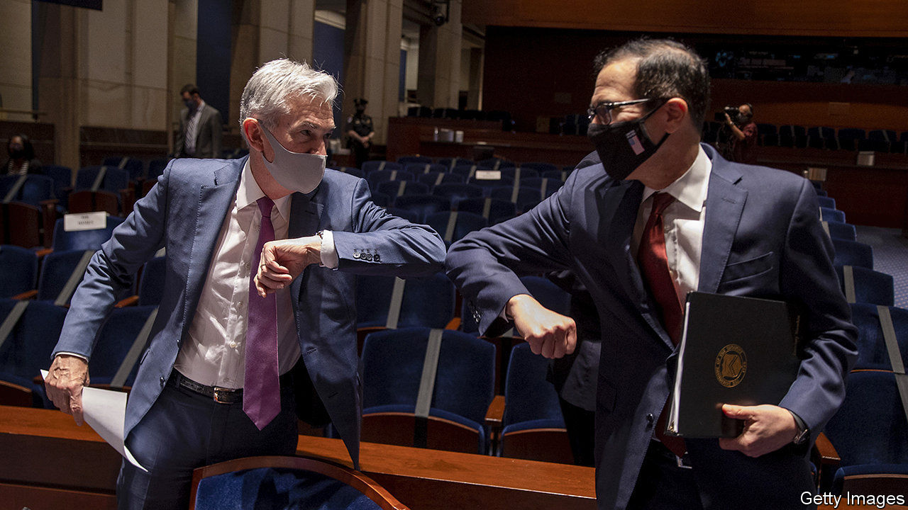

AS COVID-19 spread across America, its fiscal and monetary tsars donned their masks, bumped elbows and presented a united front. Jerome Powell, the chairman of the Federal Reserve, slashed interest rates and bought Treasuries and mortgage debt. Steve Mnuchin, the treasury secretary, pushed through a stimulus package worth $2.2trn that increased the generosity of unemployment benefits and secured funding for the Fed to support firms and market participants in need.

This partnership seemed to fracture on November 19th, when Mr Mnuchin wrote to Mr Powell to say that he would let several of the Fed’s emergency lending schemes expire on December 31st. He asked for Treasury funds that had been allocated to the Fed, as capital to support these programmes, to be returned.

Mr Mnuchin’s decision earned a rare rebuke from the Fed, which said that it “would prefer that the full suite of emergency facilities...continue to serve their important role as a backstop for our still-strained and vulnerable economy”. Just a few weeks earlier Mr Powell had said the pair were working on an extension. On November 20th, though, he acquiesced to Mr Mnuchin’s request. The Treasury had allocated $195bn in capital to support the Fed’s programmes, half of which had been transferred to the central bank. The Fed will now return $70bn, keeping $25bn for loans it has already made.

Mr Mnuchin pointed out that the programmes that would cease—including facilities to buy corporate and municipal bonds, and those that make direct loans to firms—were under-used and seemed to have served their purpose. The Fed could have made up to $2trn-worth of loans; instead it lent just $25bn. The schemes were intended to quell market dysfunction; corporate-credit and municipal spreads on Treasuries have since normalised, and companies have been able to issue plenty of debt.

Emergency-lending schemes can act as a sort of insurance, even if they are not widely used. Indeed the mere announcement of the schemes in the spring served to kick-start credit markets, even before anything had been bought. But capital markets seemed to broadly endorse the idea that the Fed’s emergency lending schemes were no longer needed. Stockmarket futures and bond yields dipped a little, as Mr Mnuchin’s letter was published, but both had recovered by the end of the day. Credit spreads did not widen.

What might explain Mr Mnuchin’s actions? With government-borrowing yields near all-time lows, the cost of allocating capital to the Fed’s facilities is small. But the political costs may have been higher. When Mr Mnuchin and Mr Powell testified to Congress in September, no fewer than seven representatives quizzed them about the poor take-up of the Main Street Lending facility, which makes loans to firms.

Mr Mnuchin has suggested directing some of the funds to other schemes, such as the Paycheck Protection Programme, a vehicle that lends to small businesses, which ran out of funds in August. Perhaps he hopes that promising support for small firms will sway Republicans reluctant to approve another stimulus package. A less charitable explanation is that he wants to obstruct the next administration. The returned cash will go to the Treasury’s General Fund, which will require legislation if it is to be tapped. If Janet Yellen, President-elect Biden’s choice for treasury secretary, wants to use it, she will have to secure the votes first. ■

This article was downloaded by calibre from <https://www.economist.com/finance-and-economics/2020/11/28/jerome-powell-and-steven-mnuchin-are-at-odds-over-emergency-loans>

|  |  |  |  |
| --- | --- | --- | --- |
| Previous | Articles | Sections | Next |

|  |  |  |  |
| --- | --- | --- | --- |
| Previous | Articles | Sections | Next |

#### Overdue action

# Bad debts in China

Debt collection, Chinese style

Nov 28th 2020 | HONG KONG

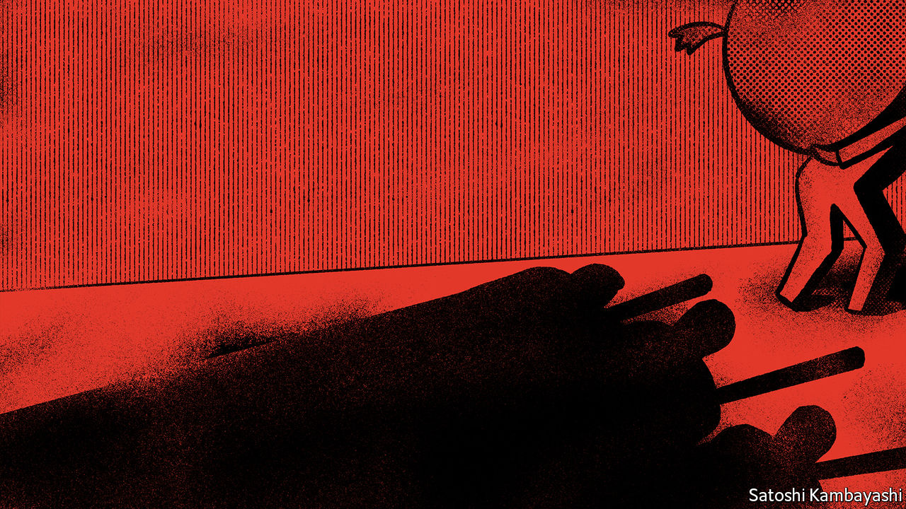

DEBT-COLLECTION videos have become a popular subgenre on Chinese clip-sharing platforms. Many feature young men deftly fielding phone calls from aggressive collectors. Some portray the abuses—hair pulling, slapping—that have come to define a business that has long gone largely unregulated in China. The result has been a Wild West for collections. Debt collectors sometimes impersonate police officers; the details of debtors’ friends and family are sold so that they can be harassed. A swift rise in personal debt, though, is forcing regulators to act.

Between 2015 and 2019 the stock of household debt in China rose by about $4.6trn, close to the $5.1trn accrued by Americans over a similar period before the global financial crisis of 2007-09, according to data from Rhodium Group, a consulting firm. The outstanding balance of delinquent consumer receivables could reach nearly 3.3trn yuan ($500bn) next year, up from just 1trn yuan in 2015, reckons iResearch, another consultancy.

In June the southern city of Shenzhen drafted the country’s first personal bankruptcy law. Courts routinely heard disputes between lenders and borrowers, but allowed only creditors to file suits. The new law, to be rolled out next year, will offer debtors more protection against creditors. A few other cities are conducting similar experiments, though “these reforms are still very limited,” says Li Jiao of Buren, a law firm.

The central bank, meanwhile, issued draft rules late last year, threatening to punish banks for working with dodgy debt collectors, though it softened the language before the guidelines took effect on November 1st this year. Government pressure, say industry executives, has prompted consolidation. Some companies, such as YX Asset Recovery, have banned in-person visits and operate only call centres—a practice considered less intrusive. YX, which had more than 10,000 agents last year, has sworn off practices including selling debtor information, impersonating government officials, and threatening violence.

Yet the early reforms do not quite hit the mark. They have helped control debt collection for banks, but it is online lenders and microloan companies that pose a bigger risk. Delinquency rates have climbed above 30% this year at many nonbank lenders, compared to 5% for banks. Most online lenders are not targeted by the new rules and tend to hire local collections agencies that pursue aggressive, often-illegal tactics for recovering debts.

Nor has the shift away from in-person visits eliminated debtor harassment. Physical threats seem to be being replaced by mediated forms of “emotional pressure”, applied during frequent phone calls, says Tom McDonald of the University of Hong Kong. Those seeking advice on how to deal with officious agents need look no further than the growing archive of debt-collection videos available online. ■

This article was downloaded by calibre from <https://www.economist.com/finance-and-economics/2020/11/28/bad-debts-in-china>

|  |  |  |  |
| --- | --- | --- | --- |
| Previous | Articles | Sections | Next |

|  |  |  |  |
| --- | --- | --- | --- |
| Previous | Articles | Sections | Next |

#### Merchant bankers

# Hawala traders are being squeezed by regulators and covid-19

But the centuries-old system will bounce back

Nov 28th 2020 | KABUL

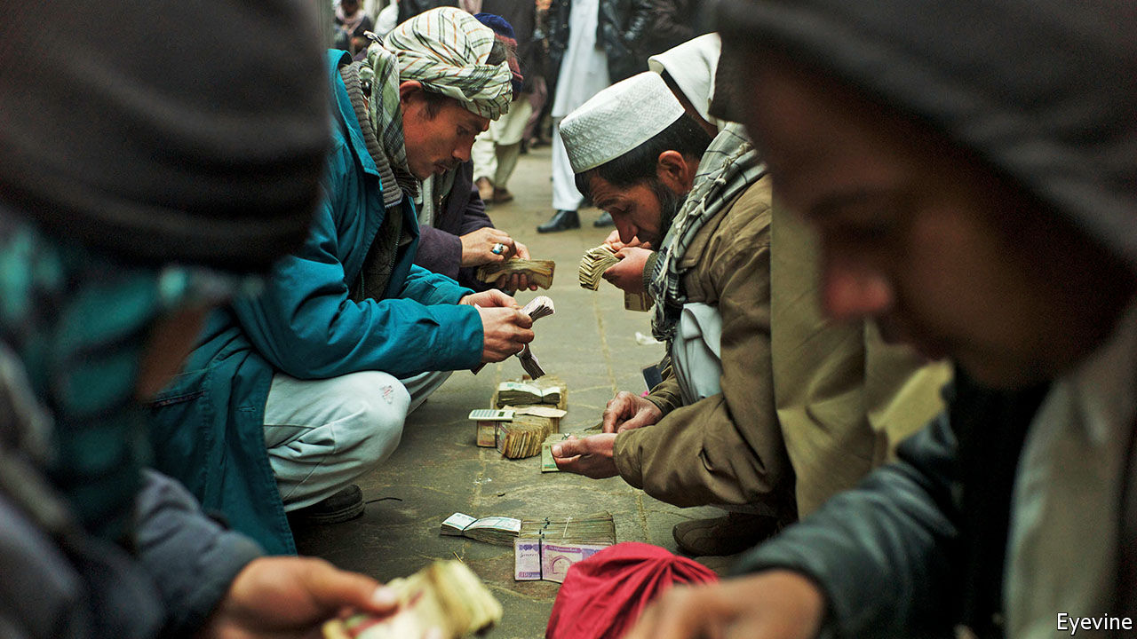

PACKED TRADING floors are rare these days. An exception is the Shahzada currency-exchange market in Kabul. Seven days a week hundreds of men crowd into a modest courtyard. Each has a bundle of banknotes; some have piles several feet deep. Prices—for American dollars, Iranian rials and Pakistani rupees—ring out and deals are done, on the spot, in cash. In the small offices around the sides, money that is changed can then be transferred to almost anywhere in the world. Cash is handed over and WhatsApp messages fly.

The money travels by hawala (from the Arabic for “transfer”), a centuries-old system. Transactions in opposite directions are matched against each other through a network of personal contacts. An Afghan in London sending remittances home might in turn finance a Kabuli merchant importing Chinese goods purchased in Britain. Banks may be used—but not formally. The sender is given a serial number, which they send (these days on WhatsApp) to the recipient, who then picks up the money from a contact of the hawala merchant.

Hawala is the core of Afghanistan’s financial system. One in six adult Afghans has a bank account; there are just two branches for every 100,000. Most remittances—which some estimates reckon amount to 15-18% of the country’s GDP each year—flow through it. Even international aid agencies use it. And Afghanistan is not the only place where hawala dominates. In Iraq, Somalia and Syria, the transfer system is vital too. Hawala is used in India and Pakistan to avoid slow and unwieldy banks. And the presence of huge numbers of migrants means it is well-established in the Gulf, especially Dubai.

Yet hawala is under intense pressure. Regulators around the world hate the system, because of its opacity and its role in helping to fund terrorism. And covid-19 has hammered many merchants, by drying up cross-border trade and closing the small shops and businesses that do transfers.

Hawala dominates in places like Afghanistan because it is so efficient. Margins on even small international transfers may be as low as 1%, far less than banks’ charges. Indeed, sending money from Afghanistan to the West is often free, says Haroun Rahimi of the American University of Afghanistan. It is not only cheaper to use a hawala merchant than a bank, but quicker and easier too. Transfers can typically be picked up the same day. Customers do not need to prove their identity, or explain why the money is being sent. That is why it is essential in places like Afghanistan and Somalia, where large parts of the population do not have identity documents.

But this is also precisely why regulators dislike it. Western banks cut off anyone they suspect is using an account to send money to places that are considered high-risk, such as Afghanistan or Somalia. In India and Pakistan hawala merchants are arrested for evading the countries’ capital controls. In Afghanistan the central bank, under foreign pressure to ensure transparency, has long sought to crack down on traders. In 2018 they were banned from holding deposits and making loans, and were required to start collecting documents on their customers. Instead of complying they went on strike, claiming that the new rules would destroy their business. Within a week the government had backed down. “Shutting down hawala markets would paralyse the economy,” says Mr Rahimi. Now an uneasy truce prevails.

Covid-19 has not helped hawala traders, many of whom also provide trade finance. In his office at Shahzada, Haji Zarak, the spokesman of the union of currency exchangers, says that the past year has been the toughest ever. When coronavirus first hit Afghanistan, the traders at the market went down to three days a week to socially distance. But the bigger hit was to goods trade. With borders closed, importers did not need to move money around, or to borrow to cover liquidity gaps. The only country with which transactions have increased is Turkey—which Mr Zarak suspects is largely rich Afghans moving money out to buy property, fearing a Taliban takeover. He worries about a second wave. “If covid-19 comes back, we will be in trouble.”

What comes next for hawala? Some think that it can, in effect, be taken over. Abdul Bari Ahmadzai of Moore, a consultancy that works on Hesab Pay, a mobile-money app, says if regulators allow it, hawala merchants could work as mobile-money agents on the side. Transactions around the country at least could be done instantaneously on phones. In Somalia, where telecoms operators are largely unregulated, that has already happened. According to the World Bank, around three-quarters of Somalis use mobile money—mostly denominated in dollars—and it is more common than cash. Mr Bari reckons the shift would in turn expand Afghans’ access to banking, and gradually formalise the financial sector.

Yet that outcome is far from guaranteed. Hawala merchants will be nervous of anything that requires them to start collecting data or comply with other regulations. And if they do not, Afghanistan’s few formal banks have a lot to lose by working with them. These already have only limited access to the international banking system. Huge amounts of money travel from Afghanistan to neighbouring Iran, its main source of imports. And as the number of people on America’s sanctions list rises, the risks for western banks dealing in the region grows. They could decide to cut off many Afghans entirely. If that happens, hawala could be the only alternative left. ■

Editor’s note: Some of our covid-19 coverage is free for readers of The Economist Today, our daily [newsletter](https://my.economist.com/user#newsletter). For more stories and our pandemic tracker, see our [hub](https://www.economist.com/news/2020/03/11/the-economists-coverage-of-the-coronavirus)

This article was downloaded by calibre from <https://www.economist.com/finance-and-economics/2020/11/28/hawala-traders-are-being-squeezed-by-regulators-and-covid-19>

|  |  |  |  |
| --- | --- | --- | --- |
| Previous | Articles | Sections | Next |

|  |  |  |  |
| --- | --- | --- | --- |
| Previous | Articles | Sections | Next |

#### Free exchange

# Why it is misleading to blame financial imbalances on a saving glut

New research calls for a careful distinction to be made between saving and financing flows

Nov 28th 2020 |

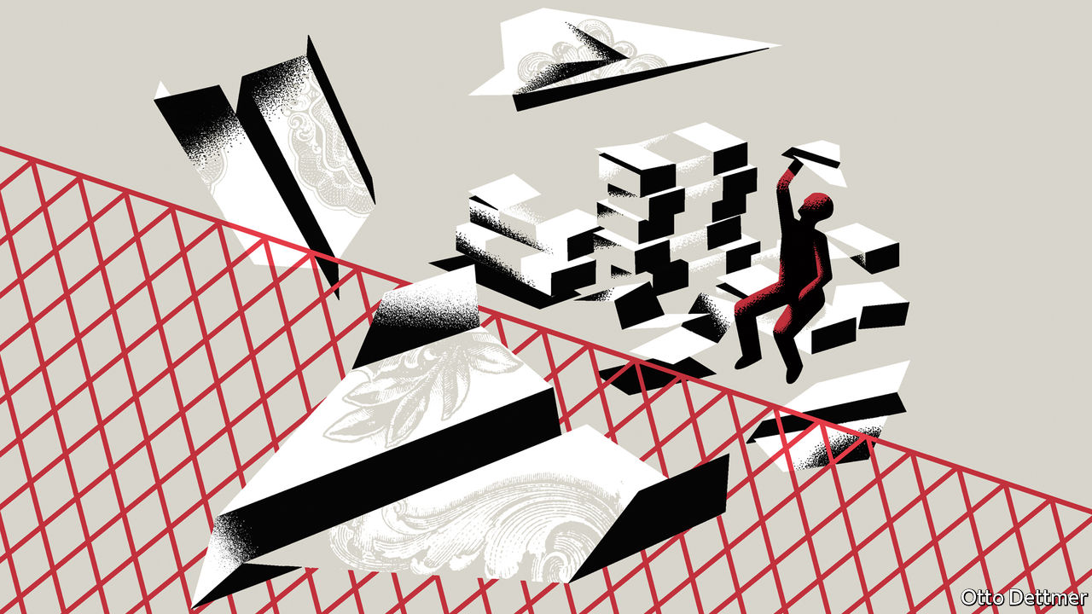

IN 2005 BEN BERNANKE, then a governor of America’s Federal Reserve, noted a “remarkable reversal in the flows of credit” to several emerging economies, especially those in East Asia. These countries had begun to save more than they invested at home, becoming a “net supplier of funds” to the rest of the world. Their “saving glut”, as Mr Bernanke called it, was helping finance America’s widening current-account deficit, allowing the world’s richest country to buy more goods and services from others than it sold to them. Mr Bernanke wondered whether this arrangement could, or should, persist. Some economists later blamed the glut for America’s housing bubble.

Similar concerns are resurfacing. In the second quarter of this year, America’s net national saving rate dipped below zero, as Stephen Roach of Yale University pointed out in the Financial Times last month. Lacking saving of its own, America instead borrowed “surplus saving from abroad”, he wrote. Its current-account deficit widened faster in the second quarter than ever before recorded.

This sort of reasoning is quite common, not least in these pages. But a number of economists, including Michael Kumhof of the Bank of England, Phurichai Rungcharoenkitkul of the Bank for International Settlements (BIS) and Andrej Sokol of the European Central Bank, take strong issue with it. Echoing work by Claudio Borio and Piti Disyatat of the BIS, they call for a careful distinction between flows of saving and flows of finance. The two are not the same. They need not even move together. The implication is that Mr Bernanke may have got things the wrong way around.

In everyday language, saving is the opposite of spending. The word evokes money accumulating in a bank account. And it is easy to imagine this money helping finance spending elsewhere. But in economics, saving is rather different. It is the opposite of consumption. By producing something that is not consumed, the economy is saving. Thus someone who spends all their earnings on home improvements is saving, however stretched they may seem, because a house is a durable asset, not a consumer trifle. Similarly a farmer who stores his harvest in a barn, rather than eating it, is saving—even if he never deposits money in a bank.

So how does saving, properly defined, flow across borders? Any output that is not consumed meets one of two fates: it is either invested or exported. It follows that anything that is neither consumed nor invested at home must be exported. (A farmer might, for example, export wheat to a barn overseas.) What flows across borders are the unconsumed goods and services themselves. “Other countries are not sending saving to America to give it ‘funds’ to finance their imports,” argue Mr Kumhof and Mr Sokol. “Their net exports are the saving, by definition.”

But how then do Americans pay for these foreign goods? That raises the question of financing. Unlike saving, financing is inseparable from money. To ask “how did you finance that?” is to ask “how did you obtain the money to buy that?”. Most money is brought into the world by banks, which have the happy ability to create it whenever they make a loan or purchase an asset. Thus the amount of financing available to a country depends heavily on the behaviour of banks, rather than on the amount of saving that either it or its trading partners do.

In a world of gluts and deficits, who finances whom? The conventional answer is that countries with excess saving finance those with saving shortfalls. But this less conventional group of economists argues that the answer depends not on the geography of saving and investment but on that of banking and finance. In many cases, American importers will fund their purchases with dollars borrowed from (or already held in) American banks.

When the purchase is complete, the dollars will be held by foreigners. They then represent a foreign financial claim on America. Because America is buying more stuff from the world than it sells, these claims on America will grow faster than the payments it receives for its exports. Many conventional economic models treat these net payment flows as the only kind of capital flow. But in reality, they are but a small fraction of the financial flows between countries. Many cross-border transactions, after all, do not involve goods and services at all. They instead represent purchases of foreign assets, including shares, bonds, property and the like. In the year Mr Bernanke made his speech, the net capital outflow from “saving glut” countries (with current-account surpluses) was 2.5% of global GDP. Gross capital flows, by comparison, were around 30%, according to Mr Borio and Mr Disyatat.

## Gluttonous behaviour

An excess of saving, then, determines neither the geographical source nor the scale of cross-border financing. Nor is excess saving necessarily the right causal starting point. The paper by Mr Kumhof and others models what they call a “credit glut”: an abundance of lending by American banks to the country’s citizens. In spending this fresh money, Americans would no doubt suck in goods from abroad. This leads other countries to increase their saving, since America cannot import goods that are being consumed or invested elsewhere. But in this case, the increase in foreign saving and surpluses is a side-effect of a financial boom within America, not a cause of its overspending. The authors believe a credit, rather than a saving, glut is a more convincing explanation for the pre-2008 imbalances identified by Mr Bernanke, although they have less to say about more recent developments.

For many people (including some economists), it is natural to think that saving must precede investment and that deposits must precede bank lending. It is therefore tempting to see saving as a source of funding and the prime mover in many macroeconomic developments. Mr Kumhof and his co-authors see things differently, giving banks a more active, autonomous role. They give less credit to saving and more to credit. ■

This article was downloaded by calibre from <https://www.economist.com/finance-and-economics/2020/11/28/why-it-is-misleading-to-blame-financial-imbalances-on-a-saving-glut>

|  |  |  |  |
| --- | --- | --- | --- |
| Previous | Articles | Sections | Next |

|  |  |  |
| --- | --- | --- |
| Finance & economics | Sections | Books & arts |

Science & technology

The coronavirus pandemic: Another covid-19 vaccine joins the party

.

Sterilising medical instruments: Sunlight is the best disinfectant

.

Palaeontology: Nursery days

.

Children’s car seats: Berth control

.

The death of Arecibo: Si monumentum requiris respicite

.

|  |  |  |
| --- | --- | --- |
| Finance & economics | Sections | Books & arts |

|  |  |  |  |
| --- | --- | --- | --- |
|  | Articles | Sections | Next |

#### The coronavirus pandemic

# Another covid-19 vaccine joins the party

But there are doubts about the data describing its efficacy

Nov 23rd 2020 |

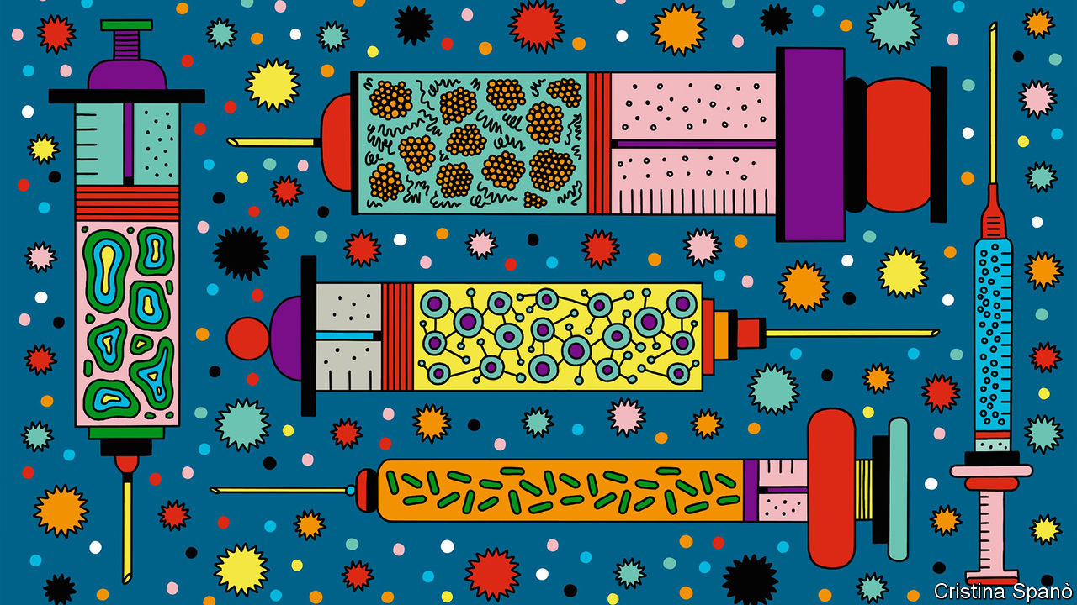

ON NOVEMBER 23RD, for the third Monday in a row, the results of an anti-covid vaccine were announced. This time the protagonists were AstraZeneca, a British-Swedish pharmaceutical company, and Oxford University. They reported their vaccine to be 70% effective. But doubts have since arisen about the conduct of the trials which arrived at this figure.

The consortium’s researchers estimated their vaccine’s efficacy from interim data collected by trials in Britain and Brazil. These involve more than 23,000 volunteers, half of whom have received the vaccine and the other half a placebo of one sort or another. Like the previous offerings (one from a partnership between Pfizer, a big American pharma company, and BioNTech, a small German one; the second from another American firm, Moderna), the AstraZeneca-Oxford inoculation is administered in two jabs. Of those given it, none has been admitted to hospital with covid-19, nor suffered a severe case of it. The researchers from AstraZeneca and Oxford also say that their vaccine may reduce passage of the virus between people—a property not yet established for either of the other two. An ideal vaccine needs to break the chain of transmission, as well as stopping recipients from falling ill, so this claim is important.

## Half measures?

The consortium’s claim of 70% efficacy is, however, complicated by concerns about a slip-up during the trials which meant some participants were given only a half-dose of the vaccine to start with, followed by a full one. Intriguingly, the efficacy of this approach seemed to be about 90%. But if that is confirmed as correct, it follows that the efficacy of the intended protocol is actually only 62%. Further complications are that the half-dose group was a small fraction of the total, making statistical analysis less robust, and that group members were under 55, rather than fully representative of the population.

Why a lower initial dose might yield a stronger response is puzzling. The answer may lie in how the AstraZeneca-Oxford vaccine delivers genetic material from the coronavirus into the recipient’s body, in order to stimulate that person’s immune system. It uses what is known as a viral vector to carry this material, a substance called RNA that is a cousin of DNA. The other two vaccines deliver RNA as a “naked” molecule, wrapped up in a fatty bubble.

Before the trials began, some researchers had worried that going down the viral-vector route might cause people to develop immunity to the vector as well as to the coronavirus proteins which the RNA payload would encourage that person’s cells to make. The findings from the accidental subgroup hint that anti-vector immunity may, indeed, be happening, causing a large first dose to prime the body to develop antibodies to the vector. These would then attack the second-dose vectors before they could do their job. A smaller first dose might diminish this priming effect—explaining the better efficacy of unequal doses. The researchers expect to gather more information about the nature of the immune response in the weeks ahead.

As with data on the other two vaccines, much of the information provided so far is frustratingly preliminary. However, the Oxford group say they hope soon to submit a paper, presumably containing fuller information, to a journal. It is not clear when those developing the other two vaccines will do the same, but data from their trials will be made available prior to meetings with the American regulator in December.

## Haste versus speed

The headline figure of 70% efficacy contrasts superficially with announced values of 95% for the other two vaccines. But, tempting as it is to compare these figures, that is actually hard to do. The most important reason for this is that developers count covid-19 cases in different ways. In particular, the AstraZeneca-Oxford trials checked participants for asymptomatic infection, rather than relying on self-reported symptoms to establish who was infected. The number of cases after vaccination may therefore seem higher than for the Pfizer-BioNTech and Moderna jabs, which relied on self-reporting by patients with a follow-up confirmatory test.

One bonus of the AstraZeneca-Oxford offering is that, if approved, it could be rolled out quickly. Pascal Soriot, AstraZeneca’s boss, says his firm has partnerships with suppliers in India, Latin America, Russia and Thailand. The Serum Institute in India agreed to manufacture the vaccine in bulk as long ago as April. “We are going to supply low- and middle-income countries around the world from different sources,” Mr Soriot says. “We are aiming at doing this more or less at the same time, so everybody gets access in an equitable manner as quickly as possible.” Altogether, AstraZeneca says the capacity exists to make 3bn doses of its vaccine over the course of next year. That compares with 1.3bn of the Pfizer-BioNTech vaccine, while Moderna hopes for between 500m and 1bn.

The AstraZeneca-Oxford vaccine is also cheap, and can be kept for at least six months in a normal refrigerator, meaning it can be stored in any surgery or pharmacy around the world. Moderna’s vaccine, by contrast, can be kept in an ordinary fridge for just a month. The Pfizer-BioNTech offering is even more sensitive. For most of the time it needs ultra-cold storage at -70°C. It can sit in a standard fridge for only a few days. Richard Hatchett, the head of CEPI, a foundation that pays for research into vaccines against novel pathogens, says he thinks the AstraZeneca-Oxford vaccine has the potential to alter the course of the pandemic, and could be delivered anywhere, including poor countries.

Although AstraZeneca says its vaccine was well tolerated by those who received it, questions remain about an unknown adverse event which caused trials to be halted temporarily earlier this year. These, and other matters, must now be considered by regulators, as they assess applications for emergency authorisation that the makers of all three vaccines will submit. AstraZeneca says it will also seek an emergency listing from the World Health Organisation. That would permit its jabs to be used in places which do not have regulatory authorities capable of assessing vaccines.

If time were not of the essence, it would make sense to wait for longer-term data on all the new vaccines. But in the face of a pandemic, that is not sensible. Regulations to allow for emergency use are designed for just such situations. Regulators will, however, have to keep tight control of these new vaccines to start with. At the outset their use will probably be restricted to those who need them most—doctors, nurses and other health-care workers, and also the elderly. Regulators will also insist on close monitoring for side-effects. But, as data accumulate over the first months of next year, those chains are likely to be loosened. The past three weeks, then, have transformed the prospects for 2021. The world now knows covid vaccines are possible. Let the hard work begin.■

This article was downloaded by calibre from <https://www.economist.com/science-and-technology/2020/11/23/another-covid-19-vaccine-joins-the-party>

|  |  |  |  |
| --- | --- | --- | --- |
|  | Articles | Sections | Next |

|  |  |  |  |
| --- | --- | --- | --- |
| Previous | Articles | Sections | Next |

#### A solar autoclave

# How to sterilise scalpels when no electricity is available

Sunlight is the best disinfectant

Nov 28th 2020 |

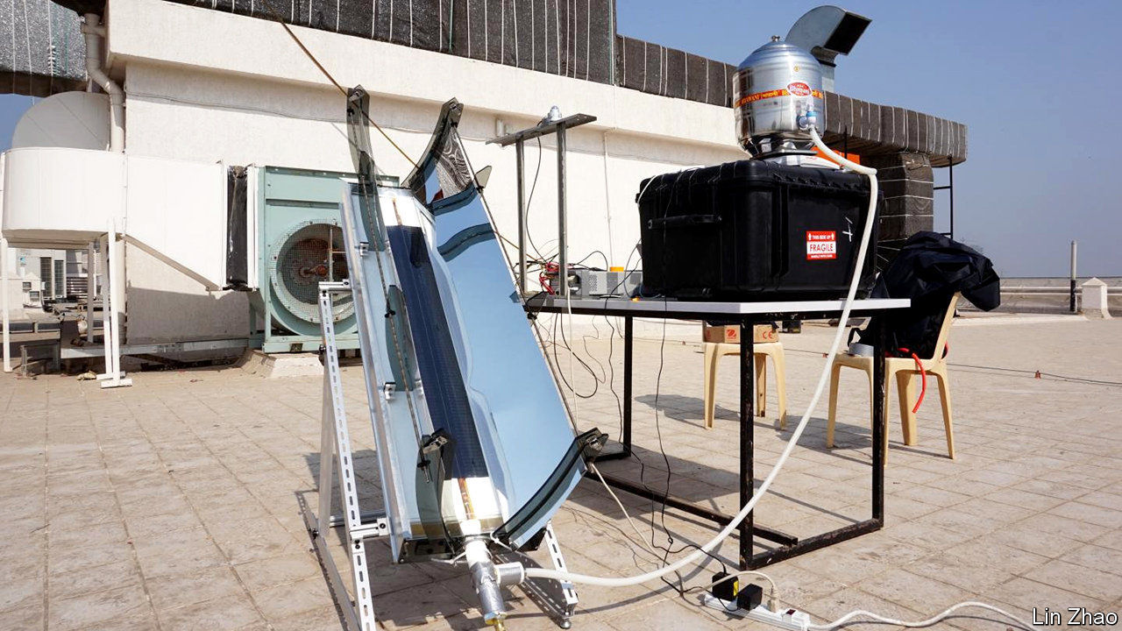

IN THE HISTORY of medicine, praise is rightly showered on those who invented vaccines, antibiotics, antiseptics and anaesthetics. Few, though, remember Charles Chamberland, inventor of the humble autoclave. Yet the ability to sterilise surgical instruments reliably, by exposing them to high-pressure steam in such a device, has been crucial to the development of modern surgery. A mere 12 minutes in an autoclave at 121°C and two atmospheres of pressure kills 99.99% of common pathogenic bacteria. Standard boiling, at 100°C and one atmosphere, takes 80 hours to achieve that level of bactericide.

Electrically powered autoclaves have, as a consequence, become so routine as to be almost unregarded—at least in those places with a reliable electricity supply. Where electricity is not reliable, though, it can be hard to keep surgical instruments germfree. This is a problem to which Zhao Lin of the Massachusetts Institute of Technology thinks he may have an answer. As he and his colleagues describe in Joule, they have designed an autoclave that is powered directly by sunlight. And not only that; they also reckon it should cost just a tenth as much to make commercially as a conventional autoclave of equivalent potency.

Dr Zhao’s device is a work of simplicity and cheap materials. It consists of a metre-long box of rectangular cross section, with two curved fins of polished aluminium, just under 30cm high, sticking out of the top (see diagram). Each fin, seen end on, forms a section of a parabola, and it is a property of parabolic mirrors to focus light from distant sources (the sun, for example) onto a single point—or, in the case of elongated mirrors like these, onto a line.

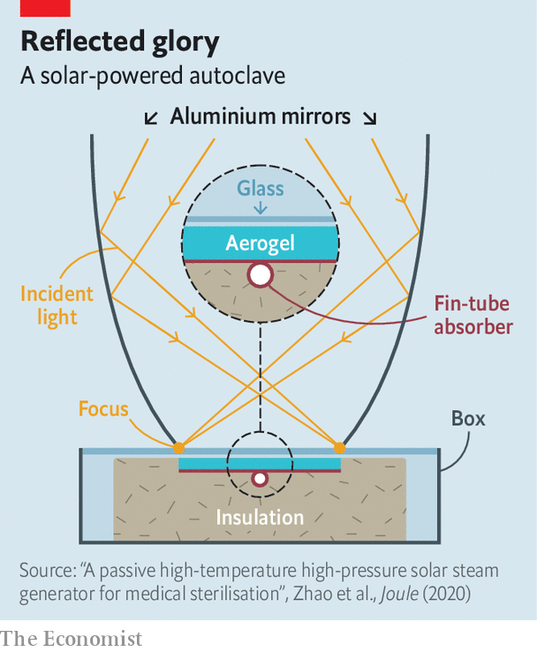

The new invention’s principal trick is that these focal lines coincide with the edges of a copper plate within the box. This plate is part of a commercially available device called a fin-tube absorber. The absorber’s other element is a copper pipe running along the plate’s central axis. The particular geometry of the aluminium fins means that any incident sunlight will continue to be focused onto the copper plate even when the sun is not directly overhead. Anything inside the pipe is therefore going to get—and stay—pretty hot.

Within the box, the fin-tube absorber is seated on a bed of glass fibre, an excellent insulator, and it is covered with a layer of silica aerogel. This stuff, referred to colloquially as “solid smoke” because it has a density of a mere 200 milligrams per cubic centimetre, has the valuable properties of being transparent to light but opaque to heat. This means it admits the sunshine reflected from the mirrors while keeping the pipe as hot as possible. Although such a material sounds rather high-tech, and does, indeed, require specialist equipment to make, silica aerogel is actually quite cheap to buy, at $4 a litre. And a production model of the autoclave, Dr Zhao reckons, would require only half a litre of the stuff.

The whole thing is then topped off with a pane of glass, to protect the aerogel from damage while admitting light. All that is needed after this is to attach a sterilisation chamber to one end of the pipe and a water supply to the other, and then aim the mirrors at the sun. With an appropriate arrangement of valves, the sun’s heat will boil the water, heat the resulting steam well above boiling-point and increase the pressure in the tube—and thus also in the sterilisation chamber.

In tests carried out at a hospital in Mumbai, in partnership with the Indian Institute of Technology in that city, Dr Zhao’s new autoclave was able to sustain steam at a temperature of 128°C and two atmospheres of pressure for half an hour. When tested with autoclave indicator tape, a material used routinely to make sure autoclaves are working properly, it passed with flying colours, meaning it would have successfully sterilised anything within the sterilisation chamber.

Demand for this product is likely to be high. Some 15% of hospital patients in low- and middle-income countries get infected while receiving treatment, and surgery is an important cause of this iatrogenesis. Dr Zhao therefore hopes to have commercial versions ready by 2022. Recognition for his work, as Chamberland might have observed, could take a while longer.■

This article was downloaded by calibre from <https://www.economist.com/science-and-technology/2020/11/28/how-to-sterilise-scalpels-when-no-electricity-is-available>

|  |  |  |  |
| --- | --- | --- | --- |
| Previous | Articles | Sections | Next |

|  |  |  |  |
| --- | --- | --- | --- |
| Previous | Articles | Sections | Next |

#### Nursery days

# Giant prehistoric sharks left their young in nurseries

The perfect place for a Miocene remake of “Jaws”

Nov 28th 2020 |



IF SHARKS HAD bony skeletons, which preserve easily as fossils, rather than cartilaginous ones, which do not, then Otodus megalodon would probably be as famous as Tyrannosaurus rex. Even though only its teeth are routinely available for study, it has starred in at least one film, “The Meg”, released in 2018. Were it better known, a whole ocean-based franchise akin to “Jurassic Park” might now exist.

No matter. It is still an intriguing animal. Adults are reckoned to have reached a length of 18 metres. (T. rex was 12 metres from snout to tip of tail.) And megalodons, as they are called colloquially, lasted as a species from the beginning of the Miocene epoch 23m years ago to 3m years ago, during the Pliocene. That is far longer than T. rex’s brief appearance 68m-66m years ago at the end of the Cretaceous. Their family life has, however, hitherto been obscure.

Perhaps “family” is a slight exaggeration. But many modern sharks lay their eggs (or, if viviparous, give birth) in places known as shark nurseries. Jose Herraiz of the University of Valencia and his colleagues wondered if that had also been true of megalodons. As they report this week in Biology Letters, it seems it was.

Shark nurseries are shallow coastal areas that have abundant food available and are, precisely because of their shallowness, difficult for predators like other, bigger sharks to move around in. Some 16m years ago part of north-eastern Spain, between what are now the cities of Barcelona and Tarragona, was just such a shallow, protected bay. And two quarries dug into the rock that formed from the sediment in this bay have yielded a number of megalodon teeth.

Shark’s teeth indicate, by their size and shape, the size of their possessor’s body. That is how O. megalodon’s adult length has been estimated. But body size within a species is also a good indicator of age. Dr Herraiz and his colleagues therefore studied the 25 best-preserved megalodon teeth from these quarries, to deduce the size distribution, and thus the age distribution, of the sharks that had lived there.

To do so they used a formula for length determination worked out for great whites, the largest existing shark that hunts individual prey. (There are larger species, such as the whale shark and the basking shark, but these filter small prey from the water in a manner similar to baleen whales.) Applying this formula to the teeth from the quarries, they found that the sharks in question had probably ranged in length from about three to 14 metres. These animals were therefore either juveniles or small adults, suggesting it was, indeed, a nursery.

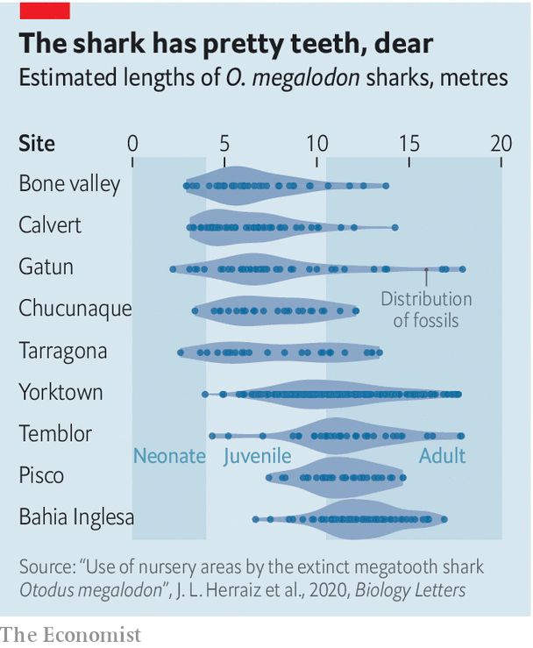

Thus encouraged, the researchers then applied their method to eight other sites from which megalodon teeth have been recovered (see chart). Four were similarly youngster-dominated. The other four were dominated by adults. They therefore think they have identified five megalodon nurseries. The remainder, they suspect, were either breeding grounds or feeding grounds for grown-ups.■

This article was downloaded by calibre from <https://www.economist.com/science-and-technology/2020/11/28/giant-prehistoric-sharks-left-their-young-in-nurseries>

|  |  |  |  |
| --- | --- | --- | --- |
| Previous | Articles | Sections | Next |

|  |  |  |  |
| --- | --- | --- | --- |
| Previous | Articles | Sections | Next |

#### Children’s car seats

# Child-safety laws may reduce the birth rate

Berth control

Nov 28th 2020 | NEW YORK

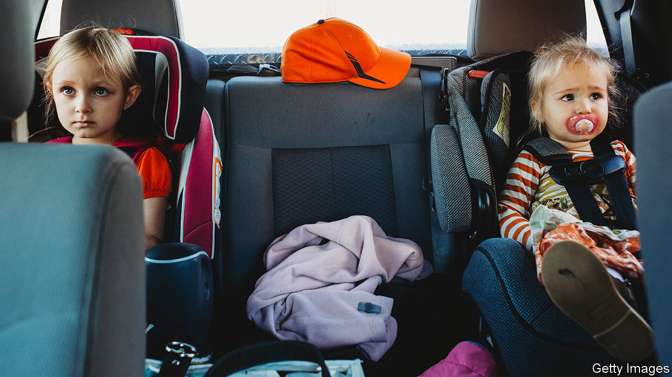

IN THE EARLY 1970s American women gave birth, on average, to 2.12 children each. By 2018 that figure had fallen to 1.73. Many alterations in people’s lives have been invoked to help explain this change, including the facts that women now are better educated, more likely to have jobs or run businesses, and have better access to contraception than their antecedents of five decades ago. Also, demand for children to work as extra pairs of hands on family farms has dropped.

None of these explanations, though, overlaps neatly with birth-rate curves. Other factors must be at work, too. And Jordan Nickerson and David Solomon, professors of finance at the Massachusetts Institute of Technology and Boston College respectively, think they have found an intriguingly counterintuitive one: America’s increasingly protective child car-seat laws.

Their study, “Car seats as contraception”, published in SSRN, a repository for so-called preprint papers that have yet to undergo formal peer review, examines the effect that car-seat policies may have had on American birth rates between 1973 and 2017. During the Reagan era, only the truly wee—tots aged under three—had normally to be secured in child-safety seats. But states’ governments have, since then, gradually ramped up the requirements. Today, most places in America make children sit in safety seats until their eighth birthdays. That concern for youngsters’ safety has had the unintended consequence, Dr Nickerson and Dr Solomon suggest, of fewer three-child families.

In drawing this conclusion they have correlated census data with changes in state laws on safety seats. They discovered that tightening those laws had no detectable effects on the rates of births of first and second children, but was accompanied by a drop, on average, of 0.73 percentage points in the number of women giving birth to a third while the first two were young enough to need safety seats. That may not sound much, but it is a significant fraction of the 9.36% of women in the sample who did become third-time mothers.

The authors also made two other pertinent observations. The reduction they saw was confined to households that did actually have access to a car. And it was larger in households where a man was living with the mother. The latter point is relevant, they think, because this man would take up space in a vehicle that could otherwise be occupied by a child.

And space in the vehicle is the crucial factor. In pre-safety-seat days, squeezing three young children into the back of a family saloon was a perfectly feasible proposition. Most such cars, though, can comfortably accommodate only two safety seats. So, the older a child must be before no safety seat is required, the longer a family must wait before a third child will fit in the car. Sometimes, that wait will mean no third child is ever conceived and born.

Unless, of course, the family concerned buys a bigger car. And here things get yet more interesting, for the obvious reasons not to do so—big cars cost more, and are more costly to run—may not be the only disincentive to changing. Dr Nickerson and Dr Solomon found, in fact, that the third-child deterrent appears stronger among wealthier families. As they observe, “large cars like minivans also have class and aesthetic connotations that may make people reluctant to switch even when they can afford to.”

## Back-seat driver

Oddly, though, the authors do not leave it at that. Instead, they point to previous studies which suggest that, for children over two, safety seats are no better than seat belts at protecting against death or serious injury in a crash. They estimate that laws requiring children to sit in special seats until they are eight years old saved about 57 lives in 2017 and contrast that number with the 8,000 children who might have been conceived and born in the absence of such rules. There is, they conclude, no “compelling social interest” in requiring child seats for children over four.

This seems weird. Comparing putative lives forgone to actual lives saved is, to put it politely, a strange moral calculation. And the empirical basis for it is, in any case, doubtful. Alisa Baer, a paediatrician in New York who specialises in car-seat safety and who says she has installed at least 15,000 such seats over the years (she is known as “The Car Seat Lady”), says that this part of the paper is “completely preposterous”. Children’s car seats, she says, “save the quality of life” of children who would suffer higher rates of injury compared with simply belting up—including massive abdominal trauma and paralysis. A recent study by Mark Anderson at the University of Washington and Sina Sandholt at Columbia University bears this point out.

That does not, though, detract from the wider observation Dr Nickerson and Dr Solomon make that well-intentioned actions can have surprising knock-on effects. And one such, it seems, is that the back seats of American cars, once renowned as places where children were conceived, may now, themselves, be acting as contraceptives.■

This article was downloaded by calibre from <https://www.economist.com/science-and-technology/2020/11/28/child-safety-laws-may-reduce-the-birth-rate>

|  |  |  |  |
| --- | --- | --- | --- |
| Previous | Articles | Sections | Next |

|  |  |  |  |
| --- | --- | --- | --- |
| Previous | Articles | Sections | Next |

#### Scientific instruments

# With the death of Arecibo, an era ends for radio astronomy

A snapped cable has irreparably damaged the dish

Nov 25th 2020 |

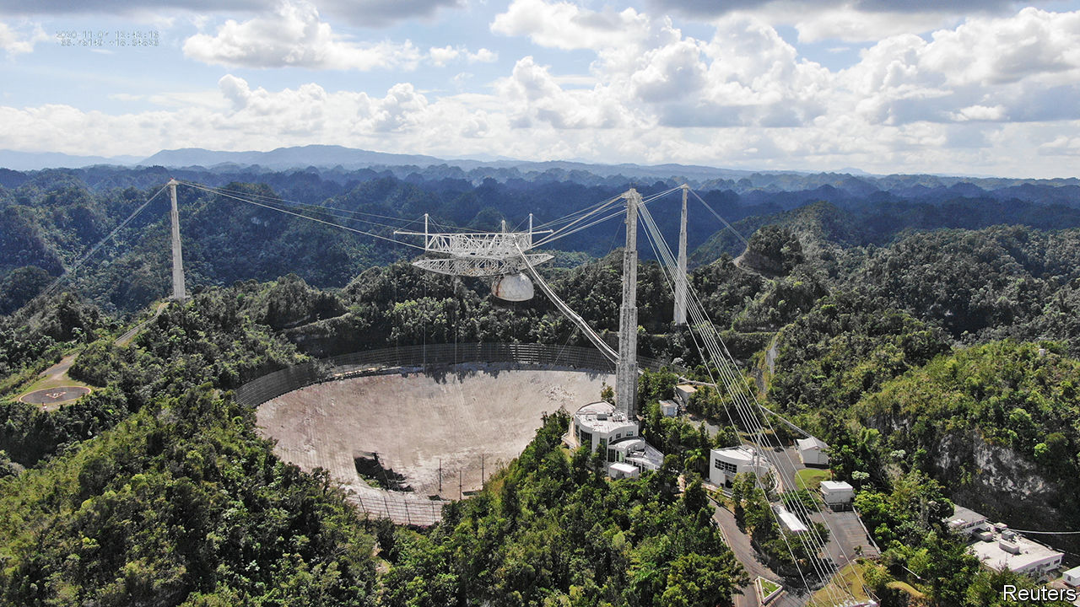

ARECIBO OBSERVATORY was conceived in an era of space-age monumentalism, an imposition of geometry onto geology as striking in its simplicity and scale as the greatest brutalist architecture. When the James Bond franchise, in its pomp a showcase for iconic 1960s design, eventually got around to using the 306-metre dish as a location in the 1990s, the only surprise was that it had taken so long.

The observatory was not new to spycraft. It was created as a tool for using radar to study the ionosphere, an electrically charged upper layer of the atmosphere. America’s defence department had an interest in such work, which might lead to new ways of characterising incoming missiles or of snooping on enemy transmissions, so it stumped up some cash.

A free-standing dish big enough for the job would have been impractical. The designers therefore looked for a hole in the ground to repurpose. They found it in north-western Puerto Rico, a sinkhole where the limestone landscape had collapsed in just the right way. They built three towers on the sinkhole’s rim and hoisted the electronic heart of the instrument—the bit which emits and receives radio waves—into the empty space between them. Signals travelling to or from this equipment would bounce off eight hectares of wire mesh stretched out beneath it.

As a radar, Arecibo used the world’s biggest dish to study not just the ionosphere but also the surfaces of nearby planets and passing asteroids. But it was as a radio telescope that it truly excelled, making some crucial discoveries during the 1960s and 1970s, radio astronomy’s golden age. The most famous was a pair of pulsars—spinning neutron stars—orbiting each other in a way which was shown to prove Einstein’s general theory of relativity. Later data revealed planets around another pulsar. This was the first definitive detection of planets beyond the solar system.

Arecibo was also used for radio astronomy’s wayward offshoot, the search for extraterrestrial intelligence. Since 1960 radio astronomers have occasionally employed their instruments to look for artificial signals from the stars. In 1974, after an upgrade that saw the original mesh replaced by a dish made up of 38,778 aluminium panels, Arecibo was used to go a step further. It transmitted a 1,679-bit message towards a star cluster 25,000 light-years away. Encoded in this message were graphical representations of basic biochemistry and astronomy, and of the technology with which it had been sent.

Over time, technological advance eroded the advantages of Arecibo’s sheer size, and its funding dwindled. The engineering began to show its age. In August one of the cables supporting the instrument platform snapped, damaging the dish. The snapping of a second, in early November, seemed to presage imminent collapse. And so it is to be closed.

But as the vegetation beneath the dish rises through its remains, and the site falls into picturesque ruin, the sketch of its cross-section encoded in that message from the 1970s will continue on its way. It is already 46 light-years from Earth. Its pixels now constitute the farthest-flung memorial to a human achievement anywhere in the universe. And they always will.■

This article was downloaded by calibre from <https://www.economist.com/science-and-technology/2020/11/25/with-the-death-of-arecibo-an-era-ends-for-radio-astronomy>

|  |  |  |  |
| --- | --- | --- | --- |
| Previous | Articles | Sections | Next |

|  |  |  |
| --- | --- | --- |
| Science & ... | Sections | Economic & ... |

Books & arts

The underworld of empire: Brothers in arms

.

Historical fiction: Cops and plotters

.

Creatures of the deep: Thar she blew

.

Lives of the composers: Too beautiful

.

Johnson: Average Joe

.

|  |  |  |
| --- | --- | --- |
| Science & ... | Sections | Economic & ... |

|  |  |  |  |
| --- | --- | --- | --- |
|  | Articles | Sections | Next |

#### Brothers in arms

# When a fraternity of revolutionaries evolved across Asia

A brilliant new history uncovers the underworld of empire

Nov 28th 2020 |

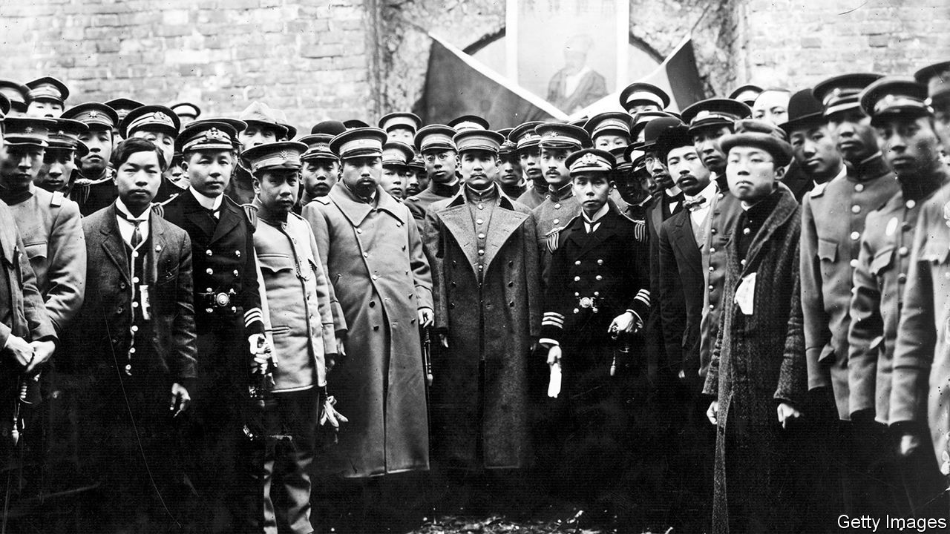

Underground Asia. By Tim Harper.Allen Lane; 864 pages; £35. To be published in America by Harvard University Press in January; $39.95.

IN JUNE 1919 a petition circulated among delegates to the peace conference at Versailles. The “Demands of the Annamite People” claimed to speak for the inhabitants of the part of French Indochina that is today the heart of Vietnam. The petition, Tim Harper writes, was one of many “into which were decanted the hopes of entire peoples”. Its demands seemed moderate enough—things like freedom of the press, the right to education, abolition of government by decree—and it was received politely by Woodrow Wilson and even the president of the French republic.

But its tone, of presuming to speak directly to power, got under the skin of the French authorities, who had built an empire in Indochina on the back of forced labour, while plantations ran their own private prisons. As the document circulated among the diplomatic missions and, within two months, hit the streets of Hanoi, the security services knew that its author, Nguyen Ai Quoc—a pseudonym meaning “Nguyen the Patriot”—was in some way important. They were to maintain that conviction for more than three decades.

Briefly, Nguyen Ai Quoc would break cover, for instance to address political meetings in Paris, scruffily dressed. Yet the expanding secret-police files on him reflected official frustration. He lied about his age, his name, his origins and his profession. He changed his accent to suit. Time and again, Nguyen Ai Quoc slipped like quicksilver through the fingers of imperial powers. His shadow was found in libraries, cafés and boarding houses across France, in port cities such as Singapore and New York, and even in the London suburb of Ealing; one rumour had him as a pastry chef under the great Escoffier. His writings surfaced in illicit journals in China and Korea. But just when the Sûreté Générale picked up his scent again, he was gone.

Nguyen Ai Quoc is emblematic of a global underground of Asian nationalists and revolutionaries that is the subject of this superbly original book. In it, Mr Harper, a historian at the University of Cambridge, describes how in the first decades of the 20th century dreams took hold of a continent freed from imperial shackles—British shackles in India and South-East Asia, Dutch in the Dutch East Indies (modern-day Indonesia), French in Indochina and those of assorted European powers in China. These dreams were nurtured in the liminal cracks of empire: in steerage class along the new steamship routes connecting Asia with Europe and North America, in the doss houses of teeming port cities from Yokohama to Marseille, and among the modernist and radical circles in metropolitan centres such as London and Paris.

“Underground Asia” breaks new ground by showing how a collective consciousness emerged among revolutionaries on this shifting terrain. Some were well-heeled, sent to Europe with imperial blessing for a good education. Sumatran traditions encouraged young men like Tan Malaka to expose themselves to “the largeness of the world”; he went to the Netherlands. Others were more like Nguyen Ai Quoc, whose father, a local magistrate, was cashiered for drunken violence, whose sister hung out with pirates, and who worked his passage to Europe as an ordinary seaman. All nevertheless shared resources and knowledge, made alliances, or “were simply witness to each other, drawing strength from a sense of co-presence”. Activists from China, Japan and Vietnam struggled to understand each other’s speech. But through “brushtalk”—deploying the Chinese logograms common to all their writing systems—they laboriously exchanged ideas into the night.

Back home this wave of consciousness fostered experiments in mass education and political instruction, a new culture popularised by radical “mosquito journals”. It generated a powerful belief that—as Narendra Nath Bhattacharya, the Indian revolutionary better known as M.N. Roy, put it—Europe was not the world.

This was a fluid realm. Western ideas raced back to Asia, transmuting into action. Anarchism, “the quintessential ideology of exile”, shaded into the republicanism of Giuseppe Mazzini and Sinn Fein. At times, Islam claimed to transcend borders.

## Back to the future

After Nicholas II of Russia abdicated in 1917, meanwhile, “the tempests of the world outside blew directly into the households of Surabaya and Semarang.” On seizing power, Vladimir Lenin had looked to Europe’s working classes to foster wider revolution. When that hope fizzled, the revolutionary potential of Asian peasantries—whom Lenin, like the colonialists, had hitherto deemed backward—was reassessed. Asian radicals were summoned to Moscow. Nguyen Ai Quoc, M.N. Roy and Tan Malaka were at the heart of what Mr Harper calls the greatest missionary effort in Asia since the Jesuits set out to convert China, India and Japan in the 16th century.

In Asia, and even in imperial homelands, action sometimes took violent form. Assassinations were attempted against the British viceroy of India and the governor-general of French Indochina. In early 1925 a young Chinese woman with the bob-cut of the “Modern Girl”, an attitude popularised in Shanghai and Tokyo before Paris or New York, walked into a welfare office in Kuala Lumpur and coolly tried to blow up two British functionaries.

Such violence aroused lurid fears of a “yellow peril”. In truth, strikes and boycotts targeting economies that required colonial subjects to be both producers and consumers had more effect. But by the late 1920s the authorities had the upper hand. Not least, borders were no longer porous, while the Sûreté and its counterparts had established IDs, fingerprinting and rigorous record-keeping. They recruited narks and watchmen from the same waterfronts and brothel areas inhabited by the revolutionaries. International co-operation was regularised when Interpol was founded in 1923.

Radicals caught in the colonial net were rounded up and sent to detention centres, such as at Port Blair in India’s Andaman Islands or, in the case of Indonesians, to Boven Digoel, upriver in malarial New Guinea. Mr Harper argues that these camps were a harbinger of the kind in which political undesirables would be held in Europe.

After the devastation suffered by even the victorious powers during the second world war, Asia’s revolutionaries saw fresh chances. Some seized the moment and rode to power. Today Nguyen Ai Quoc, he of countless aliases, has one of Asia’s most teeming metropolises named after him: Ho Chi Minh City. Tan Malaka, by contrast, was devoured by the revolution he helped spawn—killed by his own side in the fight against the Dutch and the British.

Yet the lives of both men are testament to an early premonition that, far from being a morass of backwardness requiring firm imperial tutelage, Asia lay, as Mr Harper writes, “at the forefront of human futures”. And so, though many of the revolutionaries he evokes are now forgotten—or, for some Asian nations, too inconvenient to remember—their underground stories still echo through time. ■

This article was downloaded by calibre from <https://www.economist.com/books-and-arts/2020/11/28/when-a-fraternity-of-revolutionaries-evolved-across-asia>

|  |  |  |  |
| --- | --- | --- | --- |
|  | Articles | Sections | Next |

|  |  |  |  |
| --- | --- | --- | --- |
| Previous | Articles | Sections | Next |

#### Cops and plotters

# In “The Abstainer”, Ian McGuire returns to the 19th century

The author of “The North Water” weaves a tale of policemen and Irish insurgents in Manchester

Nov 28th 2020 |

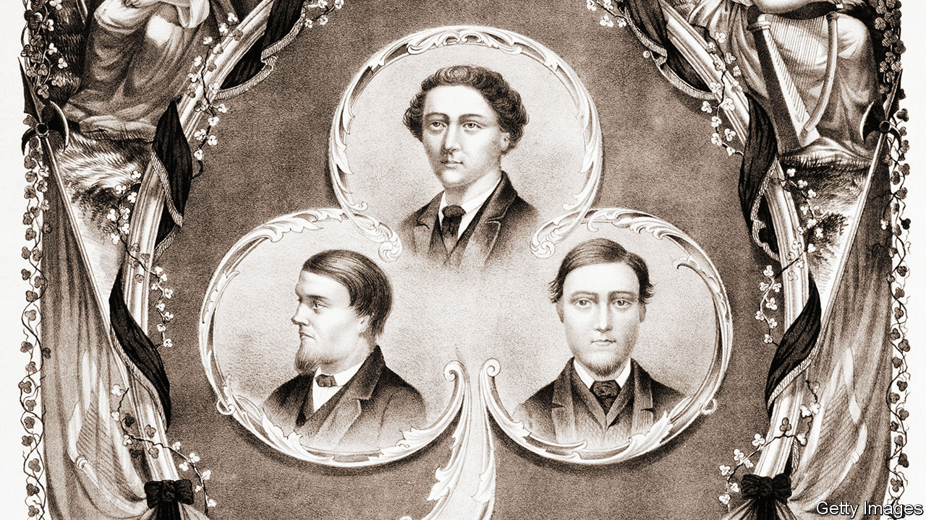

The Abstainer. By Ian McGuire.Random House; 320 pages; $27. Scribner; £14.99.

SET LARGELY in the Greenland whale fisheries of the 1850s, Ian McGuire’s “The North Water” (published in 2016) was dark, violent and propulsive. It was snapped up for a television adaptation starring Colin Farrell that is due to air soon. That novel’s many admirers will wonder whether Mr McGuire’s new book, “The Abstainer”, has the same page-turning pull.

This time the setting is tamer. It is 1867 and James O’Connor, a Dublin policeman, is on secondment in Manchester, though the assignment is not of his choosing. He is a man adrift: when his beloved wife and young son died of illness in Ireland, he took to drink, and this job is his last chance. O’Connor is the abstainer of the title, haunting coffee houses instead of saloons.

The fictional copper arrives just as three real historical figures are to be hanged for the murder of a policeman; the men were Fenians (agitators for Irish independence) and afterwards became known as the “Manchester Martyrs”. O’Connor sees that this is what they will become, and that the hangings are merely cruelty and bombast: “Yet cruelty and bombast are what the English prefer.”

His antagonist is Stephen Doyle. Born in Sligo, Doyle left for America as a teenager and fought in the civil war; he has now come to Manchester as a Fenian operative. He has about him something of the terror of Henry Drax, the animating force of wickedness in “The North Water”, though Doyle’s character is softened by a compelling backstory and the reader’s understanding of his ultimate political aim.

This blend of politics, personal tragedy and revenge is moreishly compelling. The book’s powerful setting is almost a character in itself. Mr McGuire teaches creative writing in Manchester and his passion for the city shines through. The physical world that he imagines assails the reader’s senses: the stink of a tannery, the clangour of factory bells and the way O’Connor’s grief drives him to a ruthlessness beyond his nature.

The novel’s weakness is its ending, when Mr McGuire swerves away from the consummation readers may be expecting. A small shame—but it is still worth raising a toast to “The Abstainer”.

This article was downloaded by calibre from <https://www.economist.com/books-and-arts/2020/11/28/in-the-abstainer-ian-mcguire-returns-to-the-19th-century>

|  |  |  |  |
| --- | --- | --- | --- |
| Previous | Articles | Sections | Next |

|  |  |  |  |
| --- | --- | --- | --- |
| Previous | Articles | Sections | Next |

#### Thar she blew

# An elegy for the world’s biggest creatures

An encounter with a dying whale on a beach in Perth set off Rebecca Giggs’s inquiry

Nov 28th 2020 |

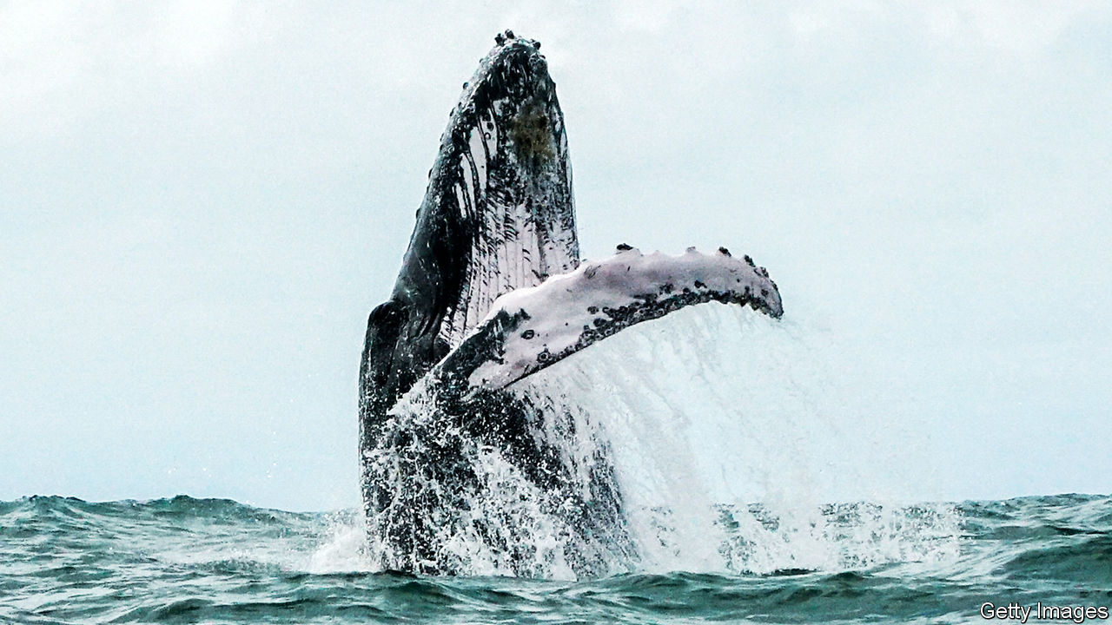

Fathoms. By Rebecca Giggs.Simon & Schuster; 352 pages; $27. Scribe; £20.

TWO YEARS ago your reviewer stood in an office overlooking the Pacific Ocean at the Monterey Bay Aquarium Research Institute in Moss Landing, California. Outside, giant pelicans sliced through the sea air. Inside, the walls and windows were shaken by a below-bass note that boomed out of huge speakers. This, said John Ryan, an oceanographer, was the moan of a humpback whale, the darling of whale-watchers, known for its impressive fin- and tail-slapping displays and haunting “song”. Most recordings of humpbacks seem almost violin-like, but this was much, much deeper—barely a sound, more a vibration that was felt rather than heard.

In the opening scene of “Fathoms”, Rebecca Giggs describes a very different kind of encounter with a humpback: on a beach in Perth, Australia, where a young giant had found itself stranded. For three days, she witnessed its enormous mass crushing its vital organs; the blubber that evolved over millions of years to keep the species alive in the frigid abyss now had the opposite effect. The humpback, she says, “was boiling alive in the kettle of itself”.

Stirred by this encounter, Ms Giggs embarks on a poetic exploration of the largest creatures alive today. “Fathoms” is a series of essays that span aeons and vast amounts of space, from the bottom of the ocean to the far reaches of the solar system. The Voyager probe carries a recording of humpback song; ionic bursts at the surface of the Sun ricochet through space, provoke the shimmery displays of the Northern Lights and eventually disrupt the geomagnetic-field maps that whales use to orient themselves. Throughout, Ms Giggs weaves the human and whale stories around a central question: did the conservationists of the late 20th century save the whales from extinction-by-slaughter, only to deliver them to a more insidious demise? From plastics to toxins, warming oceans, melting sea ice, acidifying waters and modified soundscapes, humanity is warping everything that whales need to live and thrive.

Many of these changes are reflected in the whales themselves. Their flesh, guts, blood and even their song are all, in this telling, a record of human activity. One whale is found to have ingested an entire greenhouse. Postmortems performed on others reveal gas-bubble lesions, ruptured ear canals and abnormal nitrogen levels, all of which are eventually linked to anti-submarine warfare training. And after the 9/11 terrorist attacks, researchers who were monitoring stress hormones in North Atlantic right whales (by analysing their faeces) noticed that their subjects had relaxed, presumably because most ships temporarily returned to port and, for that time, the oceans were quiet.

Death runs through the pages. Today it would be impossible to write a book about whales that did not combine a sense of awe with inevitable tragedy. But “Fathoms” is brilliantly full of wonder. A passage lingers on whale lice, describing how, even now, their genes hold traces of an epic migration made by at least one right whale in the past 1m-2m years. Another marvels at how the decimation of whales in the oceans has transformed ecologies on land: the past movements of whaling communities can be traced in aerial surveys of Arctic vegetation, in places made richer and greener by buried giants. A third section asks whether conserving whale populations might help stabilise the climate. Whales draw carbon dioxide out of the atmosphere and down into the abyss, by fertilising tiny plankton with their faeces, as well as when they die and sink to the sea floor.

The tragedy is detached rather than gory. In places it is beautiful. The afterlife of a whale is tracked from the surface, where its floating carcass is pecked, chewed and debrided by scavengers, down through the water column, past fish that resemble “bottled fireworks”, to its resting place on the seabed. There, “the ballooning mass scatters skin and sodden flesh…upon which grows a carpet of white worms.” One “whale fall” feeds entire ecosystems. It jiggles with life—crabs, fish, worms, bacteria. “A whale body is, to this glitter splash of biology, a godsend,” writes Ms Giggs in one of her finest turns of phrase.

When she encounters a live whale, she feels herself shrink to the size of a pinhead yet retains the detachment that she applies, elsewhere, to her observation of dead ones. She does not sense the affinity that others aver. “Only the most witless individual would believe in a benevolent connection with real whales,” she insists. In the presence of leviathan, “the adrenalin in me was the kick of imminent danger.” ■

For more coverage of climate change, register for The Climate Issue, our fortnightly [newsletter](https://www.economist.com/theclimateissue/), or visit our [climate-change hub](https://www.economist.com/news/2020/04/24/the-economists-coverage-of-climate-change)

This article was downloaded by calibre from <https://www.economist.com/books-and-arts/2020/11/28/an-elegy-for-the-worlds-biggest-creatures>

|  |  |  |  |
| --- | --- | --- | --- |
| Previous | Articles | Sections | Next |

|  |  |  |  |
| --- | --- | --- | --- |
| Previous | Articles | Sections | Next |

#### Too beautiful

# An exhilarating life of Mozart

Jan Swafford peppers his biography of a genius with astute critical judgments

Nov 28th 2020 |

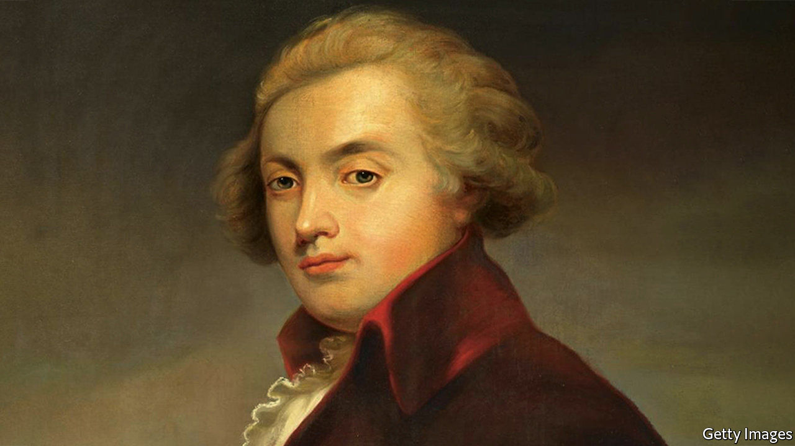

Mozart: The Reign of Love. By Jan Swafford.Harper; 832 pages; $45. Faber & Faber; £30.

THE MOMENT he saw an organ, Wolfgang Amadeus Mozart knew what to do with it. Aged six, already a prodigy on the clavier, he encountered pedals and stops for the first time in an Austrian church. Within moments he was accompanying mass and improvising freely. In the following year, 1763, an official in Heidelberg was so astonished by his organ-playing that he had a plate engraved for his church to mark the boy’s visit. Mozart composed his first symphony at eight. His father wrote that “every day God performs fresh miracles through this child.”

Youthful promise often wanes. With Mozart the reverse was true: his precocity only hinted at the wonders to come. Through him classical music may have found its most ideal expression. As Jan Swafford writes in his outstanding biography, Mozart’s compositions displayed “a kind of effortless perfection so easily worn that they seem almost to have written themselves”. He drafted quickly, often without needing to revise. He “could dispense delight by the yard”. A man of his time rather than a reactionary like Bach or a revolutionary like Beethoven, Mozart was equally at home composing for the concert salon or the opera stage.

Mr Swafford eschews myths about tortured genius. Mozart, he insists, “was fundamentally a happy man”. Despite his natural gifts, he worked relentlessly to master his art. He enjoyed a contented and loving marriage, and deftly parried his scheming father, who clung to his coat-tails while resenting his success. As he made his life’s journey from Salzburg to Vienna he remained childlike and obscene, fixated on bottoms. Mr Swafford describes “an inexplicable force of nature who could rise from a luminous improvisation at the clavier for a round of meowing like a cat and leaping over the furniture”.

He is the subject of many biographies, but the leading one, by Hermann Abert, is 100 years old and 1,600 pages long. Mr Swafford, himself a composer and a programme-writer for the Boston Symphony Orchestra, offers an updated, accessible and authoritative life, beautifully written and full of astute critical judgments and incisive notes on the works. The overture to “The Marriage of Figaro” is all “quicksilver brightness” and “indefatigable energy”; the Piano Trio in B-flat Major has “only a touch of galant preciousness”. “Eine kleine Nachtmusik” is “crystalline perfection”.

Mozart’s way with melody and keen view of human nature—his letters reveal an almost Dickensian ability to paint character—combined to elevate opera from light fare to a serious medium, the author contends. “His wit, his often-mordant scrutiny of people and their foibles, his fascination with the frenzies of love and lovemaking—all this made him the consummate composer” of the form, Mr Swafford reckons. As his characters scrambled around the stage, lost in the human comedy, Mozart gave them divine arias.

He was admired but not adored in his time. Most of his music adhered to conventional structures yet went over the heads of the average listener. Legend has it that his most important patron, Emperor Joseph II, reacted to one performance with backhanded criticism: “Too beautiful for our ears, my dear Mozart, and monstrous many notes!” Mozart, irrepressible and ever cheeky, supposedly replied: “Exactly as many as necessary, Your Majesty!” ■

This article was downloaded by calibre from <https://www.economist.com/books-and-arts/2020/11/28/an-exhilarating-life-of-mozart>

|  |  |  |  |
| --- | --- | --- | --- |
| Previous | Articles | Sections | Next |

|  |  |  |  |
| --- | --- | --- | --- |
| Previous | Articles | Sections | Next |

#### Johnson

# The president-elect lacks a silver tongue. That may be an asset

Joe Biden’s prosaic style is a contrast to 12 years of extraordinary rhetoric

Nov 28th 2020 |

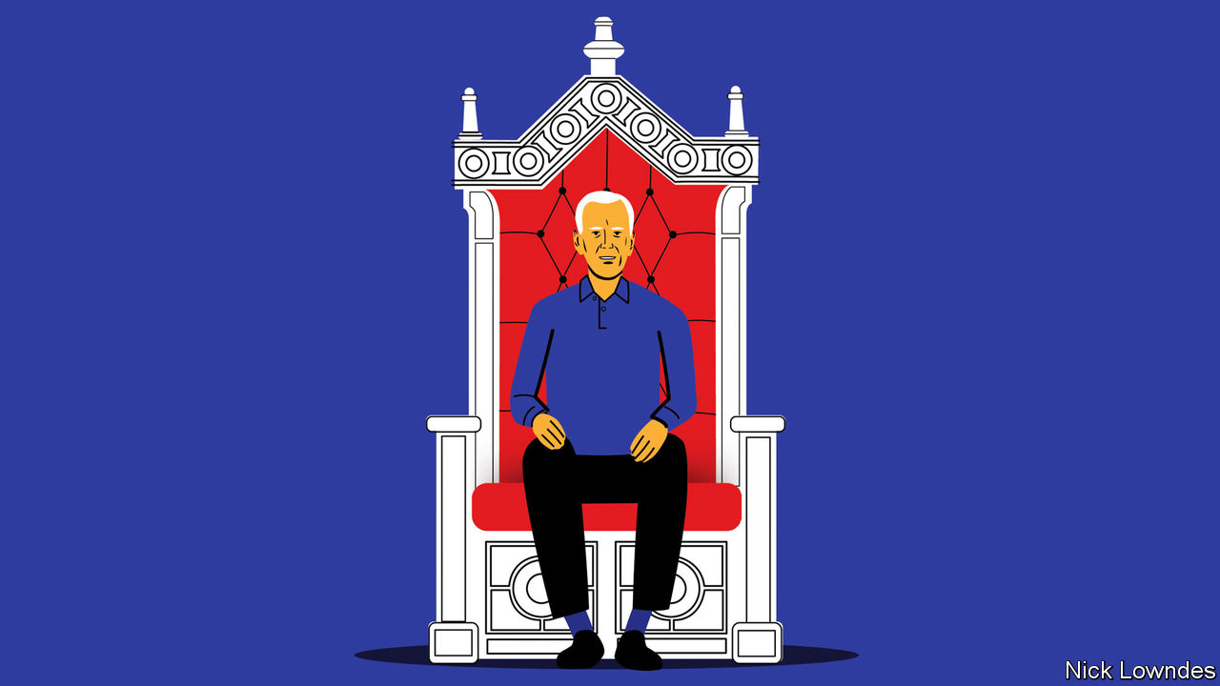

DURING THE Obama years, the Onion, a satirical online newspaper, carried a series of articles about a man it referred to as “Diamond Joe” and “The President of Vice”. It featured headlines like “Shirtless Biden Washes Trans Am in White House Driveway” and “Biden Huddling With Closest Advisers on Whether to Spend 200 Bucks on Scorpions Tickets”.

The real Joe Biden, then vice-president, was a teetotaling and avuncular elder statesman, not a hair-metal-loving party animal. But the caricature of him as a regular guy drew on an element of truth. The now-president-elect, the son of a second-hand-car salesman, will be the first president since Ronald Reagan to lack an Ivy League degree, having finished near the bottom of his class at both the University of Delaware and Syracuse University’s law school.

And this is reflected in his use of language. In his speech, he is such an everyman as to defy parody. “Saturday Night Live”, which has featured impersonators for every president since Chevy Chase’s Gerald Ford, has yet to settle on a memorable Joe Biden. Forced to name Bidenisms, you might single out “malarkey”, his favoured disparagement for humbug, or “Here’s the deal”, to signal that he’s about to cut the malarkey. His favourite vocative is the folksy “Folks...”. In his first debate with Donald Trump, perhaps the most arresting thing he said was (to his constantly interrupting opponent) “Keep yappin’, man.”

He is, it is true, known for gaffes, though these are often overstated. Competing with Barack Obama for the Democratic nomination in 2007-08, Mr Biden praised his future boss as “the first mainstream African-American” to run for the presidency, “who is articulate and bright and clean”. (A gap before “who” made clear that he did not mean previous African-American candidates lacked cleanliness, just that they had been less “mainstream”.) While vice-president, he stood just a bit too close to a microphone as he said “This is a big fucking deal” into Mr Obama’s ear at the signing ceremony for their health-care reform. He once asked a wheelchair-bound state senator to stand and be recognised.

These bloopers give the impression of a mouth running faster than a brain. Mr Obama was famous for long, thoughtful pauses; not so Mr Biden. His campaign speeches, like his questions as a longtime Senate committee chairman, tended to ramble. He once mystifyingly called a young student who asked a tough question a “lying, dog-faced pony soldier”. Accused of corruption by a voter in Iowa, a bit of hotheaded “Diamond Joe” came out: he called the man a “damn liar” and challenged him to a press-up contest. And he mused that, were they in high school, he would “beat the hell” out of Mr Trump.

Instead, he beat him in politics, with words rather than fists. As things turned out, the contrasting styles of his predecessors may have made Mr Biden’s deeply prosaic register an asset after all.

Receiving his party’s nomination in 2008, Mr Obama said future generations might remember the occasion as “the moment when the rise of the oceans began to slow and our planet began to heal”. His high-flown rhetoric raised expectations to messianic levels. Dashed hopes led many voters to look for someone who sounded as little like a politician as possible. In 2016 that meant a political novice who eschewed focus-grouped formulations in favour of provocative, often vulgar tirades. Not only did voters not mind; Mr Trump’s outrageous style was hugely effective. His vernacular delivery implied that he was a real boss, not a backslapping hack, with unique skills to get things done. But in office his coarseness turned some voters off, even as it thrilled others.

All that makes this an ideal time for Average Joe, for whom being able to talk fluidly at all was a hard-won achievement. Mr Biden grew up with a severe stutter, which he overcame as a young man. In one of the most touching scenes of his campaign, he told a boy who stutters, “Don’t let it define you. You are smart as hell.” Mr Biden took the boy’s number and called him with some tips that had helped him; later the boy spoke to the Democratic National Convention.

Even careful presidents make gaffes under constant scrutiny. In office, Mr Biden will no doubt give comics plenty of material to sharpen their impersonations. But if he gets tongue-tied or says the wrong thing every now and then, well, so do most people. After 12 years of extraordinary political speech, Americans may be ready for a president who sounds like them.

This article was downloaded by calibre from <https://www.economist.com/books-and-arts/2020/11/28/the-president-elect-lacks-a-silver-tongue-that-may-be-an-asset>

|  |  |  |  |
| --- | --- | --- | --- |
| Previous | Articles | Sections | Next |

|  |  |  |
| --- | --- | --- |
| Books & arts | Sections | Graphic detail |

Economic & financial indicators

Economic data, markets and commodities

.

|  |  |  |
| --- | --- | --- |
| Books & arts | Sections | Graphic detail |

|  |  |  |  |
| --- | --- | --- | --- |
|  | Articles | Sections | Next |

# Economic data, markets and commodities

Nov 28th 2020 |

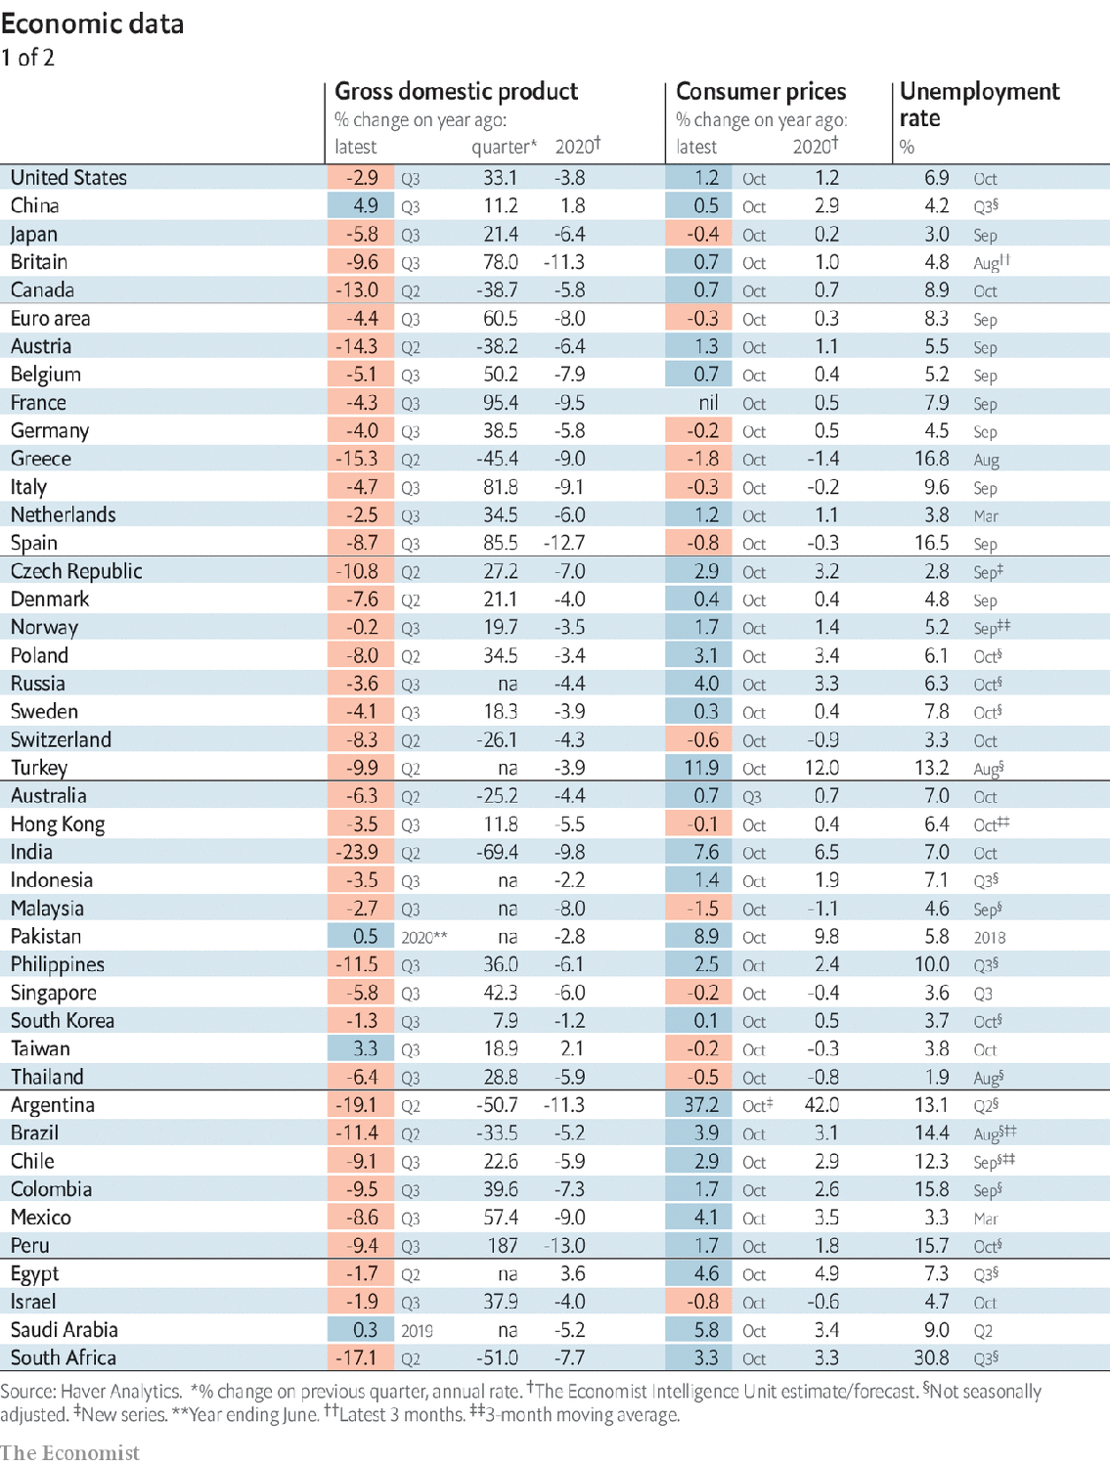

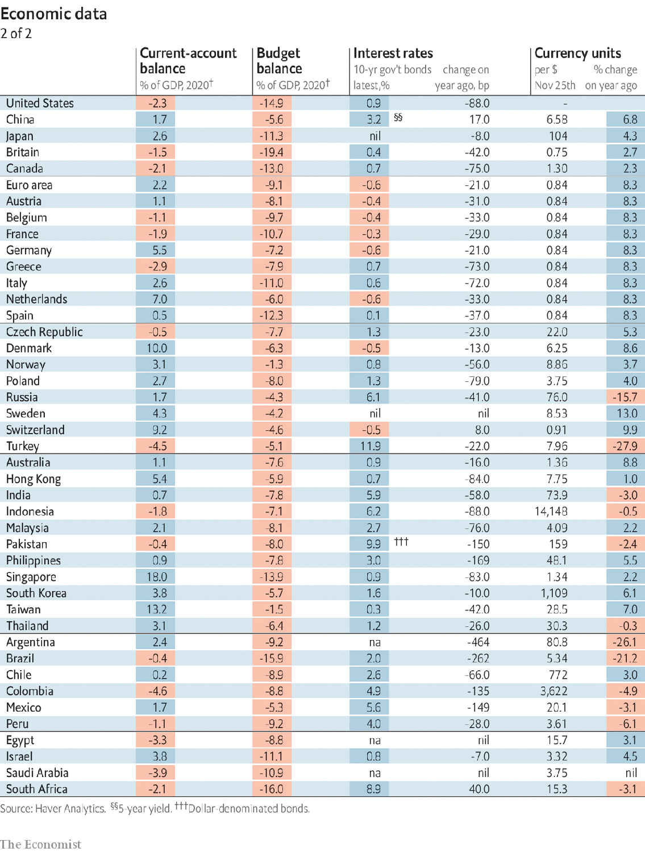

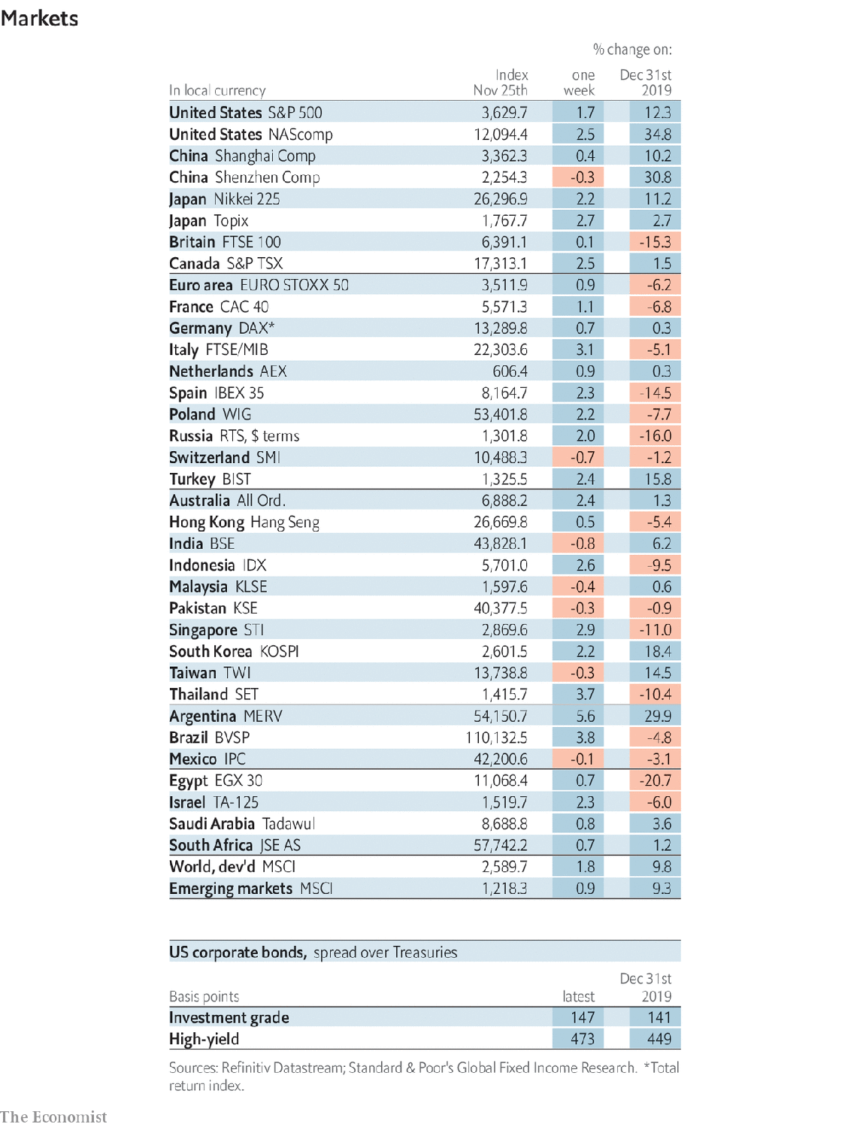

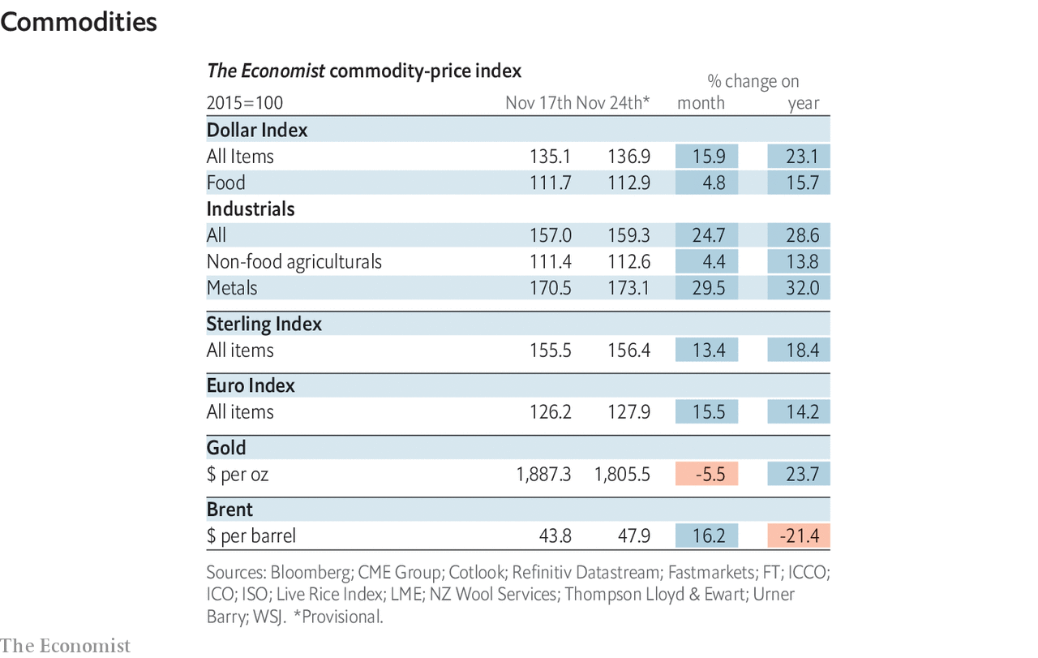

This article was downloaded by calibre from <https://www.economist.com/economic-and-financial-indicators/2020/11/28/economic-data-markets-and-commodities>

|  |  |  |  |
| --- | --- | --- | --- |
|  | Articles | Sections | Next |

|  |  |  |
| --- | --- | --- |
| Economic & ... | Sections | Obituary |

Graphic detail

Covid-19 and lockdowns: Second act

.

|  |  |  |
| --- | --- | --- |
| Economic & ... | Sections | Obituary |

|  |  |  |  |
| --- | --- | --- | --- |
|  | Articles | Sections | Next |

#### A fall in autumn

# Why Europe’s second, less severe lockdowns are working

The restrictions have limited the rate of new infections, especially from long trips

Nov 28th 2020 |

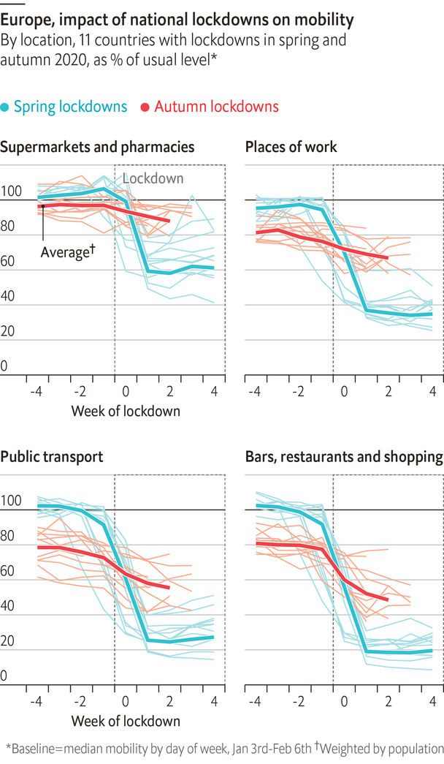

LESS THAN a year after covid-19 spread across the world, scientists have produced several vaccines that may offer high immunity. But mass inoculation is months away. Until then people must contain the virus by wearing masks, travelling less and limiting contact with other households.

Politicians who thought their citizens would stop socialising of their own accord have been disappointed. America’s daily deaths are near record highs as the virus runs amok. Europe’s cases surged in October, causing 11 governments to reimpose national stay-at-home orders. They hope these lockdowns will reduce infections to manageable levels for Christmas. But after a grim spring, they must worry that people will be less compliant this time around.

Google’s smartphone data confirm that Europe’s latest restrictions have had less impact on daily life. In March the average number of trips—to places such as supermarkets, restaurants, transport hubs and offices—fell to 35% of the level in January. After rebounding to 83% by the time of the latest lockdowns, mobility has now dropped only to 68%. This smaller effect could be caused both by more flexible rules and less enthusiasm for obeying them.

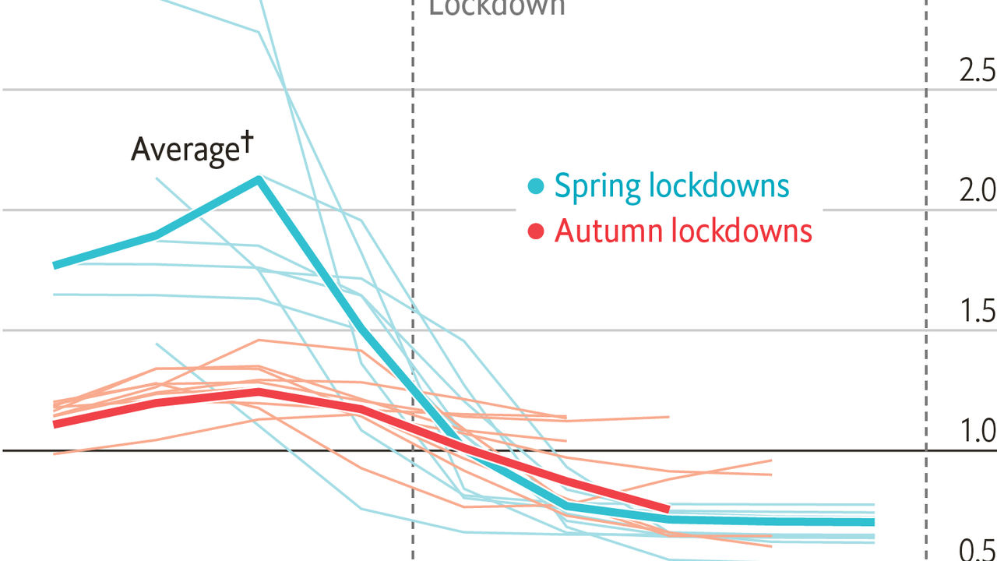

Yet these less stringent lockdowns are still working. The London School of Hygiene and Tropical Medicine’s estimates of R—the average number of new people who catch the virus from each infected person—are dropping. In European countries that enacted second lockdowns, R fell from an average of 1.1 in the week before the new restrictions to 0.9 in the week after. That small change makes a big difference. Over four weeks, it would mean new infections falling by 21%, rather than rising by 36%.

For 334 local authorities in England and Wales (akin to America’s counties), we have also calculated which aspects of lockdowns matter most. We combined estimates of R from Imperial College London with travel records from Teralytics, a Swiss technology firm, and Google’s smartphone data. Then we used mediation analysis, a statistical technique, to disentangle the effects of different types of mobility.

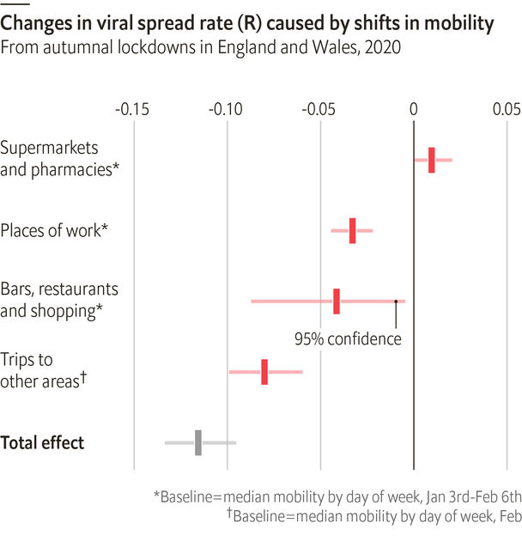

We found two ways that lockdowns suppress R. First, reducing trips to work helps, as do fewer outings to restaurants, bars and shops, though the effect of those leisure settings may vary a lot. (Usage of parks or public transport had no impact, perhaps because visitors are outside or wearing masks.) Second, lockdowns deter people from travelling to other local authorities. This is probably the most important factor in decreasing R overall.

This is all good news. Looser lockdowns cost less than total closures. And when governments reopen businesses, they can mitigate extra mingling among customers by urging them to stay in their local areas, for now. That is the best way to get the virus under control before Christmas. ■

Editor’s note: Some of our covid-19 coverage is free for readers of The Economist Today, our daily [newsletter](https://my.economist.com/user#newsletter). For more stories and our pandemic tracker, see our [hub](https://www.economist.com/news/2020/03/11/the-economists-coverage-of-the-coronavirus)

Sources: Covid19-projections.com; Google; Teralytics; Blavatnik School of Government, University of Oxford; Swapnil Mishra et al., Imperial College London; Sam Abbott et al., London School of Hygiene and Tropical Medicine

This article was downloaded by calibre from <https://www.economist.com/graphic-detail/2020/11/28/why-europes-second-less-severe-lockdowns-are-working>

|  |  |  |  |
| --- | --- | --- | --- |
|  | Articles | Sections | Next |

|  |  |  |
| --- | --- | --- |
| Graphic detail | Sections |  |

Obituary

Jan Morris: Unaltered states

.

|  |  |  |
| --- | --- | --- |
| Graphic detail | Sections |  |

|  |  |  |  |
| --- | --- | --- | --- |
|  | Articles | Sections | Next |

#### Unaltered states

# Jan Morris died on November 20th

The essayist, journalist and historian who challenged sexual expectations was 94

Nov 26th 2020 |

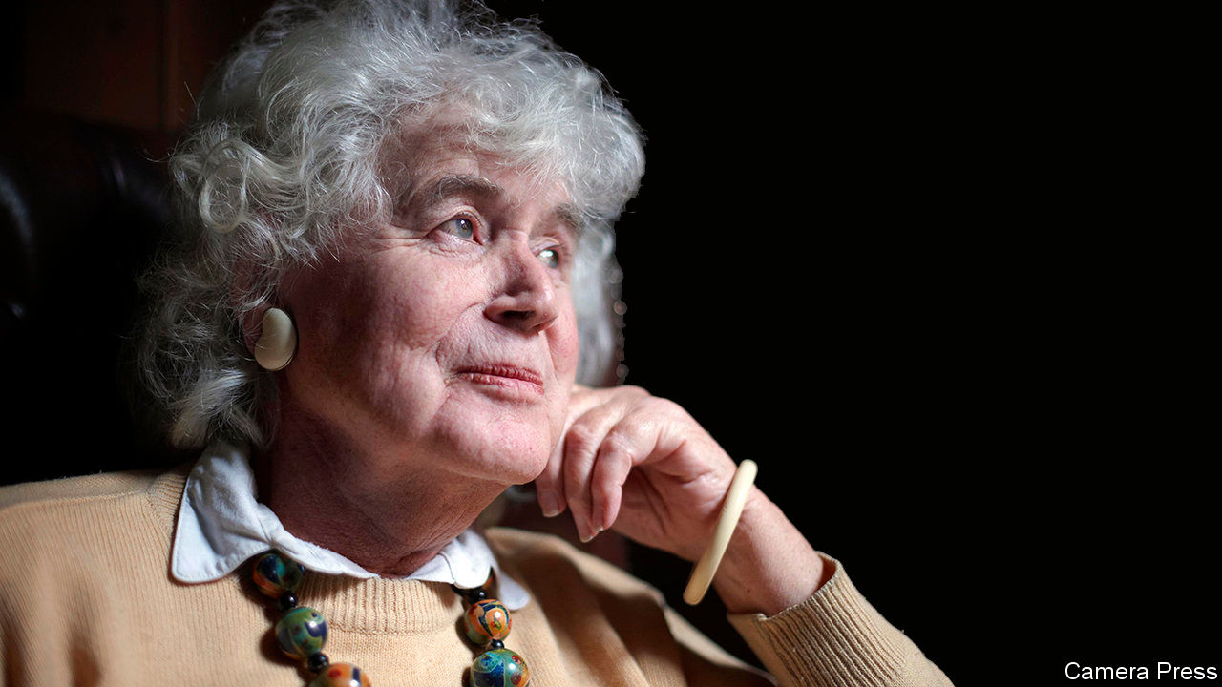

CONSIDERING her life, as she most liked to, from the sprawling stone stables of Trefan Morys in north Wales among trees, owls and waters, Jan Morris divided it into three parts. For the first 35 years she had been James Morris, a soldier and an intrepid reporter. For a decade after that, as she took the hormone pills that gradually lightened and rejuvenated her, she was an androgynous creature, untethered and strange. Then, from 1972 and the procedure in Casablanca that permanently altered her body, she was herself.

James, however, had not gone anywhere. He was still about: the little lad with his precious telescope already trained on the blue mountains of Wales, the Christ Church choirboy piping in his white and scarlet, the intelligence officer rattling in jeeps through the deserts of Arabia, the craver for fire, salt and laughter as a writer for the Manchester Guardian. He was a handsome man, tall, lean and sinewy, exulting as young men could in the full, controlled power of his body. In 1953, when he was working for the Times, he accompanied Sir Edmund Hillary’s Everest expedition (though he had never climbed a mountain before) and brought back the world scoop that the peak had been conquered. That slithering, bounding descent to the telegraph office, forcing his way down a glacier as if sparks flew from him, and the sending of the message in “skulldug” code to London in time for the queen’s coronation, was the best memory of his life, and hers.

Of the androgynous years there was less to report. Commissions flooded in, incessant travelling went on, books were written and much praised. But the work was now freelance, not for any employer, and despite marriage and children a sense of tormented solitude descended. Fame seemed repugnant, as part of maleness. In Africa or India people inquired whether this visitor was a man, a woman, or some holy hermaphrodite. The body became disturbing and could not be shown, except to a small deserted lake high in the Welsh hills that embraced it with no questions.

And then, at last, came the triumphant liberation of being a woman, as she had known she should be since toddlerhood. The “Why?” was unimportant, though it struck her as only common sense or, at least, good taste: gentleness against force, give more than take, yielding and accepting rather than pushing and initiating. The subtle subjection, the condescension and assumed inferiority, were a small price to pay. The prurient curiosity of her legions of readers could be satisfied with a book about it all, called “Conundrum”, in 1974. Then she could resume her life.

For what had really changed? Almost nothing. Her dispositions were as they had always been: a liking for cats and smart cars, moules and white wine, for speed, wind and great spaces, for the role of the loner and onlooker, and romanticism in the bones. The army still attracted her for its dash, courage, self-discipline and swagger. When she took a walk for exercise, she marched like a soldier. She remained married (though, between 1972 and 2008, formally divorced because illegal), to Elizabeth, with an intensity of love different from all others. They lived surrounded by the intimate presence of thousands of books, to which she chatted as friends.

The writing went on seamlessly, every day and with any implement available, navigating the wonderful, inexhaustible, shimmering sea of words. Through the 1970s she continued and completed a wistful three-volume history of the decline of the British Empire, “Pax Britannica”, her best work she thought, which had been started in the spirit of a Roman centurion witnessing the decline of Rome. She kept up the irresistible habit of visiting every city greater than Bucharest, barging in uninvited and ignorant with the same voracious cheek to wander and record impressions: sparkling Manhattan, where Fred Astaire might dance at any moment down Fifth Avenue; Sydney, vacuous and frigid at the soul; Beirut, a Carmen among cities, tossing its curls and flouncing its skirts; Cairo, with its smell of unrefined petrol, dust, jasmine and new concrete. She retained the old love of shifting places, not quite fixed, such as name-changing Trieste and St Petersburg, crossed by both snow-light and sea-light. Above all, she kept Venice. To drift on inky waters in a gondola at night, slightly drunk, watching the pale buildings pass, was a sublimation as good as sexual. In those years of sexual misery, it was compensation.

But far too much was made of organs. Gender was distinct from sex, a more fundamental reality, based not in the loins so much as in head and heart. It was an inner music, a light and shade. For her “the conundrum thing” was less a matter of science than a divine allegory, a union of selves. One had absorbed the other, and nothing was discarded. As with writing about a place, which was also a search for unity of a sort, hard facts were less important than feeling, mood and even imagination. These produced a subtler, personal truth. Even the British Empire was evoked in looks, smells and sensations, the dates left vague. Her first drafts were usually stream-of-consciousness, letting it all go through; her second inserted the more sober, conscious self, often, she thought, wrongly.

She attributed her mystical feelings largely to Wales, the land of her fathers, damp, demanding and bemusing as she knew it to be, but also worked through with allusions, lore and magic and underpinned by kindness. In “The Matter of Wales” she declared herself a firm nationalist, though the softness and humour of England pleased her. Something of Wales, she wrote, lurked and smiled behind all her writings, for she owned it, every lichened boulder, every spin of the pit wheel, like all her places. She was one with the peasants, the miners, the mythmakers and the shape-changers.

There at Trefan Morys, on the banks of the river Dwyfor that ran, loudly through weed and moss, round a tiny island where her ashes would be scattered, she planned to spend most of the after-life wandering with Elizabeth. She foresaw the odd excursion, though, to the seafront at Trieste, the city that always looked over its shoulder at the tangled illusions and yearnings of the past, to toast its sweet melancholy with a glass of sparkling wine. ■

This article was downloaded by calibre from <https://www.economist.com/obituary/2020/11/26/jan-morris-died-on-november-20th>

|  |  |  |  |
| --- | --- | --- | --- |
|  | Articles | Sections | Next |